



**Predicting Stroke Symptoms Using Artificial Intelligence and Convolutional Neural Networks to Aid Medical Professionals**

**By**

**AAZ AHMED MAFAAZ**

**TP071349**

**APU3F2411CS(AI)**

A report submitted in partial fulfillment of the requirements for the degree of

B.Sc. (Hons) Computer Science Specialism in Artificial Intelligence

at Asia Pacific University of Technology and Innovation.

**Supervised by Assoc. Prof. Dr. Nirase Fathima Abubacker**

**2nd Marker: Mr. Raheem Mafas**

**2025**

**DECLARATION OF THESIS CONFIDENTIALITY**

Author’s full name: AAZ AHMED MAFAAZ

IC No./Passport No.: LA29E0550

Thesis/Project title: Predicting stroke symptoms using artificial intelligence and convolutional neural networks to aid medical professionals

I declare that this thesis is classified as:

CONFIDENTIAL

RESTRICTED

OPEN ACCESS

I acknowledged that Asia Pacific University of Technology & Innovation (APU) reserves the right as follows:

1. The thesis is the property of Asia Pacific University of Technology & Innovation (APU).
2. The Library of Asia Pacific University of Technology & Innovation (APU) has the right to make copies for the purpose of research only.
3. The Library has the right to make copies of the thesis for academic exchange.

|  |  |
| --- | --- |
| Author’s Signature: |  |
| Date: | 18th July 2025 |
|  |  |
| Supervisor’s Name: | Assoc. prof. dr. nirase fathima abubacker |
| Date: | 18th July 2025 |
| Signature: | **N. F. A** |

|  |
| --- |
| **First Name:** Aaz |
| **Middle Name (only if applicable):** Ahmed |
| **Last Name:** Mafaz |
| **Title of the Final Year Project / Dissertation / Thesis:**  Predicting Stroke Symptoms Using Artificial Intelligence and Convolutional Neural Networks to Aid Medical Professionals |
| **Abstract:**  Stroke continues to be the leading cause of death and disability worldwide. Misdiagnosis and slow treatment are usually prime factors that causes this. The research paper focuses on how Artificial Intelligence (AI) with Convolutional Neural Networks (CNNs) and Machine Learning (ML) enhances the prediction of stroke. This system integrates real-time stroke analysis using CT scans and patient medical history allowing for accurate and fast predictions. The research follows the use of Rapid Application Development (RAD) for developing the system which allows for multiple iterative improvements based on the feedback of users and stakeholder. The proposed system aims to assist medical experts by improving accuracy of diagnosis, reducing human error, and making the prediction overall faster which is crucial for the treatment of stroke patients. Through its implementation the project supports SDG 3 Goal by delivering early disease diagnosis which directly improves healthcare services. |
| **A few keywords associated with the work:**  Medical Diagnosis, Stroke Detection, Artificial Intelligence, Machine Learning, Convolutional Neural Networks, Predictive Analytics |
| **General Subject:** Computer Science in Artificial Intelligence |
| **Date of Submission:** 23rd July 2025 |

# ACKNOWLEDGEMENT

I am deeply thankful for the guidance extended by my supervisor Assoc. Prof. Dr. Nirase Fathima Abubacker during my project. Her valuable feedback and continuous support throughout the research were important in shaping the foundation of the project and led to its positive development. I would also like to express my gratitude towards my second marker Mr. Raheem Mafaas for my report grading, which would aid me for the second phase of the project. I would also like to thank Asia Pacific University for allowing me access to the research papers used for this project.

Additionally, I extend my earnest thanks to my friends and family for their constant support and providing valuable insights to expand on the project. I would also like to thank the staff of Bank of Maldives for providing me an opportunity to gain hands-on experience for automation and artificial intelligence models during my internship. Their mentorship has aided me throughout the duration of the project. Lastly, I would like to express my profound appreciation to all the survey participants and test users for providing me insight and important suggestions to improve my project.

All success achieved in this project would have been possible with the collective efforts of these individuals for which I remain sincerely thankful.

# ABSTRACT

Stroke continues to be the leading cause of death and disability worldwide. Misdiagnosis and slow treatment are usually prime factors that causes this. The research paper focuses on how Artificial Intelligence (AI) with Convolutional Neural Networks (CNNs) and Machine Learning (ML) enhances the prediction of stroke. This system integrates real-time stroke analysis using CT scans and patient medical history allowing for accurate and fast predictions. The research follows the use of Rapid Application Development (RAD) for developing the system which allows for multiple iterative improvements based on the feedback of users and stakeholder. The proposed system aims to assist medical experts by improving accuracy of diagnosis, reducing human error, and making the prediction overall faster which is crucial for the treatment of stroke patients. Through its implementation the project supports SDG 3 Goal by delivering early disease diagnosis which directly improves healthcare services.

*Keywords: Medical Diagnosis, Stroke Detection, Artificial Intelligence, Machine Learning, Convolutional Neural Networks, Predictive Analytics.*

Contents

ACKNOWLEDGEMENT 4

ABSTRACT 5

LIST OF FIGURES 10

LIST OF TABLES 18

CHAPTER 1: INTRODUCTION 21

1.1 Introduction 21

1.2 Problem Background 23

1.3 Project Aim 25

1.4 Objectives 25

1.5 Scope 25

1.6 Potential Benefits 27

1.7 Overview of the FYP 27

1.8 Project Plan 29

CHAPTER 2: LITERATURE REVIEW 31

2.1 Introduction 31

2.2 Domain Research 31

2.2.1 Artificial Intelligence (AI) in Healthcare 31

2.2.2 Machine Learning (ML) in Medical Management 32

2.2.3 Convolutional Neural Network (CNNs) for Medical Image Analysis 33

2.2.4 Multimodal AI Models in Healthcare 35

2.2.5 Explainable Artificial Intelligence (XAI) in Healthcare 36

2.3 Similar Works 37

2.4 Technical Research 41

2.4.1 Physical Hardware Requirements 41

2.4.2 Software Required 42

2.4.3 IDE Chosen 43

2.4.4 Libraries and Tools Required 43

2.4.5 Database Management System Required 44

2.4.6 Operating System Chosen 44

2.4.7 Web Browser Chosen 44

2.5 Summary 45

CHAPTER 3: METHODOLOGY 46

3.1 Introduction 46

3.2 System Development Methodology 46

3.2.1 Introduction of Methodology 46

3.2.2 Methodology Choice and Justification 47

3.2.3 Phases of Rapid Application Development (RAD) 51

3.3 Data Gathering Design 52

3.4 Analysis 64

3.4.1 Section 1: General Information 65

3.4.2 Section 2: Awareness of Stroke 66

3.4.3 Section 3: Stroke in Healthcare 72

3.4.4 Section 4: AI in Healthcare 76

3.4.5 Section 5: Conclusion 81

3.5 Summary 83

CHAPTER 4: DESIGN AND IMPLEMENTATION 85

4.1 Introduction 85

4.2 System Design 85

4.2.1 System Architecture 85

4.2.2 Use Case Diagram 88

4.2.3 Activity Diagram 123

4.3 Database Design 153

4.3.1 Database Overview 153

4.3.2 ER Diagram 156

4.3.3 Data Dictionary 157

4.4 Interface Design 164

4.4.1 Menu Design 164

4.4.2 System Page Navigation 167

4.5 Implementation 171

4.5.1 Frontend Functions 171

4.5.2 AI/ML Models 190

4.6 Backend Functions (Sample Codes) 232

4.6.1 Tables.py 232

4.6.2 Schemas.py 235

4.6.3 Chatbot_routes.py 238

4.6.4 Main.py 240

4.6.5 App.js 269

4.6.6 Batch Files 270

4.7 Summary 272

CHAPTER 5: RESULT AND DISCUSSION 273

5.1 Introduction 273

5.2 Test Plan 273

5.2.1 Unit Testing 273

5.2.2 User Acceptance Testing 274

5.3 Testing Results and Discussion 277

5.3.1 Unit Testing 277

5.3.2 User Acceptance Testing 296

5.4 Summary 305

CHAPTER 6: CONCLUSION 307

6.1 Critical Evaluation 307

6.1.1 Overall Project Achievement 307

6.1.2 Justification of Project 307

6.1.3 Strengths of the Project 308

6.2 Limitation 309

6.3 Recommendation 310

References 312

APPENDICES 317

Appendix A: PPF 317

Appendix B: Ethic Form (Fast Track) 329

Appendix C: Log Sheets 331

Appendix D: Poster 332

Appendix E: Gantt Chart 333

Appendix F: Sample Code Implementation 334

Appendix G: Respondent Demographic Profile 337

Appendix H: Similarity Report 340

Appendix I: LLM Cloud Storage Link 342

# LIST OF FIGURES

Figure 1: Impact of stroke throughout the world (World Stroke Organization, 2024) 21

Figure 2: consequences of stroke (Phillips, 2022) 22

Figure 3: Differences of both types of strokes (Yetman, 2023) 24

Figure 4: Project Plan for Investigation Report 29

Figure 5: Project Plan for Project Documentation 30

Figure 6: Subsets of AI with examples. (Kourounis, 2023) 32

Figure 7: Difference of supervised and unsupervised learning (Kourounis, 2023) 33

Figure 8: Use of CNN for medical diagnosis. ( (Rguibi, 2022) 34

Figure 9: Multimodal LLM for covid-19 (Liu, 2023) 36

Figure 10: Application of using LIME in healthcare (Bruckert, 2020) 37

Figure 11: SDM Life Cycle (Oladele, 2023) 47

Figure 12: Example of RAP (Gadhavi, 2023) 48

Figure 13: Cover page 53

Figure 14: Cover page questions 54

Figure 15: General Information section questions 55

Figure 16: Awareness of stroke questions 1 56

Figure 17: Awareness of stroke questions 2 57

Figure 18: Awareness of stroke questions 3 58

Figure 19: Stroke in healthcare questions 1 59

Figure 20: stroke healthcare questions 2 60

Figure 21: AI in healthcare questions 1 61

Figure 22: AI in healthcare questions 2 62

Figure 23: AI in healthcare questions 3 63

Figure 24: Conclusion section questions 64

Figure 25: Section 1: question 1 65

Figure 26: Section 1: question 2 65

Figure 27: Section 1: question 3 66

Figure 28: Section 2: question 4 67

Figure 29: Section 2: question 5 67

Figure 30: Section 2: question 6 67

Figure 31: Section 2: question 7 68

Figure 32: Section 2: question 8 69

Figure 33: Section 2: question 9 69

Figure 34: Section 2: question 10 70

Figure 35: Section 2: question 11 70

Figure 36: Section 2: question 12 71

Figure 37: Section 3: question 13 72

Figure 38: Section 3: question 14 72

Figure 39: Section 3: question 15 73

Figure 40: Section 3: question 16 74

Figure 41: Section 3: question 17 74

Figure 42: Section 3: question 18 75

Figure 43: Section 3: question 19 75

Figure 44: Section 4 question 20 76

Figure 45: Section 4 question 21 77

Figure 46: Section 4 question 22 77

Figure 47: Section 4 question 23 78

Figure 48: Section 4 question 24 78

Figure 49: Section 4 question 25 79

Figure 50: Section 4 question 26 79

Figure 51: Section 4 question 27 80

Figure 52: Section 4 question 28 80

Figure 53: Section 5 question 29 81

Figure 54: Section 5 question 30 82

Figure 55: Section 5 question 31A 82

Figure 56: Section 5 question 31B 83

Figure 57: System architecture diagram 86

Figure 58: User Case Diagram 1 89

Figure 59: User Case Diagram 2 89

Figure 60: Activity Diagram 1 - Login 123

Figure 61: Activity Diagram 2 – View Users 124

Figure 62: Activity Diagram 3 – Register Users 1 125

Figure 63: Activity Diagram 3 – Register Users 2 126

Figure 64: Activity Diagram 4 – Delete Users 127

Figure 65: Activity Diagram 5 – Change Profile Settings 128

Figure 66: Activity Diagram 6 - Switch Between Light and Dark Mode 129

Figure 67: Activity Diagram 7 – Chat with RAG Medical ChatBot 130

Figure 68: Activity Diagram 8 – Report Issue 131

Figure 69: Activity Diagram 9 – View Reports 131

Figure 70: Activity Diagram 10 – Solve Reports 132

Figure 71: Activity Diagram 11 - Unsolve Reports 133

Figure 72: Activity Diagram 12 – View Patient Database 134

Figure 73: Activity Diagram 13 – View More Patient Details 135

Figure 74: Activity Diagram 14 – Print Patient Details 136

Figure 75: Activity Diagram 15 – Delete Patient 137

Figure 76: Activity Diagram 16 – View Person Database 138

Figure 77: Activity Diagram 17 – Delete Person 139

Figure 78: Activity Diagram 18 – View RAG Training Manager 140

Figure 79: Activity Diagram 19 – Upload PDF to Vector Database 141

Figure 80: Activity Diagram 20 – Delete PDF Sources from Database 142

Figure 81: Activity Diagram 21 – View CT Model Retraining Manager 143

Figure 82: Activity Diagram 22 - Retraining CT Model 144

Figure 83: Activity Diagram 23 – View Misclassified Scans 145

Figure 84: Activity Diagram 24 – Update Scan Labels 146

Figure 85: Activity Diagram 25 – Register Patients/Person 1 147

Figure 86: Activity Diagram 25 - Register Patients/Person 2 147

Figure 87: Activity Diagram 26 – Register Existing Patient 148

Figure 88: Activity Diagram 27 – Use of Stroke CT Scan Model 150

Figure 89: Activity Diagram 28 – Report Misclassification 150

Figure 90: Activity Diagram 29 – Use of Stroke Symptom Model 151

Figure 91: Activity Diagram 30 – Use of RAG Chatbot with Previous Model Data 152

Figure 92: Activity Diagram 31 – Logout 153

Figure 93: Tables used for the system as shown in PostgreSQL Admin 155

Figure 94: Database ER Diagram 156

Figure 95: Admin Panel Design 165

Figure 96: Supervisor Panel Design 166

Figure 97: Doctor Panel Design 167

Figure 98: Admin Page Navigation Diagram 168

Figure 99: Supervisor Page Navigation Diagram 169

Figure 100: Doctor Page Navigation Diagram 170

Figure 101: Login Page Dark Mode 171

Figure 102: Login Page Light Mode 171

Figure 103: Admin Home Page 172

Figure 104: Chatbot Page Simple Question 173

Figure 105: Chatbot Page with Clinical Insight Function 174

Figure 106: Profile Setting Page 175

Figure 107: Patient Database Page 176

Figure 108: Patient Database Page Modal Function 177

Figure 109: Patient Database Page for Admin 178

Figure 110: Person Database Page 179

Figure 111: Manage Reports Page 180

Figure 112: Manage Users Page 181

Figure 113: Issue Reporting Page 182

Figure 114: Misclassified Scans Page 183

Figure 115: CT Model Retraining Page 184

Figure 116: CT Model Retraining Page After Retraining 185

Figure 117: Chatbot RAG Training Page 185

Figure 118: Stroke Prediction Hub 186

Figure 119: Accessing Existing Page 187

Figure 120: Stroke Symptom Model Page 188

Figure 121: CT Scan Model Page 189

Figure 122: CT Scan Model Page Report Misclassification Function 190

Figure 123: Symptom Model Requirements.txt 191

Figure 124: Symptom Model Data Handling 192

Figure 125: Symptom Model Data Preprocessing 193

Figure 126: Symptom Model Exploratory Analysis 1 194

Figure 127: Symptom Model Exploratory Analysis 2 195

Figure 128: Symptom Model Exploratory Analysis 3 195

Figure 129: Symptom Model Feature Engineering 1 196

Figure 130: Symptom Model Feature Engineering 2 197

Figure 131: Symptom Model Baseline Model Implementation 1 198

Figure 132: Symptom Model Baseline Model Implementation 2 199

Figure 133: Symptom Model Baseline Model Implementation 3 200

Figure 134: Symptom Model Cross Validation Results 200

Figure 135: Symptom Model Baseline Model Implementation 4 201

Figure 136: Symptom Model Baseline Model Implementation 5 202

Figure 137: Symptom Model Final Model Evaluation 203

Figure 138: Symptom Model Explainability & Interpretability 204

Figure 139: Symptom Model AI transparency with SHAP 205

Figure 140: Symptom Model Test Case 1 206

Figure 141: Symptom Model Test Case 2 207

Figure 142: CT Scan Model Setup 1 208

Figure 143: CT Scan Model Setup 2 209

Figure 144: CT Scan Model Setup 3 210

Figure 145: CT Scan Model Dataset Structure 210

Figure 146: CT Scan Model Setup 4 211

Figure 147: CT Scan Model Setup 5 212

Figure 148: CT Scan Model Setup 6 213

Figure 149: CT Scan Model visualization of samples 213

Figure 150: CT Scan Model Training 1 214

Figure 151: CT Scan Model Training 2 215

Figure 152: CT Scan Model Training 3 216

Figure 153: CT Scan Model Training 4 216

Figure 154: CT Scan Model Training 5 217

Figure 155: CT Scan Model Training 6 218

Figure 156: CT Scan Model Training 7 219

Figure 157: CT Scan Model Training 8 220

Figure 158: CT Scan Model Training 9 221

Figure 159: CT Scan Model Training Epoch 222

Figure 160: CT Scan Model Training Epoch Confusion Matrix 222

Figure 161: CT Scan Model Training Visualization 223

Figure 162: CT Scan Model Best Model Loaded 223

Figure 163: CT Scan Model Prediction Visualization 224

Figure 164: CT Scan Model External Test Confusion Matrix 225

Figure 165: MedicalBot Chatbot Function 1 226

Figure 166: MedicalBot Chatbot Function 2 228

Figure 167: MedicalBot Chatbot Function 3 229

Figure 168: MedicalBot Chatbot Document Loading Example 1 230

Figure 169: MedicalBot Chatbot Document Loading Example 2 230

Figure 170: MedicalBot Chatbot Document Loading Example 3 231

Figure 171: Tables.py Imports 232

Figure 172: Tables.py User Class 233

Figure 173: Tables.py PatientCTScan Class 233

Figure 174: Tables.py Patient Class 234

Figure 175: Tables.py Document Class 234

Figure 176: Tables.py Create All Table Function 234

Figure 177: Schemas.py Imports 235

Figure 178: Scehmas.py Base Models 235

Figure 179: Scehmas.py Retrain Parameter Model 236

Figure 180: Schemas,py Report Model 237

Figure 181: Chatbot_routes.py Initializations 238

Figure 182: Chatbot_routes.py Ask Function 238

Figure 183: Chatbot_routes.py Clinical Insight Function 1 239

Figure 184: Chatbot_routes.py Clinical Insight Function 2 240

Figure 185: Main.py Imports 1 241

Figure 186: Main.py Imports 2 242

Figure 187: Main.py Initialization 243

Figure 188: Main.py Load Stroke CT Model 244

Figure 189: Main.py Load Stroke Symptom Model 245

Figure 190: Main.py Exception Handler 245

Figure 191: Main.py Admin User Routes 246

Figure 192: Main.py Delete Users 246

Figure 193: Main.py Update User Profile 247

Figure 194: Main.py Login Endpoint 247

Figure 195: Main.py Report Creation and Configuration 248

Figure 196: Main.py Report Functions 249

Figure 197: Main.py Stroke CT Scan Prediction 249

Figure 198: Main.py Register Patient Data 250

Figure 199: Main.py Get All Patients 251

Figure 200: Main.py Get Patient Information 252

Figure 201: Main.py Get Patient Symptoms 253

Figure 202: Main.py Get Patient CT Scans 253

Figure 203: Main.py Delete Patient/ Get Person Data 254

Figure 204: Delete Person Data 255

Figure 205: Main.py Save CT Scan 1 256

Figure 206: Main.py Save CT Scan 2 256

Figure 207: Main.py Report Misclassification 257

Figure 208: Main.py Get All Misclassification CT Scans 258

Figure 209: Main.py Approve Misclassification 259

Figure 210: Main.py RAG Upload 260

Figure 211: Main.py RAG Sources Routes 261

Figure 212: Main.py Save Symptoms 262

Figure 213: Main.py Check Patient Data Compatibility 262

Figure 214: Main.py Model Retraining Stats 263

Figure 215: Main.py Model Retraining 1 264

Figure 216: Main.py Model Retraining 2 265

Figure 217: Main.py Model Retraining 3 266

Figure 218: Main.py Model Retraining 4 267

Figure 219: Main.py Stroke Risk Prediction 268

Figure 220: App,js routes 269

Figure 221: Run_tables.bat Code 270

Figure 222: Add_admin.bat Code 271

Figure 223: Start_app.bat Code 271

Figure 224: Draft Project Proposal 328

Figure 225: Ethic forms (Fast Track) 331

Figure 226: Log Sheets 331

Figure 227: FYP Poster 332

Figure 228: Gantt Charts 333

Figure 229: add_test_user.py 334

Figure 230: App.css Example 335

Figure 231: App.css Light Mode Example 336

Figure 232: App.css Dark Mode Example 337

Figure 233: Similarity Report 341

# LIST OF TABLES

Table 1: Table of similar system 40

Table 2: hardware used for AI model development 41

Table 3: Software requirements 42

Table 4: Libraries/tools required for AI system 44

Table 5: Comparison of RAD, XP and waterfall model 50

Table 6: Use Case Specification 1 – Login 90

Table 7: Use Case Specification 2 -View Users 91

Table 8: Use Case Specification 3 – Register Users 92

Table 9: Use Case Specification 4 – Delete Users 94

Table 10: Use Case Specification 5 – Change Profile Settings 95

Table 11: Use Case Specification 6 – Switch Between Light and Dark 96

Table 12: Use Case Specification 7 – Chat with Medical Chatbot 97

Table 13: Use Case Specification 8 – Report Issues 98

Table 14: Use Case Specification 9 – View Reports 99

Table 15: Use Case Specification 10 – Solve Reports 100

Table 16: Use Case Specification 11 – Unsolve Reports 100

Table 17: Use Case Specification 12 – View Patient Database 101

Table 18: Use Case Specification 13 – View More Patient Details 102

Table 19: Use Case Specification 14 – Print Patient Details 103

Table 20: Use Case Specification 15 – Delete Patient 104

Table 21: Use Case Specification 16 – View Person Database 105

Table 22: Use Case Specification 17 – Delete Person 106

Table 23: Use Case Specification 18 – View RAG Training Manager 107

Table 24: Use Case Specification 19 – Upload PDF to Vector Database 108

Table 25: Use Case Specification 20 – Delete PDF Sources from Database 110

Table 26: Use Case Specification 21 – View CT Model Retraining Manager 110

Table 27: Use Case Specification 22 – Retrain CT Model 112

Table 28: Use Case Specification 23 – View Misclassified Scans 112

Table 29: Use Case Specification 24 – Update Scan Labels 113

Table 30: Use Case Specification 25 – Register Patients/Person 115

Table 31: Use Case Specification 26 – Register Existing Patient 116

Table 32: Use Case Specification 27 - Use of Stoke CT Scan Model 118

Table 33: Use Case Specification 28 – Report Misclassification 119

Table 34: Use Case Specification 29 – Use of Stroke Symptom Model 121

Table 35: Use Case Specification 30 – Use of RAG Based Chatbot with Previous Model Data 122

Table 36: Use Case Specification 31 - Logout 123

Table 37: Data Dictionary 1 – Users Table 157

Table 38: Data Dictionary 2 – Person Table 158

Table 39: Data Dictionary 3 – Patient_Data Table 158

Table 40: Data Dictionary 4 – Patient_Symptoms Table 160

Table 41: Data Dictionary 5 – Patient_CT_Scans Table 161

Table 42: Data Dictionary 6 – Misclassified_CT_Scans Table 162

Table 43: Data Dictionary 7 – Retraining_CT_model Table 162

Table 44: Data Dictionary 8 – Reports Table 163

Table 45: Data Dictionary 9 – Document Table 163

Table 46: MedicalBot Chatbot LLM Suggestions 227

Table 47: Unit Testing Table Example 274

Table 48: UAT User Demographic Profile Example 275

Table 49: UAT User Interface Criteria Example 275

Table 50: UAT System Functionality Criteria Example 276

Table 51: UAT AI Model Functionality Criteria Example 276

Table 52: UAT Overall User Experience Example 276

Table 53: UAT Tester Feedback/Suggestions Example 277

Table 54: Unit Testing - Login 278

Table 55: Unit Testing - Manage Users 279

Table 56: Unit Testing - Change Profile Settings 280

Table 57: Unit Testing - Switch Themes 281

Table 58: Unit Testing - Chat with RAG Medical Chatbot 282

Table 59: Unit Testing - Report Issue 282

Table 60: Unit Testing - Manage Reports 283

Table 61: Unit Testing – Patient Database 285

Table 62: Unit Testing – Person Database 285

Table 63: Unit Testing – RAG Training 287

Table 64: Unit Testing – CT Model Retraining 288

Table 65: Unit Testing – Misclassified Scans 289

Table 66: Unit Testing – Register Patient/Person 291

Table 67: Unit Testing – Register Existing User 292

Table 68: Unit Testing – Stroke CT Scan Model 294

Table 69: Unit Testing – Stroke Symptom Model 295

Table 70: Unit Testing – RAG Chatbot with Previous Model Data 296

Table 71: Unit Testing – Logout 296

Table 72: Respondent Demographic Profile 339

# INTRODUCTION

## Introduction

Stroke is one of the most common causes of death throughout the world. In about 1 to 4 adults over 25 has experience with stroke at one point in their lives. Half of the population who have experience Stroke do not survive the encounter. While people who have experienced the encounter have significant impact on their daily life including their impact on physical mobility, the ability to eat, their communication skills, their emotions as well as their cognitive functions. The challenges would of lead to substantial care and financial issues for both the stroke patients and the caregivers while also having a higher demand on healthcare and social support systems. (World Stroke Organization, 2024)

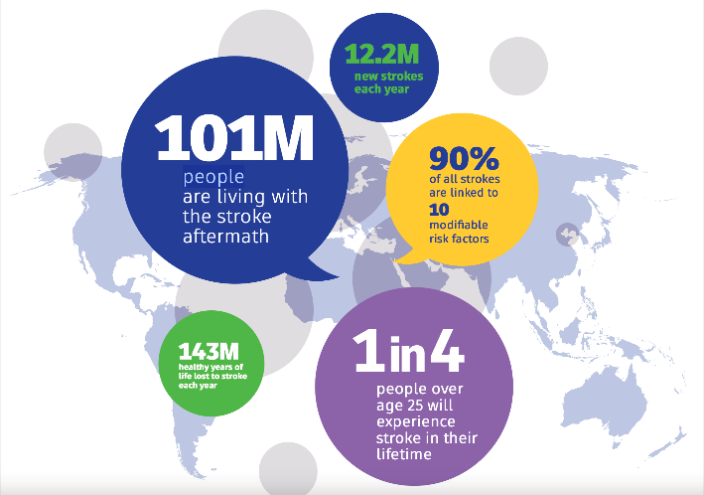

Figure : Impact of stroke throughout the world (World Stroke Organization, 2024)

A stroke would occur when the blood supply to the brain is interrupted, leading to the death of brain cells which would have a major impact on body functions as well as how a person acts and feels. The consequences of stroke would depend on its location in the brain as well as the size of the affected area. (Stroke Association, 2024). Stroke consists of mainly two types of strokes. Ischemic Stroke which occurs when blood flow to the brain is blocked, preventing oxygen and nutrients from reaching, this causes the brain cells to die within minutes. Hemorrhagic stroke is the second type of stroke which happens when there is a sudden bleeding in the brain, this sudden leaking of blood creates pressure on brain cells which lead to prolong damage of brain. (NIH, 2023)

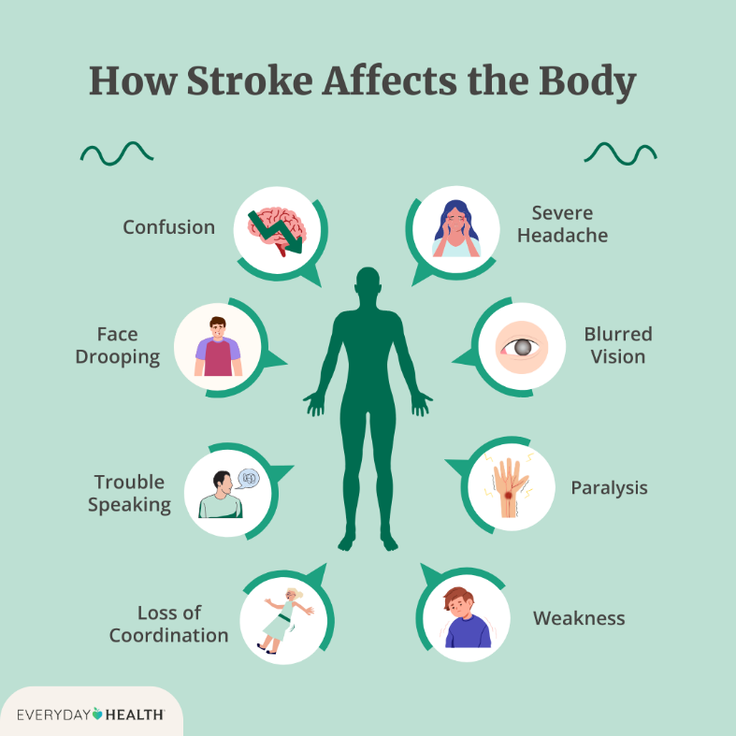

Figure : consequences of stroke (Phillips, 2022)

Convolutional Neural Network (CNN) is a type of deep learning architecture commonly used in computer vision, which itself is a type of artificial intelligence focused on aiding computers find and understand the visual information such as audio, video, and images. (geeksforgeeks, 2024). The convolutional layer is always the first step in a convolutional network and while it can be followed by more convolutional or pooling layers, the final layer is fully connected. As the data moves through the layers the network becomes more complicated and starts to identify more detailed patterns of the images. The earlier layers focus on basic features while the deeper layers identify larger shapes and elements eventually allowing the network to identify the complete object. (IBM, 2024)

This research paper will focus on SDG goal 3: Good Health and Well-Being, using convolutional neural networks (CNN) to identify stroke type detection using brain CT/MRI scans, as well as AI models that spot how much of a risk a patient is of getting stroke based on the patient data. The main goal is to create a tool that can help medical professionals make faster and accurate diagnoses in a shorter period improving the time needed to treat more patients with the ultimate goal of reducing death by stroke. This project does not intend to replace doctors, as such each report generated by the AI models must be validated by a professional doctor.

## Problem Background

Strokes are frequently diagnosed incorrectly because many conditions share similar symptoms, and strokes are often thought to not effect younger people and only older patients. When healthcare professionals do not take their time to carefully assess a patient showing signs of a stroke, they risk misdiagnosing or overlooking this serious condition to which they might be liable to malpractice. (The Tinker Law Firm, 2024). Often these issues are causes by high patient load where physicians may be dealing with multiple patients simultaneously or because other conditions have similar symptoms to stroke leading to getting misdiagnosed with another disease. Symptoms such as dizziness and headaches may not suddenly raise the attention notably if the patient is young or does not have serious risk factors such as any other cardiovascular disease. (Bell Law, 2024), As such the focus of this project would be to develop a real-time stroke prediction AI system with the help of CNN to help medical professionals identify stroke a person has as efficiently as possible to reduce the chance of misdiagnosis.

One common misdiagnosis is epilepsy. The Postictal state after a seizure which is an unusual condition that occurs at the end of an epileptic seizure can copy cognitive impairment often found in stroke leading to misdiagnosis as epilepsy. Seizures cause temporary blood flow changes that mimic stroke patterns leading to brain scans often misdiagnosing the condition, and in addition to that, younger patients would be more likely to be evaluated for epilepsy than stroke. One other example is Acute Vestibular Syndrome (AVS) being often misled for inner ear disorders such as vestibular neuritis. CT scans often have low sensitivity for detecting early stroke at posterior circulation region leading to misdiagnosis. (P Candelaresi, 2023).

As mentioned before there are mainly two types of strokes with each type requiring a different treatment plan. When an ischemic stroke has occurred experts usually give the patients medication known as TPA to reverse the effect of stroke and to break blood clots. One other option is the use of clot-busting medication or mechanical thrombectomy to try to remove the clot as fast as possible. As such ischemic stroke patients make take aspirin and anticoagulants to remove the chances of subsequent blood clots. Unlike that when a hemorrhagic stroke arises thrombolysis medicine is not given to the patient as it would make the bleeding worse and the chance of fatality higher. Instead of this a surgery known as craniotomy is preformed to lessen the pressure on the brain. During a stroke time could decide if a patient would live or not and as such misdiagnosis of stroke is extremely dangerous. (Johnson, 2023)

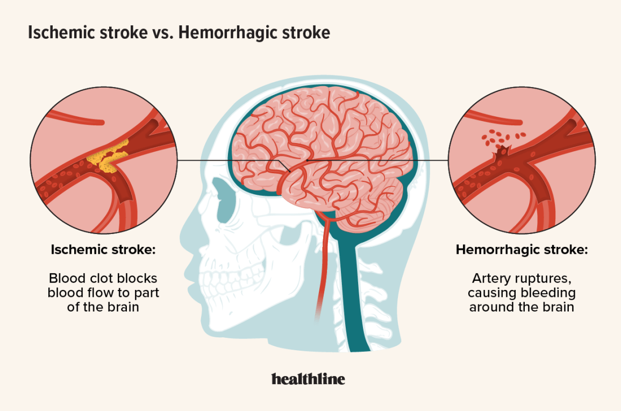

Figure : Differences of both types of strokes (Yetman, 2023)

A common concern when building the AI model is in relation to the dataset used for training the model. Collection of datasets that combines stroke data from different sources to preform classification on large datasets would be needed for accuracy of the model. In addition to that parameter for CNN such as filter size and number of layers should be automatically determined during training to make the system fully automated. (Polat, 2024). To prevent overfitting and for the model to be a multi-class classification model many different types of image data that combines CT images and well as MRI scans would be needed to prevent misdiagnosis. (Ferdous, 2024)

Misdiagnosis of stroke would lead to improper treatment and as such more time delayed on treating the patient properly which could be fatal. As such AI driven stroke detection can enhance the accuracy of stroke detection supporting, SDG Goal 3 improving on diagnosis of early detection of stroke and ultimately preventing more cases of stroke deaths. At the same time data used to train the model and model reliability must be taken into consideration when making the system ensuring it is as efficient as possible.

## Project Aim

The primary aim of this project is to aid medical professionals in identifying stroke symptoms more accurately and efficiently using Edge AI for real-time analysis that is integrated with convolutional neural network (CNN) and machine learning models.

## Objectives

1. To collaborate with medical professionals to ensure AI system works within the clinical environment and meets the ethical regulations
2. To use real-time analysis for faster decision making.
3. To enable retraining of AI models for enhanced adaptability
4. To design a user-friendly system that can be used by people not familiar with AI systems.

## Scope

Scope Tasks

The main center of the finished AI model will consist of three parts. The first part uses CNN to identify stroke type based on CT scans. The second part of the AI model uses Machine Learning (ML) to identify stroke risk percentage using patient symptoms. The final part involves building a RAG-based LLM model to combine both of the previous models and support the system. The main tasks to develop and train this model include:

1. **Collection of data and preprocessing:** This involves gathering both CT scans as well as medical records dataset to train the model and test on the mode. In addition to that image enhancement as well data cleaning is preformed for data to be used efficiently
2. **Development of model and training**: Python is used as the main programming language to train the model along with Pytorch library. Firstly, CNNs is trained with the CT scans to classify if a person has stroke or not and if a person is suffering from an ischemic stroke or a hemorrhagic stroke. After that, a predictive ML model is trained using the patient medical records to determine what percentage chance the person is of having a stroke. An LLM model is the trained on custom document using RAG to deliver suggestions based on combined data of previous models.
3. **Integration of system:** A user-friendly web-based application is then developed by using Flask or React to allow medical professionals to interact with the AI in real-time. In addition to this patient record is safely stored in a secure database.

Constraints

* **Limited dataset:** high quality dataset would be secured behind hospitals and clinics as most medical facilities comply to regulations to protect patient data.
* **System requirements:** CNN and machine learning models require high-end PCs as well as high performance graphics cards. While you can create models on mid-range PCs it will not be efficient for deployment.
* **Integration of AI model into clinical flow:** Integration of the AI system to the current hospital system for predicting stroke would need to be smooth for operations to be conducted efficiently. In addition to that the UI for the system needs to be user-friendly to allow medical experts to be able to use the system.

Project Exclusions

* **Replacing medical professionals:** the AI system will assist medical experts to identify stroke types, symptoms and suggest ways the patient can reduce the risk, but the final decision as well as the information is conveyed to the patient by the doctors.
* **Public use of AI system:** The system is only to be used with medical experts that have the authority to use it from a recognized hospital or clinic.

Target Users

* **Hospital and clinics:** These medical institutes act as the main healthcare provider for stroke patients, enabling them to get the right medication and treatment. As such the AI system will be mainly deployed in both hospitals and clinics
* **Medical experts:** Medical experts mainly neurologist and radiologists focus on treating and advising stroke patients, as such the AI system is mainly used by them as a support tool for confirming stroke symptoms.
* **Medical researchers:** Medical researchers play a vital role in enhancing stroke diagnosis using current technology. As such providing them with the AI model would enable future enhancements for the AI system enabling the system to perform better over time.

## Potential Benefits

Tangible benefits

* **Faster Stroke Diagnosis:** Reduces the time taken for detection of stroke increasing time to treat patients.
* **Increased accuracy of prediction:** Improved prediction of early stroke which in turn reduces human error and misdiagnosis rates.
* **Reduced stroke treatment expenses:** Lowers treatment expenses by preventing procedures and misdiagnose treatment that is not needed.
* **Reduced workload for medical professionals:** Reduces workload for medical experts by automating tasks and by giving suggestions to issues.
* **Scalability:** Can be deployed to any hospital or clinic server with ease and security allowing staff to be able to use the system easily.

Intangible benefits

* **Improved outcomes for patients:** better recovery rate for patients due to getting treatment on time reducing long time consequences.
* **Knowledge base for medical students and trainees:** The AI system can be used by authorized medical students to view general symptoms encountered for stroke and how treatment is carried out for scenarios.
* **Increased trust for AI to be used in medical settings:** Builds confidence in using AI in medical fields as well as encourages AI professionals to collaborate with medical professionals in the future to create similar systems.

## Overview of the FYP

CHAPTER 1: INTRODUCTION

Chapter 1, introduction section presents a synopsis of the project including problem background of the project, the aim of the stroke prediction system as well as the defined objective and scope limitation of the project. Additionally, the section details the potential benefit of AI implementation in stroke medication. The introduction defines the research framework through the research significance and what it will contribute to the project, as well as when the system is being developed.

CHAPTER 2: LITERATURE REVIEW

Chapter 2, literature review analyzes the research carried out on Artificial intelligence (AI), machine learning (ML) techniques as well as convolutional neural network (CNNs) within medical settings. Chapter two examines various domains of research connected to the AI stroke prediction system as well as compare existing similar systems with each other to explore the most optimal method of developing the AI model. All the research done in this chapter is to establish the key requirements needed when making the model as well as to establish a connection between the current research and the developing system.

CHAPTER 3: METHODOLOGY

Chapter 3, methodology explores the software development methodology (SDM) used when developing the AI model. This chapter compares common methodologies used with each other view the advantages and disadvantages of each methodology and the best methodology is selected to be implemented for the project. In addition to that the phases of the selected methodology is briefly explained. This chapter also explains the data collection method used, a survey and the analysis of the result of the survey. This ensures a structured and efficient implementation process for the system

CHAPTER 4: DESIGN AND IMPLEMENTATION

Chapter 4 focuses on the design and development of the stroke detection system and its AI components. This chapter explains the functions of the system through use case diagrams and activity diagrams as well as page navigation diagram showcasing the system workflow. The database design is also explained in this chapter with details about each table and its function in the system. Additionally, backend and frontend development is explained in this chapter with the relevant code screenshots. Lastly all three AI model developments and their features are fully explained in this chapter.

CHAPTER 5: RESULT AND DISCUSSION

Chapter 5 focuses on testing the validity of the main system. It includes unit testing and User Acceptance Testing (UAT) to test the technical performance and UI usability of the system. In addition to this feedback and suggestions given by testers are used to evaluate the overall effectiveness of the system and improvements needed for the system.

Chapter 6: Conclusion

Chapter 6 summarizes the research and systems’ main achievements. This chapter identifies the core strengths and overall justification of the project. The chapter also details the current restrictions of the system and what can be done to improve the system in the future.

## Project Plan

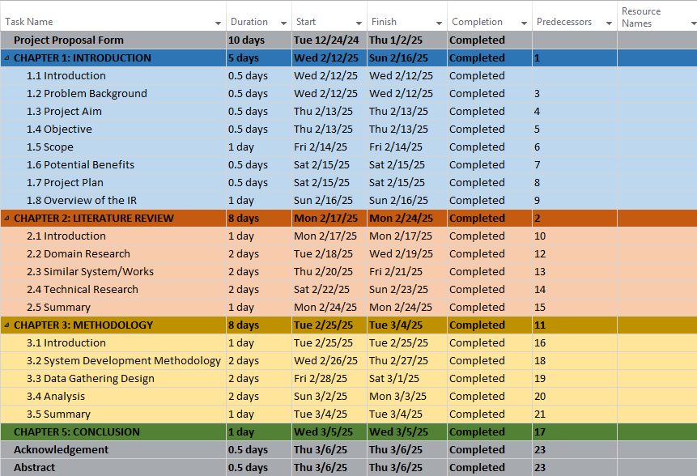

Figure : Project Plan for Investigation Report

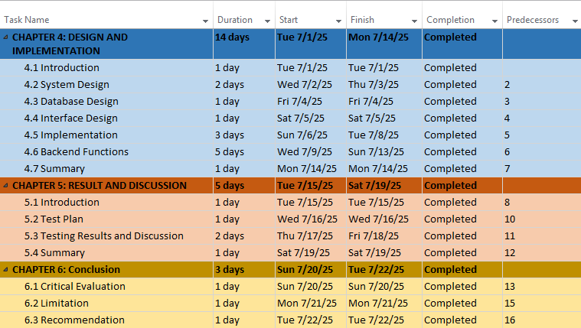

Figure : Project Plan for Project Documentation

# LITERATURE REVIEW

## Introduction

This chapter is about the review of research and technology related to Artificial Intelligence (AI), Machine Learning (ML) as well as Convolutional Neural Networks (CNNs). In addition to that this chapter also reviews research about the use of AI in the medical field.

The chapter is split into numerous sections, starting with exploring the background of stroke prediction and the study of how ML and CNNs aids in analyzing CT/MRI scans as well as patient data to predict stroke in patients. In addition to that this chapter also focuses on how SDG Goal 3 (Good Health and Well-being) aligns with the AI based solutions to stroke detection. The next section then reviews existing literature review of similar and existing systems that predict stroke detection using AI. Strengths and weakness of these systems are reviewed, and cross checked to view if they have successfully contributed to the SDG Goal 3. The next section afterwards then drafts the hardware and software needed for the completion of the project. This section details tools needed for running the AI system as well as the tools needed for the implementation of the system.

The last section will summarize the main findings of chapter 2 and how insight from these sections will provide a better idea on how AI and machine learning work for prediction of stroke. In addition to this the findings will also help identifying the weaknesses and limitations of existing healthcare methods as well as preventive measures to avoid or reduce current limitations.

## Domain Research

### Artificial Intelligence (AI) in Healthcare

Artificial Intelligence (AI) is revolutionizing numerous sectors on a huge scale, and as such medical care is one of them. This is especially important in the medical field where pinpoint accuracy makes a significant difference. (Alzghoul, 2024). At its core AI are intelligent computer systems that can execute tasks such as human intelligence, clinical training as well as problem solving and image analysis which usually need human intellect to execute. (S. Lewis, 2024)

One main concern is Patients would suffer serious consequences as result of errors caused by these systems that would lead to misdiagnosis or incorrect treatment. To counter this issue Explainable Artificial Intelligence (XAI) was developed. The main function of XAI is to comprehend the complex black-box nature of machine learning models. There are mainly two types of XAI algorithms they include Local Interpretable Model-Agnostic Explanations (LIME) and SHapley Additive exPlanations (SHAP) which can provide explanations to the models which in turn enhances trust of the system by providing feature importance. (Ali, 2023). The application of using AI for development of healthcare directly links with SDG Goal 3.

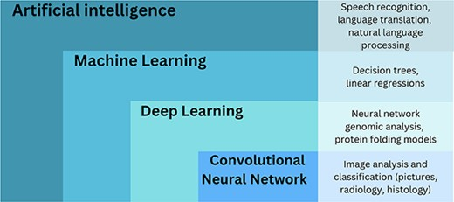

Figure : Subsets of AI with examples. (Kourounis, 2023)

### Machine Learning (ML) in Medical Management

Machine learning (ML) are found in a wide range of settings from different sectors. These days it is a necessity in these sectors and as such the same apples to the healthcare sector where ML is used for the forecast of disease as well as patient medical records analysis. (Verma, 2022).

ML is by extension a subset of AI and it involves training AI models that review from data and enhance themselves based on that specific task. ML consists of there main layers, input layer, hidden layer, and an output layer. The layer we give information or data to is called input layer while the hidden layer is where all the mathematical processes such as linear regression is carried out. The output layer is the result of the solution generates from the hidden layer. (Kourounis, 2023)

The two main types of ML are supervised learning and unsupervised learning. The main aim of supervised leaning to generate classification tools by training the model on datasets. One example of supervised learning would be use of retinal photos to create a tool to detect diabetic retinopathy. The amin aim of unsupervised learning is finding significant differences in the data by training the model with the dataset where the needed output is unknown. Unsupervised models learn by finding links and patterns in the data. One example of this is the application of using unsupervised model to uncover a drug with chemical attributes not found before. (Kourounis, 2023). The use cases of ML directly ties to SDG Goal 3

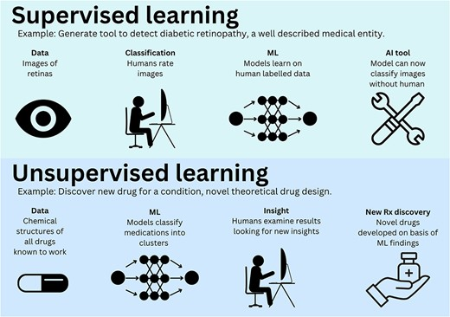

Figure : Difference of supervised and unsupervised learning (Kourounis, 2023)

### Convolutional Neural Network (CNNs) for Medical Image Analysis

One subset of ML is known as Deep Learning (DL) which processes and learns data from numerous hidden layers called “deep neural network”. Each hidden layer in the deep learning model is tasked to complete a specific task and after the task is completed it passes its output to the next layer which would lead to the neural network to learn more complicated data. (Kourounis, 2023)

Convolutional Neural Networks (CNNs) are more advanced versions of DL models that are specialized for image identification applications. To extract vital features of an image all the layer of CNNs execute a process known as convolutions on each pixel. This process would allow CNNs to shine at identifying links between photos and unusual data from pictures. CNNs then extract these features to provide information that can be used for various purposes. (Kourounis, 2023)

The most popular use case of CNNs in the medical field would be for radiology applications such as using CNNs in chest X-rays (XCR), usage of CNNs models for brain stroke using magnetic resonance imaging (MRI) scans, and the usage of the model for appendicitis for computed tomography (CT) scans. (Kourounis, 2023). In addition to that CNNs are widely used for early cancer diagnosis using medical image processing. These models can be trained for detection of cancerous cells as well as tissues. One example is the use of the model for detection of unusual cells or classification of cancerous cells using a histopathology image. As such the same model can also be used for classification of both skin lesions and cancerous lesions. (Pacal, 2025). As such the implementation of CNNs perfectly compliments SDG Goal 3 where it has been used to revolutionize disease identification.

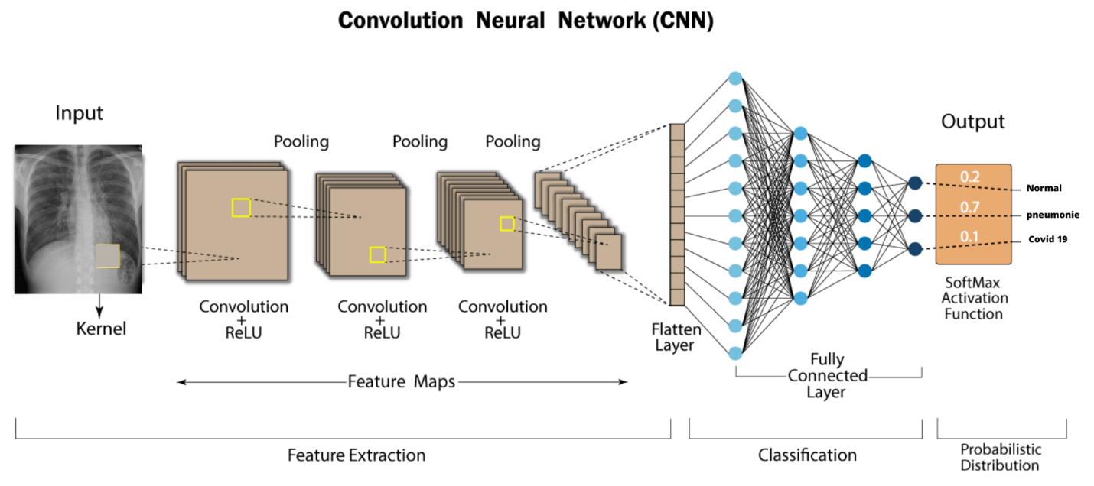

Figure : Use of CNN for medical diagnosis. ( (Rguibi, 2022)

### Multimodal AI Models in Healthcare

Machine learning and CNNs models have heavily focused on using data from a singular modality which in has limited their accuracy in effectively duplicate the clinical practice of combining data from numerous sources to enhance the decision making of the model for the accurate output. Medical professionals often must use multiple types of different data which includes lab tests, patient medical history as well as their imaging data to make the correct decision. Due to recent advancement of AI, it is possible to follow this approach thanks to integration of multimodal data, which in turn replicates how the decision making occurs in medical facilities better than before. (Krones, 2025)

Generally medical multimodal signals have combined using three distinct approaches. In sensor-level fusion, many unique signal modalities are preprocessed and joined together. For this approach data normalization, buffering, synchronization as well as removing of noise is needed. For feature-level fusion features from numerous dissimilar signals are first extracted and then combined for classification. For this approach feature normalization as well as feature selection is needed for the model to work accordingly. The last approach decision-level fusion would entirely depend on signal processing and classification of each modality which is then followed by second classification phase which combines both output values depending on the quality rating of each modality. The classifier output can be combined in variety of different ways such as voting of majority, maximum probability as well as confidence score. (Muhammad, 2021)

Multimodal learning expands on the application of intelligent models in the medical industry. For example, it could be difficult for patients to articulate verbally about skin conditions and instead a visual question-answering (VQA) system can be integrated to so that the patient can cluster multiple images that is uploaded by patients for more accurate diagnosis. During the recent years there was a substantial quantity of study aimed towards multimodal healthcare system due to the importance of its practical use in the medical industry. As such with positivity there is a clear demand and trend with these system in recent times. (Qika Lin, 2025). Multimodal learning models directly help with SDG Goal 3 by combining current systems with higher accuracy to form a model that can be used with multiple sources of data.

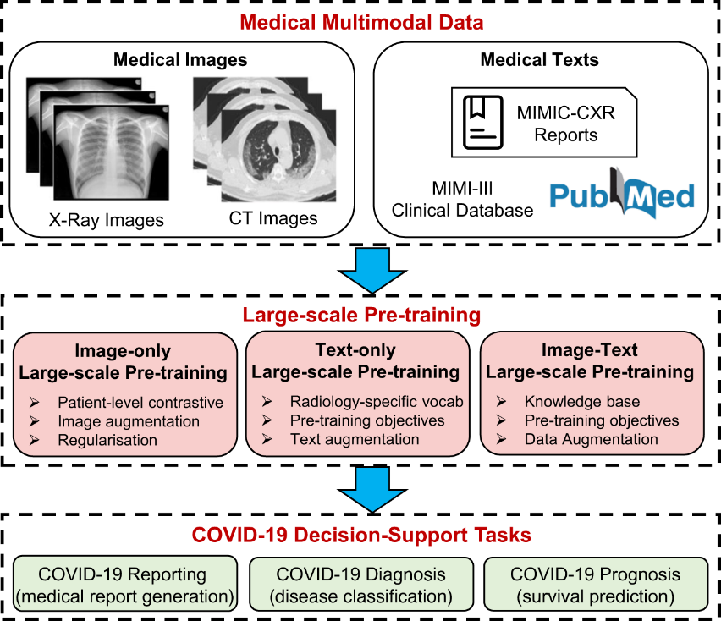

Figure : Multimodal LLM for covid-19 (Liu, 2023)

### Explainable Artificial Intelligence (XAI) in Healthcare

Explainable Artificial Intelligence (XAI) is an important area of research that got popular in recent time. The research focuses on the black-box component of the complex and challenging to interpret machine learning algorithms. By using XAI techniques like Local Interpretable Model-Agnostic Explanations (LIME) and Shapely Additive exPlanations (SHAP) an explanation for these complex algorithms can be acquired which increases the confidence in the system which improves trust in the prediction. (Hassan, 2025)

LIME’s flexibility and adaptability allows it to produce explanations for a variety of machine learning models that includes gradient boosting, random forest, and deep learning neural networks. This feature is also referred to as “model-agnostic” which allows it to explain any workable machine learning model. On example would be when the primary model will forecast that a patient would get the flu. By using XAI techniques, LIME can offer an explanation crediting the diagnosis of the model “flu” to the presence of symptoms that include headache, sore throat and runny nose that were collected from the patient’s medical records. (Hassan, 2025)

Medical imaging researcher are keener on using LIME than SHAP. This occurs as while SHAP tends to usually focus on local and global explanations which are more resource intensive and not as immediately useful in the field LIME corresponds to the result of the black-box model locally which allows for rapid and accessible understanding of individual predictions. The LIME technique is especially helpful in medical imaging where medical experts would need local, instantaneous, and interpretable explanations to justify and validate AI-driven decisions. XAI techniques, mostly LIME is currently being used in a variety of disease detection through the application of image analysis and as such directly aid in SDG Goal 3. (Hassan, 2025)

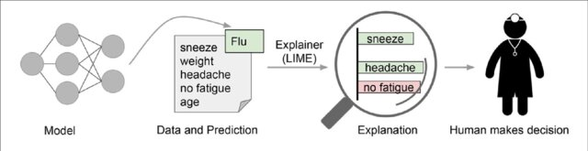

Figure : Application of using LIME in healthcare (Bruckert, 2020)

## Similar Works

|  |  |  |  |  |
| --- | --- | --- | --- | --- |
| **System Name** | **Technical Requirements** | **Key Features/ Functionalities** | **Outcomes** | **Limitations** |
| ViT-LSTM stroke detection model ( (Hossain, 2025) | - **Hardware:** High-end GPU (Google Colab 125 GB RAM)  - **Software:** Python, TensorFlow, PyTorch  - Dataset: BrSCTHD-2023 (primary hospital dataset) and Kaggle brain stroke dataset | **-** Hybrid ViT-LSTM architecture for stroke classification  - ViT(Vision Transformer)  - LSTM (Long Short-Term Memory)  - XAI techniques (Explainable Artificial Intelligence)  - Class imbalance handling | **-** Achieved 94.55% accuracy for BrSCTHD-2023 dataset  - Achieved 96.61% accuracy for Kaggle brain stroke dataset  - Did better than traditional CNN model for stroke detection  - Use of XAI explanations improved stroke classification | - High-end computer resources needed due to architecture  - Requires large dataset for training  - Model interpretability needed improvements  - Longer processing time for analyzing CT images |
| ENSET (ensemble CNN model for brain stroke prediction) (Ferdous, 2024) | - **Hardware:** NVIDIA Tesla T4 GPU  -**Software:** Python, TensorFlow, Pytorch  - **Pretrained CNN models:** InceptionV3, MobileNetV2, Xception  - Dataset: Kaggle brain CT scan dataset | - Use of an ensemble CNN models  - Automated stroke classification of stroke from CT scans  - Performance evaluation using precision, recall, F1-score, ROC curve  - Transfer learning applied for improving feature extraction | **-** Achieved 98.86% accuracy which preforms better than standalone CNN models  - Higher recall (98.4%) and F1-score (98.03%) compared to individual models  - Improved stroke classification and accuracy | - High-end computer resources needed due to ensemble CNN architecture  - Limited dataset size as such augmentation is needed to avoid overfitting  - No mutli-class classification as it only uses stroke vs normal detection |
| DivFE-v1 (Divergence-Based CNN model for stroke classification) (Polat, 2024) | - Hardware: Linux Ubuntu with 32-core CPU and NVIDIA GTX 2080 Ti GPU  - **Software:** Python  - **Deep learning framework:** Custom CNN trained with Walsh matrices  - **Dataset:** 6650 CT images from the Turkish Ministry of Health | **-** Feature extraction using Walsh matrices  - Minimum Distance Network (MDN) for classification  - Multli-class classification (stroke vs normal and ischemic vs hemorrhagic)  - Automation structure determination (filter size) during training | **-** 99.248% accuracy in stroke vs normal  - 99.324% accuracy for ischemic vs hemorrhagic  - 99.097% accuracy for combined classification  - Outperforms previous CNN stroke classification systems | - Limited dataset as it is a single source data  - High computer resources needed for training  - No automatic determination of feature numbers in layers  - Would require further validation on different datasets |
| Cross-Transformer Network (Anaya-Isaza, 2023) | - **Hardware:** Tesla T4 GPU, 25 GB RAM  - **Software:** Python, TensorFlow, keras  - **Dataset:** Figshare brain tumor dataset. MRI-D, TCGA-LGG | **-** Cross transformer model combines attention mechanism with a self-care model  - Transfer learning used for better performance with limited data  - Data augmentation used to improve accuracy  - Detection and classification of glioma, meningioma, pituitary tumors | **-** 97% accuracy for tumor classification  - Improved tumor detection accuracy using FLAIR imaging sequence  - Faster training compared to other models. | -Higher computational resources required for training  - Limited data availability for with variations of image resolution  - Overfitting caused due to dataset being smaller  - Performance variation based on MRI sequences |
| CNN-based stroke classification system (Tursynova, 2023) | - **Hardware:** High performance GPU  - **Software:** Python, TensorFlow  **Dataset:** Kaggle brain stroke dataset  **Image processing:** Data augmentation such as horizontal flip | - CNN used for stroke classification  - Classifies CT images into ischemic and hemorrhagic stroke or normal brain  - Early stopping method to prevent overfitting | **-** Achieved 81% accuracy on stroke classification  - Improved recall and F1-scores compared to traditional methods  - Mentioned as demonstrated potential as a computer-aided diagnostic (CAD) system | - Lower accuracy compared to other models  - Limited dataset and as such effects model generalization  - Does not use multi-class classification for improved accuracy |

Table : Table of similar system

Several AI driven systems for detection of stroke and other similar diseases that require MRI-CT scans are currently being developed with some systems being fully functional. Most if not all the systems use deep learning and CNNs to get an accurate prediction although systems usually use a more advanced type of CNNs or a multimodal that combines CNNs with another artificial intelligence system. All the systems directly contribute to SDG Goal 3 by making healthcare more efficient for both the patient and medical experts.

## Technical Research

### Physical Hardware Requirements

The real-time AI system consists of three AI models. A CNNs model for CT/MRI image classification, ML based model for stroke risk prediction which uses patient medical records and a RAG-based LLM that grows its knowledge base using PDF medical documents. As such to run these AI models efficiently as well as for the models to work in real-time specialized hardware would be needed for developing the model as well as to train the model. As such the initial hardware used would be:

|  |  |
| --- | --- |
| Processor | AMD Ryzen 7 7800X3D @ 4.20 GHz |
| RAM | 32GB DDR4 |
| Storage | 1 TB SSD |
| GPU | NVIDIA GeForce RTX 5070 Ti (16GB VRAM) |

Table : hardware used for AI model development

This setup can run the AI models well including large datasets. This setup can be used to run the initial testing as the hardware is fully equipped to build AI models for medium sized CNN models as well as for running ML algorithms efficiently. The system can also run medium LLM models in real time without any issues in performance. In addition to that, the power of the processor allows handling of tasks simultaneously. Since RTX 5070 Ti uses the CUDA programming platform from NVIDIA. It has access to tools, libraries and APIs that reduce the complication of building and deploying of AI models. Without a dedicated GPU the AI may have reduced crawling speed, inefficiency of power as well as having issues of scaling. (Kandhan, 2024) . To run a decent AI model a RAM that has higher than 16GB is necessary for faster training of data. Although the specification for the computer is 1 TB of SSD, the size of the SSD can be lower. This is since SSDs are up to hundred times faster than HDDs which would vastly make a difference when developing an AI model. (Kingston Technology, 2021).

If the AI model requires a very large dataset for testing or a large LLM model with very high parameters there would be limitations due to the processing demands. To solve this issue cloud-based GPUs can be used such as google colab or NVIDIA cloud.

### Software Required

|  |  |
| --- | --- |
| **Software** | **Use** |
| Python | Primary programming language used for the development of the AI models |
| React | Web framework used for creating APIs and web application. |

Table : Software requirements

Python is the most popular choice to be used by AI and ML developers. This is due to its simplicity compared to other programming languages as well as the fact that python allows users to run the same script on GPU which is essential as most AI developers recommend using GPU instead of CPU on creating AI models. These scripts include acceleration of AI and deep learning operations that use variety of different input data. One other advantage is that python has a massive catalog of libraries dedicated to AI and image processing unlike other languages. (Yadoshchuk, 2024) React will be used for creating the website as it is flexible and easy to integrate with AI models.

### IDE Chosen

Microsoft Visual Studio (VS code) will be used for most of the time to create the AI model, as it is ideal for experimentation. At the same time Jupiter Notebook will also be used in VS code for ease of debugging.

### Libraries and Tools Required

|  |  |
| --- | --- |
| **Library/Tool** | **Use** |
| Pytorch | For training CNNs for stroke classification |
| TorchVision | Supports pretrained model for medical imaging |
| Scikit-learn | Used for handling ML algorithms that are used for classification and regression such as prediction of stroke based on patient records |
| Pandas | Handles patient data for ML training. |
| NumPy | Support of mathematical calculating during AI model training |
| Matplotlib | Used for creating 2D plots, charts, and other visualization |
| OpenCV | Used for image enhancement and noise reduction. (Used for CT/MRI scans) |
| Pillow (PIL) | Used for image resizing and format conversions. (Used for CT/MRI scans) |
| Llama.cpp | Used for integrating local LLMs into the system. |

Table : Libraries/tools required for AI system

PyTorch is a fully featured python library commonly used for creating machine learning models such as deep learning models which are used for image identification as week as language processing. Most developers pick PyTorch for its easy to learn interface and its exceptional GPU support which allows computer graphics to be modified easily without too many restrictions. As such PyTorch makes a popular choice for developers wanting to make a quick prototype to experiment on. (Nvidia, 2025)

### Database Management System Required

PostgreSQL would be used as the primary database management for the AI stroke prediction system as it is an open-source system popularly used large dataset and real-time queries. Since AI stroke prediction system relies on structured patient history data to make predictions PostgreSQL can store these data with security and integrity while forwarding the information to the AI model at the right time.

### Operating System Chosen

For the development and deployment of the AI model windows 11 would be the main operating system (OS) as it the most used environment in general which would help medical professionals not accustomed to more complicated OS such as Ubuntu (Linux) get an idea of how the system works.

### Web Browser Chosen

The AI stroke prediction system would use a web-based interface to allow medical experts and researchers to interact with the AI model in real time to assist them in stroke prediction. While the AI model can be used in most other browsers most of the testing would be done on google chrome as it is the most popular web browser.

## Summary

Chapter 2 of the report revied the various domains of AI, ML as well as CNNs in stroke prediction of stroke as well as how they effected healthcare in general. Past systems were compared and crosschecked with each other to identify their functionalities, strengths, and weaknesses. Each domain and system were also highlighted on their impact to SDG Goal 3.

In addition to that the chapter also reviewed the hardware and software requirements for developing prediction models. Key libraries, development tools and deployment strategies were discussed in this chapter for efficient and smooth deployment.

Overall, this chapter provided major insight into the current research of using AI with medical care as well as the technical and ethical limitations currently in place for the use of AI with healthcare.

# METHODOLOGY

## Introduction

This chapter deals with the structure of developing the AI-based stroke prediction system using system development methodology. The chapter details the justification and benefit of choosing preferred system compared to the other present methodologies. This chapter also details the phases of the preferred system and the tasks carried out for each phase.

This chapter also details the data gathering design used, where a google form survey was used to collect data from participants regarding their awareness of stroke, how health facilities manage stroke in their opinion, what they think of AI being used in healthcare as well as their final opinion on the AI-based stroke system. The data gathered from the survey is analyzed to bring any technical or ethical changes to the system. In addition to that the survey is taken to gain insight into how much of a threat stroke is to the public to reinforce the usefulness of the system in real world medical scenarios

## System Development Methodology

### Introduction of Methodology

System Development Methodology (SDM) is an organized framework used for planning and managing the software creation process. The main aim of SDM is to make sure that the software is delivered on the required time, while having all the objects of the software project achieved while mitigating the risks. (Nikitin, 2024). In addition to that SDM follow design principles which makes sure that the development process as week as the software’s features align together to solve the necessary problem. (Indeed Editorial Team, 2025)

SDM offers different types of methodologies each offering a distinct approach for software management and development life cycle. The uniqueness of each methodology allows groups to decide on the better choice that aligns with their unique condition and specifications. As such to find the optimal SDM for their use case or business they must compare various factors and reviews the advantages and disadvantages of each methodology before choosing the optimal methodology. (Nikitin, 2024) In some cases, hybrid SDMs can also be used consisting of two compatible SDMs joined together to create a much broader selection of choices for companies.

Well-constructed steps alongside good design elements and process philosophy make compelling procedures. Selecting the appropriate method of approach would lead to advantages to both clients as well as the development team. This is because it would create accurate time schedules and improve on the productivity while providing higher quality deliverables on time. (Rikkeisoft Corporation, 2022). For this project rapid Application Development (RAD) would be used.

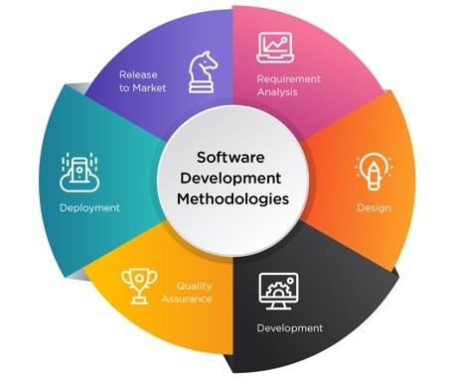

Figure : SDM Life Cycle (Oladele, 2023)

### Methodology Choice and Justification

Rapid Application Development (RAD) is a SDM that mostly focuses on continuing software development through stakeholder or client feedback instead of relying on strict planning techniques or following strict steps included in planning. This methodology gives clients and users with set of prototype releases before obtaining feedback for each development iteration. (Sherrer, 2024). RAD’s main focus is the quick adaptation towards challenges, opportunities as well as updates while being able to make data-based decision making. This approach allows developers to base their solutions onto the original requirements combined with real-time information from current and preceding processes. (Beres, 2024 ). The table below showcases the comparison between RAD and other SDM.

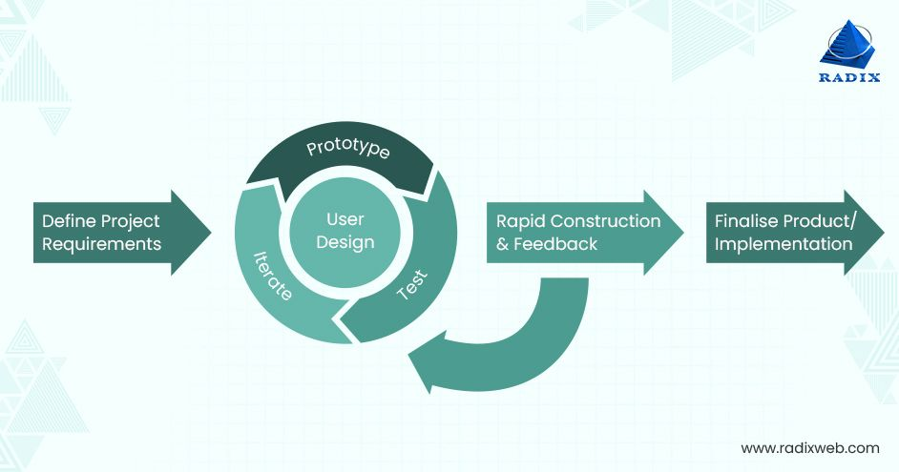

Figure : Example of RAP (Gadhavi, 2023)

|  |  |  |  |
| --- | --- | --- | --- |
| **Characteristic** | **Rapid Application Development (RAD)** | **Waterfall Model** | **Extreme Programming (XP)** |
| Approach to development | Iterative, user-driven, quick prototyping | Sequential, strict phase based | Agile, team based. Repeated refinement |
| Flexibility | High – Allows for quick changes to be made and iterations | Low – Strict as changes are difficult once a phase is complete | High – Continuous testing as well as feedback allows for high felxibility |
| Development | Very fast – Prototypes are built rapidly and refined iteratively | Slow – Necessary to complete each phase before moving to the next phase | Fast – Short development cycles but it required team collaborations |
| Solo development | Yes – Does not depend on team members, ideal for solo development | Possible – Can use for solo development but time consuming for one person due to rigid structure | No – Relies completely on teamwork, pair programming and collaboration |
| Project complexity | Medium – large projects that require iterative testing | Large scale projects where the requirements are well-defined | Complex team-driven projects where frequent code changes |
| User feedback | Conitous – Users provide feedback for prototype frequently | Minimal – Users provide input only during the requirement gathering and final testing | Continuous – Users provide feedback frequently during refinement |
| Risk management | Low risk – Iterative improvements would minimize project failures | High risk – Errors would cost a lot of time and would be difficult to fix due to rigid structure | Low risk – Continuous testing and refactoring problems early on |
| Approach of testing | Continuous testing as well as feedback required throughout the development | Testing would occur in the later stages only leading to delayed issue discovery | Testing done before implementation |
| Updates and changes | Easy – Changes can be made easily due to the iterative cycles | Difficult – Changes in later stages would require revisiting the earlier stages | Easy – Frequent changes would allow for quick adjustments |
| Resource requirements | Low – Can be handled by a single developer | High – requires structured teams | High – Requires dedicated team members for pair programming |
| Deployment timeframe | Short – Requires deployment of functional prototype early on | Long – The final deployment only occurs after all the phases are complete | Moderate – Frequent iterations allows for earlier releases that require collaborations |
| Scalability | Medium to high – Can adapt depending on user feedback and as requirements grow | High – Well documented as such suitable for larger projects | Medium – Would work well for projects that have their requirements grow but requires team coordination |

Table : Comparison of RAD, XP and waterfall model

As referred in the table above using Rapid Application Development (RAD) is the most ideal SDM to be used for a single developer due to aligning well with the requirements of AI model development and deployment. This is done due to RAD having a flexible design pattern, quick prototyping functions as well as an iterative approach to the project. Unlike team based SDMs such as Scrum or Extreme Programming (XP), RAD allows for individual developers to work easily without the restrictions of strict planning and rigid cycles.

In addition to that, RAD focuses on early system functionality allowing developers to construct and test the main components (AI features and web interface) simultaneously. This would make sure that the system can be adjusted and refined in real time which reduces the chances of major redevelopment later. By focusing on rapid prototyping and continuous refinement, RAD would enable developers to create numerous AI models, evaluate the performance with the stakeholder and make continuous refinements without strict phase limitations. As such RAD provides developers a perfect balance of speed, efficiency as well as adaptability making it the most suitable SDM for Solo developing AI-driven systems.

### Phases of Rapid Application Development (RAD)

Phase 1: Requirement Planning

During the first phase creators, users, stakeholders communicate to select the right objective and expectations for the project as well as any issue that the creator would think the project would face currently and any potential issues that may rise during the development of the project. (Lucid Software Inc, 2025). In the requirement planning phase the systems objective, the dataset the system would use to train the AI model as well as the implementation of the system is noted. The focus on the project, real-time stroke detection with risk prediction would be established and the idea would be presented to the supervisor for reviewing. Then the dataset which contains the CRI/MRI scans and patient medical history would be collected from the respective database. Then the software and hardware needed for the implementation of the system is also noted. In addition to that a survey is taken to gain insight into how much of a threat stroke is to the public to reinforce the usefulness of the system in real world medical scenarios. This phase would set the foundation of the upcoming stages by identifying the key components needed for the project.

Phase 2: User Design

During this phase, the developer work with the stakeholder to make sure the project objectives are met before implementation. Developers test each of the prototypes they made and is presented to the supervisor to ensure the objectives are met at each step before the final product. (Lucid Software Inc, 2025). The user design phase focuses on rapid development of the AI models. Two models are trained, one model to classify strokes based on scans using CNN and another model for predicting stroke based on ML models. These are then integrated into a web browser by using flask for user interface. In addition to that a MySQL database is also linked for secure patient data storage. This is all reviewed by supervisor during each step.

Phase 3: Rapid Construction

During phase 3 the prototypes as well as the beta systems from the last phase is converted into working models. (Lucid Software Inc, 2025). Rapid construction phase would focus on optimization of AI performance while using the feedback of the stakeholder. Accuracy of the AI is checked and improved, if necessary, through optimization methods. Real-time processing is optimized for speed and after the previous process is reviewed docker is used for deployment. This phase would be longest as constant changes would be brought to the system based on stakeholder feedback until the most efficient model is made that would fit the objective criteria, in addition to that any extra features are also implemented in this phase and the system is reviewed for errors or any changes to be made.

Phase 4: Implementation

During this phase, the final changes are made, and the system is launched while the developer continues to look for any error in the system (Lucid Software Inc, 2025). During the implementation stage the AI system is deployed into real-time stroke prediction operations. The system can be uploaded to most of the servers via docker for accessibility. Error tracking and security measures are also implemented to maintain efficiency. Future updates to the system are taken into consideration after more user feedback.

## Data Gathering Design

A survey was chosen as the primary data gathering design for this project to get the public opinions opinion on how much of a threat stroke is to the public to reinforce the usefulness of the system in real world medical scenarios as well as to get the opinion of the public on the use of AI in medical scenarios to view if they have any ethical concerns regarding these systems. The survey is conducted on a google form consisting of mostly close-ended questions with one open-ended question to gather more responses. The survey was distributed on social media to reach broader participants. Before the survey was opened any ethical concerns of the survey was discussed with the supervisor to ensure the established guideline were correctly followed.

The design of the survey consists of a cover page as well as 32 questions which were divided into 6 sections as shown below. There was a total of 35 respondents that answered the survey.

­ 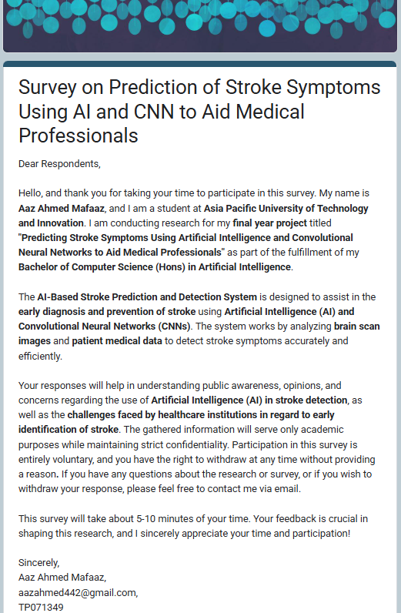

Figure : Cover page

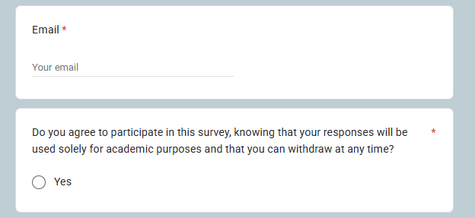

Figure : Cover page questions

The first section of the survey consist of a cover page which details the introduction and objectives of the sruvey, as well as contact information of the developer if the participants have any additonal questions or want to have their response removed later. In addition to that the last question infroms that the participants can withdraw at any time and the data will only be used for educational purpose. The participants can only proceed if they agree to participate after agreeing to the last question.

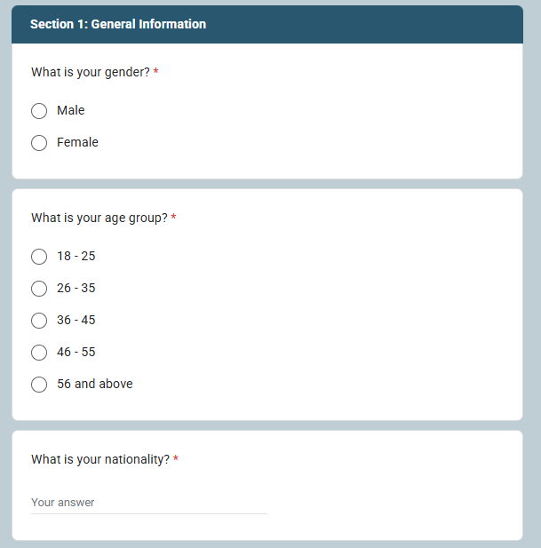

Figure : General Information section questions

This section gives details on information about the respondent which will be used to identify the demographic which would be used for analysis.

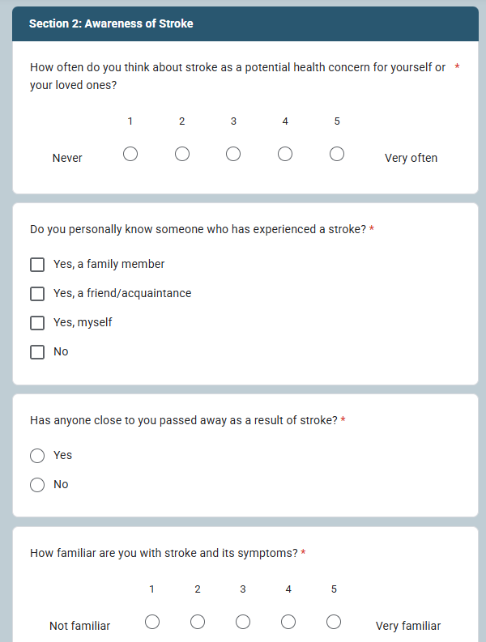

Figure : Awareness of stroke questions 1

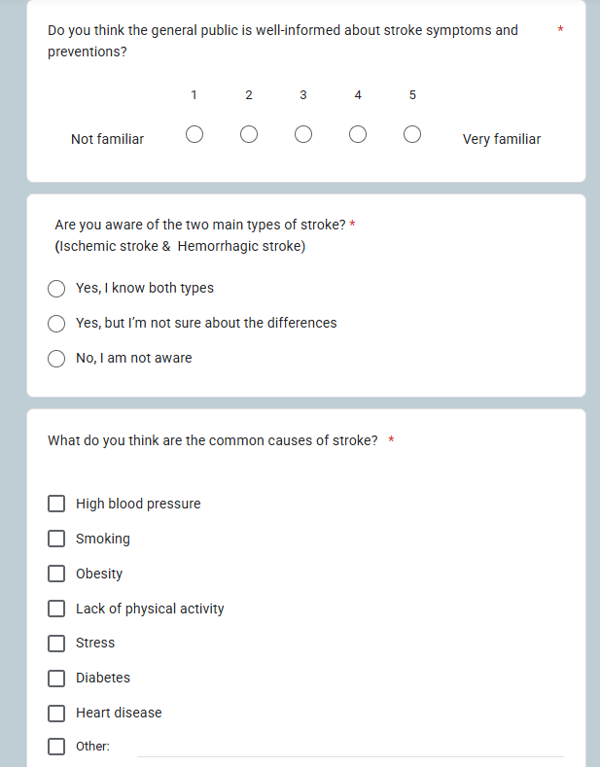

Figure : Awareness of stroke questions 2

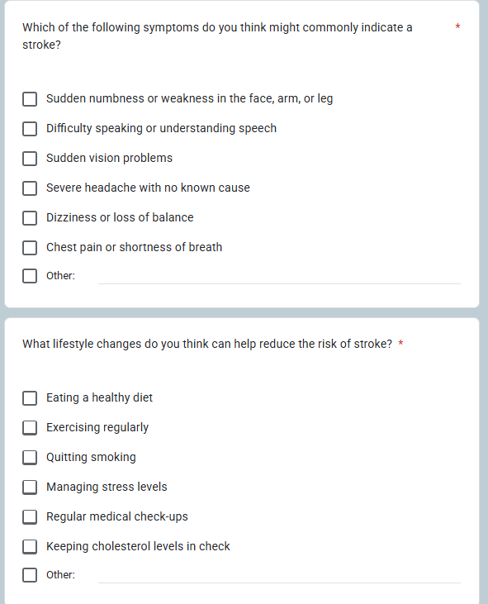

Figure : Awareness of stroke questions 3

This section focuses on the participants awareness of stroke, including if the general public knows about the symptoms of stroke, the types of strokes and the preventive measures that should be taken to avoid getting a stroke.

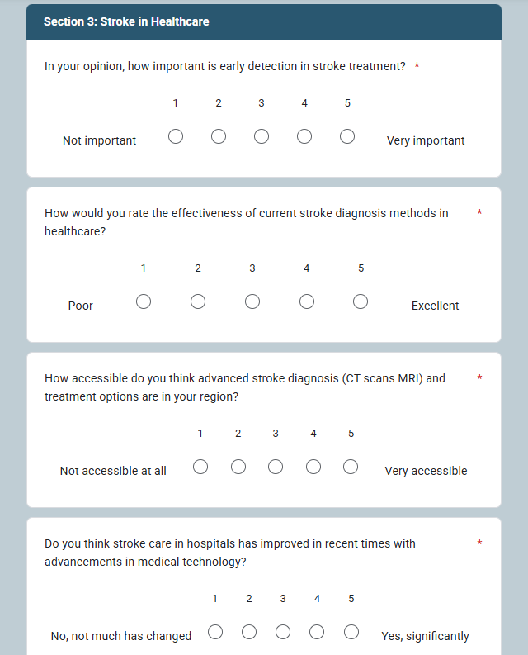

Figure : Stroke in healthcare questions 1

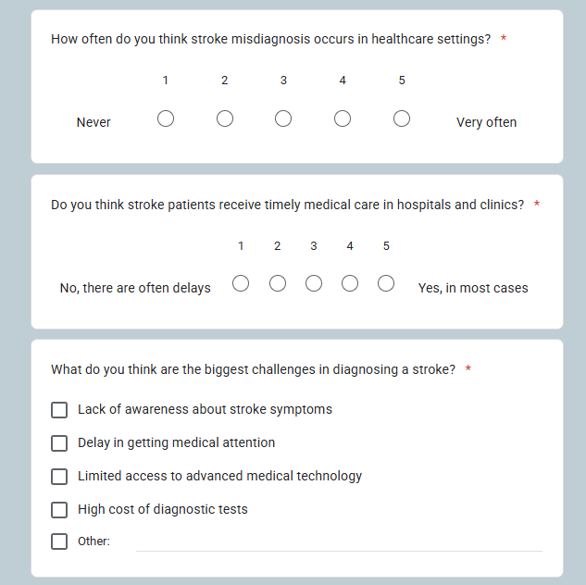

Figure : stroke healthcare questions 2

This section focuses on the participants opinion on how stroke is currently handled by their healthcare system. The section focuses on how often misdiagnosis of stroke occurs as well as asking the participants how accessible treatment and diagnosis options are for stroke in their region.

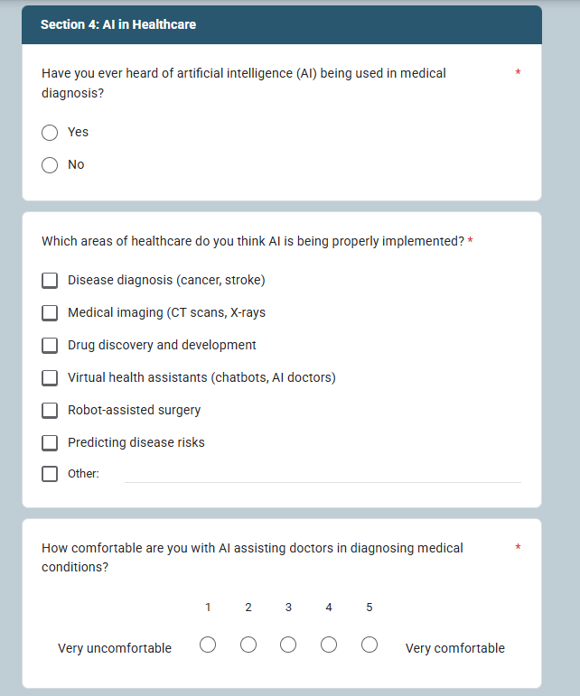

Figure : AI in healthcare questions 1

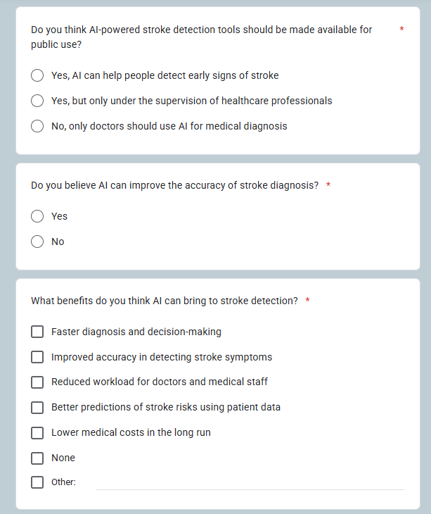

Figure : AI in healthcare questions 2

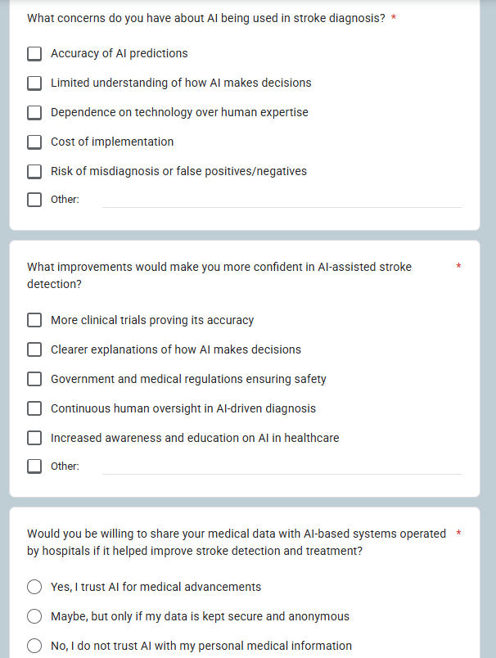

Figure : AI in healthcare questions 3

This section focuses on the participants opinion on AI being used in healthcare. The section outlines how comfortable the participants are on AI being used in healthcare, in which areas the participants feel like AI is already being implemented, what benefit does the participants think AI can bring to stroke detection and what concerns they have on AI being used in stroke diagnosis

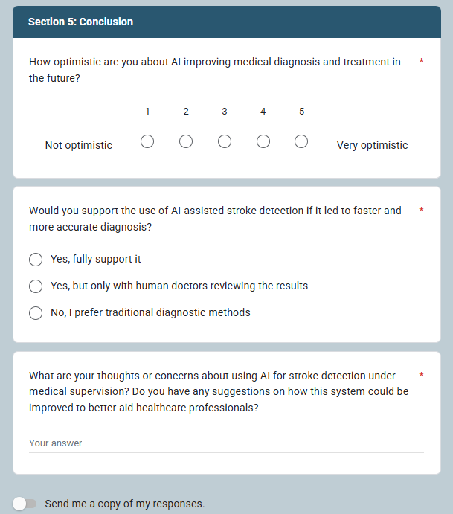

Figure : Conclusion section questions

This section focuses on the conclusion of the survey where it outlines how optimistic the participants are of AI being implemented more for diagnosis and treatment in the future what the participants would suggest improving the stroke detection system as well as any concerns for the implementation of the stroke detection system.

## Analysis

This section focuses on analyzing the 35 responses to find linking data between the responses that would help when making the AI-based stroke detection system or when the system is being implemented

### Section 1: General Information

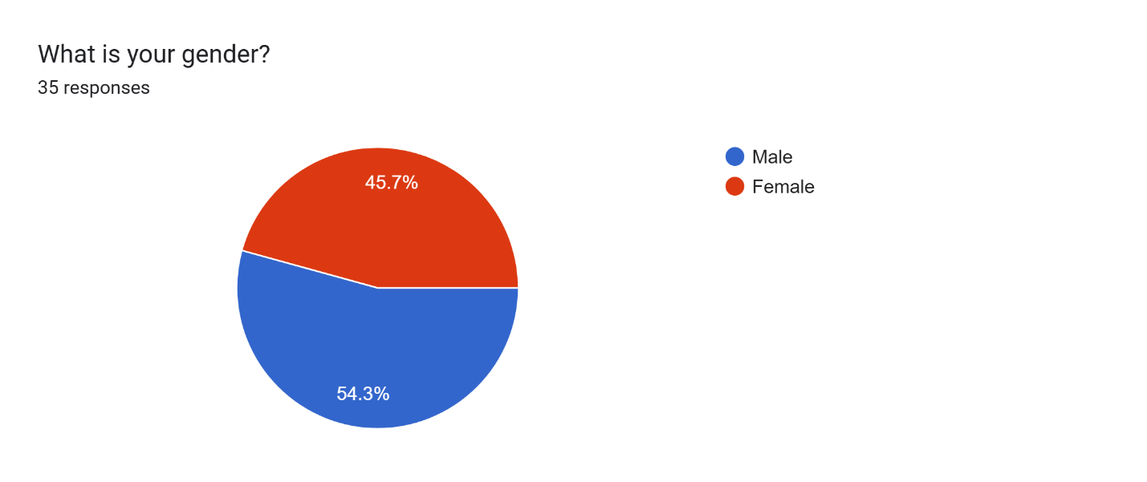

Figure : Section 1: question 1

The pie chart details the gender of the responses with the responses being of almost equal value

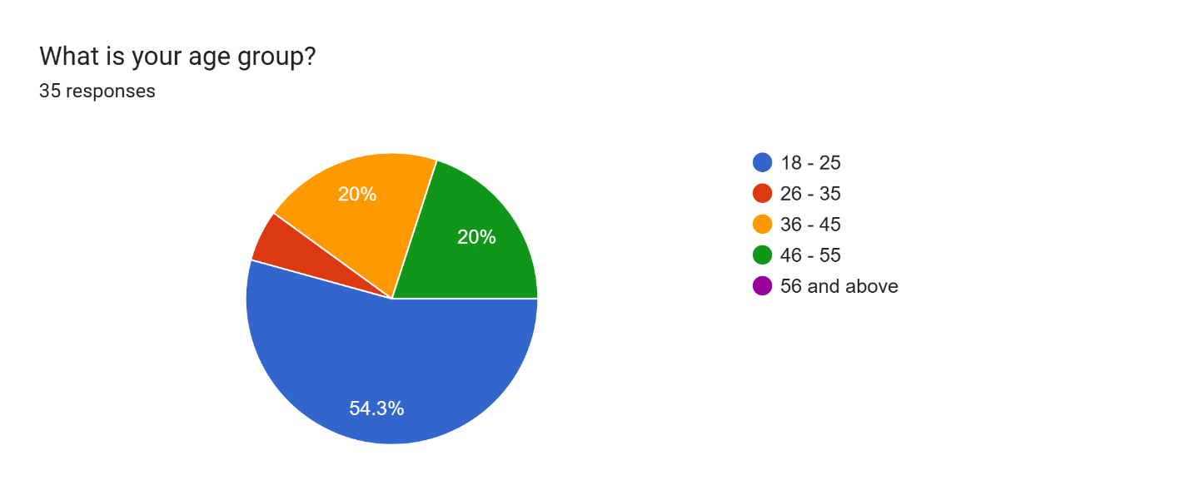

Figure : Section 1: question 2

The pie chart details the age range of the responses with the majority being of the age range 18-25. About 54.3%.

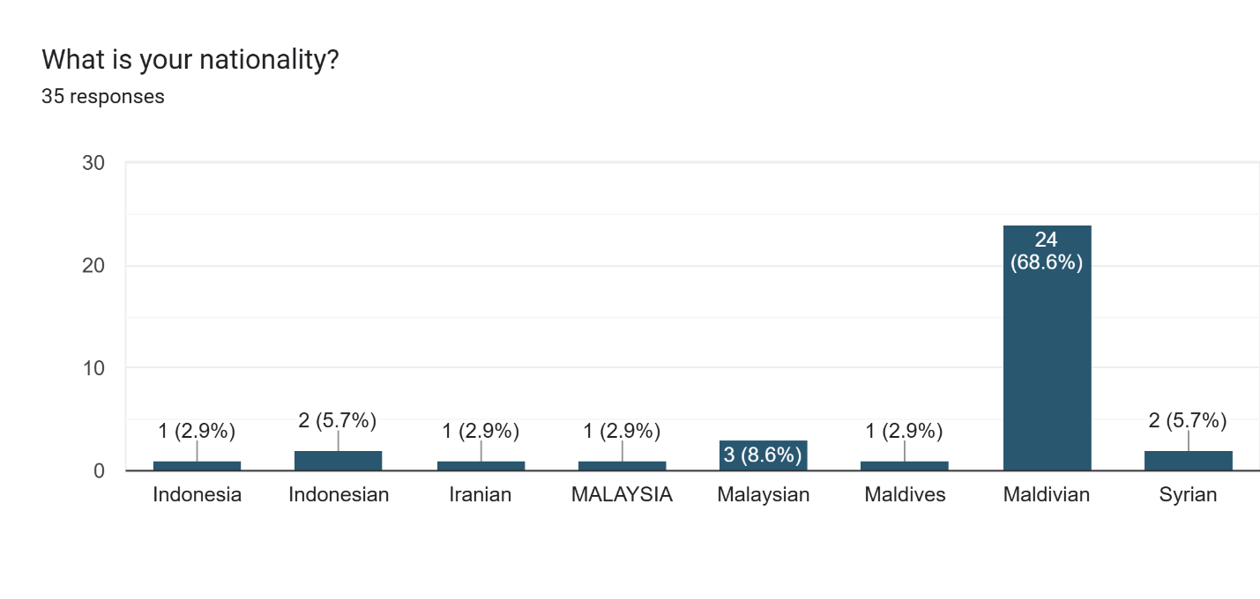

Figure : Section 1: question 3

The bar graph above details the nationality of the respondents, with the majority being Maldivian (about 25 respondents), Malaysian, and Indonesian. The nationality of the respondents would have an impact on their experience with how stroke is handled by their healthcare system as well as their awareness of the impact of stroke.

### Section 2: Awareness of Stroke

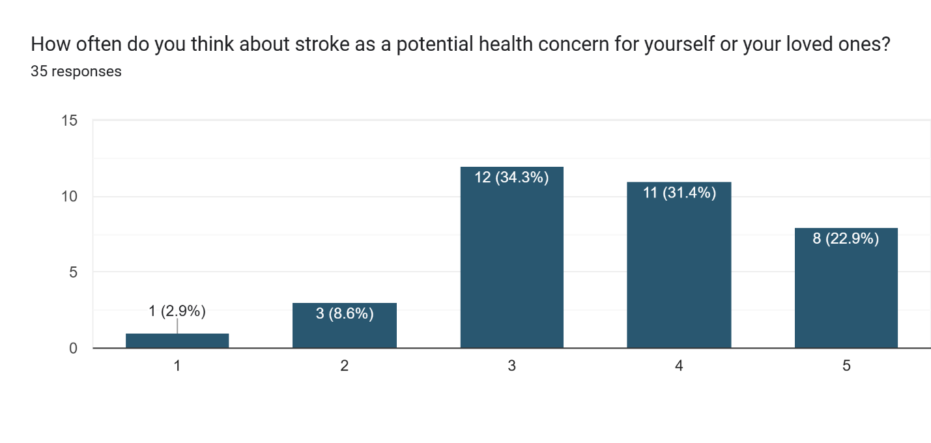

Figure : Section 2: question 4

From the bar graph above we can say that most people were leaning towards stroke being a potential risk with about 54.3% respondents seeing it as a threat.

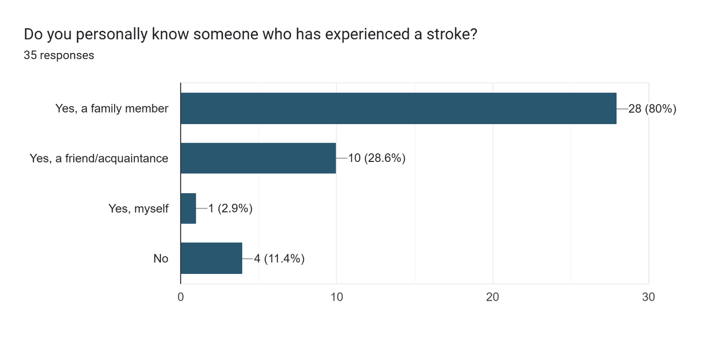

Figure : Section 2: question 5

From the graph above only 11.4% of the respondents do not know anyone that has experienced stroke, proving that stroke is an extremely common disease.

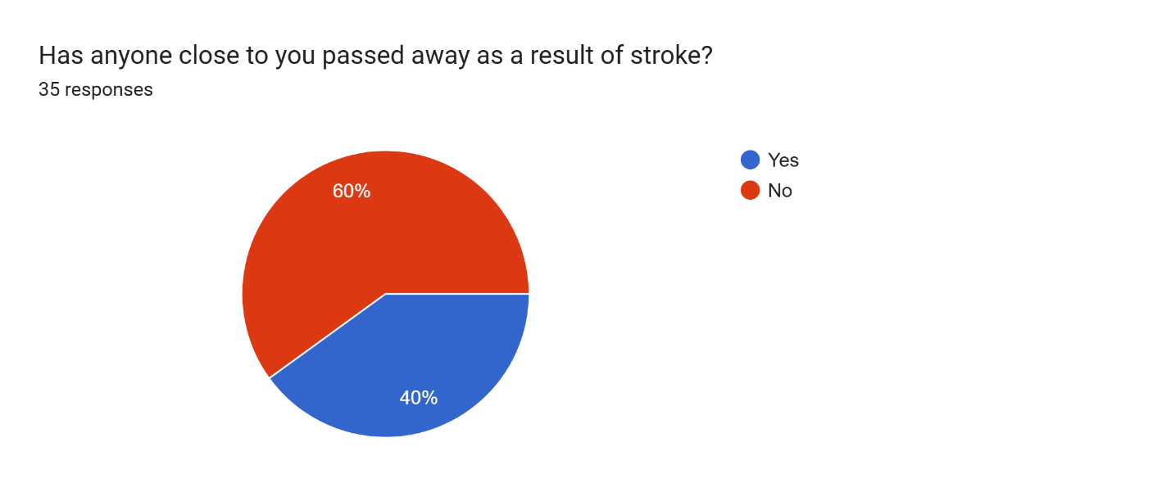

Figure : Section 2: question 6

From the pie chart above we can say that the majority of 60% of participants do not know anyone who has passed away due to stroke but about 40% of the participants know people that have passed away due to stroke. If we look at the previous graph, we can say that not only is stroke a common disease, but the mortality rate caused by stroke is higher.

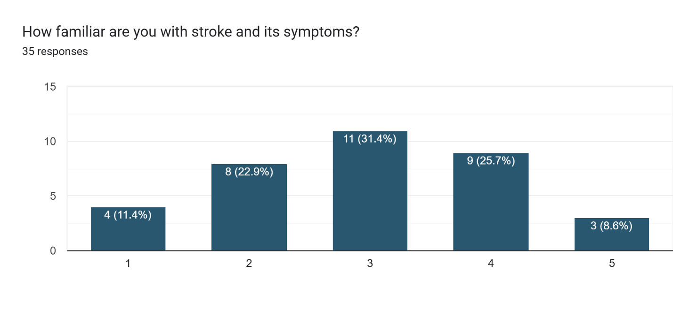

Figure : Section 2: question 7

From the graph above we can speculate that most participants do not know about the symptoms of stroke with about 34.3% sure about the symptoms of stroke.

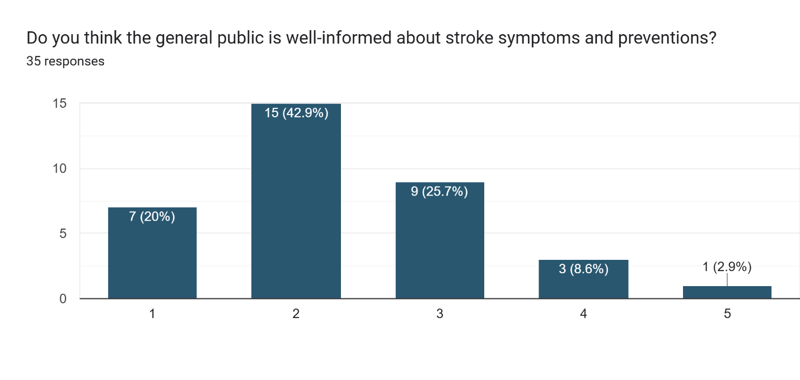

Figure : Section 2: question 8

From the graph above we can conclude that most participants of about 62.9% think that the public does not know about stroke as much as they need to.

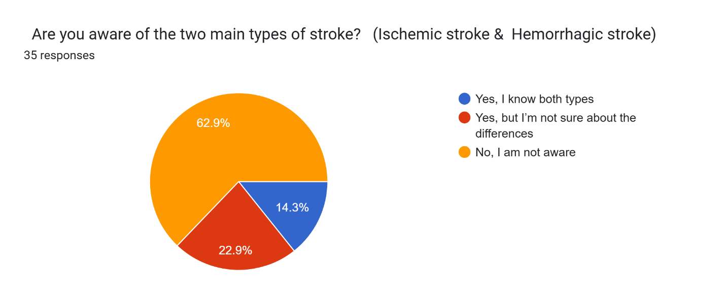

Figure : Section 2: question 9

From the pie chart above we can conclude that the majority of participants do not know about the two types of strokes of about 62.9% participants and at the same time 14.3% participants have heard about the two types of stroke but are not exactly sure about the differences between them.

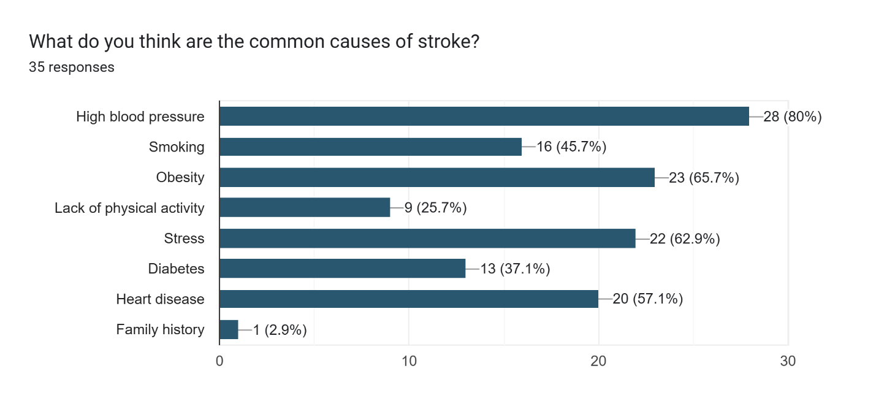

Figure : Section 2: question 10

From the graph above we can conclude that most participants believe that common causes of stroke include high blood pressure (80%), obesity (65.7%), stress (62.9%) and heart disease (57.1%).

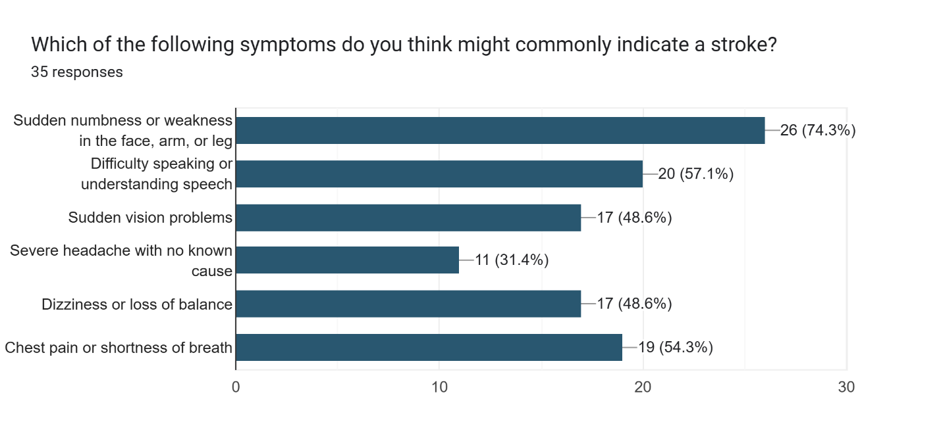

Figure : Section 2: question 11

From the graph above we can conclude that most participants believe that sudden numbness (74.3%), difficulty speaking (57.1%), chest pain (54.3%) are common indications of stroke, meanwhile severe headache (31.4%) is the least likely symptom of stroke.

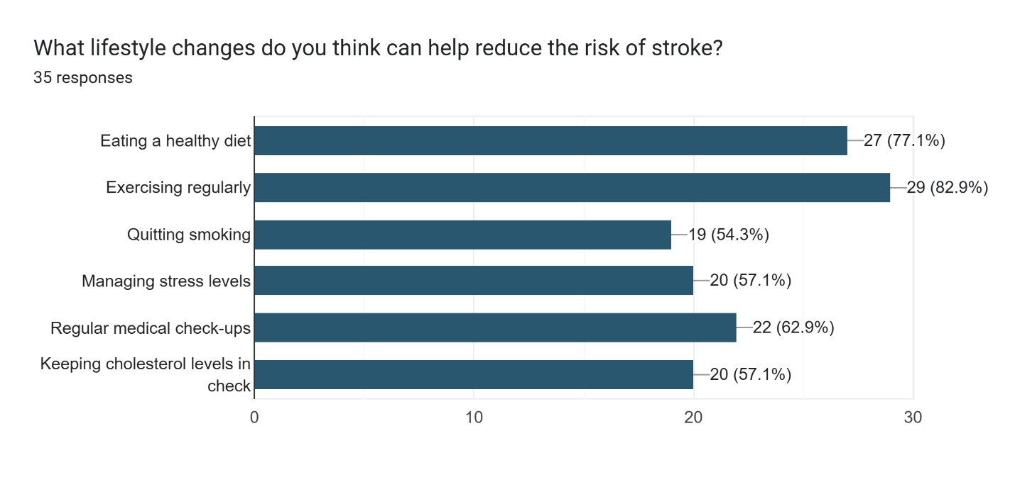

Figure : Section 2: question 12

According to the graph above we can speculate that most people believe that exercising regularly (82.9%) and eating a healthy diet (77.1%) is the most common lifestyle changes to reduce stoke.

### Section 3: Stroke in Healthcare

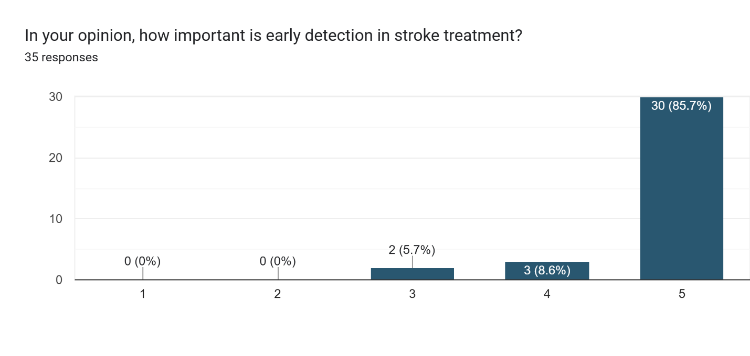

Figure : Section 3: question 13

As we can see from the graph most participants of about 85.7% participants believe that early detection in stroke is necessary.

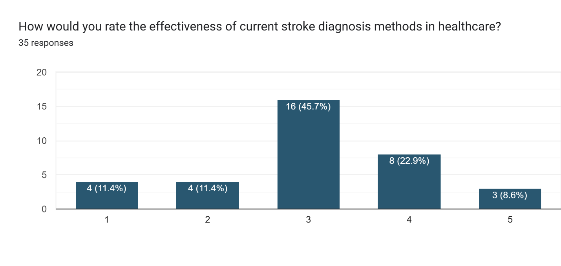

Figure : Section 3: question 14

According to the graph we can conclude that most participants of 45.7% are neutral with how effective stroke diagnosis methods are in healthcare. About 31.5% of participants believe that healthcare can improve with the current technology.

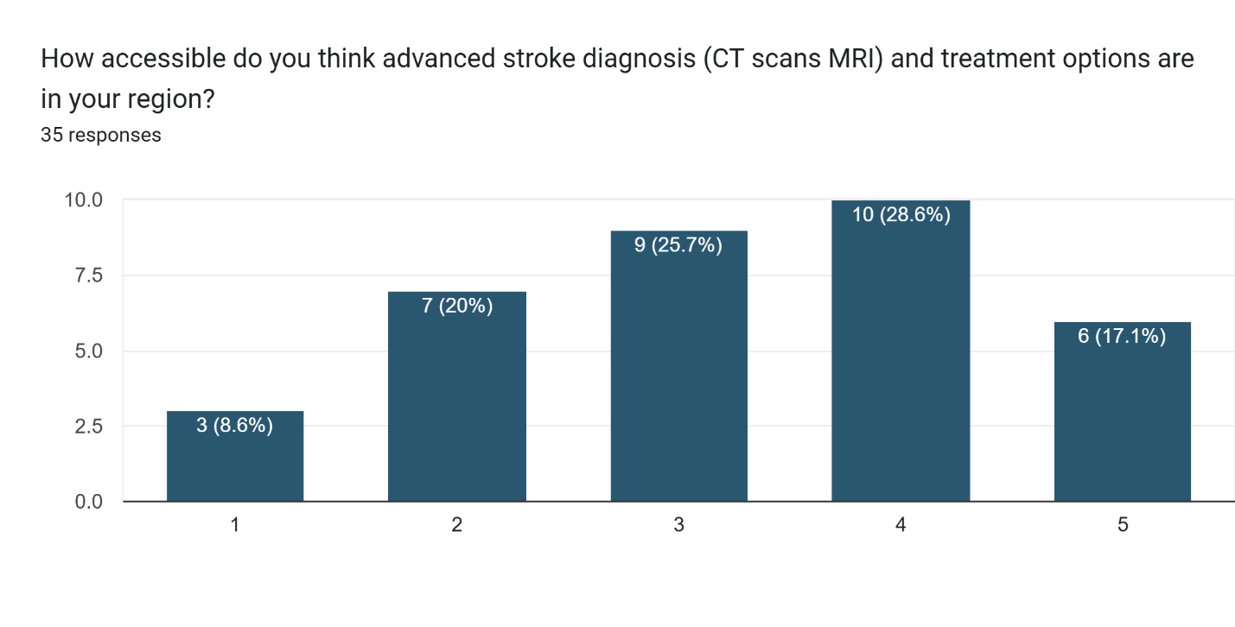

Figure : Section 3: question 15

According to the graph majority of participants of about 45.7% believe that both stroke diagnosis methods as well as treatment options are easily accessible in their region with about 28.6% participants believing that they don’t have easy access to the facilities.

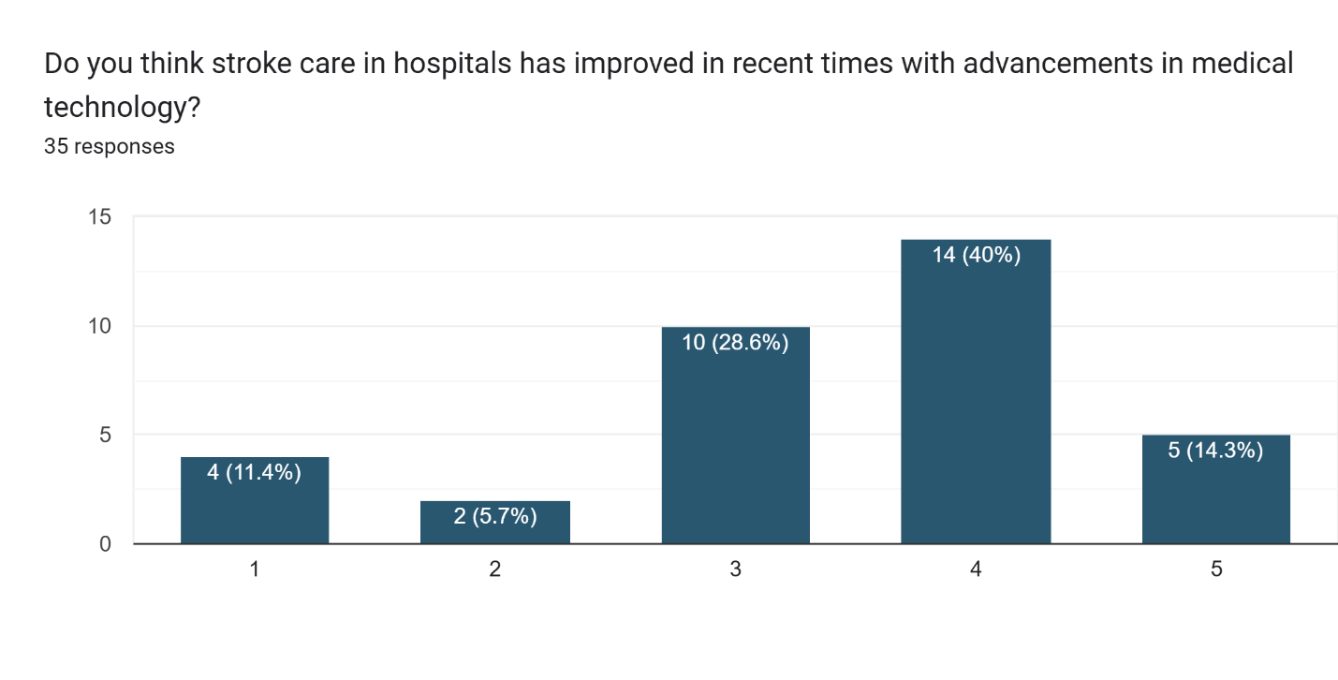

Figure : Section 3: question 16

According to the graph above most participants of about 44.3% believe that hospitals have improved greatly when it comes to stroke care.

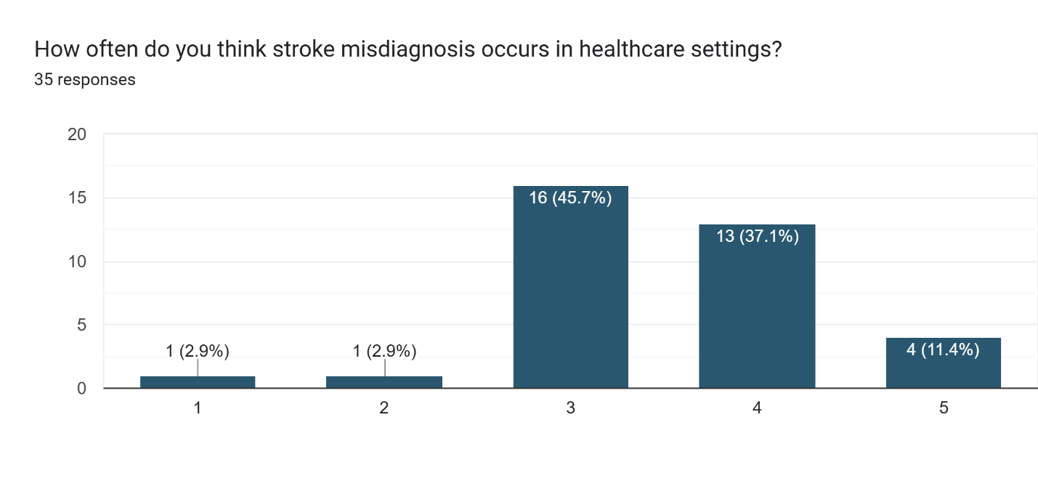

Figure : Section 3: question 17

According to the graph above most participants of about 48.5% believe that misdiagnosis is frequent in the healthcare settings, while only 5.8% of participants believe that misdiagnosis is not common in the healthcare setting.

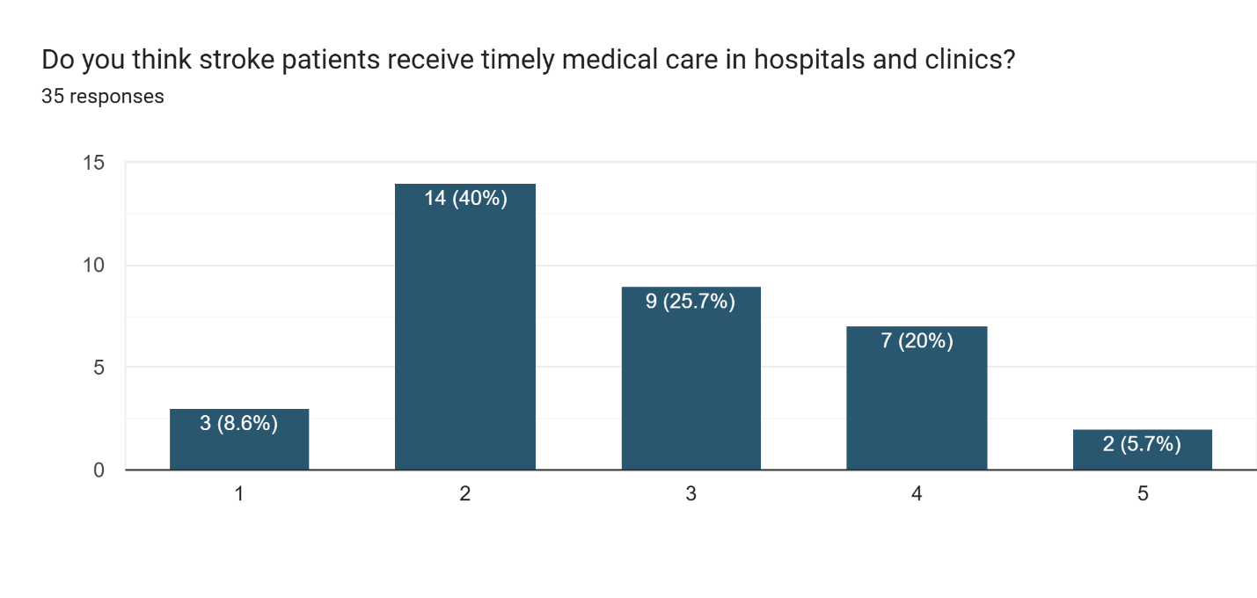

Figure : Section 3: question 18

According to the graph most of the participants of about 48.6% believe that stroke patients are not getting the timely medical care they are needed, which is essential during treatment of stroke.

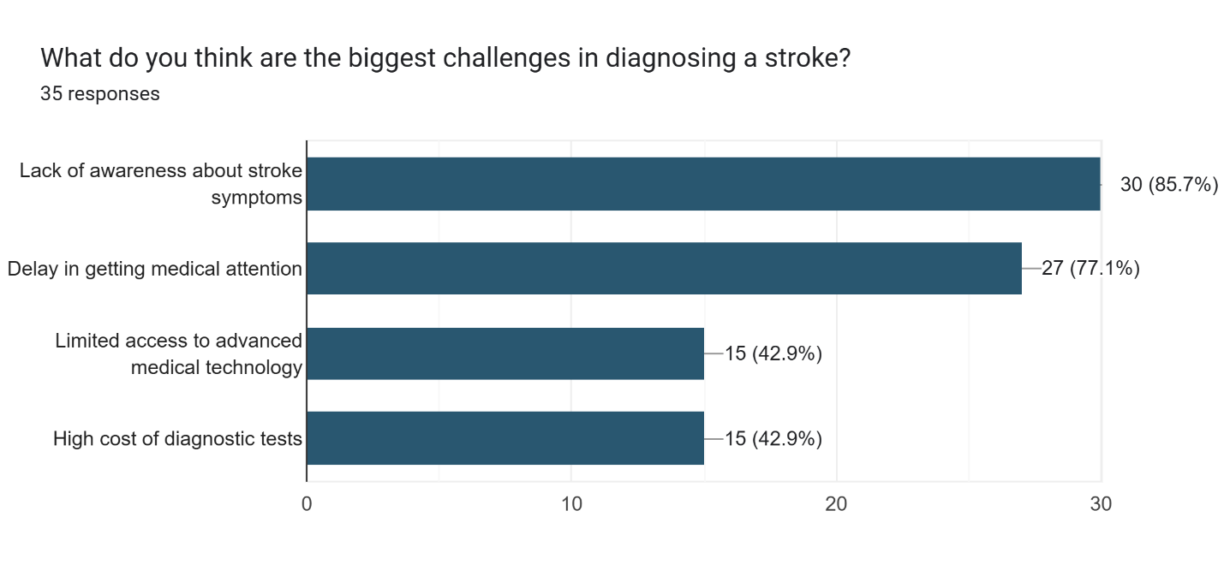

Figure : Section 3: question 19

According to the graph most of the participants believe that lack of awareness of stroke (85.7%) and delay in getting medical attention (77.1%) are the biggest challenges of stroke diagnosis.

### Section 4: AI in Healthcare

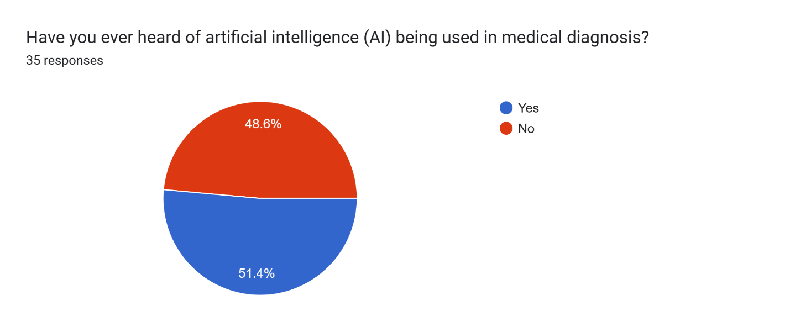

Figure : Section 4 question 20

According to the pie chart we can conclude that the percentage of participants that know about AI being used in medical diagnosis is about 51.4% with a substantial number of participants of about 48.6% not knowing that AI is being used for medical diagnosis.

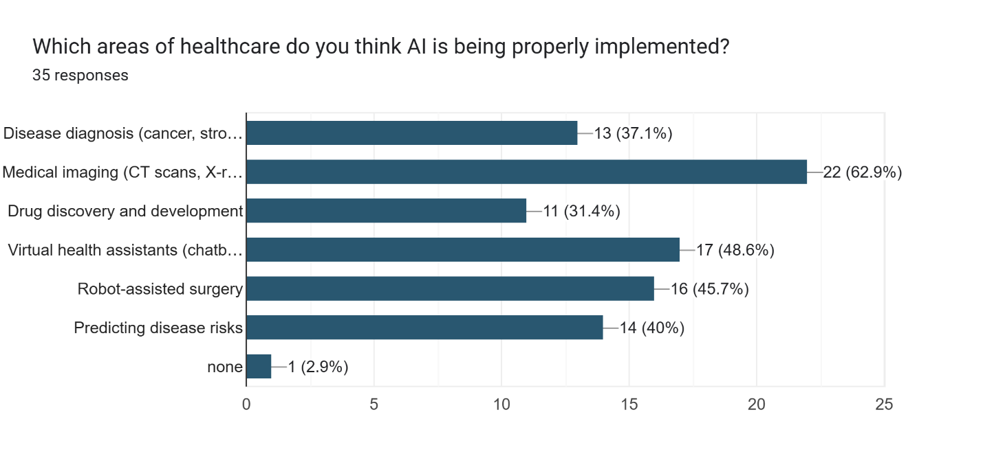

Figure : Section 4 question 21

According to the graph we can conclude that most participants believe that AI is being implemented in disease diagnosis (62.9%), virtual health assistant (48.6%) and robot assisted surgery (45.7%)

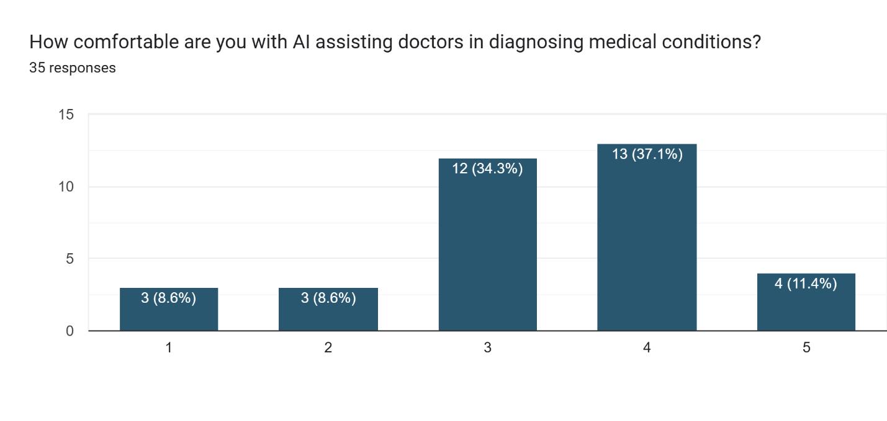

Figure : Section 4 question 22

According to the graph we can conclude that majority of the participants of about 48.5% are comfortable with doctors using AI based models for diagnosing medical conditions while only 17.2% of participants feel uncomfortable with it.

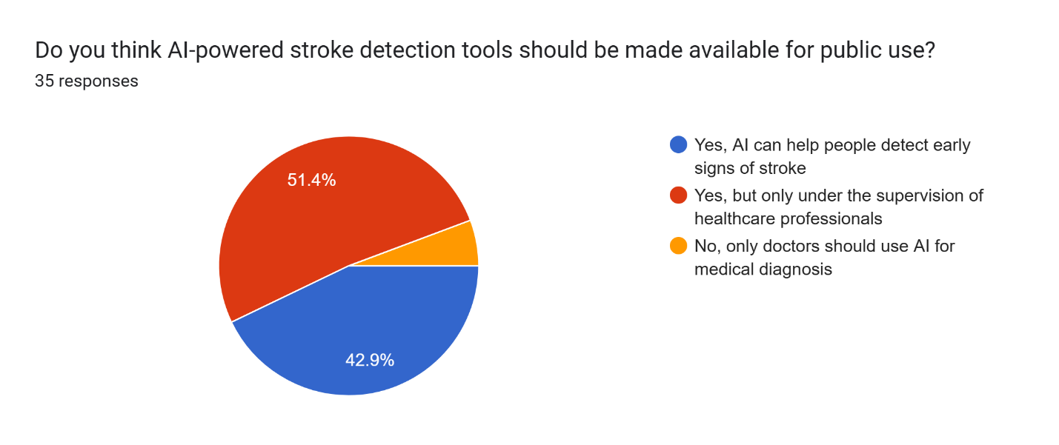

Figure : Section 4 question 23

According to the pie chart most participants of about 51.4% believe that AI stroke detection tools should be used under the supervision of healthcare experts while 42.9% participants believe the public should also get access to the model.

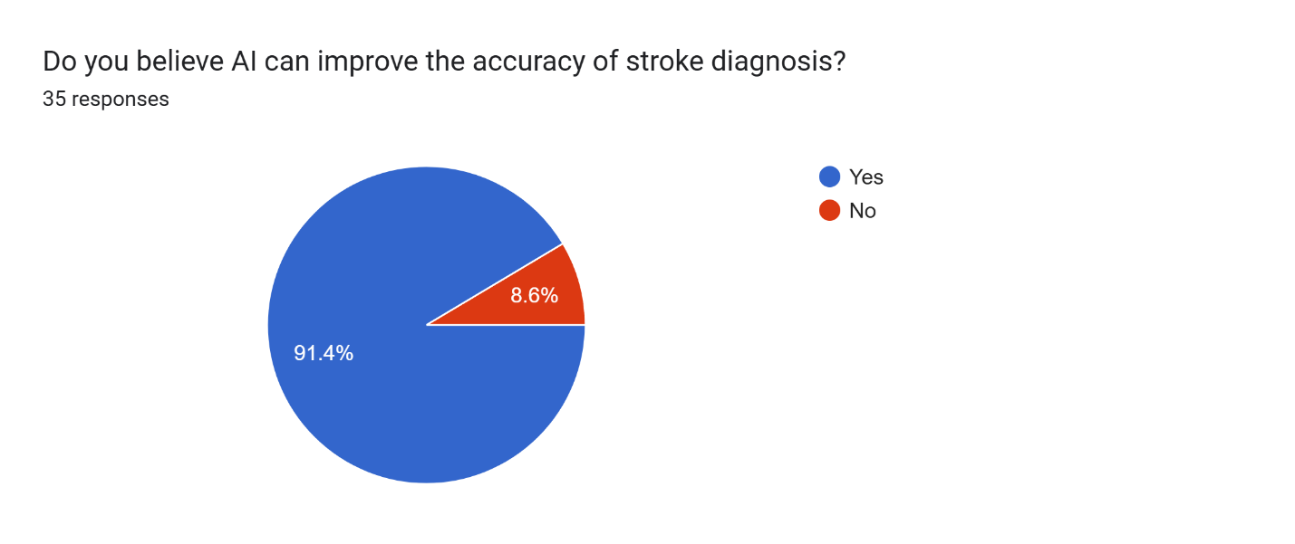

Figure : Section 4 question 24

According to the pie chart most of the participants of about 91.4% are positive that AI can help with the accuracy of stroke diagnosis.

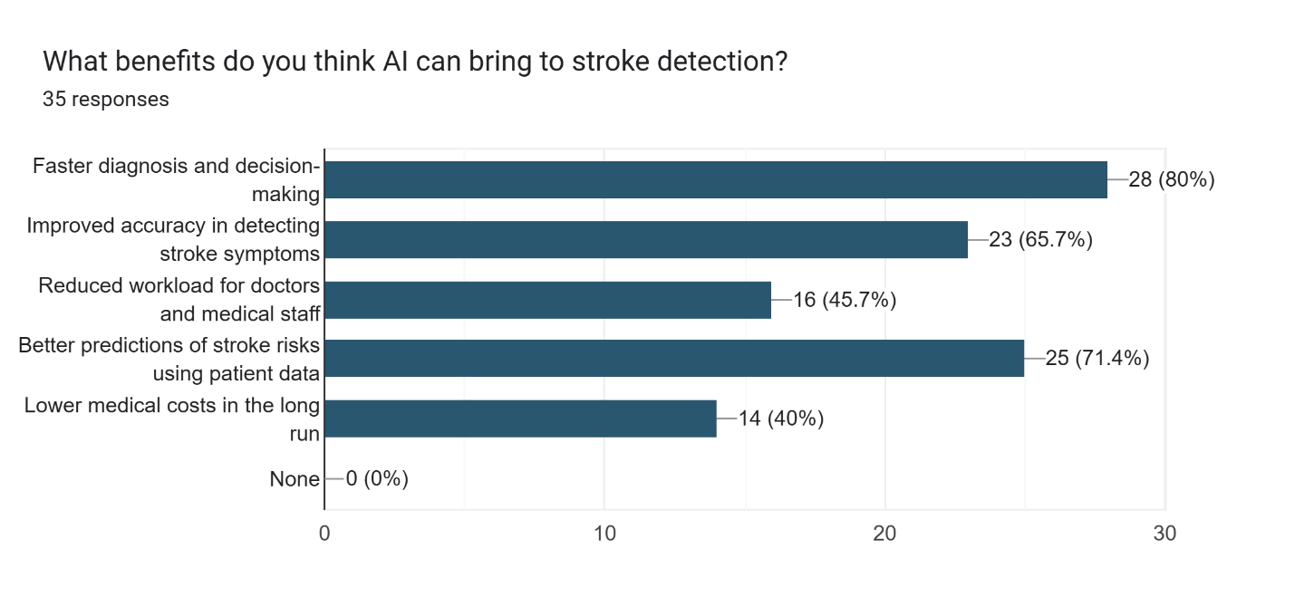

Figure : Section 4 question 25

According to the graph most participants of about 80% believe that faster diagnosis and decision making of AI models can be the most helpful with stroke prediction. In addition to that participants of about 71.4% believe that better prediction of stroke risks using patient data can be highly beneficial as well.

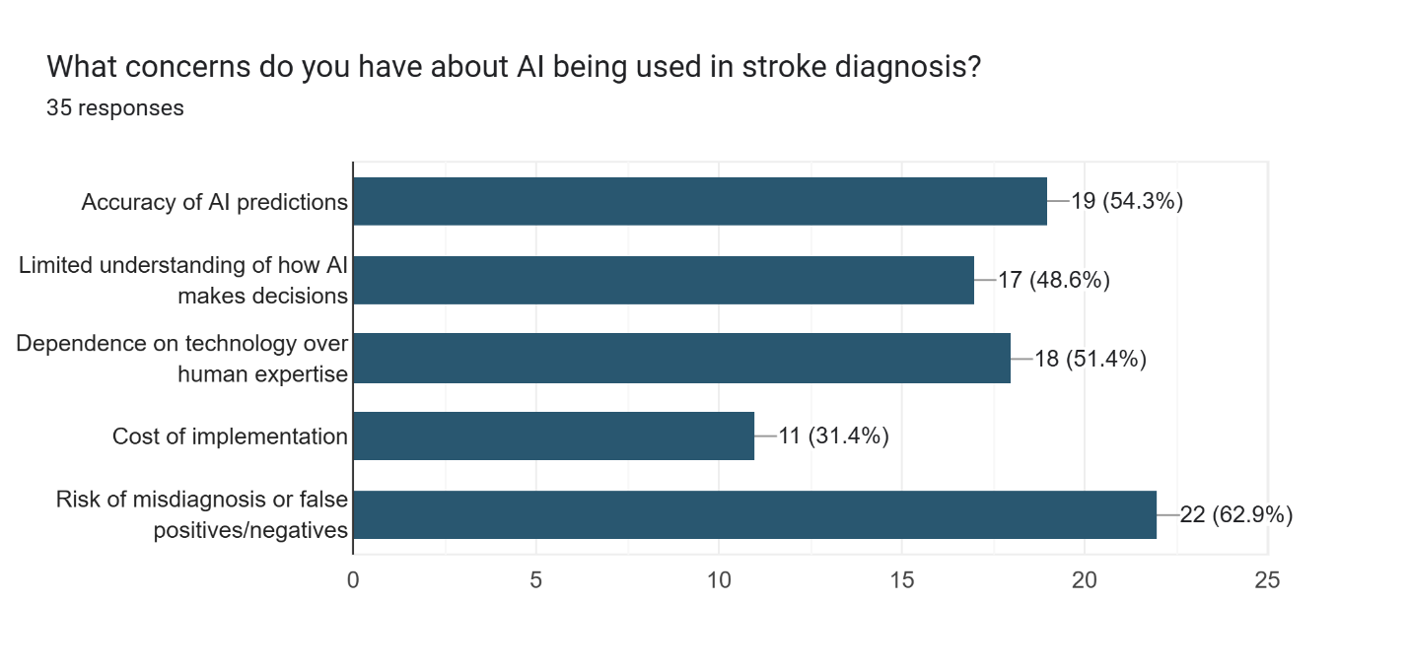

Figure : Section 4 question 26

According to most of the participants are concerned with risk of misdiagnosis by the AI model (62.9%) and the accuracy of AI predictions (54.3%) which is of the same type of error that AI models can face.

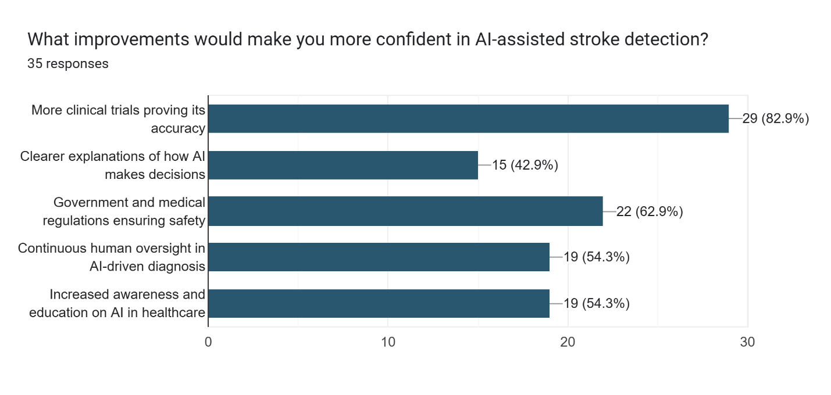

Figure : Section 4 question 27

According to the graph most of the participants believe that using more clinicals trials for the AI model (82.9%) would make them more confident in the AI system.

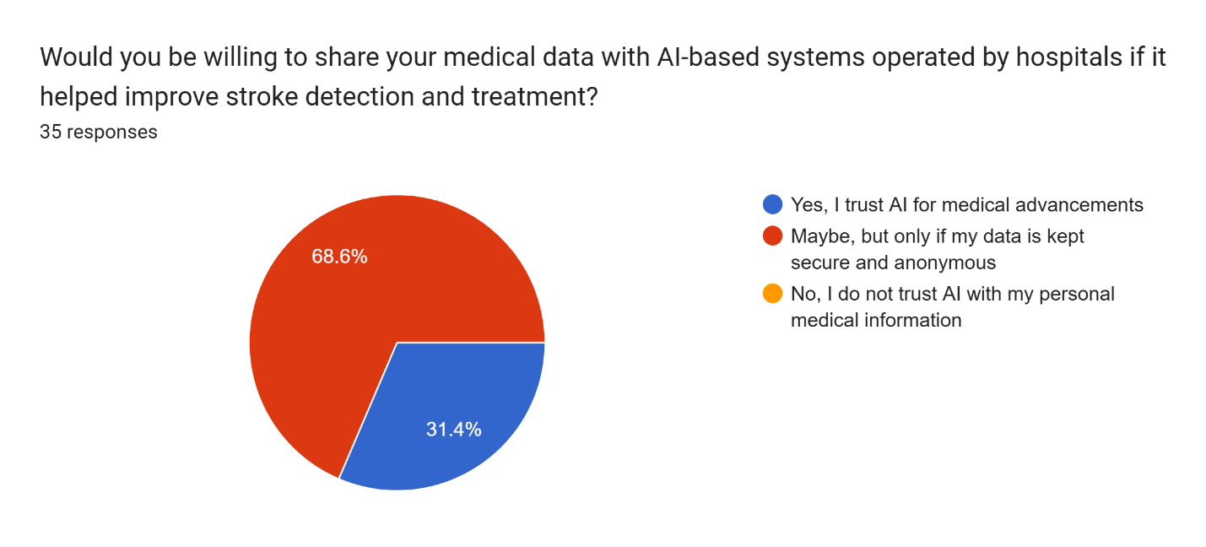

Figure : Section 4 question 28

According to the pie chart most of the participants of about 68.6% would trust AI-based systems to use their personal data to improve the AI model only if they have a guarantee their data can be kept secure.

### Section 5: Conclusion

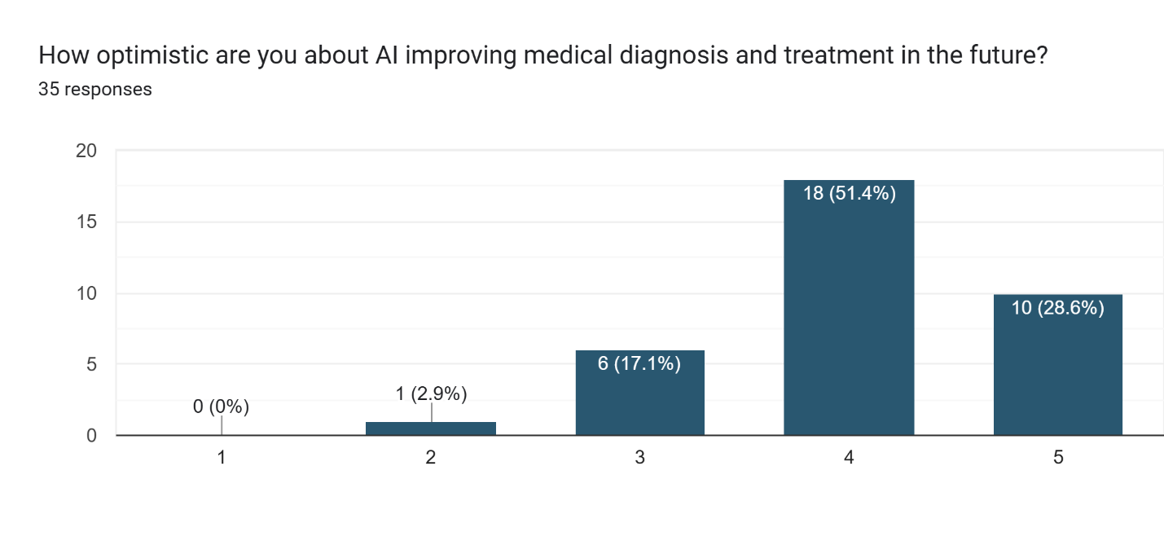

Figure : Section 5 question 29

According to the graph most participants of about 80% believe that AI can improve medical diagnosis and treatment in the future.

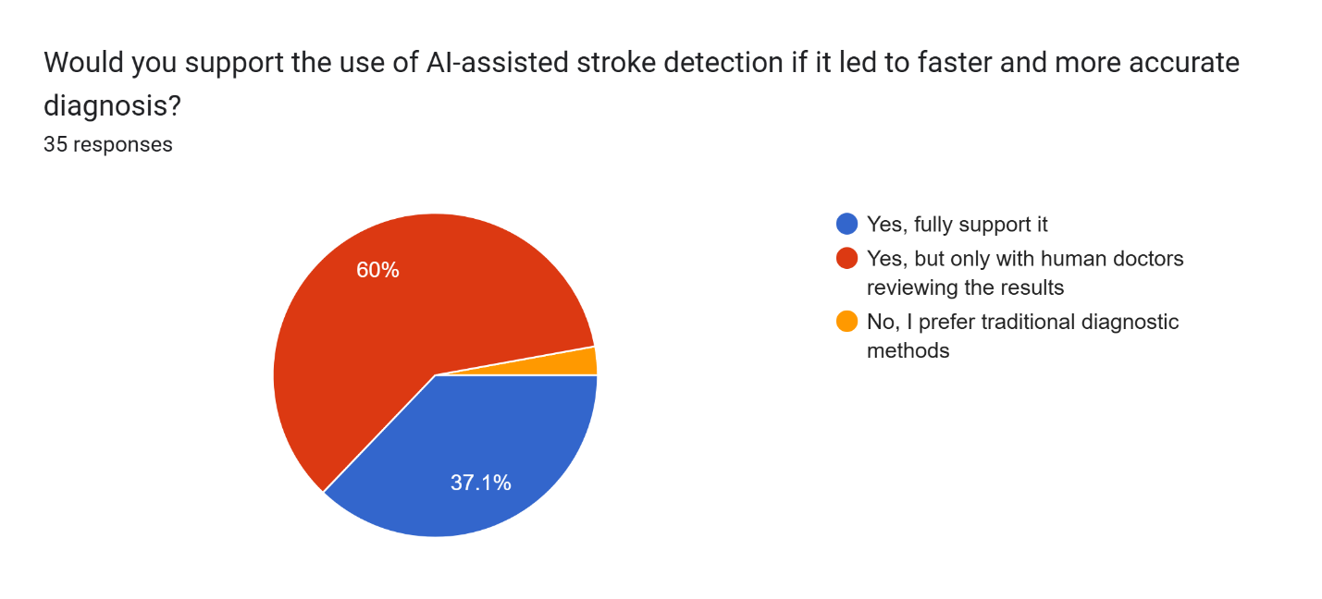

Figure : Section 5 question 30

According to the pie chart about 60% of the participants would support the AI-assisted stroke system if human doctors review the results. And totally about 97.1% participants support the use of AI-assisted stroke detection system.

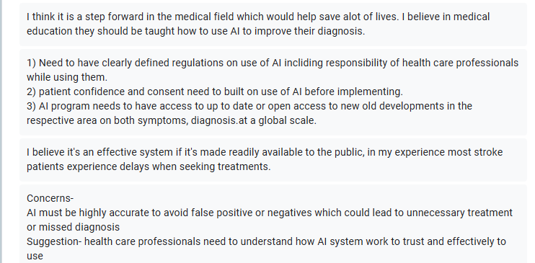

Figure : Section 5 question 31A

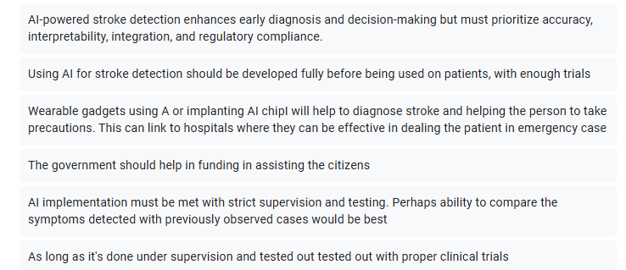

Figure : Section 5 question 31B

According to the open-ended questions Most participants are positive with the implantation of the AI system if certain conditions are met. These include:

* Strict trials done before the implementation
* Only implemented with the supervision of medical experts
* Must prioritize accuracy to prevent misdiagnosis
* Medical experts must be taught about the AI system before they get access to it.

## Summary

Chapter 3 presents the methodology as well as the data gathering design caried out for the system. The chapter focuses on why Rapid Application development (RAD) is chosen as a methodology for the system due to its flexibility as well its suitability for solo development. This is further proved by a comparison between RAD, waterfall model and Extreme Programming (XP). In addition to that this chapter also focuses on the four phases of RAD that includes requirement planning, user design, rapid construction, and implementation.

Chapter 3 also discusses the insight of the data collected through the survey from the google form, showcasing how much of a threat stroke is, how the current healthcare handles stroke and participant’s opinion on using AI in medical diagnosis. Overall, this chapter ensured on how the AI-prediction system would be developed as well as how the system would align with real-world medical needs.

# DESIGN AND IMPLEMENTATION

## Introduction

This chapter explores how the developed system was designed and implemented. The chapter starts by outlining the system design used for the system which includes the system architecture, use case diagram and specifications as well as activity diagrams to get an idea of how the overall structure of the system works and how the user interacts with the system. Next the structure of the database is described with how different types of data in the system are being managed and functioned effectively to complete its functions.

This chapter also covers the interface design of the system which includes the menu design and how the system navigation works. Next the implementation of the system is shown, showing screenshots of the UI as well as explanations on how user interaction works for the system. Lastly the backend functions or the main codes used to make the system function are shown with screenshots and explanations on how they play their role in making the system function.

## System Design

### System Architecture

The system architecture of the stroke prediction system is designed for implementing a healthcare AI system that uses an easy-to-understand interference to allow for doctors, and other healthcare professionals to identify the stroke risk and type of stroke a person has with ease and efficiency. In addition to this the system allows for easy management of input and output data that can be useful for medical admins and supervisors. The system uses a user-friendly frontend built on React, FastAPI-based python backend, file management services for photos and documents, a relational database built on PostgreSQL, as well as AI models that are split into three categories.

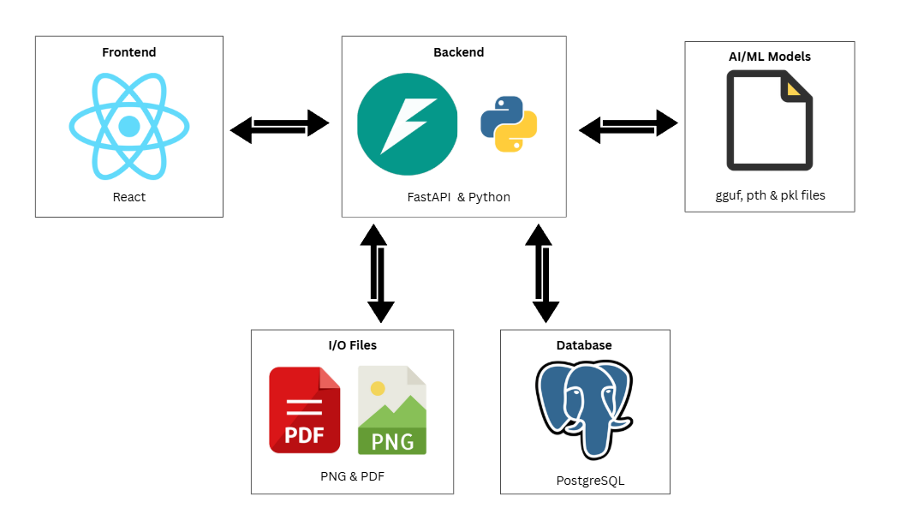

Figure : System architecture diagram

The frontend of the system is developed using React which allows users to interact with the main functions of the system in an easy and efficient way. Users can upload documents, scan images, provide patient data and directly chat with the built-in medical chatbot. In return the users can get chatbot responses, predictions from the AI models as well as other data related to patients and stroke directly from the backend.

The backend of the system uses FastAPI and Python to act as the central hub for retrieving data from the various sources in the system as well as sending data back to these sources. It coordinates the combination of the frontend, I/O operations, database and AI models all in real-time with multiple user roles. One major example is the use of RAG-based chatbot which combines all four functions. The backend will first manage the generations of vectors of the uploaded PDF document by the user and store the vectors in the database. When the user asks the chatbot questions using the frontend the backend will search for similarities in the vector database to retrieve chunks that are related to the question, afterwards the data is loaded into the medical LLM model which generates an appropriate answer for the user in the frontend.

The system contains three main AI components. The biggest component is the Retrieval Augmented Generation (RAG) chatbot which is powered by fine-tuned large language model (LLM) built for medical responses. As mentioned before this allows users to upload pdf files to the system which are then vectorized which then can be used for semantic and contextual responses. This model combines prediction and data of the two other AI models to give suggestions and addition information to the user. Another AI component is the regression stroke prediction model which uses a patient’s age and symptoms to give a percentage on the risk of stroke. The final AI component is a classification stroke prediction model built on CNN which uses brain CT scans to predict if a patient is normal, has ischemic or hemorrhagic stroke. All these models work in real-time to allow processing of data without any delay.

### Use Case Diagram

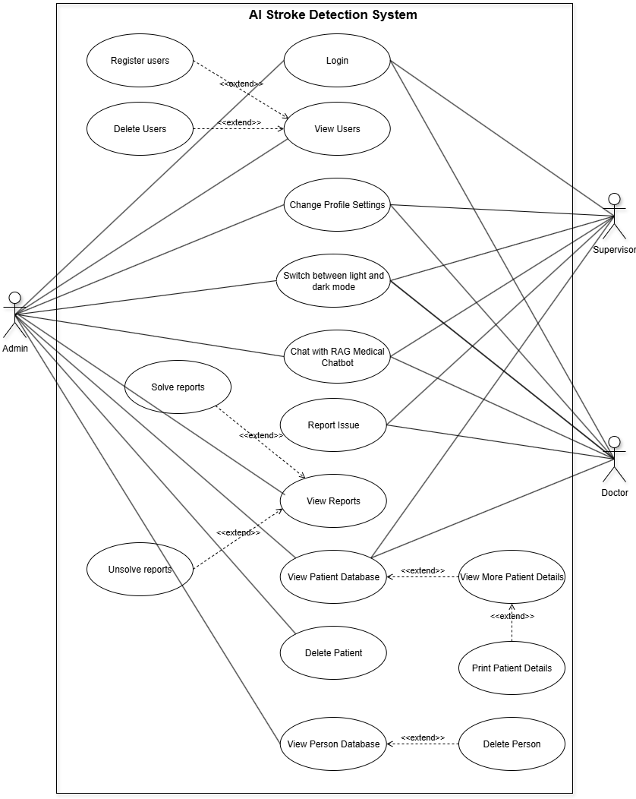

Figure : User Case Diagram 1

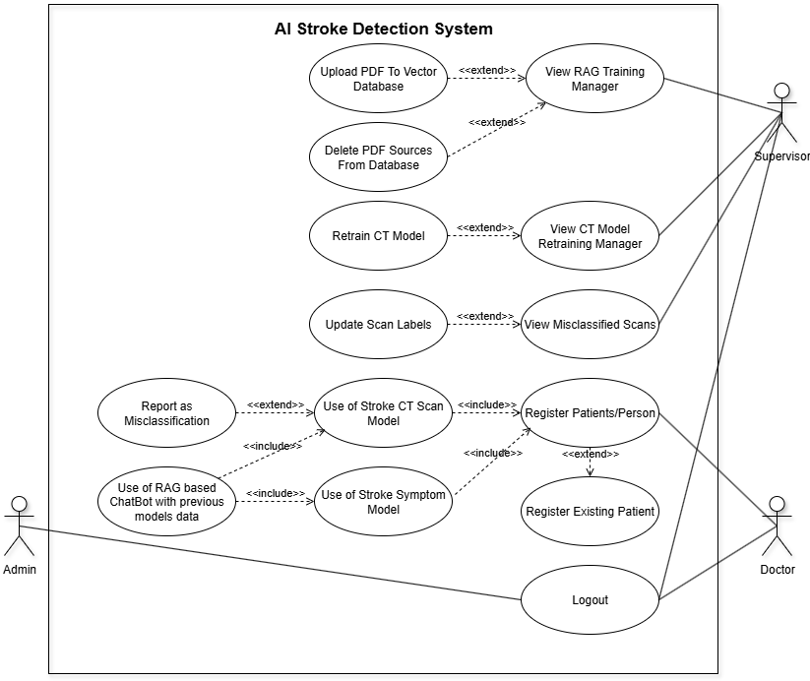

Figure : User Case Diagram 2

#### Use Case Specification – Login

|  |  |
| --- | --- |
| Use Case Name | Login |
| Actor | Admin, Supervisor, Doctor |
| Description | Allows users to log into the AI stroke detection system using their registered email and password. Afterwards they are directed to their homepage based on their role. |
| Priority | High |
| Precondition | Users need to first be registered in the system through the admin |
| Main Flow | 1. The user first goes to the login page of the system 2. The user enters their email and password 3. The data is compared to the data saved in the database 4. If the data that the user input matches with the registered data in the database, the user can login. 5. The user is directed to their homepage based on the role they were registered |
| Alternative Flow | **Entered credentials do not match**   1. If the entered credentials do not match with registered data, then the user gets an error 2. The user then can try logging in again |
| Postcondition | * User is successfully logged in to the system and redirected to their homepage * The system will maintain the user session until the user logs out or the connection with the system is nullified. |

Table : Use Case Specification 1 – Login

#### Use Case Specification – View Users

|  |  |
| --- | --- |
| Use Case Name | View Users |
| Actor(s) | Admin |
| Description | Allows users with admin role to view the registered users present in the system. The page shows the user’s email and their respective role. |
| Priority | Medium |
| Precondition(s) | * The user has the role of admin * The system has pre-existing users registered |
| Main Flow | 1. The admin first navigates to the “Manage Users” page through their sidebar dashboard 2. The system retrieves and displays the list of users, and their relevant information registered in the system |
| Alternative Flow | **No Users Found**   1. If no users are found, then it displays a blank page 2. The system also shows an error message and logs the issue |
| Postcondition(s) | * Admin users can view the list of registered users * No changes are made unless the admin executes other use cases in the page. |

Table : Use Case Specification 2 -View Users

#### Use Case Specification – Register Users

|  |  |
| --- | --- |
| Use Case Name | Register Users |
| Actor(s) | Admin |
| Description | Allows Admin users to register new users into the system by providing the necessary email, password (which can be changed later by the user), and role. It is an extension of view user use case by providing additional functions for the “Manage User” page. |
| Priority | High |
| Precondition(s) | * The user has the role of Admin * Admin user is on the “Manage User” page |
| Main Flow | 1. Admin User enters the new user’s information on the registration form 2. The system validates the input registered by the user 3. If the input is valid the system registers the user and updates the database 4. The user is notified that a new user has been registered through the UI. |
| Alternative Flow | **Invalid Input**   1. Shows an alert ‘Please fill in all fields’ if the user has not entered data for all fields in the registration form 2. Shows an alert ‘Please enter a valid email address (must contain "@").’ If the input email does not contain @ 3. Shows an alert 'Name must only contain letters and spaces.' If the input name contains other symbols and numbers. 4. Shows an alert 'Password must be at least 6 characters long.' If entered password is less, then the required amount. 5. Shows an alert 'Failed to create user.' If the same email is registered in the database already.   **Network Error**   1. Shows alert 'Network error. Please try again.' If there is an issue connecting with the database |
| Postcondition(s) | * A new user would be added to the system that can be then viewed in the automatically updated user list on the same page |

Table : Use Case Specification 3 – Register Users

#### Use Case Specification – Delete Users

|  |  |
| --- | --- |
| Use Case Name | Delete Users |
| Actor(s) | Admin |
| Description | Allows Admin users to delete existing users in the system. It is an extension of the View Users use case which allows Admins to directly delete from the user list visible in the “Manage User” page. |
| Priority | High |
| Precondition(s) | * The user has the role of Admin * Admin user is on the “Manage User” page |
| Main Flow | 1. Admin views the list of users from the user list 2. Admin selects the user they want to delete 3. System gives an alert for confirmation 4. Admin confirms the removal of the user 5. System removes the user from the database 6. The user list will then be automatically updated in real time 7. The user will be notified that the selected user has been removed from the system through the UI. |
| Alternative Flow | **Cancel Deletion**   * An option is given by the system to confirm the removal of the user, if Admin presses cancel no action would be taken   **Deletion Failure**   * If an error occurs while deleting the user displays the alert message 'Failed to delete user' and logs the issue   **Network Error**   * Shows alert message 'Network error while deleting user' if there are any issues with the network while deleting the user |
| Postcondition(s) | * The selected user would be removed from the system and the user list will be automatically updated showing the list without the deleted user |

Table : Use Case Specification 4 – Delete Users

#### Use Case Specification – Change Profile Settings

|  |  |
| --- | --- |
| Use Case Name | Change Profile Settings |
| Actor(s) | Admin, Supervisor, Doctor |
| Description | Allows users to view their account information such as name and email. In addition to this also allows users to change their name and password. Users would strictly be not allowed to change their email, would be only for display in the UI. |
| Priority | Medium |
| Precondition(s) | * User must be logged into the system * Users must navigate to the “gear icon” shown in their sidebar dashboard |
| Main Flow | 1. System displays current registered user details 2. User can edit their name, and password 3. If password is changed must re-enter the password again in the confirm password field 4. Users submit their updated information 5. System goes through the input and updates the user’s profile in the database 6. Confirmation message is shown to the user through the UI as 'Profile updated successfully!'. |
| Alternative Flow | **Network Error**   * Shows alert 'Network error' if there is any issue connecting with the network or database   **Invalid Input**   * Shows the alert 'Passwords do not match.' If the password entered initially does not match with input in the confirm password field |
| Postcondition(s) | * User profile setting would be updated and stored in the database. |

Table : Use Case Specification 5 – Change Profile Settings

#### Use Case Specification – Switch Between Light and Dark Mode

|  |  |
| --- | --- |
| Use Case Name | Switch Between Light and Dark Mode |
| Actor(s) | Admin, Supervisor, Doctor |
| Description | Allows users to switch between light and dark UI themes using icons on the top right corner of the screen in the UI. This can be changed on any page actively by the user |
| Priority | Low |
| Precondition(s) | * User is logged in * The theme icon (sun or moon) is visible on the top right side of the UI. |
| Main Flow | 1. The user presses on the theme toggle icon (moon on light mode and sun on dark mode) 2. System switches to the opposite theme 3. The system UI is updated across all pages to reflect on the selected theme |
| Alternative Flow | **Error Loading Theme**   * Makes dark theme the default theme if there is any issue with changing themes |
| Postcondition(s) | * The application displays the selected theme |

Table : Use Case Specification 6 – Switch Between Light and Dark

#### Use Case Specification – Chat with RAG Medical Chatbot

|  |  |
| --- | --- |
| Use Case Name | Chat with RAG Medical Chatbot |
| Actor(s) | Admin, Supervisor, Doctor |
| Description | Allows users to interact and chat with the medical chatbot. Users can send medical or stroke related questions for which the LLM chatbot responds to the users with references (if available) using a RAG based model |
| Priority | Medium |
| Precondition(s) | * User is logged in * Users must navigate to the “robot icon” shown in their sidebar dashboard to access the chatbot page |
| Main Flow | 1. The user types in a medical question 2. The backend RAG model processes the query 3. The model then responses with references (if found in the vector database) 4. The chatbot then displays the response in the conversation UI 5. The steps 1–4 are repeated for continuous interaction with the chatbot |
| Alternative Flow | **Empty question**   * The system ignores the request and does not send the query to the chatbot   **Backend Failure**   * The chatbot shows alert message ‘Failed to get response’   **Multiple Questions asked at the same time**   * The chatbot shows message in the chat box “The assistant is currently busy processing another request. Please wait” |
| Postcondition(s) | * The user receives medical related answers and references generated from the chatbot during the session * The messages are shown in the chatbot UI but is not stored permanently. |

Table : Use Case Specification 7 – Chat with Medical Chatbot

#### Use Case Specification – Report Issue

|  |  |
| --- | --- |
| Use Case Name | Report Issue |
| Actor(s) | Supervisor, Doctor |
| Description | Allows Doctors and Supervisors to report issues they face when using the system. The issue is submitted by a category and description, which is then sent to the Admin through the system for review. |
| Priority | High |
| Precondition(s) | * The user must have the role Doctor or Supervisor * Users must navigate to the “exclamation mark icon” shown in their sidebar dashboard to access the report page |
| Main Flow | 1. User selects the one of the categories in the category list. The list will differ from Doctor and Supervisor 2. Users can then write in the description field details of the issue 3. Users can then submit the report 4. System validates the input with the database 5. If request validates, the report will be stored in the database 6. System displays the message 'Report submitted successfully.' |
| Alternative Flow | **Empty Fields**   * The system will display the message 'Please fill in all fields.' If any text field is empty   **Backend Call Fails**   * Error Message 'Something went wrong.' Or ‘Failed to submit report.' Is displayed and the error is logged. |
| Postcondition(s) | * The issue would be stored in the database to be reviewed by the admin later. |

Table : Use Case Specification 8 – Report Issues

#### Use Case Specification – View Reports

|  |  |
| --- | --- |
| Use Case Name | View Reports |
| Actor(s) | Admin |
| Description | Allows the Admin to view all reports which were submitted by other users. Reports include report id, category, description, details about the reporter as well as the submission time. |
| Priority | High |
| Precondition(s) | * User must have Admin role * Admin must navigate to the “Manage Report” page shown in their sidebar dashboard to access the view report functions |
| Main Flow | 1. The system fetches all submitted reports from the database 2. Reports are then displayed in a structured list 3. Admin can also navigate by category, role, solved and unsolved reports |
| Alternative Flow | **Backend Failure**   * The system shows alert message 'Failed to load reports.'   **No Report in Database**   * If there is no report in the database only shows table columns. |
| Postcondition(s) | * Admin can view and search for reports submitted by Doctors and Supervisors |

Table : Use Case Specification 9 – View Reports

#### Use Case Specification – Solve Reports

|  |  |
| --- | --- |
| Use Case Name | Solve Reports |
| Actor(s) | Admin |
| Description | An extension of View Report use case, allows Admins to mark a submitted report as solved by toggling its status in the UI as “Solved” |
| Priority | High |
| Precondition(s) | * Admin is using the “Manage Report” page * At least one unsolved report available in the report table |
| Main Flow | 1. Admin finds an unresolved report 2. Admin toggles the “Solve” status for the unsolved row through the system UI 3. System updates the report as “Solved” 4. The UI is refreshed automatically to show the changes in real time for the report table |
| Alternative Flow | **Backend Failure**   * The system shows alert message 'Failed to load reports.' |
| Postcondition(s) | * The report is marked as “Solved” in the database * The report is moved to the “Solved” filter in the system UI |

Table : Use Case Specification 10 – Solve Reports

#### Use Case Specification – Unsolve Reports

|  |  |
| --- | --- |
| Use Case Name | Unsolve Reports |
| Actor(s) | Admin |
| Description | An extension of View Report use case, allows Admins to mark a previously “Solved” report back to “Unsolved” |
| Priority | Medium |
| Precondition(s) | * Admin is using the “Manage Report” page * At least one solved report available in the report table |
| Main Flow | 1. Admin finds a solved report 2. Admin toggles the “Unsolve” status for the solved row through the system UI 3. System updates the report as “Unsolved” 4. The UI is refreshed automatically to show the changes in real time for the report table |
| Alternative Flow | **Backend Failure**   * The system shows alert message 'Failed to load reports.' |
| Postcondition(s) | * The report is marked as “Unsolved” in the database * The report is moved to the “Unsolved” filter in the system UI |

Table : Use Case Specification 11 – Unsolve Reports

#### Use Case Specification – View Patient Database

|  |  |
| --- | --- |
| Use Case Name | View Patient Database |
| Actor(s) | Admin, Supervisor, Doctor |
| Description | Allows all users to view the table of all registered patients, including information related to the patients and when they were registered in the system. In addition to that allows users to use the search function to search for registered patients |
| Priority | High |
| Precondition(s) | * Users are logged into the system * Users must navigate to the “Patient Database” page shown in their sidebar dashboard to access the functions |
| Main Flow | 1. The system fetches all registered patients, and their relevant information found in the database 2. Users can use the search bar optionally 3. Able to filter patients by name |
| Alternative Flow | **Backend Failure**   * The system shows alert message 'Failed to load patients:' and an error is logged by the system |
| Postcondition(s) | * Registered Patients are displayed in table format with relevant information |

Table : Use Case Specification 12 – View Patient Database

#### Use Case Specification – View More Patient details

|  |  |
| --- | --- |
| Use Case Name | View More Patients |
| Actor(s) | Admin, Supervisor, Doctor |
| Description | An extension of “View Patient Database” use case, allow users to view detailed information about the patient they have selected. These include the patients’ symptoms and details about their CT scan. |
| Priority | High |
| Precondition(s) | * Users must be on the “Patients Database” page * At least one patient record is available in the database |
| Main Flow | 1. The user clicks on the “View” button on the patient record they want to view additional information 2. The system fetches patient, symptom and CT scan details 3. The system opens a modal with the full details of the patients shown |
| Alternative Flow | **Patient Does Not Have CT Scans and/or Symptoms Registered**   * The section is replaced with either “No Symptoms reported” or “No CT scan data available”   **Backend Failure**   * The system shows alert message ' Failed to load patient details:' and an error is logged by the system. |
| Postcondition(s) | * A modal with the full patient details is shown |

Table : Use Case Specification 13 – View More Patient Details

#### Use Case Specification – Print Patient Details

|  |  |
| --- | --- |
| Use Case Name | Print Patient Details |
| Actor(s) | Admin, Supervisor, Doctor |
| Description | An extension of “View More Patient Details” use case, allows the user to print the full patient details shown in the modal from the previous use case. |
| Priority | Low |
| Precondition(s) | * The patient detail modal is open |
| Main Flow | 1. The user clicks on the “print” button 2. The print dialog is triggered 3. Gives users an option to print the page without the additional buttons in the UI. |
| Alternative Flow | **Pressing Cancel on the Print Summary**   * Closes the print window and allows the user to continue where they left. |
| Postcondition(s) | * Uses can choose to print the full patient details |

Table : Use Case Specification 14 – Print Patient Details

#### Use Case Specification – Delete Patient

|  |  |
| --- | --- |
| Use Case Name | Delete Patient |
| Actor(s) | Admin |
| Description | Users with Admin role can remove the patient record from the database. |
| Priority | High |
| Precondition(s) | * User has the role of Admin * There is at least one patient record in the database * Users must be on the “Patients Database” page |
| Main Flow | 1. The Admin clicks on the “Delete Patient” button on the row of the patient the Admin wants to delete 2. The system prompts a confirmation message 3. The Admin confirms the message 4. The system deletes the patients from the database and automatically updates the patient list in the UI. |
| Alternative Flow | **Cancel Deletion**   * An option is given by the system to confirm the removal of the patient, if Admin presses cancel no action would be taken   **Backend Failure**   * The system shows alert message "Delete failed" or "Error deleting patient:" and an error is logged by the system. |
| Postcondition(s) | * The selected patient record, symptom record and CT scan record are all deleted at the same time from the database and the list is updated in real time. |

Table : Use Case Specification 15 – Delete Patient

#### Use Case Specification – View Person Database

|  |  |
| --- | --- |
| Use Case Name | View Person Database |
| Actor(s) | Admin |
| Description | The Admin user can view all the people registered in the database. One person can be linked to multiple patients records depending on how many times they were registered in the system. The table is searchable and filtered making it easy for the user to navigate |
| Priority | Medium |
| Precondition(s) | * Admin is logged in * Admin must navigate to the “Person Database” page shown in their sidebar dashboard to access the functions |
| Main Flow | 1. Admin Opens the “Person Database” page 2. The system then fetches all the person records 3. System then displays them on the UI by the person table 4. Admin has an option to filter results in search bar 5. Filtered results are updated automatically in real time |
| Alternative Flow | **No Records in Database**   * If the database has no registered person the system shows in the UI “No persons found”   **Backend Failure**   * The system shows alert message 'Error loading person data' and an error is logged by the system. |
| Postcondition(s) | Person list is shown in table format to the user, the user also has an option to filter the patient list |

Table : Use Case Specification 16 – View Person Database

#### Use Case Specification – Delete Person

|  |  |
| --- | --- |
| Use Case Name | Delete Person |
| Actor(s) | Admin |
| Description | Acts as an extension of View Person Database use case, allows the admin user to remove a person record from the database. Deletion is blocked if there is any patient record linked to the person |
| Priority | Low |
| Precondition(s) | * User with Admin role is logged in * Admin must be on the “Person Database” page * Selected person record to delete must have no patient records linked. |
| Main Flow | 1. The Admin clicks on the “Delete” button on a person record with zero patients 2. System prompts a confirmation message 3. Admin confirms the message 4. System sends a delete request to the backend 5. If the deletion is successful removes the record of the person from the database as well as the table in real time 6. Shows a confirmation message as an alert |
| Alternative Flow | **Pressing Delete button on Person with Patient Count > 0**   * The delete button would be disabled, greyed out and the system ignores the user   **Cancel Deletion**   * An option is given by the system to confirm the removal of the person, if Admin presses cancel no action would be taken   **Backend Failure**   * The system shows alert message "Error deleting person." and an error is logged by the system. |
| Postcondition(s) | * The person record is removed from the database and does not appear on the table UI. |

Table : Use Case Specification 17 – Delete Person

#### Use Case Specification – View RAG Training Manager

|  |  |
| --- | --- |
| Use Case Name | View RAG Training Manager |
| Actor(s) | Supervisor |
| Description | The Supervisor user can access the RAG training manager to view all the currently uploaded documents (PDF files) that have been stored in the vector database |
| Priority | Medium |
| Precondition(s) | * User with Supervisor role is logged in * Supervisor must navigate to the “ChatBot RAG Training” page shown in their sidebar dashboard to access the functions * The database should be compatible as a vector database |
| Main Flow | 1. The Supervisor navigates to the “ChatBot RAG Training” page 2. The system fetches a list of trained documents which is listed in the database 3. The system then displayed the document list in the UI |
| Alternative Flow | **No Document Sources Available in Database**   * If there is no PDF stored in the vector database, then the system displays the message “No documents uploaded yet” in the system UI. |
| Postcondition(s) | Supervisor can view the list of uploaded and trained PDFs that the chatbot will use to answer users. |

Table : Use Case Specification 18 – View RAG Training Manager

#### Use Case Specification – Upload PDF To Vector Database

|  |  |
| --- | --- |
| Use Case Name | Upload PDF to Vector Database |
| Actor(s) | Supervisor |
| Description | Acts as an extension for View RAG Training manager use case. Allows for Supervisor to upload PDF files which are then parsed as well as embedded into the RAG vector base to be used by the medical bot later. |
| Priority | High |
| Precondition(s) | * Supervisor is logged in * Supervisor must be on the “ChatBot RAG Training” page |
| Main Flow | 1. Supervisor clicks on the “Choose File” button 2. The user can then select any PDF file they want from the file explorer 3. The name of the selected PDF file is then shown in the UI 4. The user clicks on the “Upload & Train” button 5. The server loads the file and stores the chunks inside the vector database 6. The system then displays the message 'Uploaded successfully!' in the UI |
| Alternative Flow | **No File Selected**   * The button is “Upload & Train” button is disabled and greyed out   **Duplicate file uploaded**   * Shows the alert message "Document (file name) already exists.", and does not proceed with saving the document in the vector database   **Backend/Network Error**   * The system shows alert message 'Upload failed. Server error.' and an error is logged by the system. |
| Postcondition(s) | * PDF file is successfully stored and indexed in the vector database so it can be reused by the RAG chatbot later. |

Table : Use Case Specification 19 – Upload PDF to Vector Database

#### Use Case Specification – Delete PDF Sources from Database

|  |  |
| --- | --- |
| Use Case Name | Delete PDF Sources from Database |
| Actor(s) | Supervisor |
| Description | Acts as an extension for View RAG Training manager use case. Allows the Supervisor to delete the preciously uploaded PDF documents from the RAG vector database |
| Priority | High |
| Precondition(s) | * Supervisor is logged in * Supervisor must be on the “ChatBot RAG Training” page * At least one PDF source listed on the page |
| Main Flow | 1. Supervisor views the list of uploaded PDF files in the page 2. User clicks on “Delete” button next to the specific file name 3. The system prompts a confirmation message 4. The supervisor confirms the message 5. On confirmation the delete request is sent to the backend by the system 6. After confirmation the system deletes the all the chunks under the file name in the vector database 7. The system shows how many chunks were deleted in the system UI 8. The system refreshes the list and shows the alert message 'Deleted.' |
| Alternative Flow | **Cancel Deletion**   * An option is given by the system to confirm the removal of the PDF file from the database, if Supervisor presses cancel no action would be taken   **Backend/Network Error**   * The system shows alert message 'Delete failed' and an error is logged by the system. |
| Postcondition(s) | * The selected document is removed from the database and the document source list is updated in real time. |

Table : Use Case Specification 20 – Delete PDF Sources from Database

#### Use Case Specification – View CT Model Retraining Manager

|  |  |
| --- | --- |
| Use Case Name | View CT Model Retraining Manager |
| Actor(s) | Supervisor |
| Description | Allows the Supervisor to check the training data statistics. (characteristics of the images available for retraining the CT stroke model) |
| Priority | Medium |
| Precondition(s) | * User with Supervisor role logged in |
| Main Flow | 1. Supervisor must navigate to the “CT Model Retraining” page by clicking on the label showcased in the sidebar dashboard 2. The system fetches and displays the number of scans eligible to be used for retraining of the model categorised by the characteristic of the image (Normal, Haemorrhagic, Ischemic) |
| Alternative Flow | **Backend/Network Error**   * The system shows alert message 'Failed to load stats' and an error is logged by the system. |
| Postcondition(s) | * Training dataset statistics are displayed by the system UI |

Table : Use Case Specification 21 – View CT Model Retraining Manager

#### Use Case Specification – Retrain CT Model

|  |  |
| --- | --- |
| Use Case Name | Retrain CT Model |
| Actor(s) | Supervisor |
| Description | Acts as an extension for View CT Model Retraining Manager use case. Allows Supervisor to retrain the CT Stroke Model using the eligible CT scans, there must be at least 5 eligible scans available for the process to start |
| Priority | High |
| Precondition(s) | * Supervisor is logged in * Supervisor must be in “CT Model Retraining” page * Must have at least 5 eligible CT scans available |
| Main Flow | 1. Supervisor clicks on the “Retrain Model” button 2. System validates the minimum amount of CT scans required to begin the process (at least 5 scans) 3. If the validation is successful displays an animated progress bar to show the progress of retraining 4. Upon completion of retraining displays the message 'Retraining completed.' Along with the training accuracy 5. The new retrained model replaces the current model 6. Backup of the previous model is stored in the system 7. Accuracy, date of creation of the new model is stored in the database for additional information |
| Alternative Flow | **Not Enough Scans Available**   * System blocks the retraining process and alerts the user through the message 'Need at least 5 eligible scans to retrain the model.'   **Backend/Network Error**   * The system shows alert message 'Retraining failed.' and an error is logged by the system. |
| Postcondition(s) | * The stroke model is retrained, and the accuracy of the new model is showed. * The new model replaces the old model * Backup of the old model is stored in the system |

Table : Use Case Specification 22 – Retrain CT Model

#### Use Case Specification – View Misclassified Scans

|  |  |
| --- | --- |
| Use Case Name | View Misclassified Scans |
| Actor(s) | Supervisor |
| Description | Displays the CT scans that were misclassified by the AI model and flagged by Doctors for Review |
| Priority | High |
| Precondition(s) | * User with Supervisor role logged in * At least one misclassification is submitted by the Doctor |
| Main Flow | 1. Supervisor must navigate to the “Misclassified Scans” page by clicking on the label showcased in the sidebar dashboard 2. The system then loads and displays the flagged scans from the database. Information showcased include what the AI predicted, what the doctor says the prediction should be, doctor name and date/time the scan was misclassified |
| Alternative Flow | **No Misclassified Scans in the Database**   * Displays the error message “No scans found” in the system UI   **Backend/Network Error**   * The system shows alert message "Failed to fetch misclassified scans" and an error is logged by the system. |
| Postcondition(s) | Misclassified scan information is visible to the Supervisor |

Table : Use Case Specification 23 – View Misclassified Scans

#### Use Case Specification – Update Scan Labels

|  |  |
| --- | --- |
| Use Case Name | Updated Scan Labels |
| Actor(s) | Supervisor |
| Description | Acts as an extension of View Misclassified Scans user case. Allows Supervisor to update the AI models misclassified label with the corrected label and approve it for retraining with the CT Scan Model |
| Priority | High |
| Precondition(s) | * Supervisor is logged in * Supervisor must be in “Misclassified Scans” page * At least one misclassification is submitted by the Doctor |
| Main Flow | 1. The Supervisor presses the correct label from the dropdown menu (Normal, Haemorrhagic, Ischemic) for the Misclassified record the Supervisor wants to change 2. The Supervisor clicks on the button “Approve & Save”. 3. The scan is removed from the database and misclassified list and stored instead in the Patient CT Scan table 4. The scan is also marked as eligible to be used for retraining the model. |
| Alternative Flow | **Backend/Network Error**   * The system shows alert message "Failed to approve scan." and an error is logged by the system. |
| Postcondition(s) | * Updated CT scan is removed from the original list and database location, instead is moved to the Patient CT Scan table of the database * The CT scan is marked as eligible for use in retraining the model |

Table : Use Case Specification 24 – Update Scan Labels

#### Use Case Specification – Register Patients/Person

|  |  |
| --- | --- |
| Use Case Name | Register Patients/Person |
| Actor(s) | Doctor |
| Description | Allows the Doctor to register new patients by entering their personal details which are then stored in the database. If the patient has never been registered in the system, the system also registers Person data (ID number, name and gender). |
| Priority | High |
| Precondition(s) | * The user must have the role as Doctor * The patient data entered must match with the person data that was registered in the database if it is a returning patient |
| Main Flow | 1. Doctor must navigate to the “Stroke Prediction Model” page by clicking on the label with the same name showcased in the sidebar dashboard 2. Doctor must fill all the fields of the form (ID number, name, phone number, age and gender 3. The Doctor clicks either the “Predict from Symptom” or “Predict from CT Scans”. 4. System validates the input, after input is validated saves the patient information in the database 5. If the patient is not a returning patient and has never been registered in the system before, in addition to registering patient details, registers the patient as a person in another table 6. Navigates to the selected prediction route |
| Alternative Flow | **Invalid Input**   1. Shows an alert ‘Please fill in all fields’ if the user has not entered data for all fields in the registration form 2. Shows an alert 'Name must only contain letters and spaces.' If the input name contains other symbols and numbers. 3. Shows an alert "Please enter a valid phone number (only digits, 7-15 characters). If entered phone number is less or more then the required amount. 4. Shows an alert "Please enter a valid age." If the age is below 1.   **Person Details Does Not Match with Database**   * Displays the alert message "Name or gender does not match existing record for this ID number."   **Backend/Network Error**   * The system shows alert message 'Failed to save patient data. Please check your internet connection and try again.' and an error is logged by the system. |
| Postcondition(s) | * Patient is registered in the database and their ID is used in stroke prediction. * If the patient has never been registered in the system previously registers some of the information in the person table in the database. |

Table : Use Case Specification 25 – Register Patients/Person

#### Use Case Specification – Register Existing Patient

|  |  |
| --- | --- |
| Use Case Name | Register Existing Patient |
| Actor(s) | Doctor |
| Description | Acts as an extension for Register Patient/Person use case. Allows Doctor to retrieve an existing patient that was already registered in the system for use in prediction models |
| Priority | High |
| Precondition(s) | * The user must have Doctor role * Patient must have already been registered in the database * User must be first on “Stroke Prediction Model” Page |
| Main Flow | 1. Doctor must click on the link on the page labelled “[Already registered? Click here to proceed](http://localhost:3000/ExistingPatient)” 2. Doctor enters a valid Patient_ID in the input field 3. System validates if patient is present in the database 4. If patient is found stores patient details in localStorage for future use 5. Navigates to the selected prediction route |
| Alternative Flow | **Invalid Input**   1. Shows an alert ‘Please enter a Patient ID’ if the user has not entered data for the Patient_ID field   Patient Not Found   * If no match is found for the entered Patient_ID gives alert “No patient found with that ID”   **Backend/Network Error**   * The system shows alert message 'Failed to fetch patient data. Please try again.' and an error is logged by the system. |
| Postcondition(s) | * Doctor is redirected to the selected prediction route * Doctor can use the prediction models without re-entering patient data |

Table : Use Case Specification 26 – Register Existing Patient

#### Use Case Specification – Use of Stroke CT Scan Model

|  |  |
| --- | --- |
| Use Case Name | Use of Stroke CT Scan Model |
| Actor(s) | Doctor |
| Description | Allows the Doctor to upload a CT image of the patients brain and obtain a stroke classification (Normal, Ischemic or Haemorrhagic) from the classification CNN model. The result then can be confirmed and saved or corrected if misclassified (another use case) |
| Priority | High |
| Precondition(s) | * Doctor must be logged in * Patient must have been registered before * Must complete Register Patient/Person use case before accessing this page * CT scan must be in PNG format |
| Main Flow | 1. The Doctor upload the PNG CT scan by pressing the appropriate button 2. The system sends it to the backend for classification of the model through the CNN model. 3. Doctors View the results 4. Doctors can then save the results in database or flag it as misclassification |
| Alternative Flow | **No File Selected**   * Displays an error message prompting the user to upload a file   **Backend/Network Error**   * The system shows alert message "Server error while checking access. Please try again." and the error is logged by the system.   **Classification Record/Misclassification Record Already Exists**   * If patient CT scan record already exists display error " This patient's CT scan has already been saved. You cannot upload it again." * If there is a patient misclassification record display error 'Misclassification already exists or invalid data.' |
| Postcondition(s) | * The predicted classification is stored in the system database * If classification is flagged as misclassification goes Report as Misclassification use case * Patient is eligible for combined analysis (CT + Symptoms) through MedicalBot if patient was tested on both models |

Table : Use Case Specification 27 - Use of Stoke CT Scan Model

#### Use Case Specification – Report as Misclassification

|  |  |
| --- | --- |
| Use Case Name | Report as Misclassification |
| Actor(s) | Doctor |
| Description | Acts as an extension of Use of CT Stroke CT Scan Model use case. Allows Doctors to report incorrect CT scan predictions and provide the correct classification between Normal, Ischemic, and Hemorrhagic. |
| Priority | High |
| Precondition(s) | * Doctor must be logged in * Prediction from CT Scan Classification must be complete |
| Main Flow | 1. After the classification prediction is finished the Doctor clicks on the “Report Misclassification” button 2. Doctor selects the correct label from the dropdown 3. Doctor presses “Submit Correction” 4. System submits the request and stores it in the database |
| Alternative Flow | **No Label Selected**   * System displays the error message 'Please select a correct classification.'   **Backend/Network Error**   * The system shows alert message ‘submitting correction.’ and the error is logged by the system.   **Classification Record/Misclassification Record Already Exists**   * If patient CT scan record already exists display error " CT scan already exists. Cannot report misclassification.” * If there is a patient misclassification record display error 'Misclassification already reported for this patient' |
| Postcondition(s) | * The Misclassification request along with the misclassified label and corrected label is stored in the database, which is then reviewed by the supervisor. |

Table : Use Case Specification 28 – Report Misclassification

#### Use Case Specification – Use of Stroke Symptom Model

|  |  |
| --- | --- |
| Use Case Name | Use of Stroke Symptom Model |
| Actor(s) | Doctor |
| Description | Allows Doctor to input symptoms related to the registered patient and use the stroke prediction model to check the risk percentage of stroke. Results then can be saved future steps |
| Priority | High |
| Precondition(s) | * Doctor must be logged in * Patient must have been registered before * Must complete Register Patient/Person use case before accessing this page |
| Main Flow | 1. Doctor Selects values (Yes/No) for symptoms that the patient is experiencing 2. Doctor presses the “Predict” button to get the stroke percentage 3. The stroke percentage is then displayed in the system UI below the “Predict” button 4. Doctor then presses the “Save Data” to store the results 5. The system validates the data and gives the message "Data saved successfully". 6. Doctor has the option to then to go to CT scan prediction page or MedicalBot page if the conditions are met |
| Alternative Flow | **Invalid Patient Session**   * System displays the error message "No patient data available" and logs the error   **Prediction Failure**   * System displays the error message 'Error: Could not get prediction' and logs the error   **Backend/Network Error**   * The system shows alert message "Server error while checking access. Please try again." and an error is logged by the system.   **Save button Pressed before prediction**   * Shows alert message “Please generate the stroke prediction before saving” |
| Postcondition(s) | * Stroke Prediction is shown to the doctor * Risk percentage and symptoms are saved in the database * Patient is eligible for combined analysis (CT + Symptoms) through MedicalBot if patient was tested on both models |

Table : Use Case Specification 29 – Use of Stroke Symptom Model

#### Use Case Specification – Use of RAG based Chatbot with Previous Models Data

|  |  |
| --- | --- |
| Use Case Name | Use of RAG based Chatbot with Previous Models Data |
| Actor(s) | Doctor |
| Description | Allows Doctors to query a clinical chatbot that uses patient data from previous models (symptom regression model and CT classification model) to generate clinical insights using RAG |
| Priority | High |
| Precondition(s) | * Doctor must be logged in * Patient Symptom data must be submitted * Patient CT scan must be submitted * LLM and RAG (optional) must be operational |
| Main Flow | 1. Doctor presses “MedicalBot” button on either Symptom model page or CT scan model page. 2. System retrieves symptom and CT scan data from the database based on patient ID. 3. Both data are joint in a clinical summary 4. The summary is sent to the LLM with an option of retrieving information from the RAG vector database 5. A structured response is returned with observations and recommendations 6. If RAG is used includes source documents for transparency 7. Doctor can continue asking the chatbot questions |
| Alternative Flow | **Missing Patient Data**   1. Prevents users from access the page unless the patient has both symptom and CT scan data. If attempted displays the error message “MedicalBot access requires both symptom and CT scan data”. 2. If the user still manages to send the message to the bot displays an error message through the chatbot reply   **Backend/Network Error**   * The system shows alert message ‘Error checking patient readiness’ and the error is logged by the system.   **The function is used multiple times**   * The error message is shown in the chat box “error: the assistant is currently processing another request. Please wait.” |
| Postcondition(s) | * Doctor can get suggestions and recommendations from the chatbot based on combined patient data * If RAG is enabled Doctors will also receive the source of documents for transparency |

Table : Use Case Specification 30 – Use of RAG Based Chatbot with Previous Model Data

#### Use Case Specification – Logout

|  |  |
| --- | --- |
| Use Case Name | Logout |
| Actor(s) | Admin, Supervisor, Doctor |
| Description | Allows users to safely end their session and clean any stored data from local storage. |
| Priority | High |
| Precondition(s) | * User is logged into the system |
| Main Flow | 1. User clicks on the “Logout Icon” located in the sidebar dashboard 2. The system then removes all session related data such as User information 3. User is brought back to the login page 4. User must log in with email and password to access the user page again |
| Alternative Flow |  |
| Postcondition(s) | * User session will be successfully terminated * Local storage would be cleared * User must log in again to access the system |

Table : Use Case Specification 31 - Logout

### Activity Diagram

#### Login

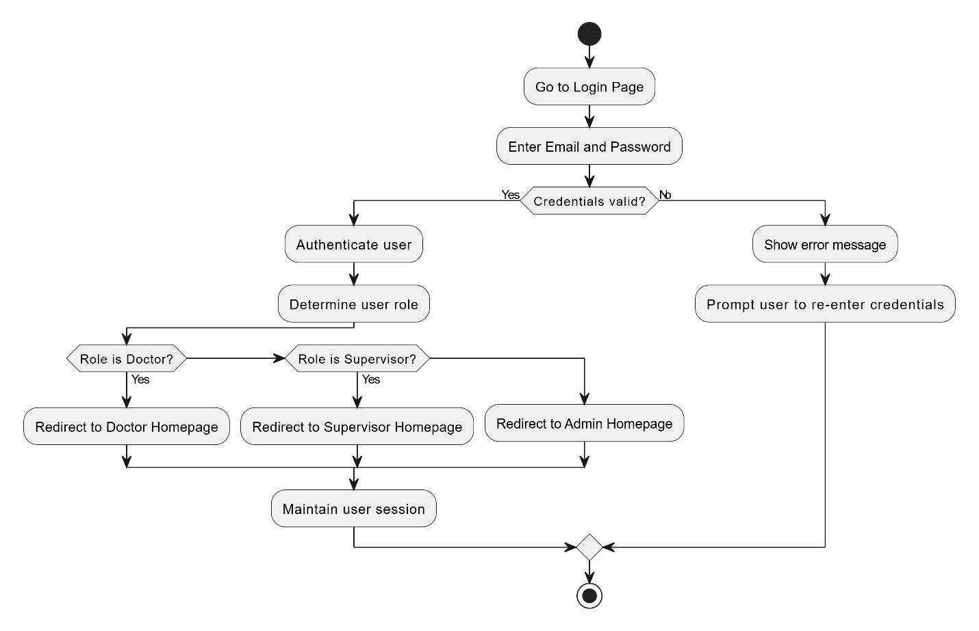

Figure : Activity Diagram 1 - Login

#### View Users

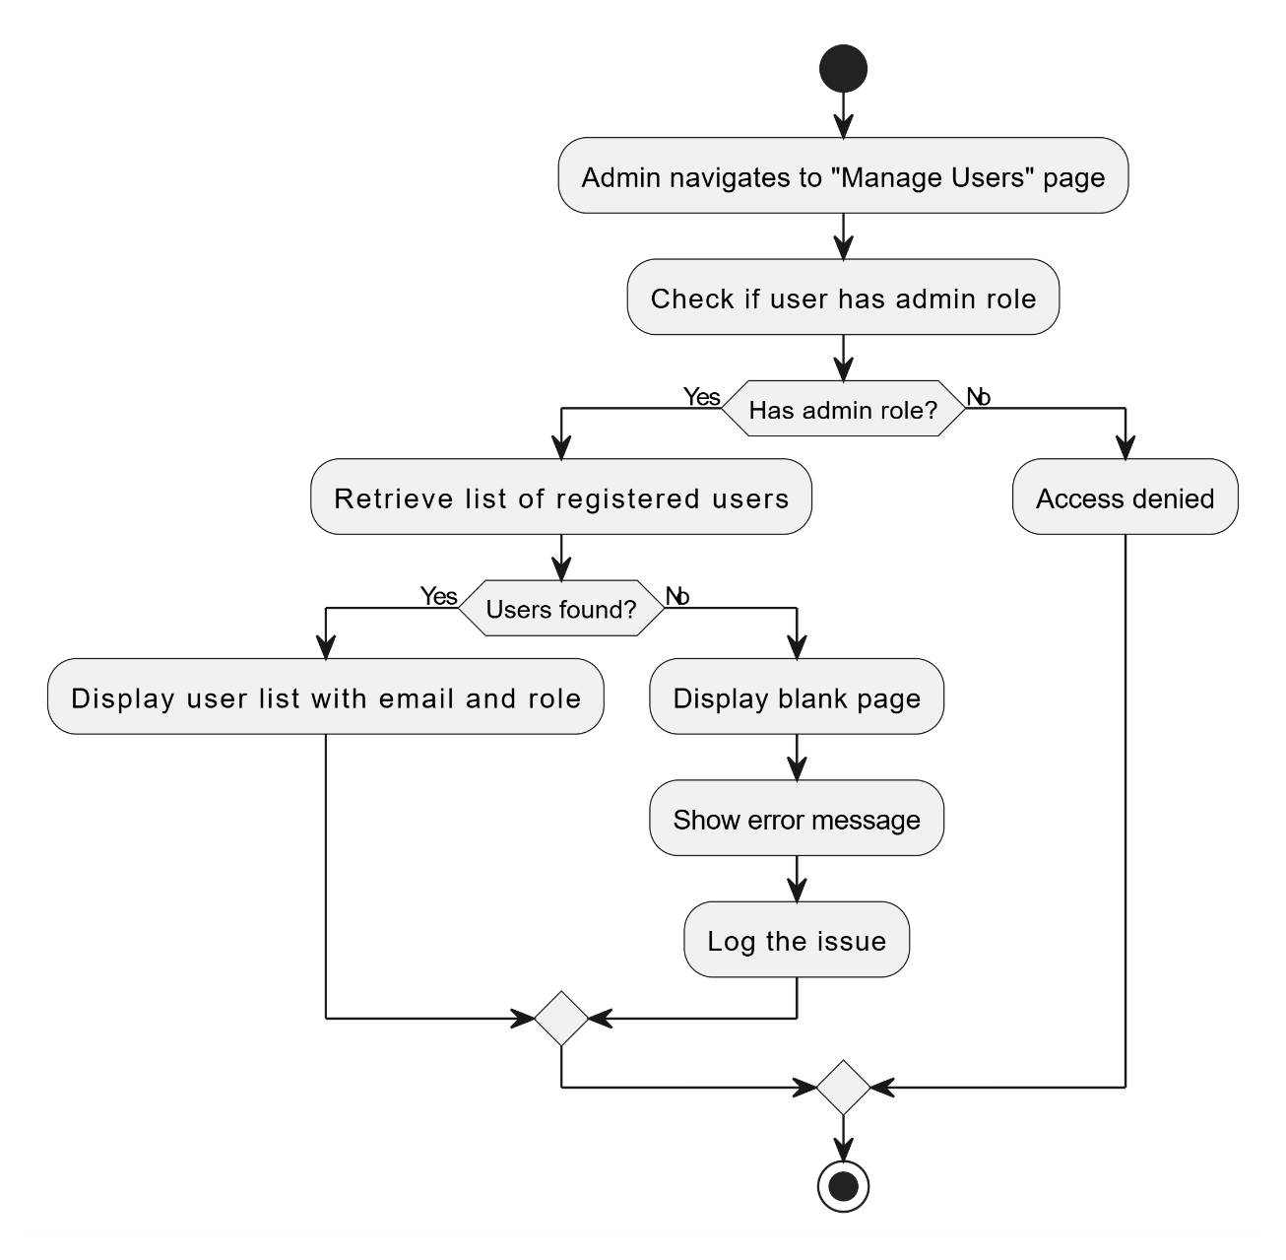

Figure : Activity Diagram 2 – View Users

#### Register Users

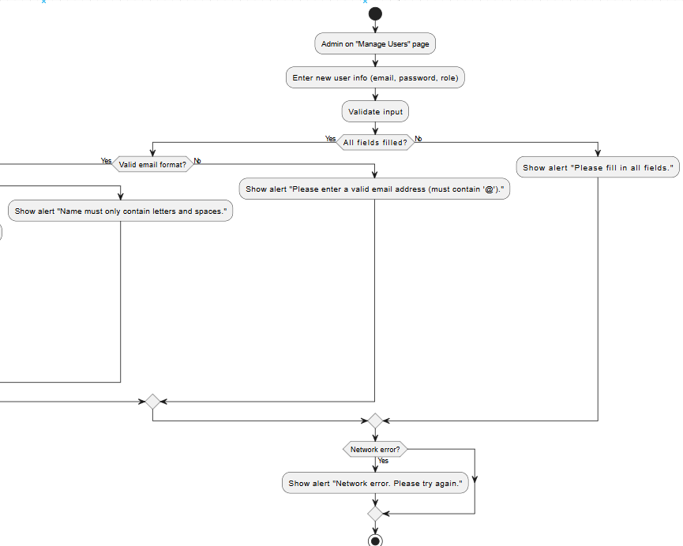

Figure : Activity Diagram 3 – Register Users 1

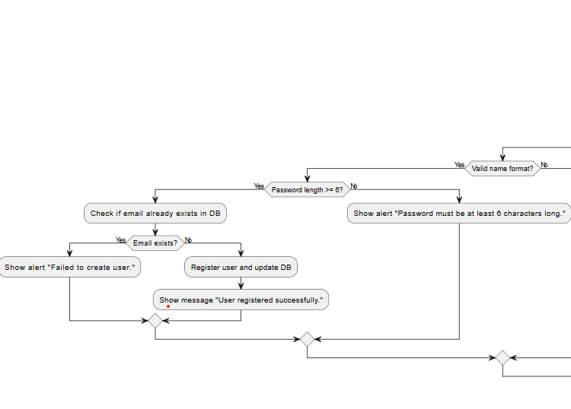

Figure : Activity Diagram 3 – Register Users 2

#### Delete Users

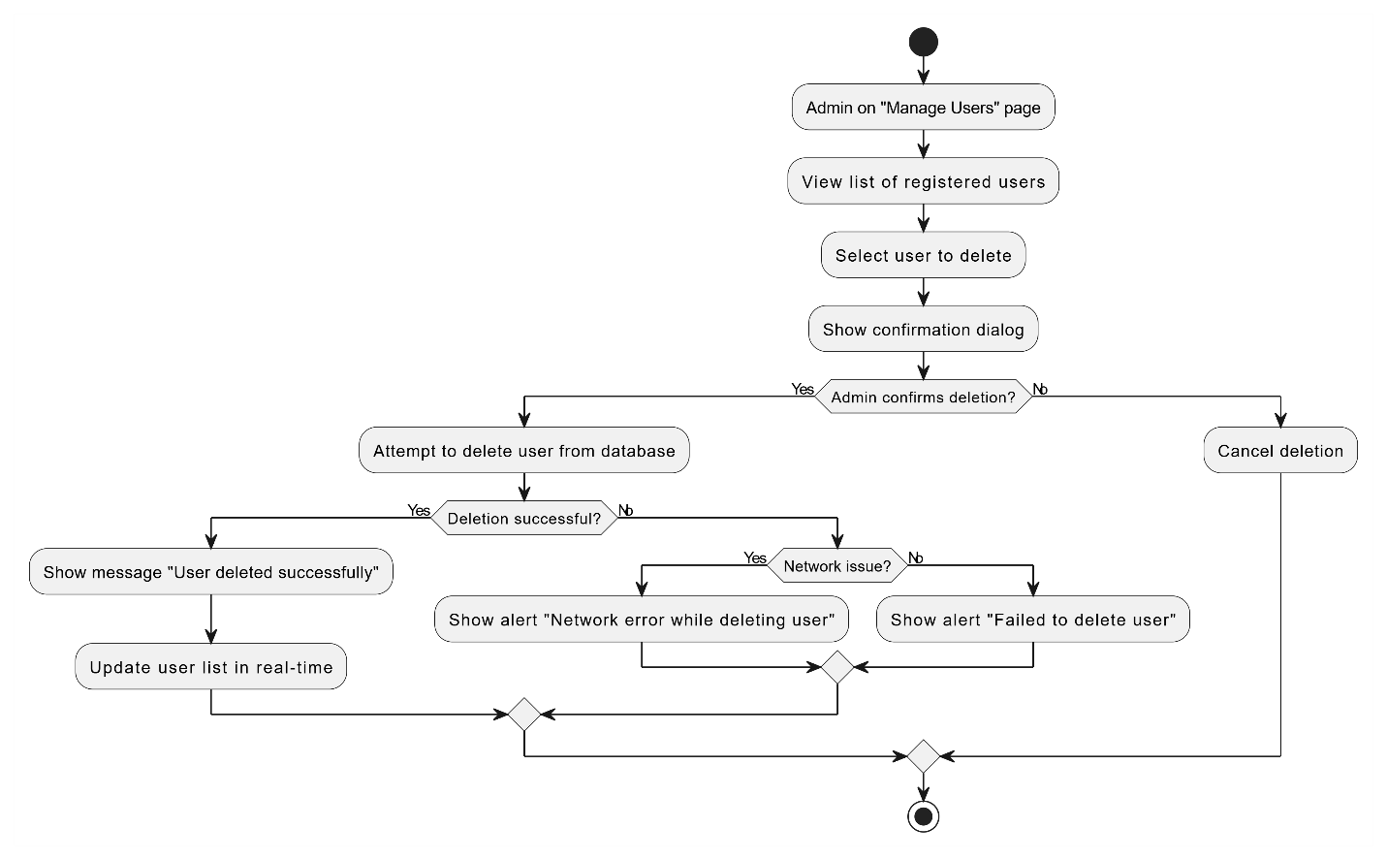

Figure : Activity Diagram 4 – Delete Users

#### Change Profile Settings

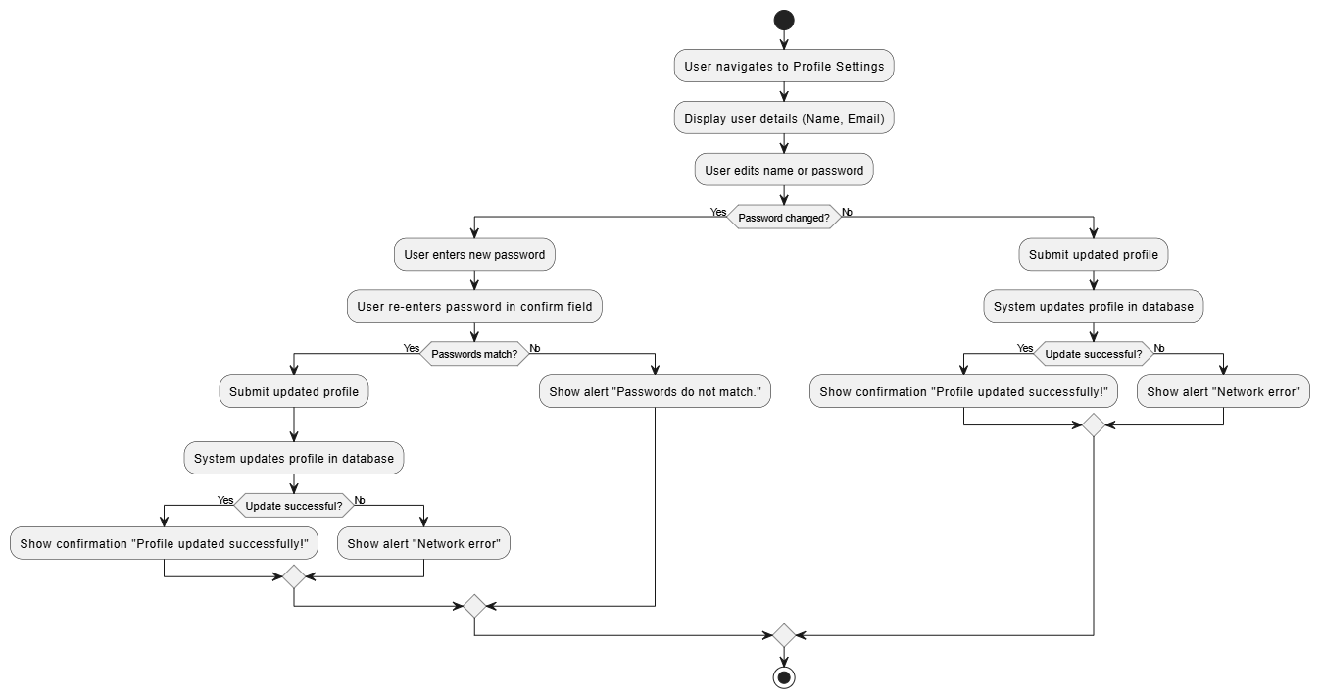

Figure : Activity Diagram 5 – Change Profile Settings

#### Switch Between Light and Dark Mode

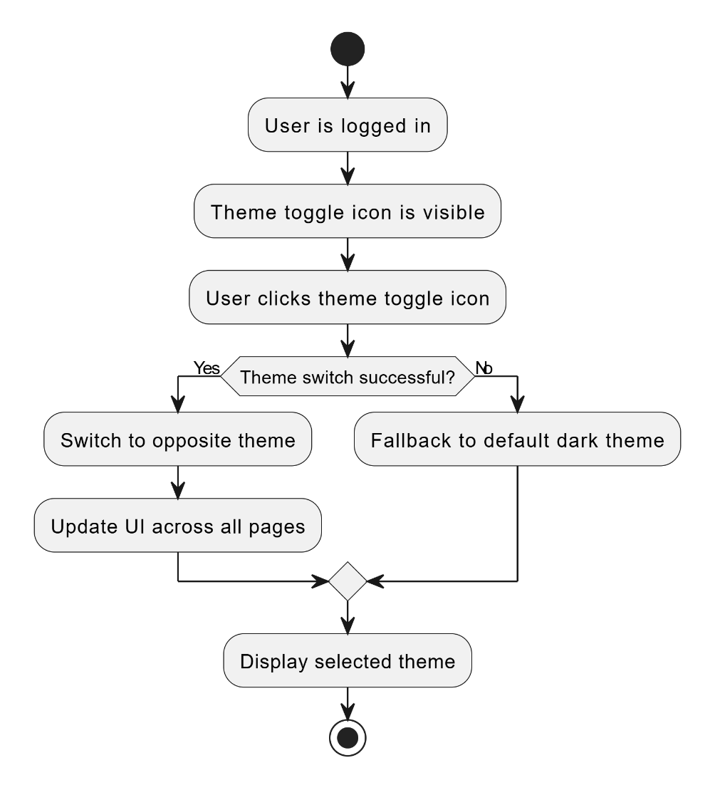

Figure : Activity Diagram 6 - Switch Between Light and Dark Mode

#### Chat with RAG Medical ChatBot

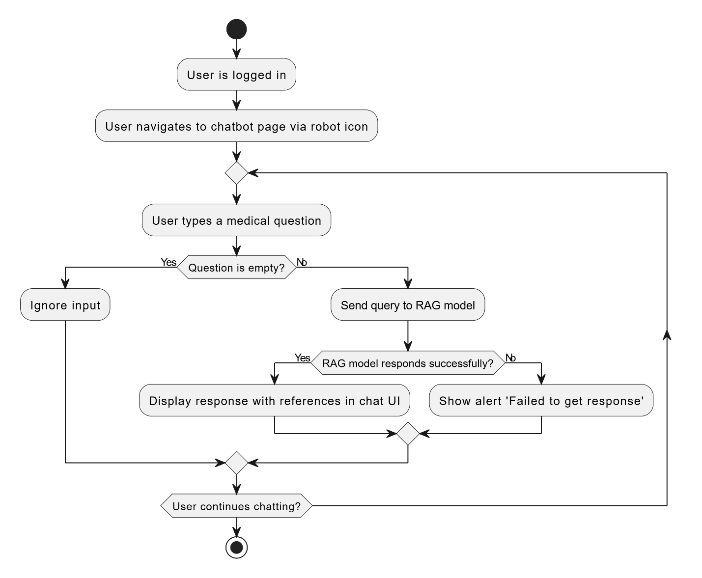

Figure : Activity Diagram 7 – Chat with RAG Medical ChatBot

#### Report Issue

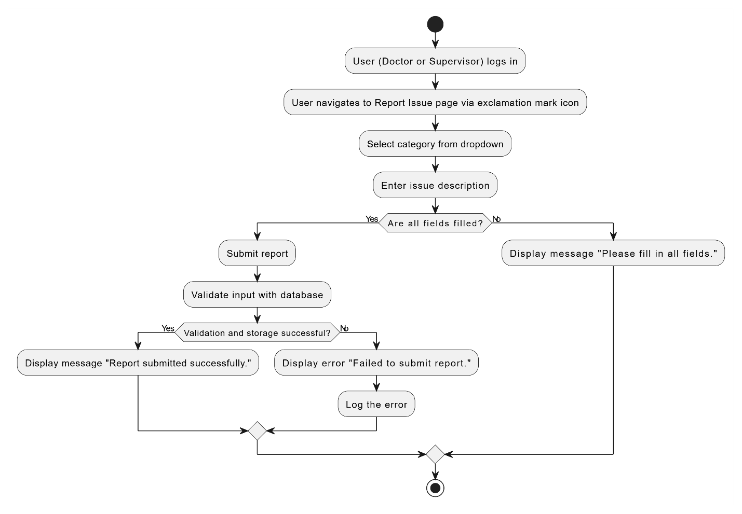

Figure : Activity Diagram 8 – Report Issue

#### View Reports

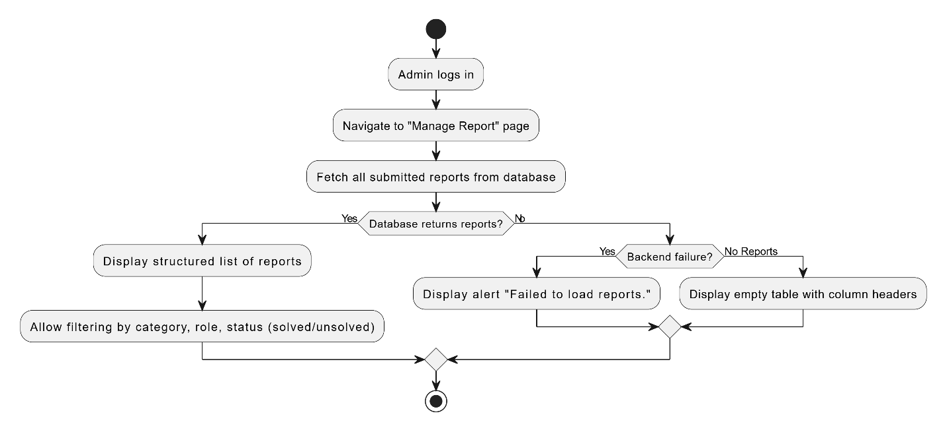

Figure : Activity Diagram 9 – View Reports

#### Solve Reports

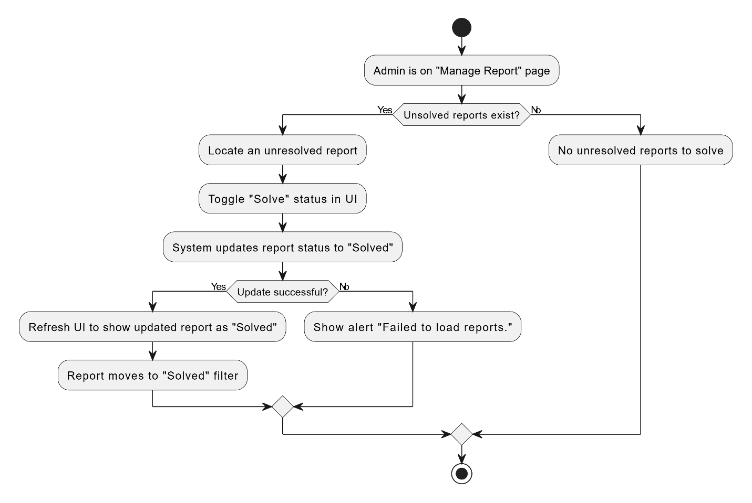

Figure : Activity Diagram 10 – Solve Reports

#### Unsolve Reports

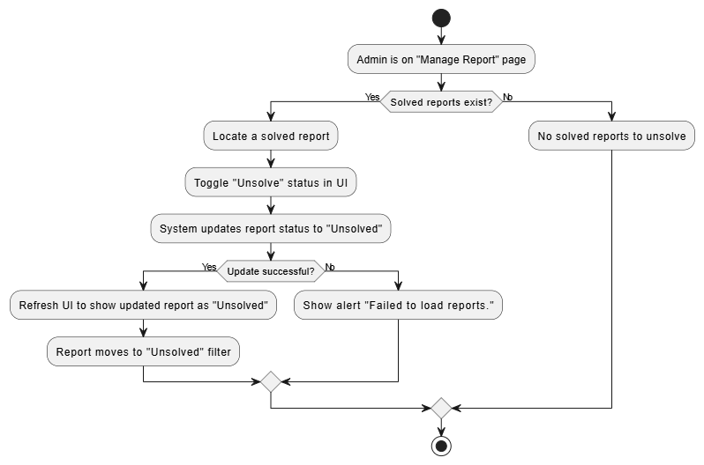

Figure : Activity Diagram 11 - Unsolve Reports

#### View Patient Database

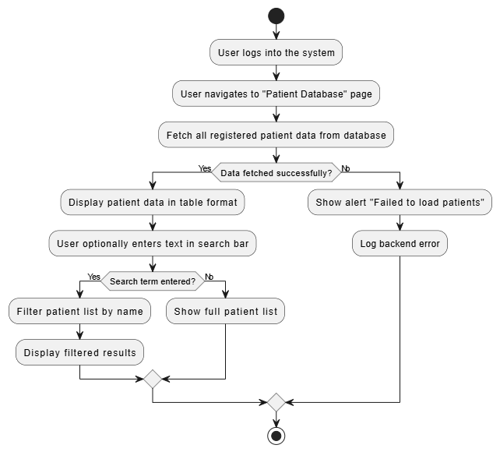

Figure : Activity Diagram 12 – View Patient Database

#### View More Patient Details

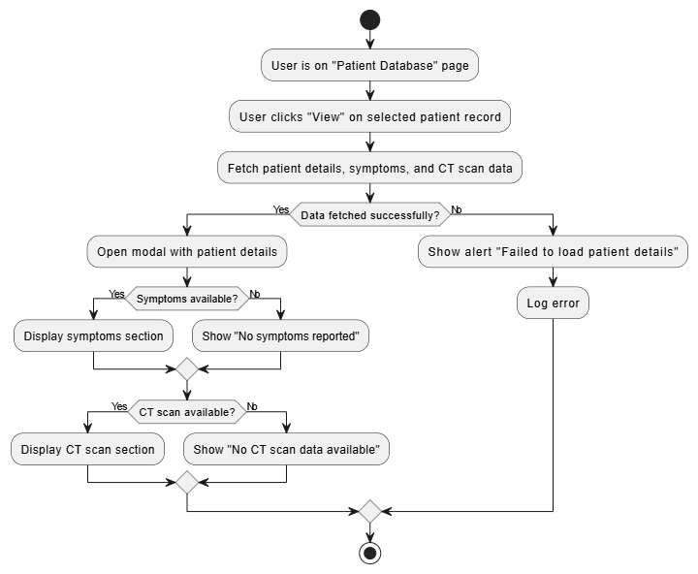

Figure : Activity Diagram 13 – View More Patient Details

#### Print Patient Details

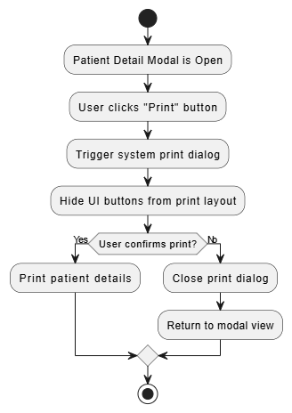

Figure : Activity Diagram 14 – Print Patient Details

#### Delete Patient

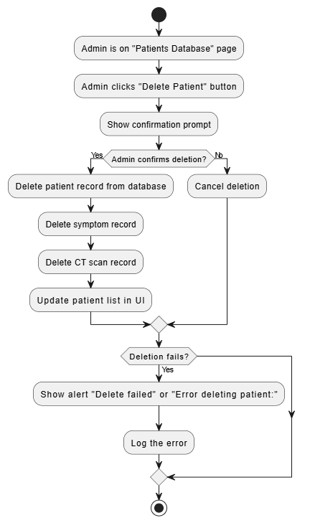

Figure : Activity Diagram 15 – Delete Patient

#### View Person Database

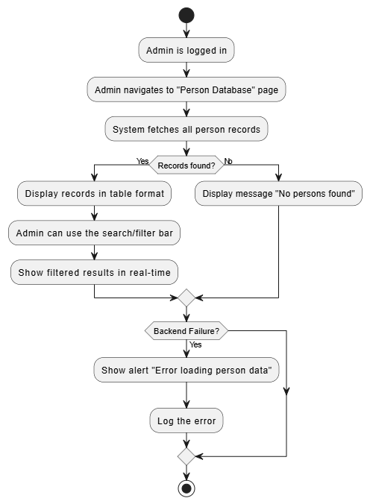

Figure : Activity Diagram 16 – View Person Database

#### Delete Person

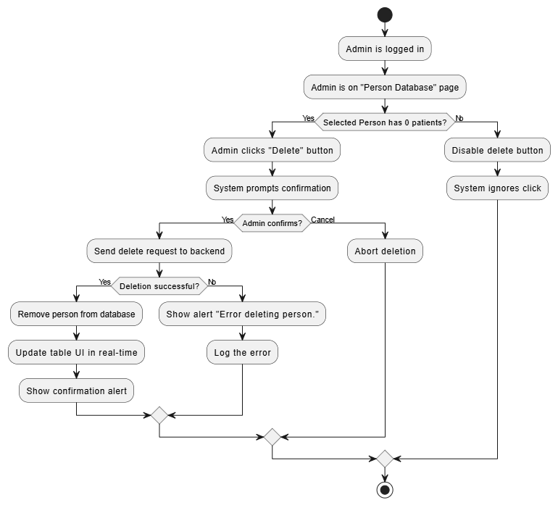

Figure : Activity Diagram 17 – Delete Person

#### View RAG Training Manager

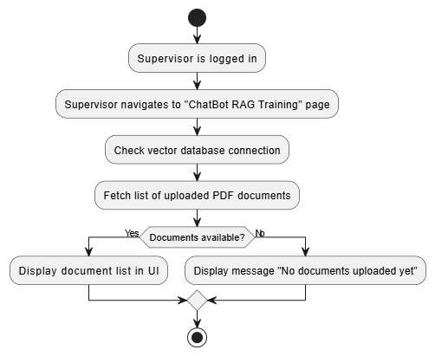

Figure : Activity Diagram 18 – View RAG Training Manager

#### Upload PDF to Vector Database

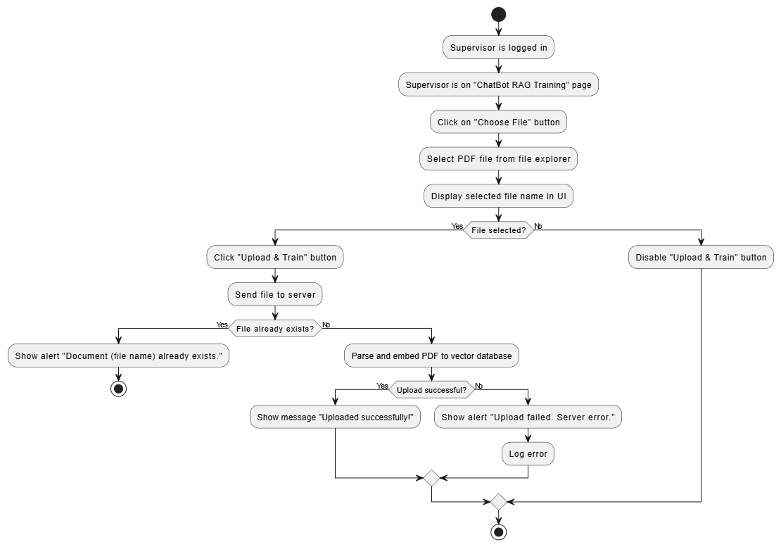

Figure : Activity Diagram 19 – Upload PDF to Vector Database

#### Delete PDF Sources from Database

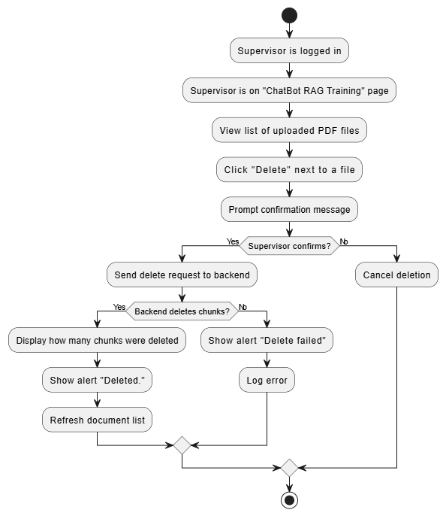

Figure : Activity Diagram 20 – Delete PDF Sources from Database

#### View CT Model Retraining Manager

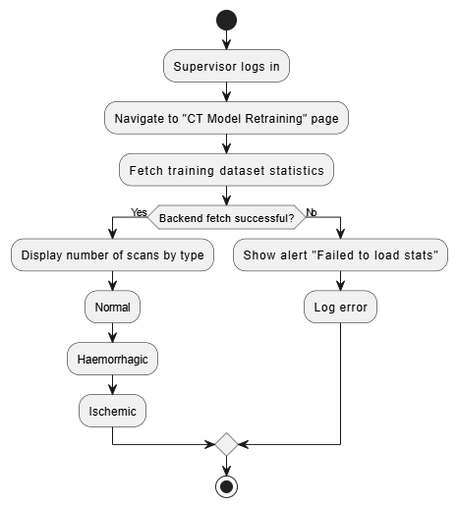

Figure : Activity Diagram 21 – View CT Model Retraining Manager

#### Retraining CT Model

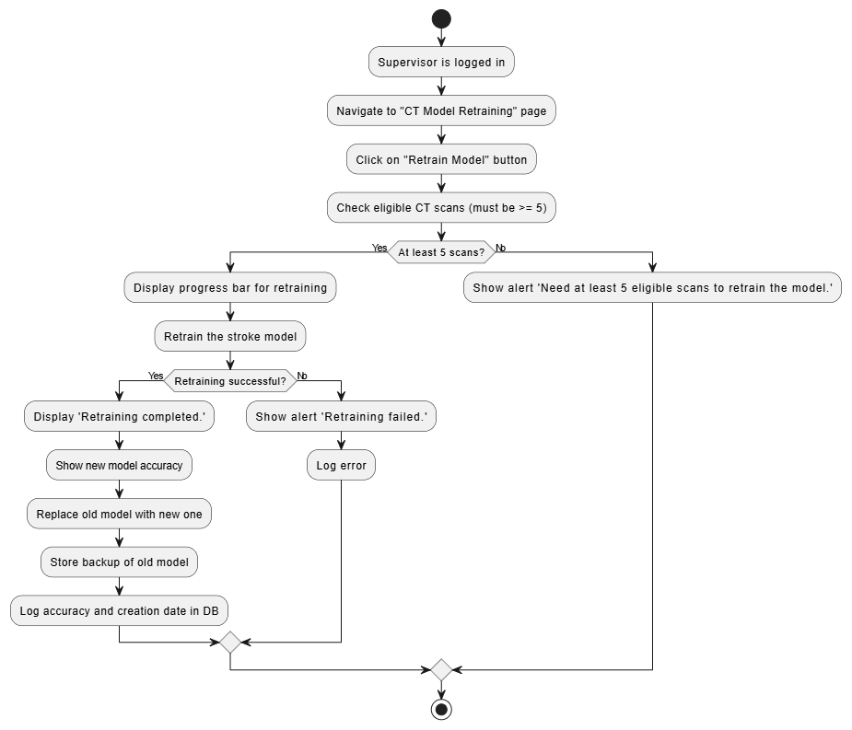

Figure : Activity Diagram 22 - Retraining CT Model

#### View Misclassified Scans

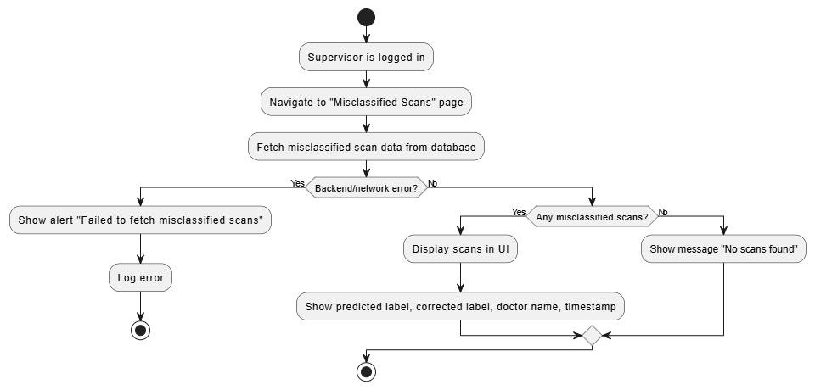

Figure : Activity Diagram 23 – View Misclassified Scans

#### Update Scan Labels

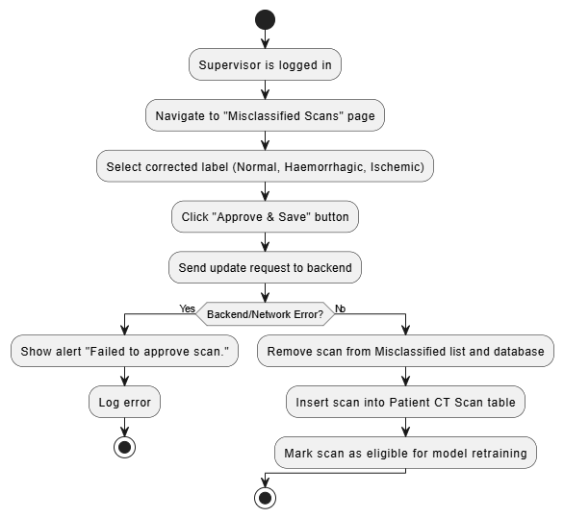

Figure : Activity Diagram 24 – Update Scan Labels

#### Register Patient/Person

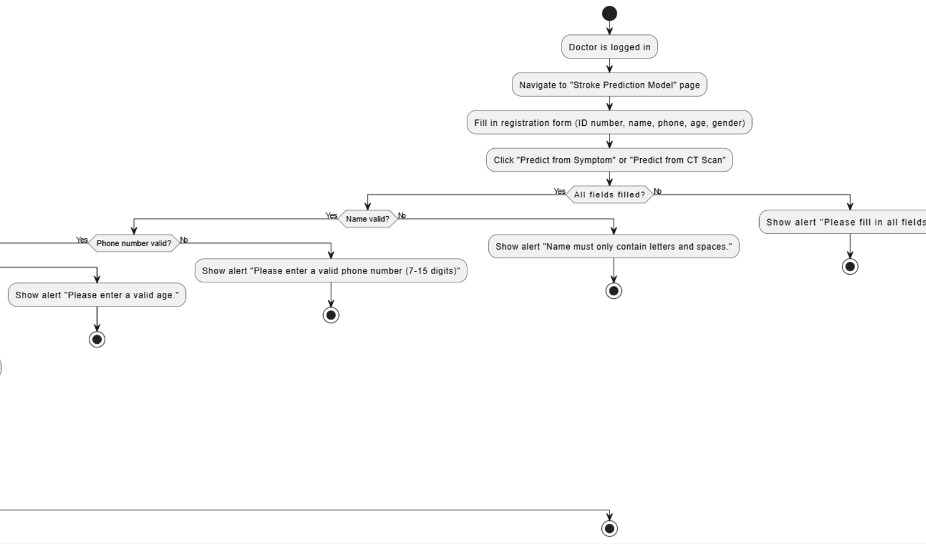

Figure : Activity Diagram 25 – Register Patients/Person 1

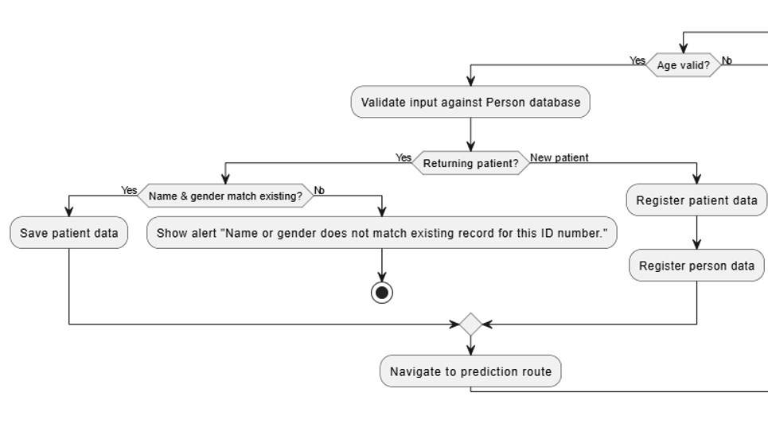

Figure : Activity Diagram 25 - Register Patients/Person 2

#### Register Existing Patient

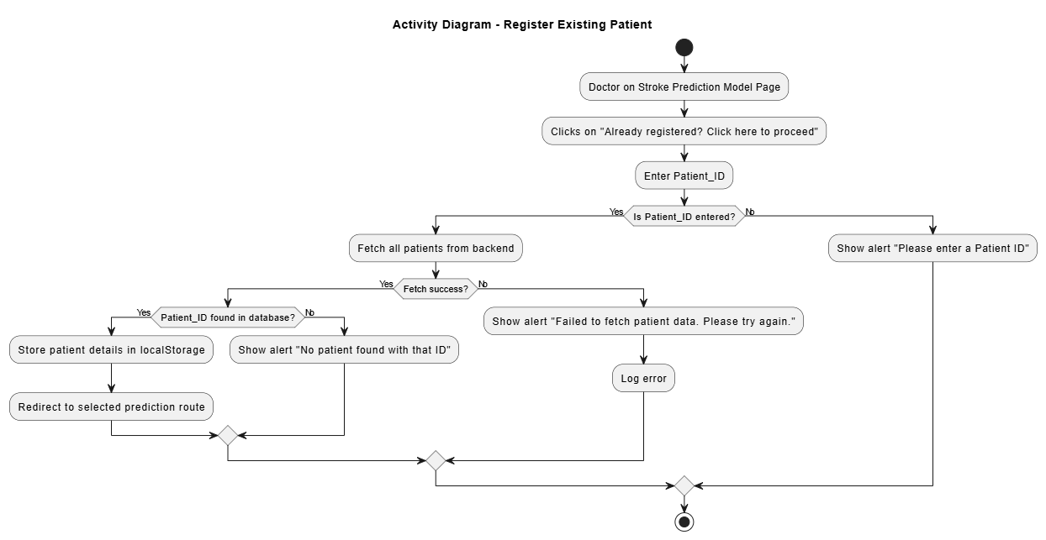

Figure : Activity Diagram 26 – Register Existing Patient

#### Use of Stroke CT Scan Model

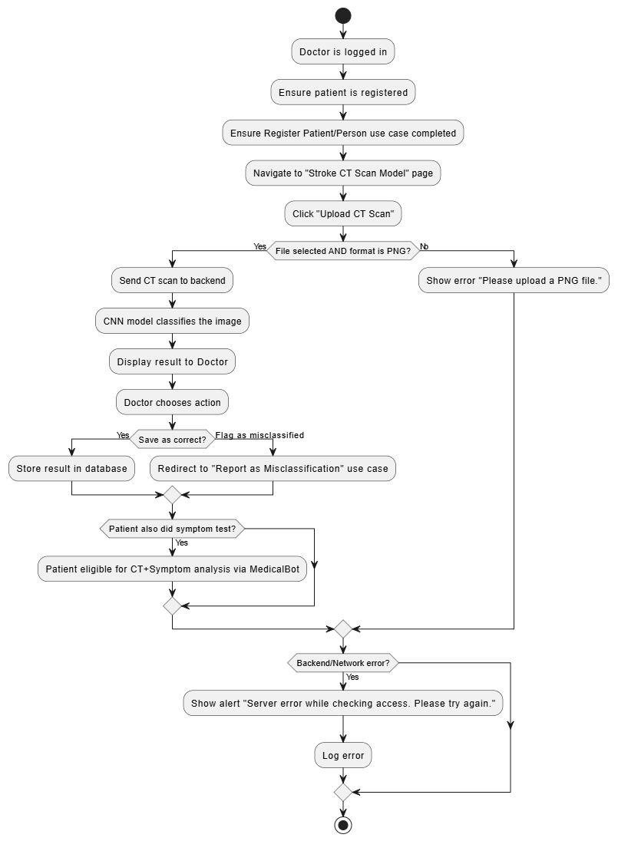

Figure : Activity Diagram 27 – Use of Stroke CT Scan Model

#### Report Misclassification

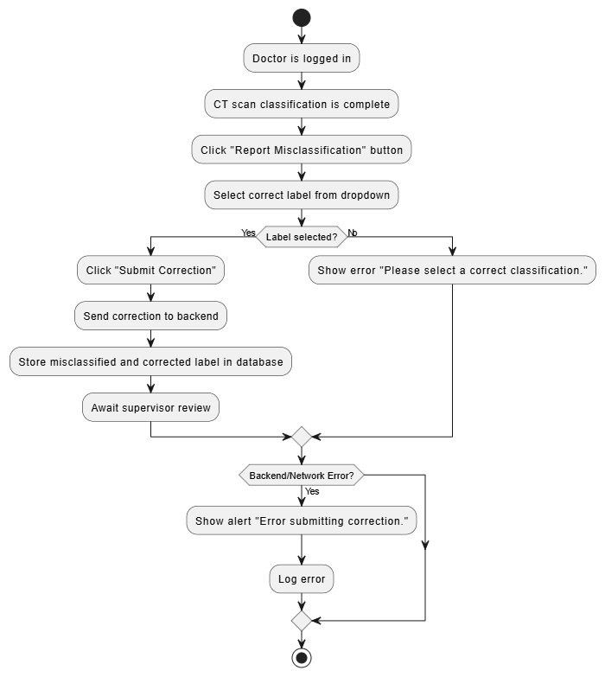

Figure : Activity Diagram 28 – Report Misclassification

#### Use of Stroke Symptom Model

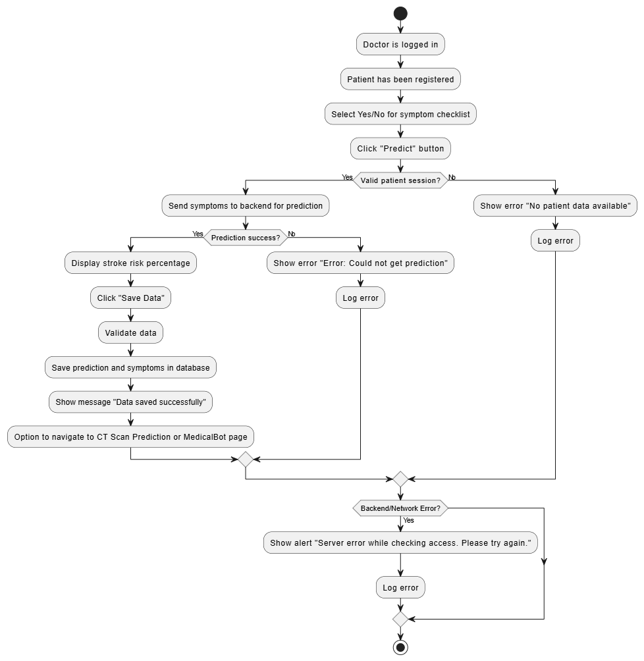

Figure : Activity Diagram 29 – Use of Stroke Symptom Model

#### Use of RAG based Chatbot with Previous Model Data

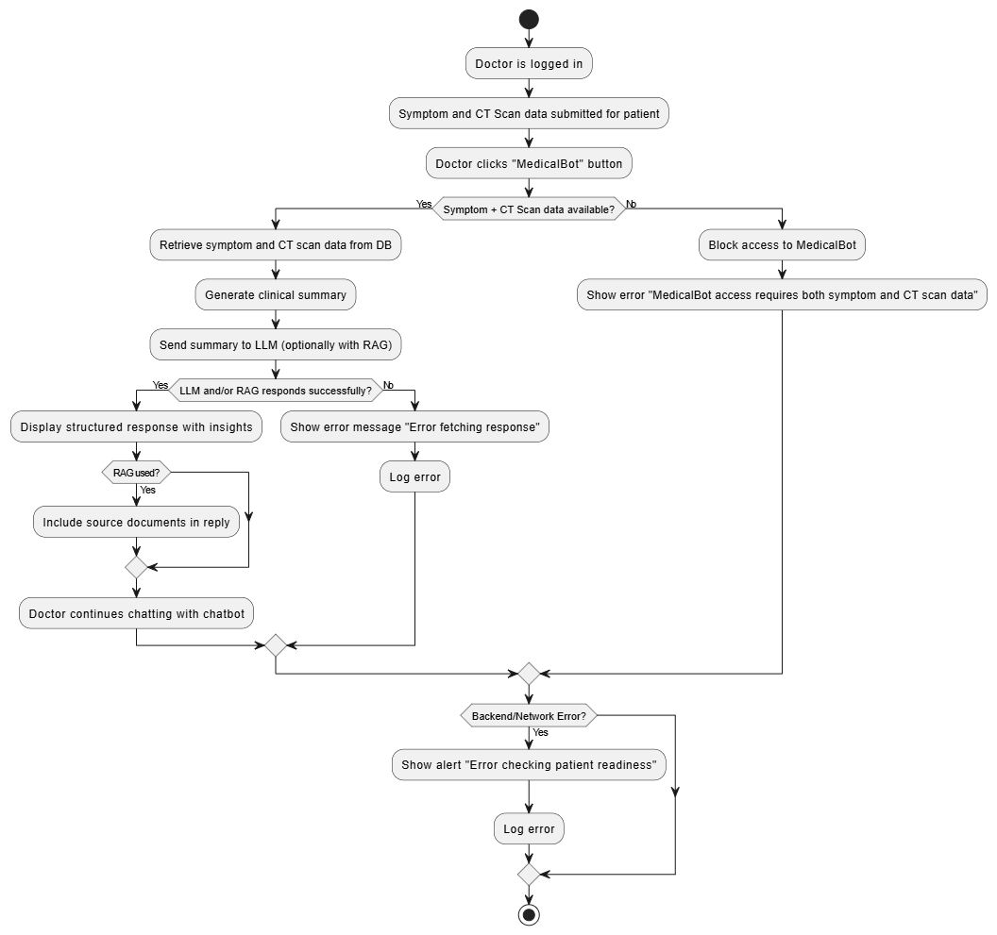

Figure : Activity Diagram 30 – Use of RAG Chatbot with Previous Model Data

#### Logout

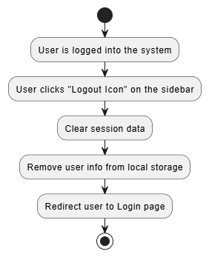

Figure : Activity Diagram 31 – Logout

## Database Design

### Database Overview

The database system that stroke prediction system uses is PostgreSQL. It is an advanced open-source relational database management system (RDBMS). The main reason PostgreSQL was chosen over the other databases is because of its reliability, scalability and the numerous options of dealing with different kinds of queries and relations between tables. One important feature is that due to its open-source nature it allows for easy customizability and integration with other software and applications. This is the main reason why pgvector extension was easy to implement with this database system, which allows for easy implementation of RAG based models.

PostgreSQL acts as the central data source for majority of the input and output of the system. It stores all the patient related information, account information, AI/ML model information as well as other important information related to the system. This is accessed through the help of SQLAlchemy which is a Python ORM (Object Relational Mapper) which acts as a high-level framework for querying, defining and handling the databases via the backend python classes.

One another important feature is the support of the RAG-based MedicalBot in the system using pgvector PostgreSQL extension which is used to store documents information (PDF for this system) and split the information into easy to find chunks for the AI model. This then allows for similarity search of vector embeddings based on user input. This allows for easy connectivity between the vector database and the LLM (Large Language Model) which is used by the chatbot to answer user questions. Other useful features include:

* **User Authentication:** Securely stores user login information such as user roles to direct users to role exclusive pages and manages session details for each user.
* **Management of Patient Information:** Keeps the details of patient information and their medical history (symptoms, stroke predictions and CT scan classifications). In addition, stores some patient details in person table to allow for one person to have multiple patient records based on number of times the person undergoes diagnosis. This allows for easy navigation for past medical history.
* **Model Retraining Loop:** Allows retraining of the CT classification model by which misclassified data are reviewed and corrected to allow for retraining of the model for better accuracy in real-time. In addition, the system stores the older models for backup in case the newer models do not meet the standards. All of the training details and details of the older models are all recorded in the database for easy error handling at the backend.
* **Management of Reports:** Stores reports submitted by users, and displays the reports to the admin users in real time to allow for quick error fixing.

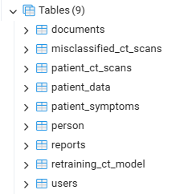

Figure : Tables used for the system as shown in PostgreSQL Admin

### ER Diagram

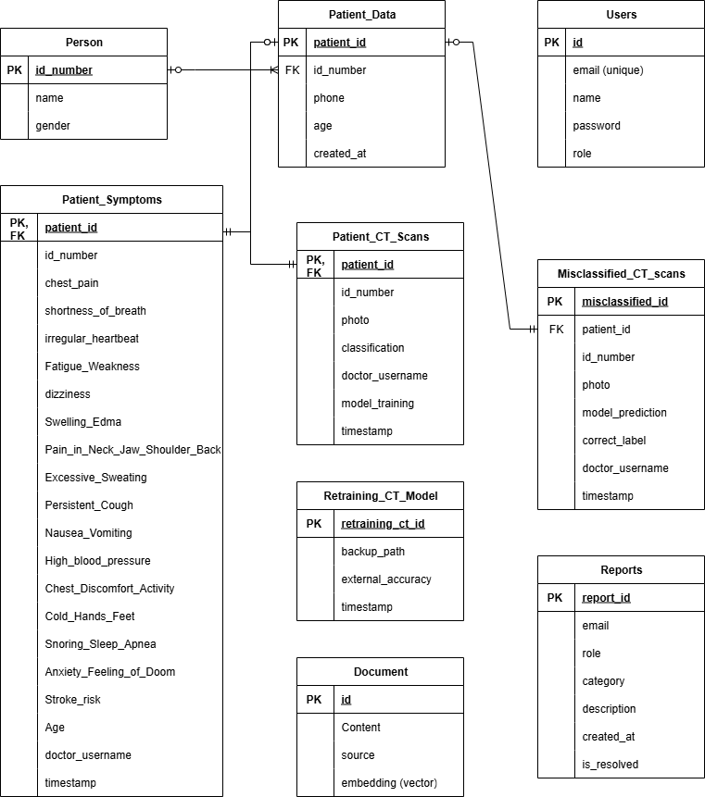

Figure : Database ER Diagram

**Tables**

1. **Users:** Stores credentials and roles of the users
2. **Person:** Contains general information about patients registered in the system
3. **Patient_Data:** Contains patient information for one session
4. **Patient_Symptoms:** Stores symptoms related to the patient as well as their risk percentage
5. **Patient_CT_Scans:** Stores CT scans files and classification of stroke patient has
6. **Misclassified_CT_Scans:** Stores misclassified CT scans and what their actual classification should be
7. **Retraining_CT_model:** Stores information regarding current model accuracy and the location of the previous model backup
8. **Reports:** Stores reported issues by users to be viewed by the admin later in real-time
9. **Documents:** Used by the RAG-based medical chatbot. Vectorizes and stores input documents for semantic search

### Data Dictionary

#### Users Table

|  |  |  |
| --- | --- | --- |
| Field Name | Field Type | Description |
| id | Integer (PK) | Acts as a unique verification for users |
| email | String | Users email address (must be unique in the database) |
| name | String | Name of user |
| password | String | Hashed password of user |
| role | String | Role of the user (Either Admin, Supervisor, or Doctor) |

Table : Data Dictionary 1 – Users Table

#### Person Table

|  |  |  |
| --- | --- | --- |
| Field Name | Field Type | Description |
| id_number | String (PK) | Patient’s national ID/Passport number |
| name | String | Full name of patient |
| gender | String | Gender of patient |

Table : Data Dictionary 2 – Person Table

#### Patient_Data Table

|  |  |  |
| --- | --- | --- |
| Field Name | Field Type | Description |
| Patient_id | String (PK) | Unique verification for patients (PXXXX) |
| id_number | String (FK) | Acts as a foreign key from person.id_number |
| phone | String | Patient’s phone number |
| age | Integer | Age of the patient |
| Created_at | DateTime | Timestamp of registration |

Table : Data Dictionary 3 – Patient_Data Table

#### Patient_Symptoms Table

|  |  |  |
| --- | --- | --- |
| Field Name | Field Type | Description |
| patient_id | String (PK, FK) | Acts as a foreign key from patient_data.patient_id. At the same time acts as the primary key of the table |
| id_number | String | Patient’s national ID/Passport number |
| Chest_pain | Integer | Binary (1/0) indicating if the patient has the symptom or not. |
| Shortness_of_breath | Integer | Binary (1/0) indicating if the patient has the symptom or not. |
| Irregular_heartbeat | Integer | Binary (1/0) indicating if the patient has the symptom or not. |
| Fatigue_Weakness | Integer | Binary (1/0) indicating if the patient has the symptom or not. |
| dizziness | Integer | Binary (1/0) indicating if the patient has the symptom or not. |
| Swelling_Edema | Integer | Binary (1/0) indicating if the patient has the symptom or not. |
| Pain_in_Neck | Integer | Binary (1/0) indicating if the patient has the symptom or not. |
| Excessive_Sweating | Integer | Binary (1/0) indicating if the patient has the symptom or not. |
| Persistent_Cough | Integer | Binary (1/0) indicating if the patient has the symptom or not. |
| Nausea_Vomiting | Integer | Binary (1/0) indicating if the patient has the symptom or not. |
| High_blood_pressure | Integer | Binary (1/0) indicating if the patient has the symptom or not. |
| Chest_Discomfort_Activity | Integer | Binary (1/0) indicating if the patient has the symptom or not. |
| Cold_Hands_Feet | Integer | Binary (1/0) indicating if the patient has the symptom or not. |
| Snoring_Sleep_Apnea | Integer | Binary (1/0) indicating if the patient has the symptom or not. |
| Anxiety_Feeling_of_Doom | Integer | Binary (1/0) indicating if the patient has the symptom or not. |
| Stroke_risk | Integer | Output of stroke risk prediction |
| Age | Integer | Patient’s age |
| Doctor_username | String | Name of the doctor that submitted the data |
| timestamp | DateTime | Time of submission of form |

Table : Data Dictionary 4 – Patient_Symptoms Table

#### Patient_CT_Scans Table

|  |  |  |
| --- | --- | --- |
| Field Name | Field Type | Description |
| patient_id | String (PK, FK) | Acts as a foreign key from patient_data.patient_id. At the same time acts as the primary key of the table |
| id_number | String | Patient’s national ID/Passport number |
| photo | String | Path and name of the patient’s CT scan image |
| classification | String | Model prediction of the CT scan image (either Normal, Ischemic or Hemorrhagic) |
| doctor_username | String | Name of the doctor that submitted the data |
| model_training | String | Indicates if the image was used for retraining (Yes/No) |
| timestamp | DateTime | Time of submission |

Table : Data Dictionary 5 – Patient_CT_Scans Table

#### Misclassified_CT_Scans Table

|  |  |  |
| --- | --- | --- |
| Field Name | Field Type | Description |
| misclassified_id | Integer (PK) | Unique verification for misclassification record |
| patient_id | String (FK) | Foreign key from patient_data.patient_id. |
| id_number | String | Patient’s national ID/Passport number |
| photo | String | Path and name of the misclassified CT scan image |
| model_prediction | String | Incorrect model prediction of the CT scan image |
| correct_label | String | Corrected label given by the doctor |
| doctor_username | String | Name of the doctor that submitted the data |
| timestamp | DateTime | Time of submission |

Table : Data Dictionary 6 – Misclassified_CT_Scans Table

#### Retraining_CT_Model Table

|  |  |  |
| --- | --- | --- |
| Field Name | Field Type | Description |
| retraining_ct_id | String (PK) | Unique verification for retraining model table |
| backup_path | String | Path and name of the backup model |
| external_accuracy | Float | Accuracy of the model tested against an external dataset |
| timestamp | DateTime | Time of retraining the model |

Table : Data Dictionary 7 – Retraining_CT_model Table

#### Reports Table

|  |  |  |
| --- | --- | --- |
| Field Name | Field Type | Description |
| report_id | String (PK) | Unique verification for report table |
| email | String | Email of the reporting user |
| role | String | Role of the reporting user |
| category | String | Type of report (chatbot, other) |
| description | String | Description of the issue |
| created_at | DateTime | The time to create the report |
| is_resolved | Boolean | Status of the report (solved or unsolved) |

Table : Data Dictionary 8 – Reports Table

#### Documents Table

|  |  |  |
| --- | --- | --- |
| Field Name | Field Type | Description |
| id | Integer (PK) | Unique verification for document table |
| content | String | Text chunk taken form the document |
| source | String | Name of the document |
| embedding | Vector(384) | Vector representation of content using pgvector |

Table : Data Dictionary 9 – Document Table

## Interface Design

### Menu Design

The system implements a role-based sidebar navigation menu to give users their own menu based on their assigned roles of either Admin, Supervisor or Doctor. The sidebar menu acts as a permanent left side container that appears throughout all the pages and acts as the main way users can navigate through the many pages in the system. All the layouts are named differently in the backend to allow customization of the specific sidebar to only show relevant menu items that are used for each role. The sidebars are named AdminLayout, SupervisorLayout and DoctorLayout in the backend.

The footer section of the sidebar menu also has an option of icons that redirect users to specific pages in the system that is more based on general or extra functions rather than specifically based on the main role functions of the predicting stroke. These include a robot icon for access to the medical chatbot directly, gear icon for changing profile settings, exclamation icon for submission of error/bug reports (not included in Admin), and sign out icon for logging out of the system. This structure not only eliminated clutter in the UI of the system but also provides a visually ordered structure for ease of interaction for the users.

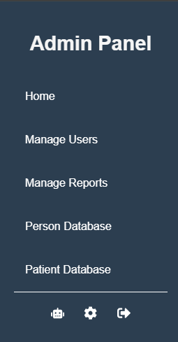

Figure : Admin Panel Design

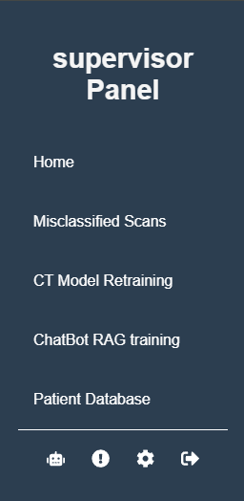

Figure : Supervisor Panel Design

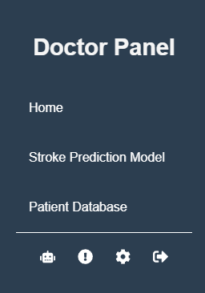

Figure : Doctor Panel Design

### System Page Navigation

Admin Navigation

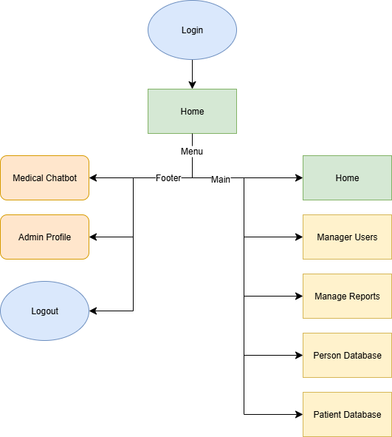

Figure : Admin Page Navigation Diagram

Supervisor Navigation

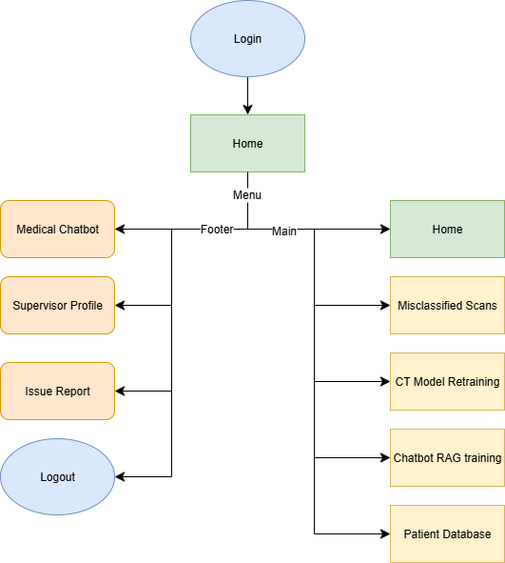

Figure : Supervisor Page Navigation Diagram

Doctor Navigation

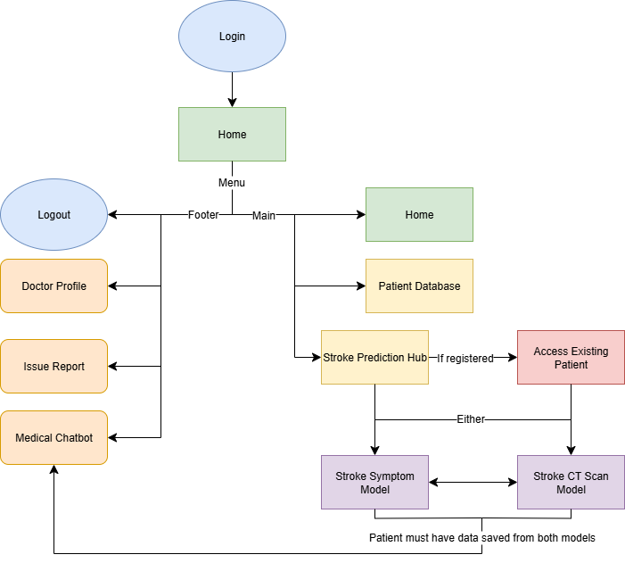

Figure : Doctor Page Navigation Diagram

## Implementation

### Frontend Functions

#### Login Page (All)

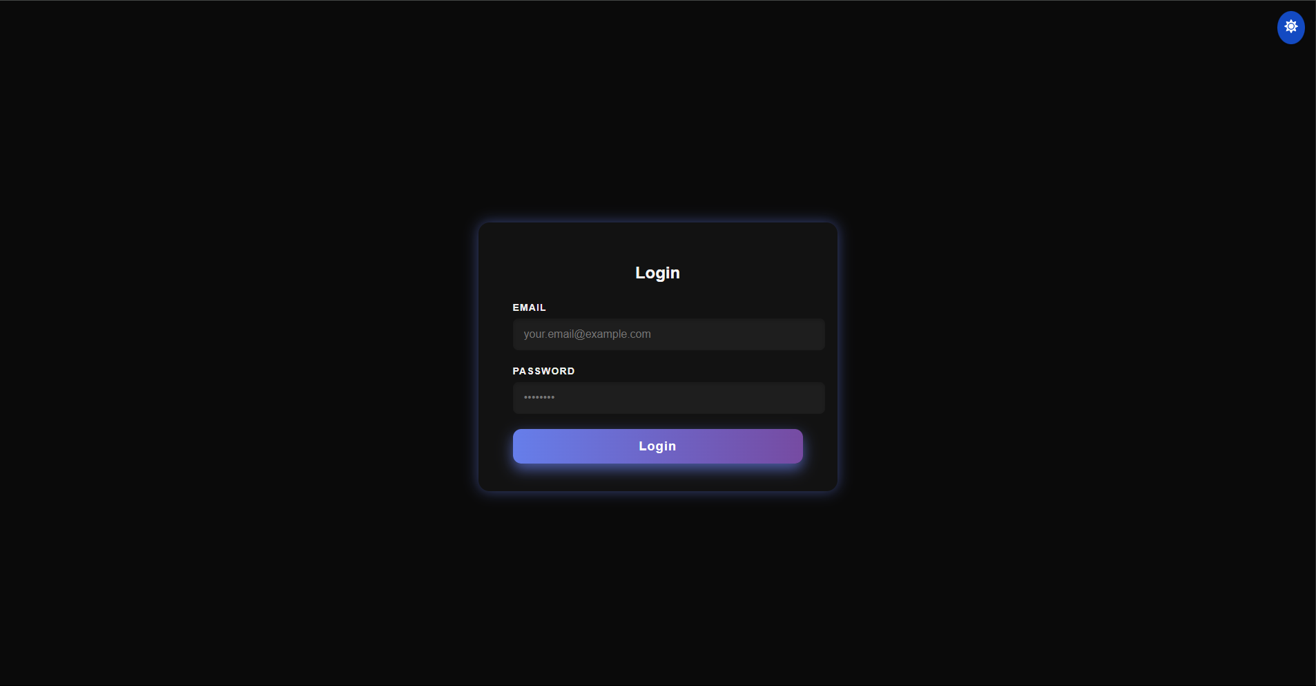

Figure : Login Page Dark Mode

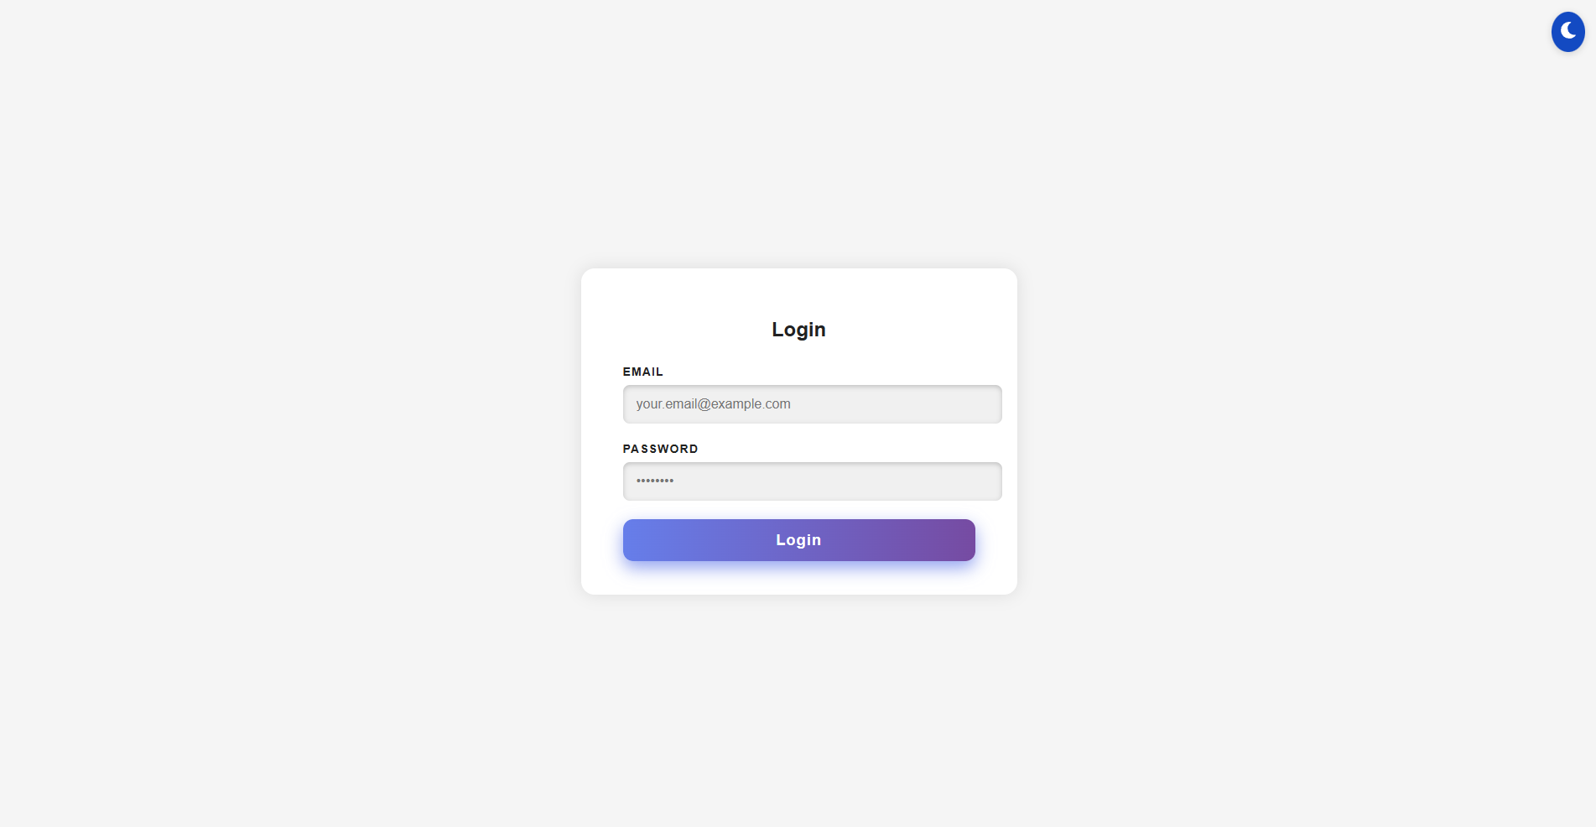

Figure : Login Page Light Mode

Login Page acts as the first page users see when they launch the system and it acts as a gateway into the system by creating the same entry point to all the users that would diverge depending on their user role when the login is successful. Users must enter their password and email on this page, which is crosschecked by the system to authenticate their identity. After successfully logging in and verifying the user role, the system then redirects them to their homepage using useNavigate method from the React Router.

The interface used for Login Page remains simplistic with only a textbox for email and password available with placeholder texts. If the user does not complete the form and submits the system will alert the user with an error message “Please fill in both fields”. After authentication of the user the system stores the username and email in localStorage so it can be used in other pages and functions in the system.

The Login page similar to all the other pages contain a “sun” or “moon” icon which users can click to toggle dark or light mode on. This changes colours and contrast of the UI into two different modes which users can actively turn on and off in real-time based on their preferences. For most of this documentation dark mode would be used as an example.

#### Home Page (All)

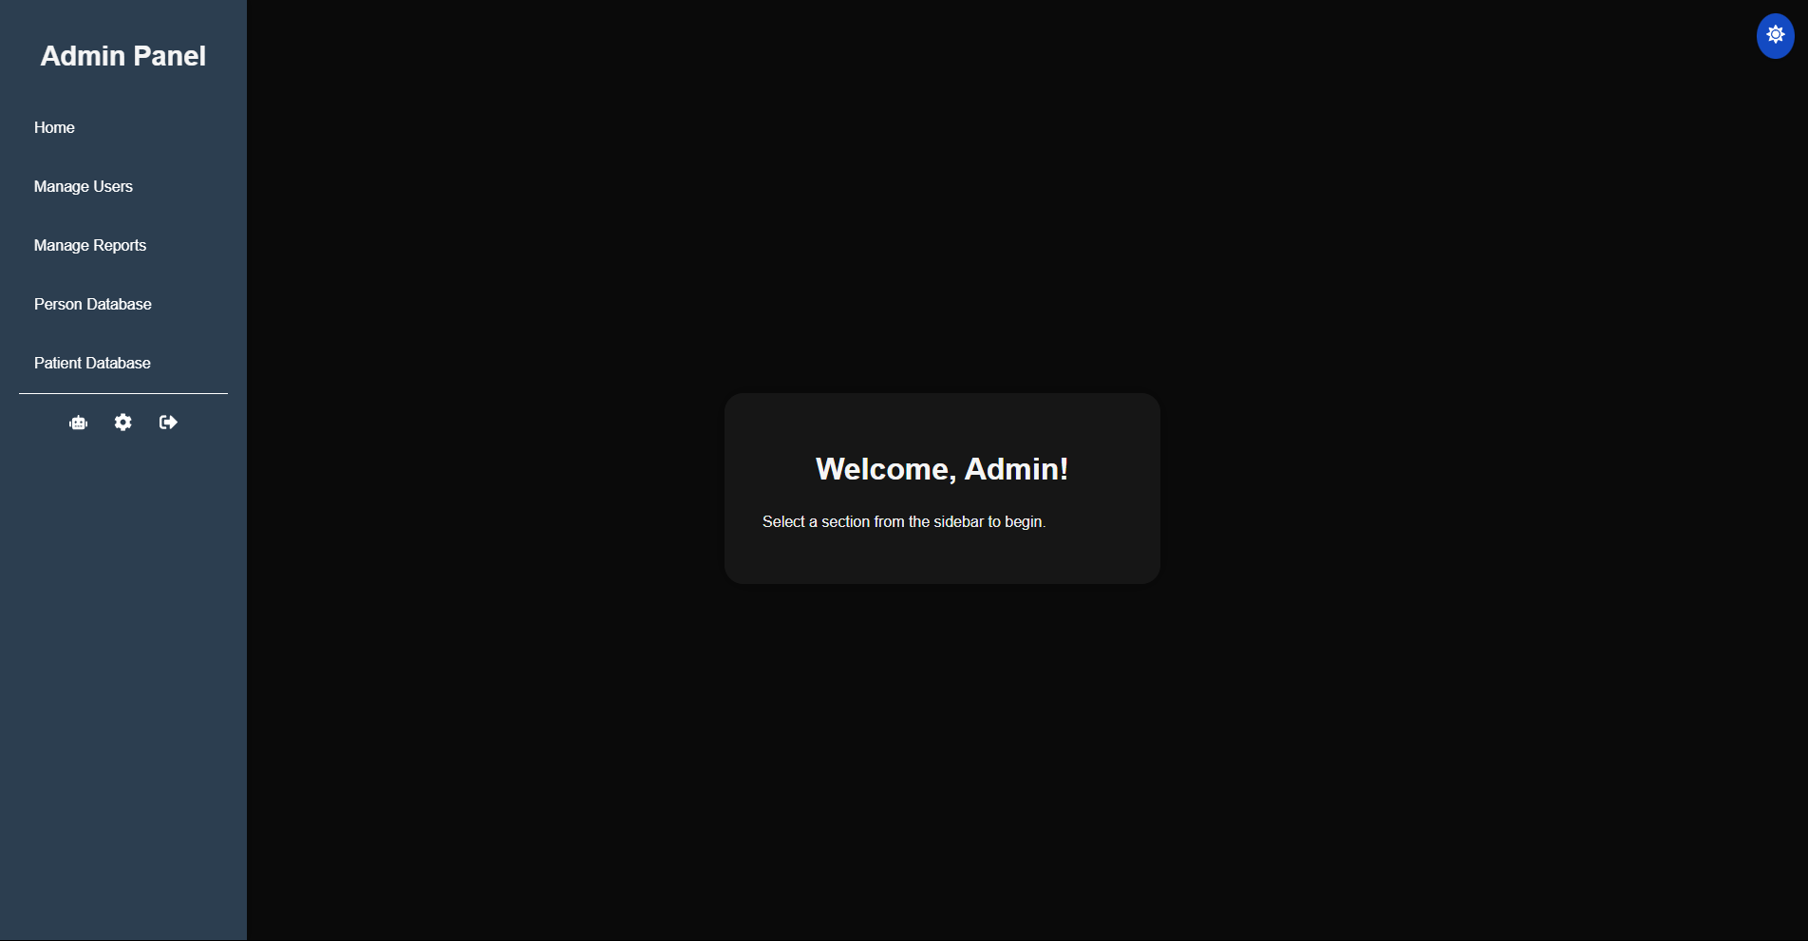

Figure : Admin Home Page

After a successful login users are redirected to their Home Page. It provides users with a personalized welcome message using the username retrieved from localStorage mentioned before during login. Each role would have a different sidebar menu for their home page which will be permanently carried with them for each page, allowing easy navigation of the various pages in the system. The user interactivity of the page is not complicated but it does bring visibility and simplicity to allow users easy access to other important parts of the system.

#### Chatbot Page (All)

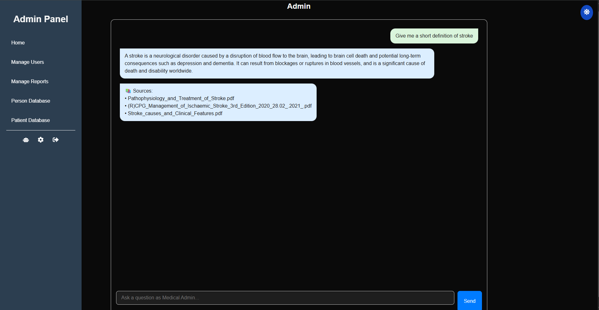

Figure : Chatbot Page Simple Question

The Chatbot page acts as the main UI for interacting with the RAG-based LLM medical chatbot locally embedded in the system. It acts as a smart assistant available to all user roles and offers real-time chat features which it is able to respond to users on queries related to medical questions. In addition to this, due to the RAG features of the chatbot it will respond to users on document information it has been provided through the Chatbot RAG Training Page. The chatbot will also display the source reference of the document it got the answer from, providing clarity and transparency to users. The UI is designed in a way to make it similar to other popular chatbot systems to give users an easier understanding of how the chatbot would work.

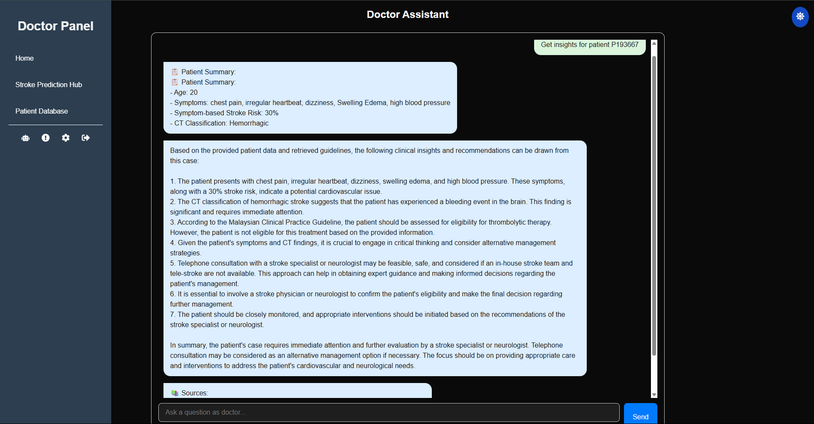

Figure : Chatbot Page with Clinical Insight Function

One other important function of the Chatbot Page is the automatic response related to its Clincial Insight function. After patient data is taken from both the symptom prediction model and the CT scan model Doctor users can automatically send all the information as a patient summary to the system with a press of a button to trigger this function which uses a custom prompt to give a response in regard to the patient summary given. This will redirect the Doctor user back to the main chatbot page with details about the patient and will generate an answer. The answer will depend on the documents provided to the chatbot during RAG training and will also provide the source references of the documents used to generate the answer. This can help Doctors gain a quick analysis of the severity of patient’s condition and some quick actions they can take which is essential during stroke cases.

#### Profile Settings Page (All)

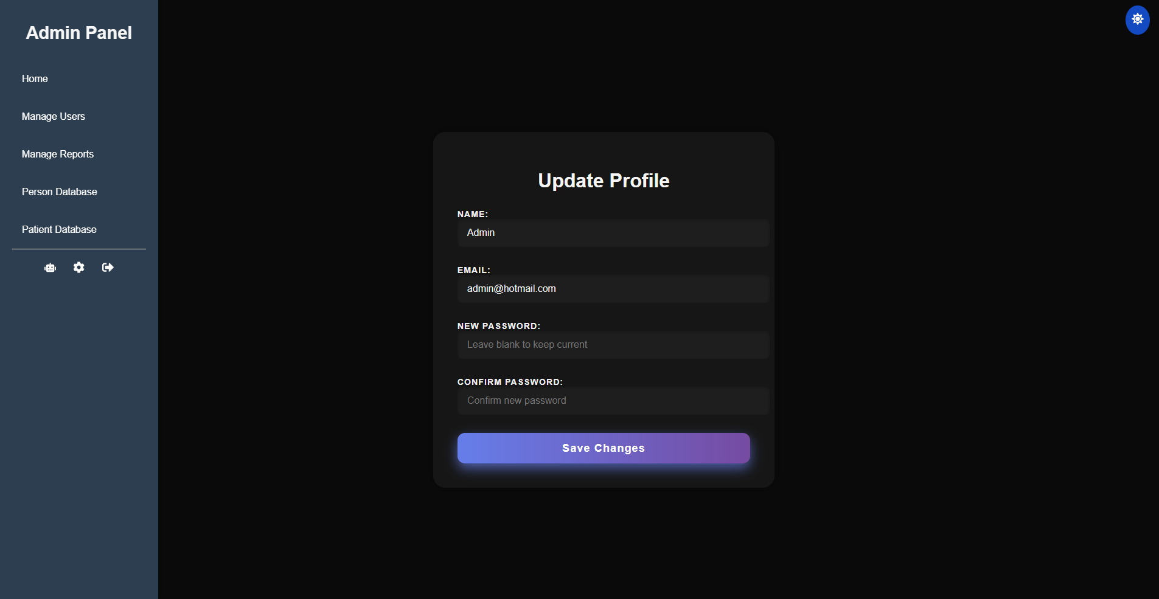

Figure : Profile Setting Page

Profile Setting Page is another component that is available to all users. This page allows users to update and manage their profile related information securely. The Update Profile Form is automatically filled with the user’s name and email address when the user enters the page. This user information is taken from the localStorage when the page is loaded allowing confirmation of user data stored in the database. The email address field is made read only and cannot be altered by the user as it is used as a unique identifier for the user when they log into the system

Unlike email address users have an option to change their name and password. If the user wants to change their password, they must confirm their password in a different textbox to ensure no mistake is made when the password is entered, as all passwords in the system are hashed for extra security. After submission of the form through the “Save Changes” button, if successful the system changes the information in the database as well as the current information in the localStorage ensuring real-time consistency of the system.

#### Patient Database Page (All)

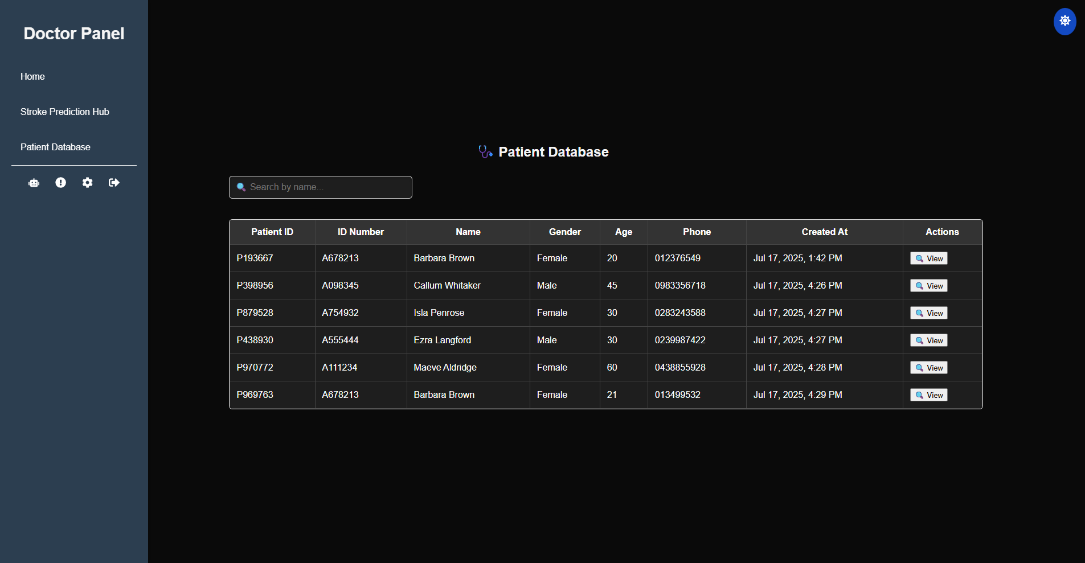

Figure : Patient Database Page

The Patient Database Page is of the main components of the system available to all users, although there will be a slight difference between the Admin version compared to the Supervisor and Doctor version. The page showcases a complete overview of the patients registered in the system. In addition to this, users can also search for patients by entering their name, and check for additional information about the patient’s medical history by clicking on the “View” button.

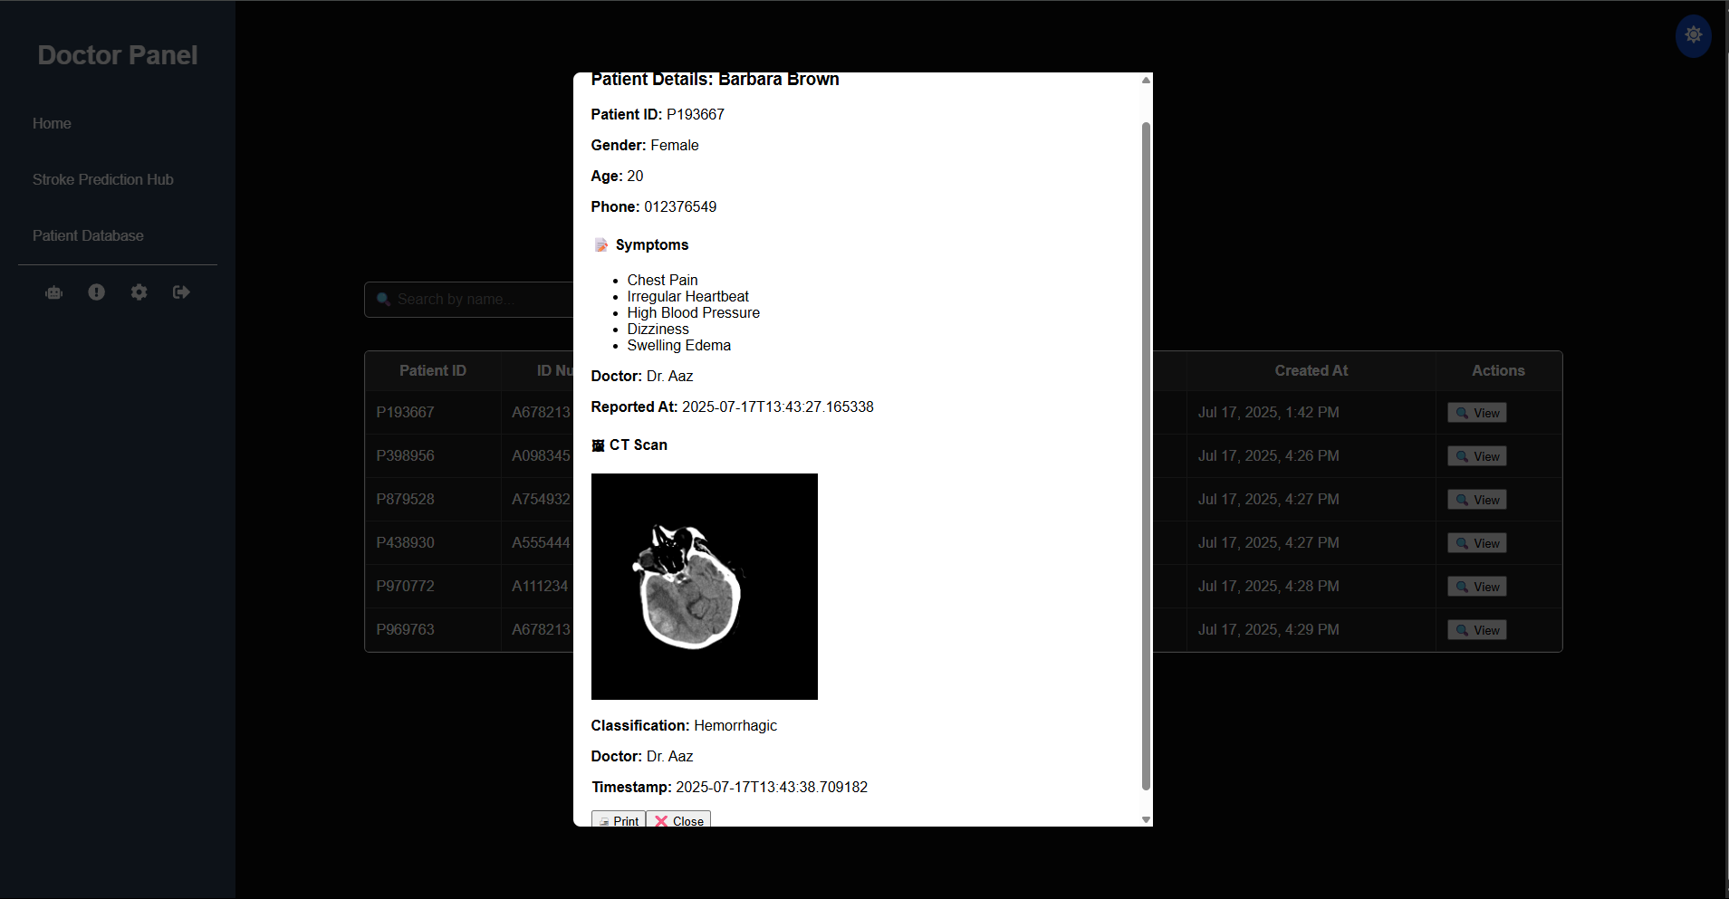

Figure : Patient Database Page Modal Function

When the “View” button is clicked the system will fetch patient medical history from the database based on previously submitted data from other prediction and classification models such as symptom records and CT scan data. All the data will be shown in a modal popup arranged cleanly with the name of the attending doctor and the timestamp of when the data was entered into the database. The modal popup will also have an embedded print capability which enables the user to print the modal popup, without the “Print” or “Close” buttons for later physical reference.

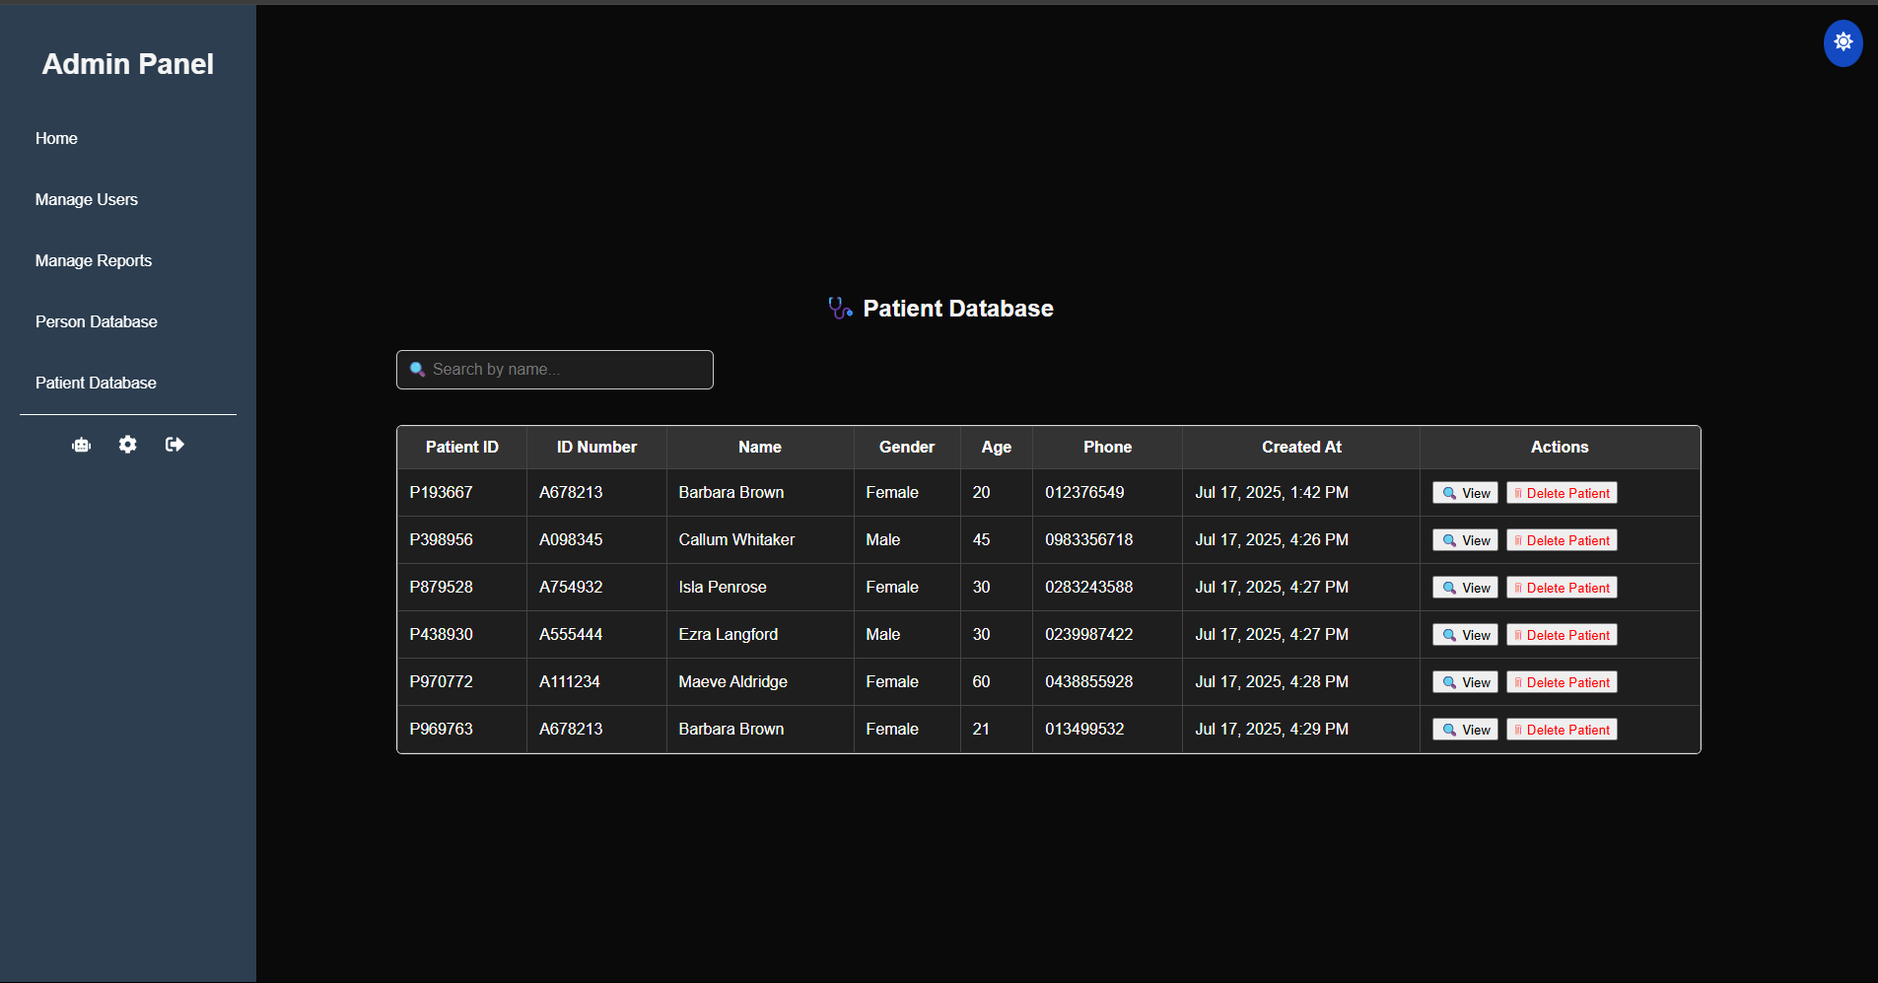

Figure : Patient Database Page for Admin

For Admin users there would be an extra feature added to allow for admins to delete patient records by pressing the “Delete Patient” button. This will completely remove the patient records including past medical records such as the results from symptom model and CT scan model for that session under the same Patient ID. This page is an essential part of the system for managing patient data and for finding patterns with patient medical history for future stroke-based research.

#### Person Database Page (Admin)

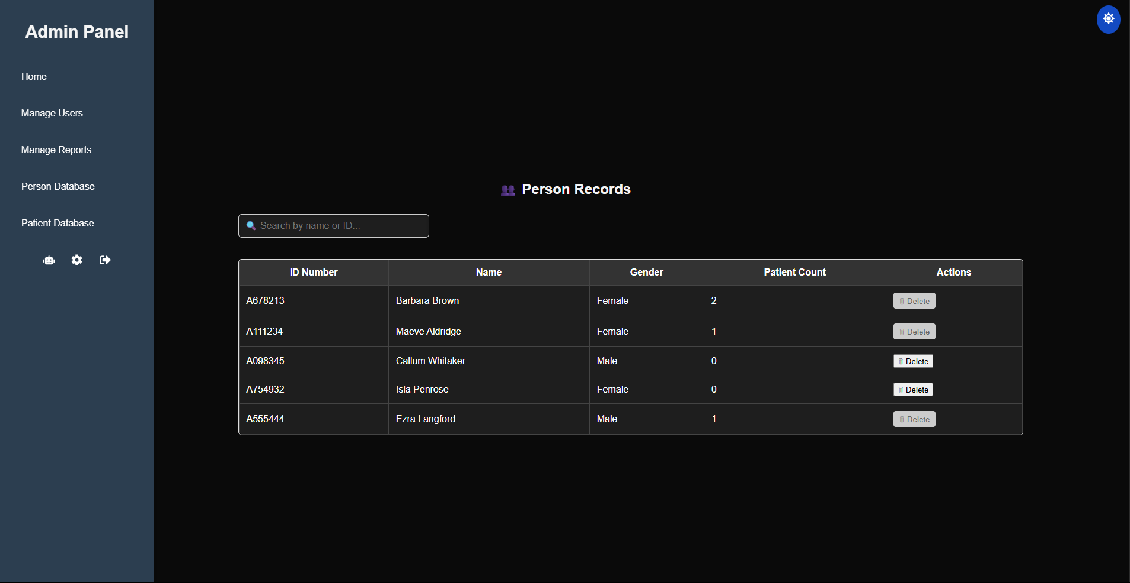

Figure : Person Database Page

Person Database Page is an Admin exclusive page designed for managing person details, which are an extension of patient details. One person can have multiple patient records as patient records are linked to one doctor consultation. This interface is necessary for checking and organizing past medical records for each individual registered in the system. Similar to Patient Database the Person Database Page also provides similar search functions for easy filtering of records.

Another important feature of Person Database is the delete function through the “Delete” button which allows Admins to delete a registered individual in the database if the person does not have any patient records attached to the Person record through the ID Number. The delete button is left disabled and lightly shaded if the patient record is more than zero to ensure all data for the individual is not deleted all at once. The Admin first must delete all Patient Data records in the Patient Database in order to complete the function. This is a security measure to make sure any accidental deletion is prevented.

#### Manage Reports Page (Admin)

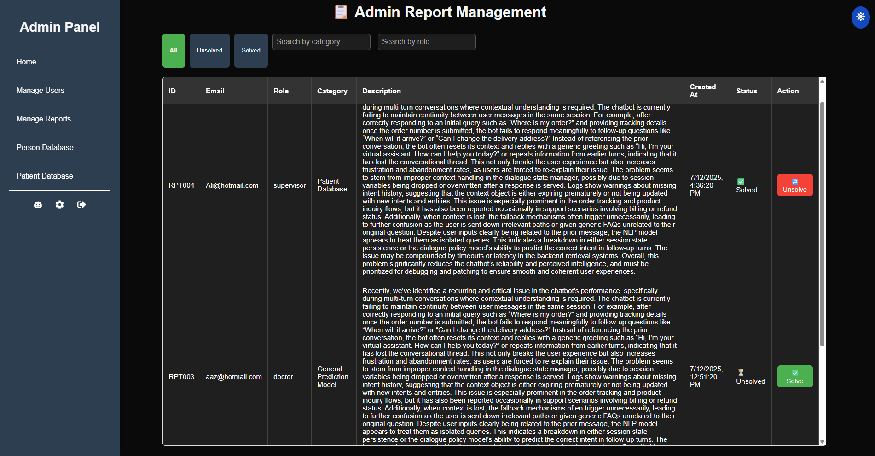

Figure : Manage Reports Page

Manage Report Page is also an Admin exclusive page where users can manage, filter and take action for submitted reports by Supervisors and Doctors. Implementing this into the system will help in making it easier and faster to maintain the system as well as recording earlier issues faced by users interacting with the system. The page also contains dynamic filtering, allowing users to filter based on status of the report, category and role of the report.

Each individual report row under “Action” category has an option to toggle “Solve” or “Unsolve” depending on the status of the report. After the status has been changed the system instantly updates the report in real-time to declare if the issue has been solved or not.

#### Manage Users Page (Admin)

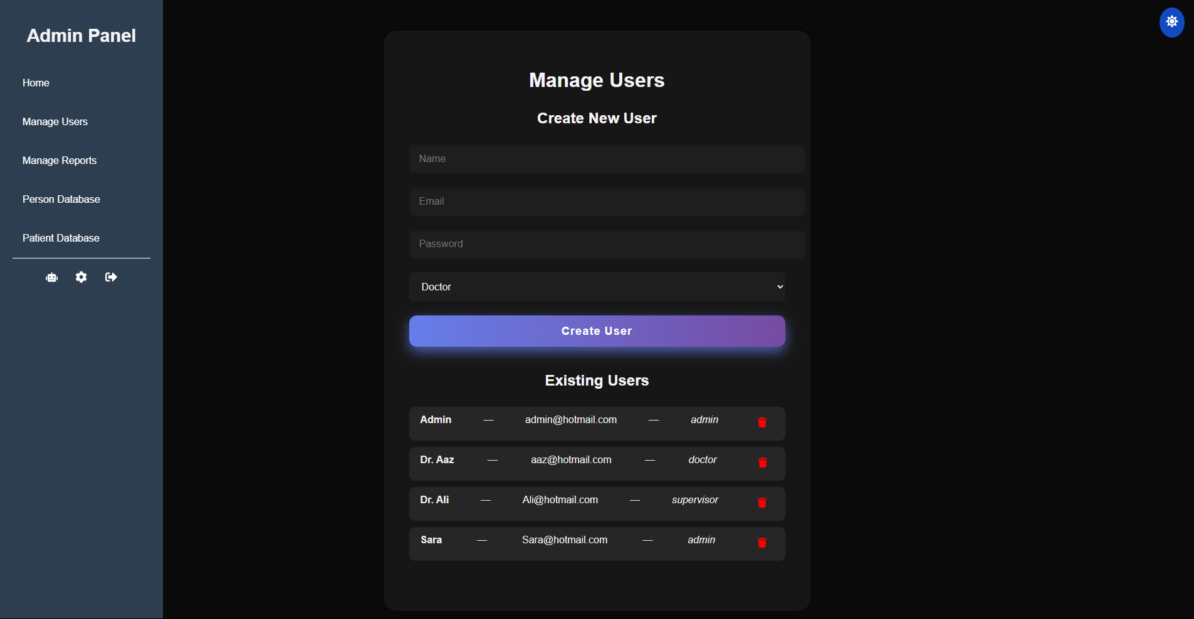

Figure : Manage Users Page

The Manage Users Page is another Admin exclusive page that enables the user to manage existing users as well as register new users into the system. This is an essential part of all systems that use multiple users and roles. It helps to manage user restrictions and access as well as prevent unauthorized users from getting access to the system. The page also includes a delete icon which can be used to delete users no longer using the system. The system will prompt the user to prevent accidental deletion of users and will update the list in real time for both registration and deletion of users.

The top side of the page acts as a registration form to enter new users. The form includes essential user information such as name, email address, password and role selected for the specific user. Numerous input validations are also present preventing accidental entries such as not having “@” symbol in the email and having less than six characters in the password for additional security measures. When the form is submitted password will be hashed and the registered user can change their password through the profile setting page later.

#### Issue Reporting Page (Supervisor and Doctor)

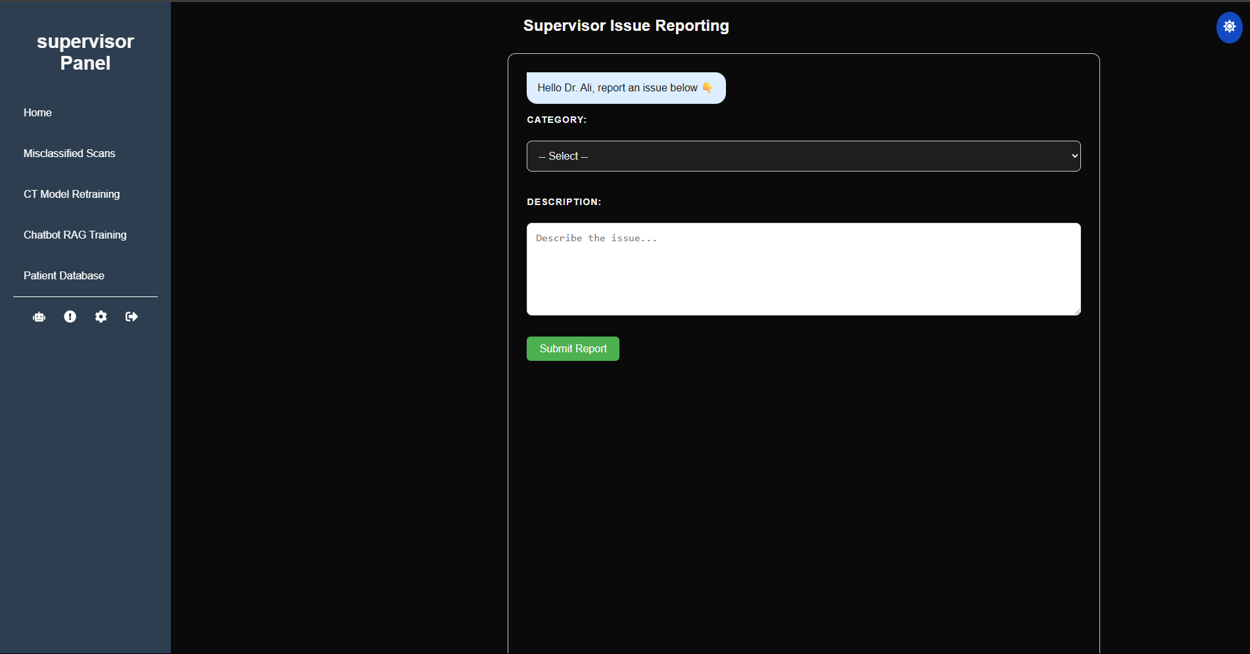

Figure : Issue Reporting Page

The Issue Reporting Page is a Supervisor and Doctor exclusive page that is used for reporting issues or suggestions which are related to the system. The page allows communication to Admin users through the system to enable faster reporting of data and storing of system issues for future reference. The same UI is displayed for both Supervisor and Doctor but the components for the category drop down list changes dynamically depending on the user role. Supervisor would for example have categories related to its exclusive functions such as CT Model Retraining and Misclassified Scans, which the Doctor would not have on its list. The overall use of this page is to allow easier collaboration between the medical staff and the administrative staff.

#### Misclassified Scans Page (Supervisor)

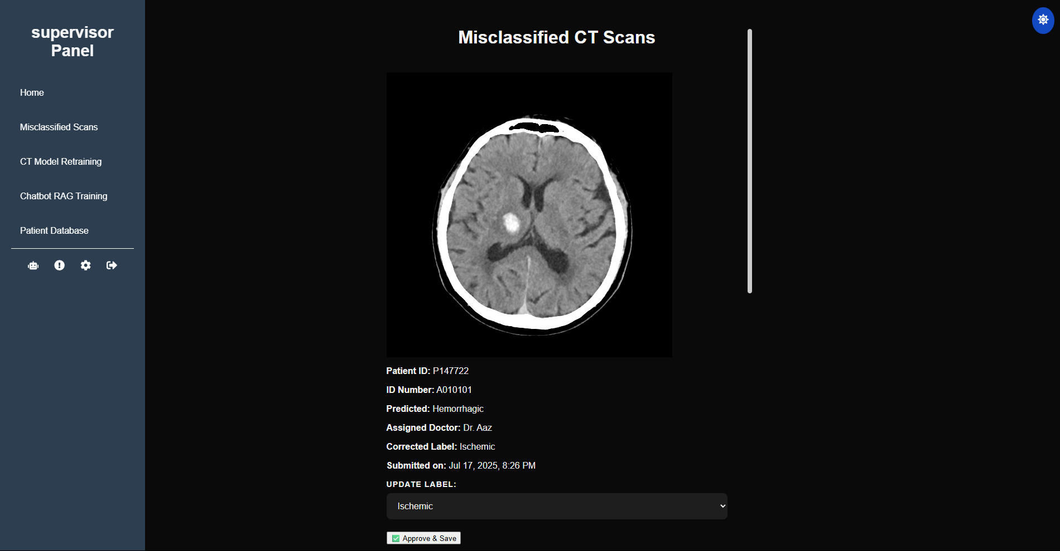

Figure : Misclassified Scans Page

The Misclassified Scans Page is an exclusive page for Supervisor that aids Supervisors on reviewing CT scan predictions that have been flagged as misclassified by Doctor users. This page plays a vital role for correcting crucial medical data as well as for later model retraining. The retuned data includes critical information such as the doctor responsible for flagging the predicted classification, the predicted label by the CT Scan model and the Corrected label from the doctor arranged in a card-style layout for easier navigation and interface.

The Supervisor can confirm the corrected label or choose another label from the drop-down list (Normal, Ischemic and Hemorrhagic) and can confirm the changes by clicking on “Approve & Save” button. If the save is successful the record is removed from the database, which in turn removes the record from the page in real-time as well. The record will then be transferred to the Patient CT Scan table where rightly classified records go towards after model prediction. This will then allow the Supervisor to retrain the model with the same records applying a cycle of supervised learning to the model which prevents such misclassifications in the future.

#### CT Model Retraining Page (Supervisor)

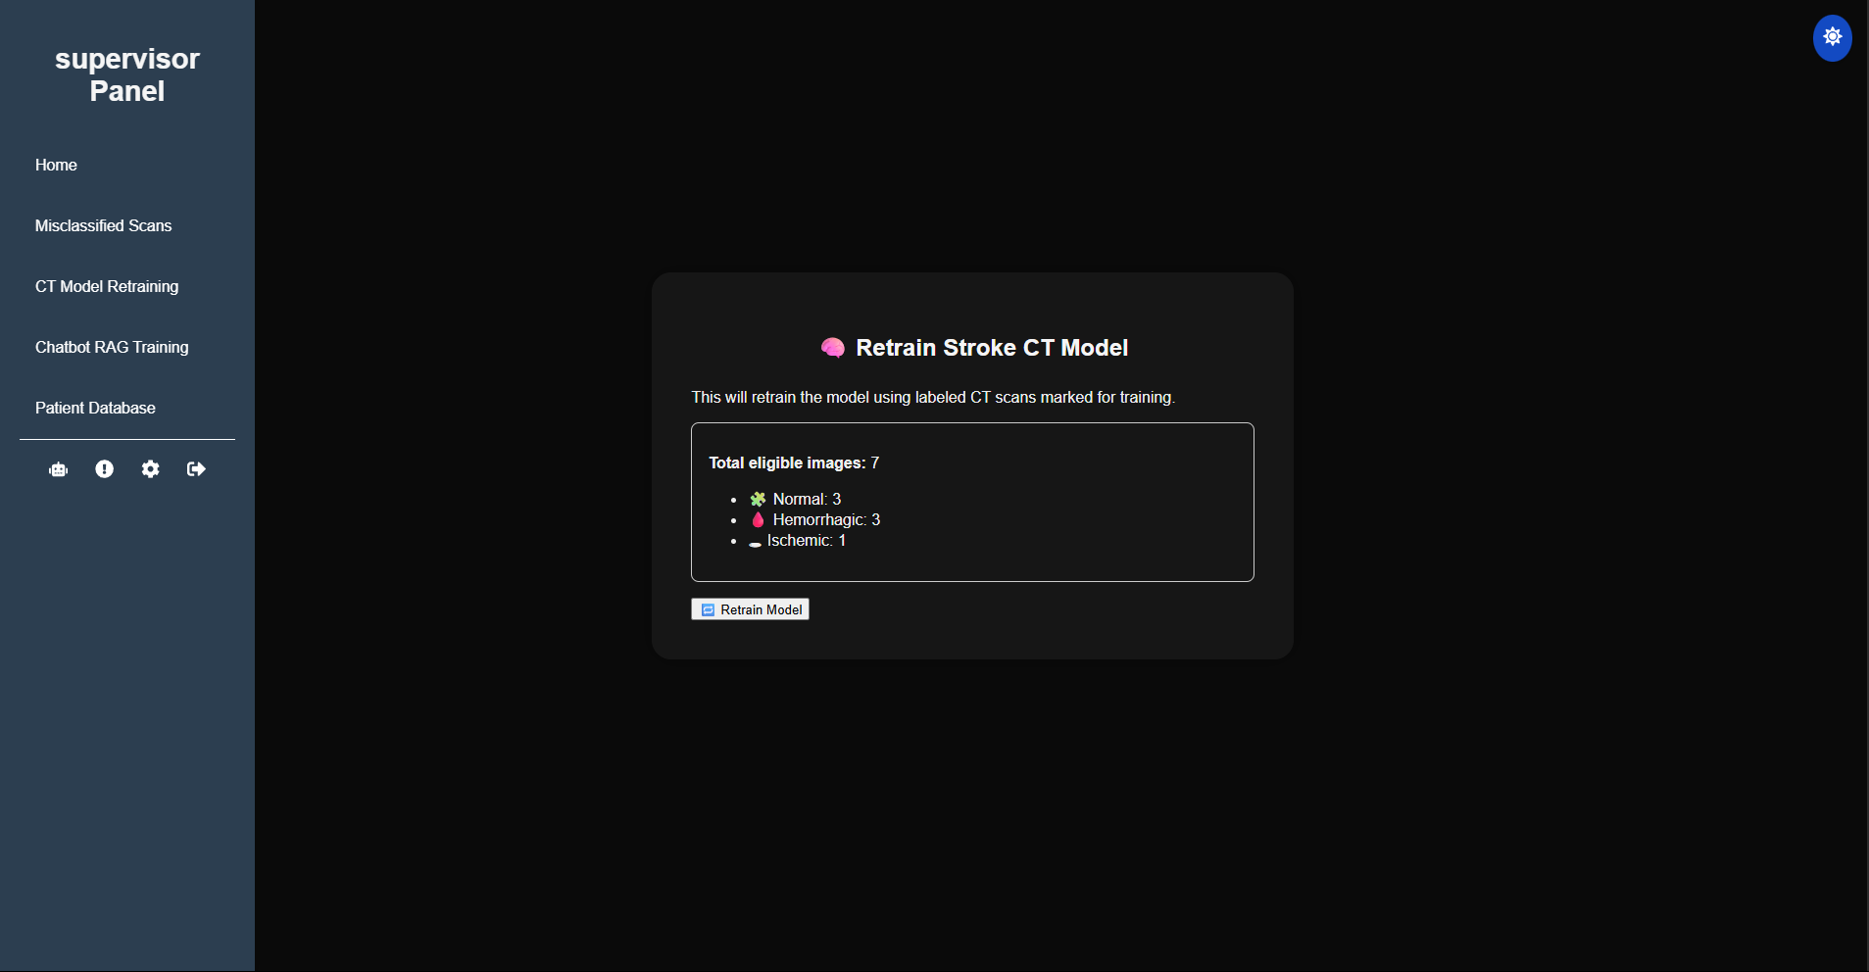

Figure : CT Model Retraining Page

The CT Model Retraining Page is another page exclusive to the Supervisor, which allows the Supervisor to start retraining the CT Scan Stroke Model with newly labeled and validated CT scan images from patients that underwent classification from the CT Scan Model. This would allow the model to have better accuracy against future scans as well as for anomaly scans that were not related to their initial training dataset, which would greatly reduce misclassification of the model.

The UI of the page would show the total number of eligible CT Scan images and breakdown the various images into the labels it was assigned to, to ensure transparency to the user on what type of data the model will be trained on. The number of eligible images must be above 5 (or the amount in the backend) for the system to start the retraining process or else the system would block the process and display an error message. This is used to prevent retraining on a smaller dataset to ensure better accuracy.

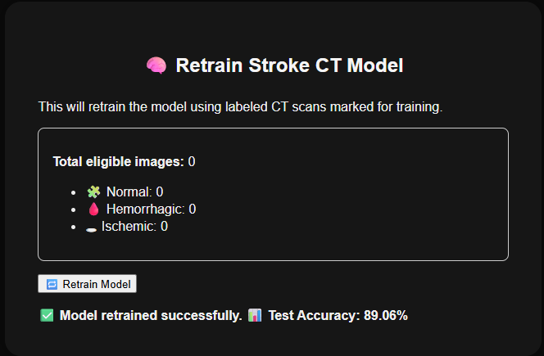

Figure : CT Model Retraining Page After Retraining

When the user clicks on the “Retrain Model” button a progress bar would appear showing the progress of the retraining process. After the training is completed, statistics are displayed as test accuracy % and the previous model is saved in the system as backup.

#### Chatbot RAG Training Page (Supervisor)

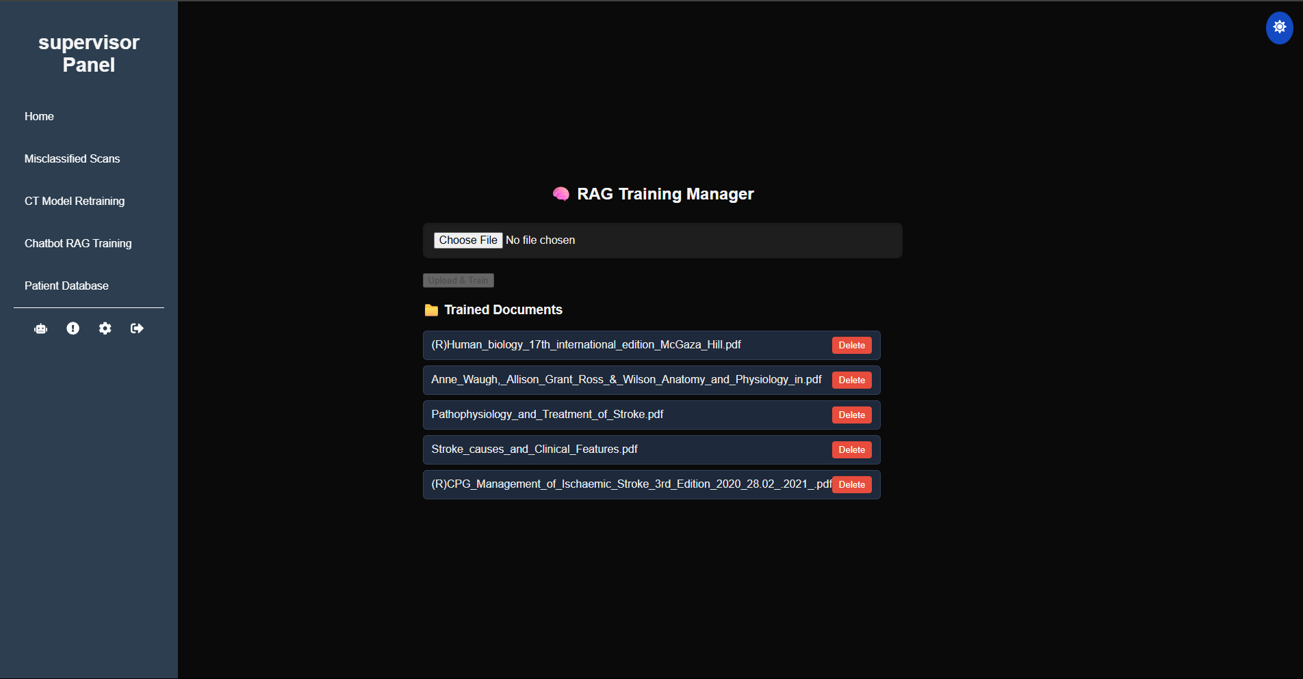

Figure : Chatbot RAG Training Page

The Chatbot RAG Training Page is another Supervisor exclusive page that uses a user-friendly interface to allow handling of documents that are used to train the knowledge base of the chatbot. This would greatly expand the chatbot’s ability to answer user questions based on the domain of the document submitted and increase user transparency due to chatbot answering while referencing the uploaded documents.

The main components of the page include an option for users to upload document files as PDF for RAG training. The system would prevent any duplicate files from being trained to avoid one document data from overfitting the database with repeated data. The page also displays documents currently in the database as well as an option to delete these from the database by pressing the “Delete” button which completely deletes any chunks under the name of the document and updating the document list UI in real-time.

#### Stroke Prediction Hub Page (Doctor)

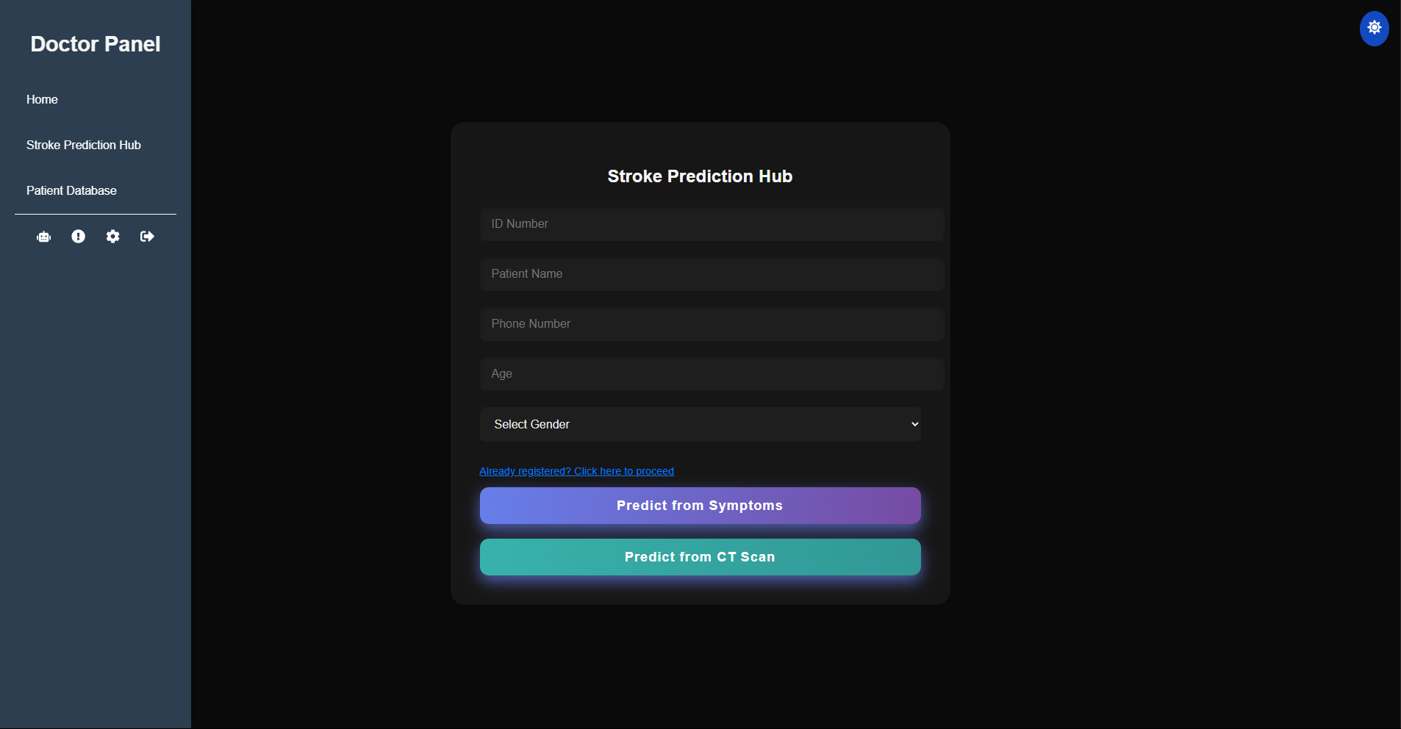

Figure : Stroke Prediction Hub

The Stroke Prediction Hub is a Doctor exclusive page that acts as a gateway toward the main prediction models in the system. The page is used for getting key patient data and redirecting the user to the correct prediction page after successfully registering the user. The system uses real-time validation to ensure the registration fields contain valid input such as ensuring names are alphabetic only and ensuring phone numbers use only numbers. These validity checks prevent accidental submission errors.

If the patient is a returning patient from a previous session, the system would cross check their ID Number, Name and gender to check if it matches the data available in the system database and presents an error if there is a mismatch to further prevent accidental submission errors. In addition to this, if the patient has never been registered in the system, upon successful registration the key user data mentioned before is saved in the system database as new Person data to validate the user on future check-ups. If Doctor wants to skip user registration for accessing the prediction model for registered patients in current sessions, they can click on the “Already Registered” hyperlink to access the “Existing Patient Page”.

#### Access Existing Patient Page (Doctor)

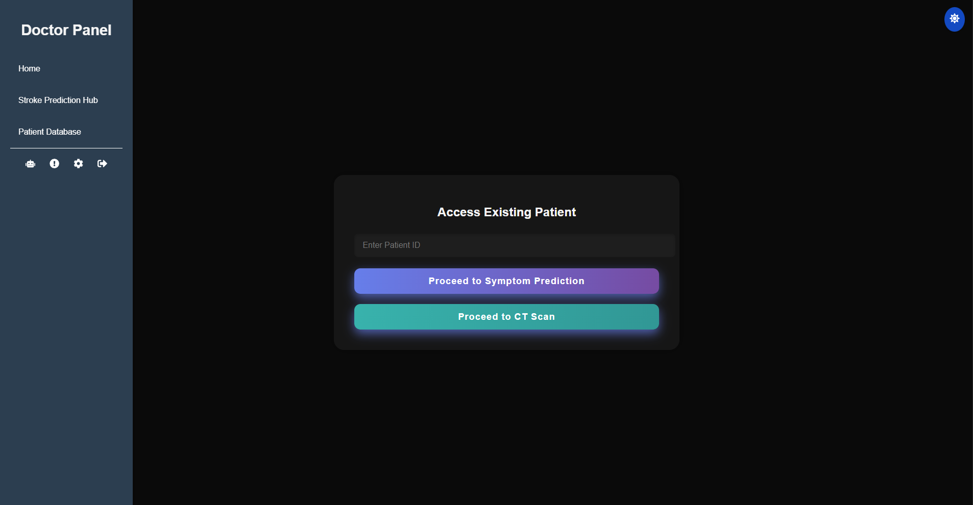

Figure : Accessing Existing Page

The Access Existing Patient Page is another page exclusive to Doctor users. It acts as an extension of the earlier page so that instead of registering the patient in the current session again the user can validate the Patient ID to call and use previously registered information about the patient for the stroke prediction model pages

#### Stroke Symptom Model Page (Doctor)

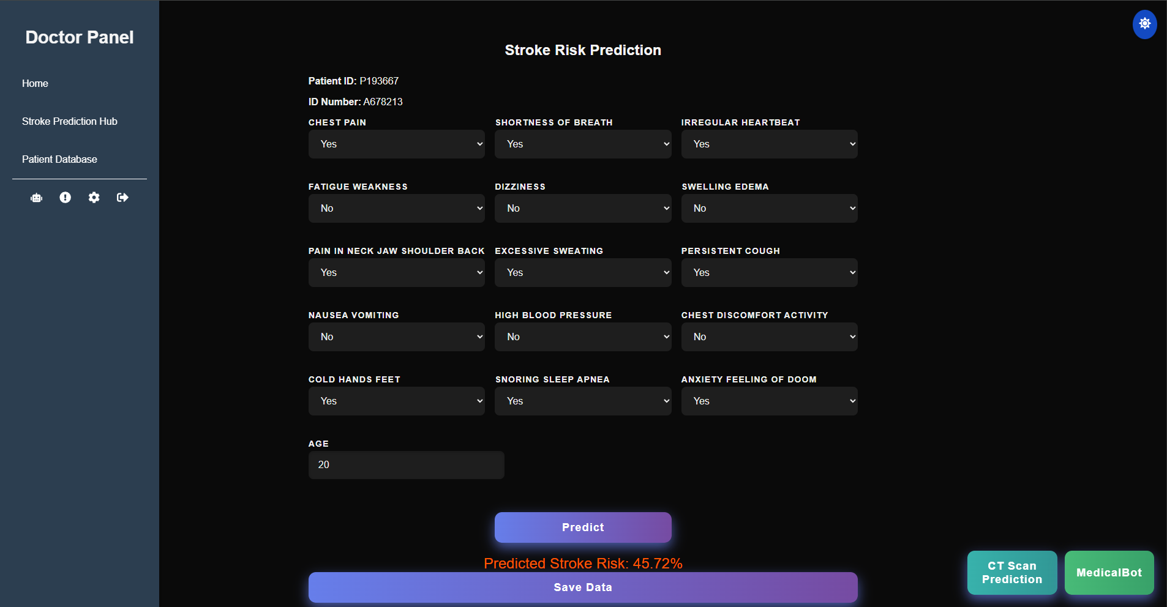

Figure : Stroke Symptom Model Page

The Stroke Symptom Model Page is another page exclusive to Doctor users. It allows users to access and predict the percentage stroke risk of a patient according to their symptoms and age. The page relates to the Patient registration page where patient details such as Patient ID and age are retrieved from the localStorage for use in this page. This enables the “AGE” textbox to be automatically filled and makes sure that the saved medical data is linked with the patient based on their Patient ID.

The page allows users to toggle between symptoms with the help of the drop down menu where users can select either “Yes” or “No”. After all the relevant data is input the “Predict” button can be used for the system to send the input to the ML model to calculate the percentage stroke risk of the patient. Users can then save the data and optionally continue to CT Scan Prediction Page or interact with the MedicalBot chatbot. The chatbot is disabled until the patient has both Symptom based model and CT Scan model prediction.

#### Stroke CT Scan Model Page (Doctor)

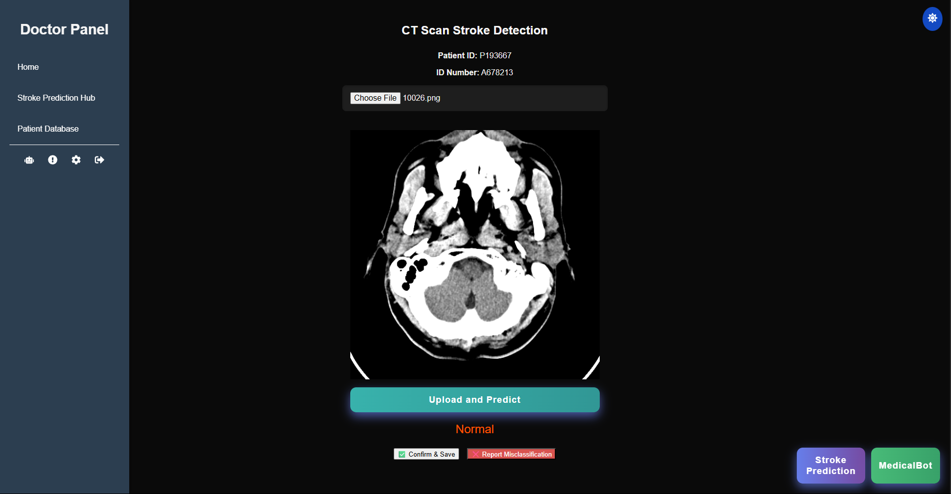

Figure : CT Scan Model Page

The CT Scan Model Page is another Doctor exclusive page that enables doctors to upload images of the patient CT scan and get classification predictions of stroke types based on the CNN AI model in the system. Similar to Stroke Symptom model Page patient data is automatically loaded from the localStorage to ensure connectivity between patient profile data and patient medical data. The user then selects a CT image png file which the system showcases in the UI for added clarity. When the user clicks the “Upload and Predict” button the system sends the data to the CNN AI model which then classifies the image into either (Normal, Ischemic or hemorrhagic). The user can then press the “Confirm & Save” button to save the prediction in the database under the Patient ID.

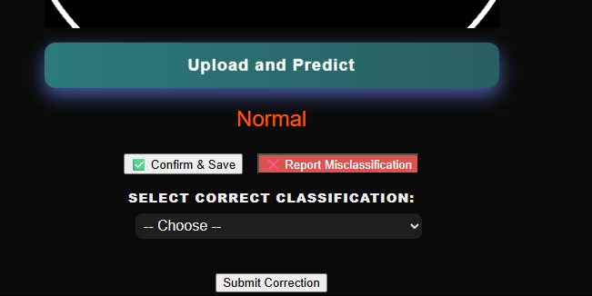

Figure : CT Scan Model Page Report Misclassification Function

Users also have an option to report misclassification of the prediction if they believe that the model’s results are incorrect. The Doctor can then pick the corrected label from the drop-down menu and submit the corrected results for later revision by the Supervisor. Similar to Stroke Symptom model Page users can access the MedicalBot chatbot if the patient has both Symptom based model and CT Scan model predictions. Misclassifications will not count until the issue has been resolved by the Supervisor.

### AI/ML Models

#### Symptom Model (ML Model)

Dataset Used

To train the Stroke risk based on symptom regression model the author has chosen the “Stroke Risk Prediction Dataset Based on Symptoms” dataset (Tusher, 2025) available from Kaggle. This dataset is used for machine learning and deep learning algorithms to estimate the probability of strokes, and it supports both binary classification and regression estimation. Both the risk groups and non-risk groups are equally balanced (50% for both) to prevent model bias during training.

A combination of medical literature, statistical input as well as expert opinions were used to make the dataset as clinically accurate as possible. Some of the medical literature used include American Stroke Association, WHO statistics, medical textbooks such as Harrison’s Principle of Internal Medicine, Oxford and Cambridge stroke handbooks. As such the dataset contains various characteristics inspired by real-world risk factors. (Tusher, 2025)

Each record in the dataset contains the age of the individual as well as a collection of 15 core symptoms with each symptom having binary values (1 for present and 0 for absent). The records also contain two output variables. One binary variable indicates if a person has stroke or not (1 for present and 0 for absent), and another variable which indicates the percentage of stoke risk an individual has (such as 35%). (Tusher, 2025) . As such the dataset perfectly fit in with the overall objective of the stroke regression model.

Libraries Used

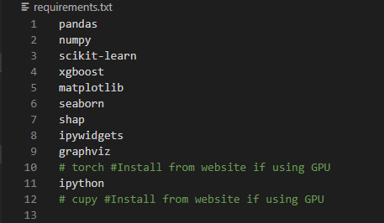

Figure : Symptom Model Requirements.txt

The stroke symptom model is built on jupyter notebook to ensure efficiency of testing and development of the model. The model uses various python libraries to process the data, train the model and visualize some of the output. Notable libraries include XGBoost, a powerful library used for gradient boosting, which is the main machine learning algorithm that will be used by the model. SHAP (Shapley Additive exPlanations) is also used as explainable AI for this model to ensure the model is more transparent. Pytorch is also an essential part of building the model, where users have an option of using either the GPU or CPU version. GPU was used for this example to ensure that data was processed faster, reducing delays for mode deployment. Cupy can then be used if GPU is enabled allowing faster numerical computations directly from the GPU which vastly reduces training time for the model.

Data Handling

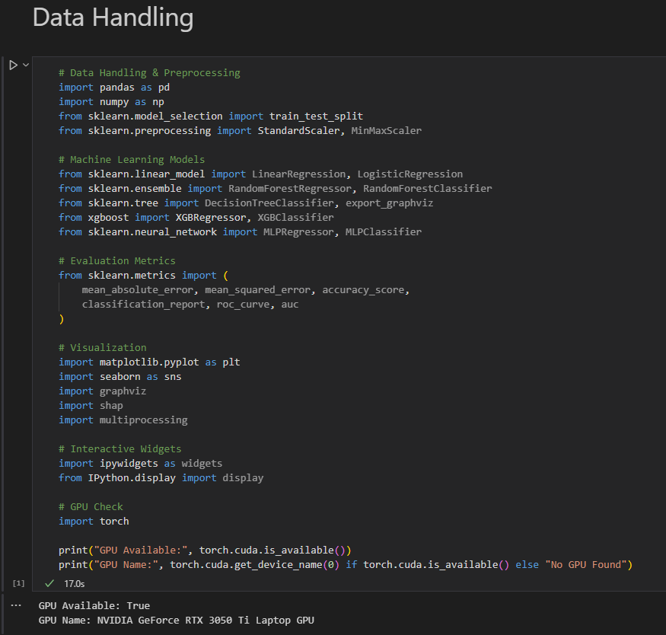

Figure : Symptom Model Data Handling

This section is used for importing libraries that were mentioned before. In addition to that the code also contains an option to check if the user’s GPU is compatible for building and testing the model

Data Preprocessing

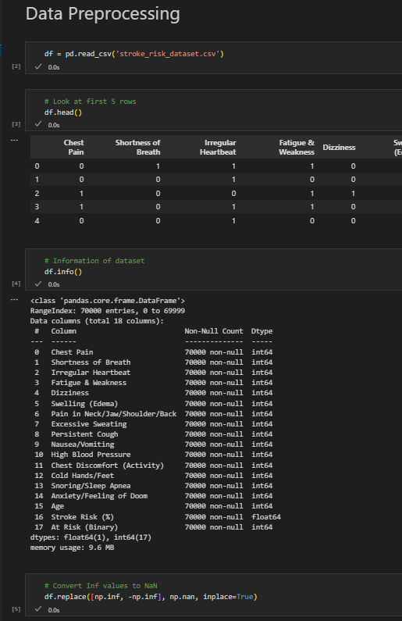

Figure : Symptom Model Data Preprocessing

The dataset is loaded in this section to see that the CSV file contains about 70,000 records and the 18 features that were mentioned before. To keep the data processing clean, any infinite values were converted to NaN using the df.replace( ) function.

Model Exploratory Analysis

After the dataset was loaded in, an Exploratory Data Analysis (EDA) was conducted to interpret the distribution and relationship of the dataset. Firstly, a count plot of at risk (binary) target and a histogram of the age feature proved that there was mostly equality in terms of risk distribution within the dataset. A correlation heatmap which did not include the stroke risk and age-related features were generated to highlight the patterns and relationship between the symptoms. Distribution of induvial symptoms were compared against the stroke risk using a group count plot to show how the individual symptom effects the stroke risk.

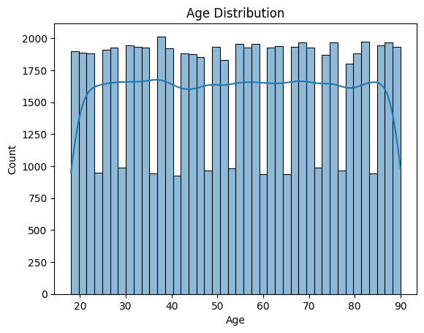

Figure : Symptom Model Exploratory Analysis 1

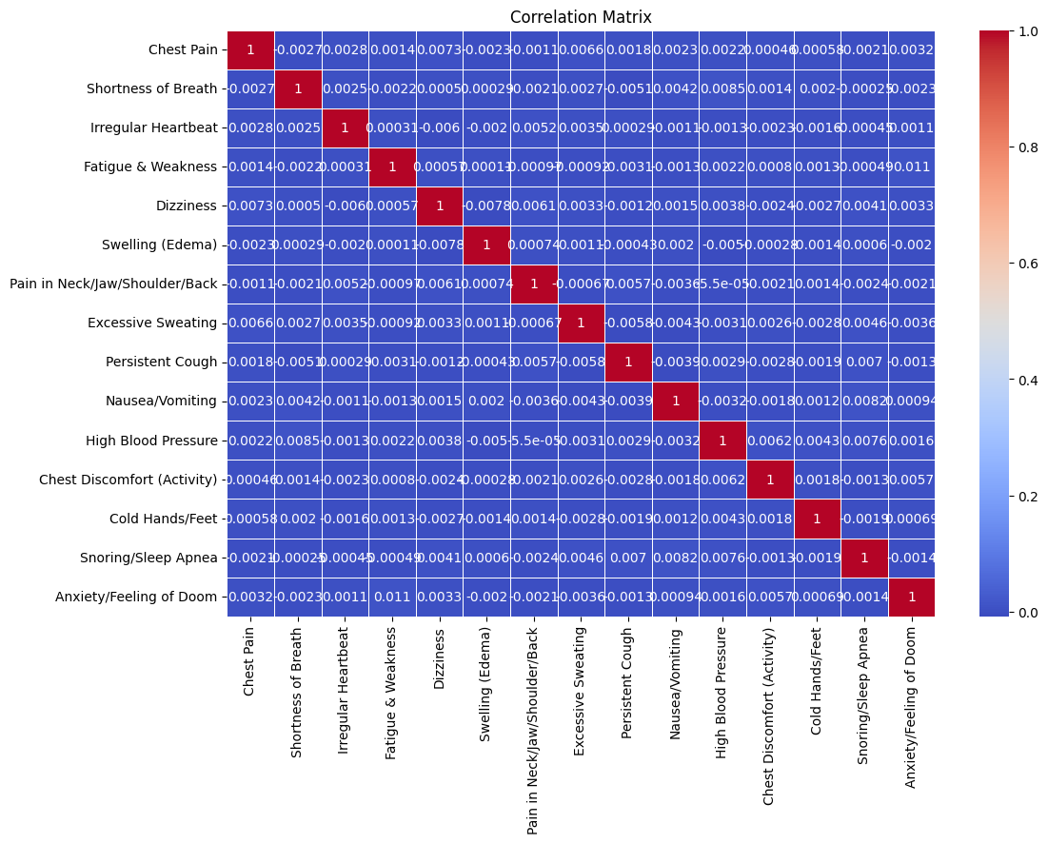

Figure : Symptom Model Exploratory Analysis 2

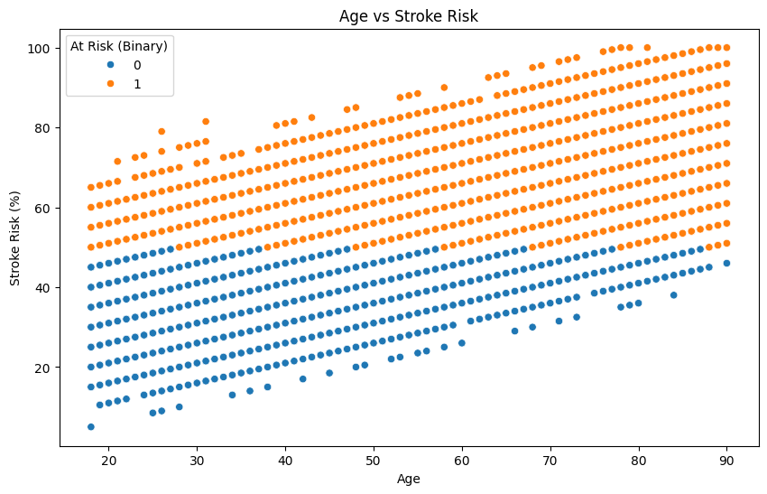

Figure : Symptom Model Exploratory Analysis 3

Feature Engineering

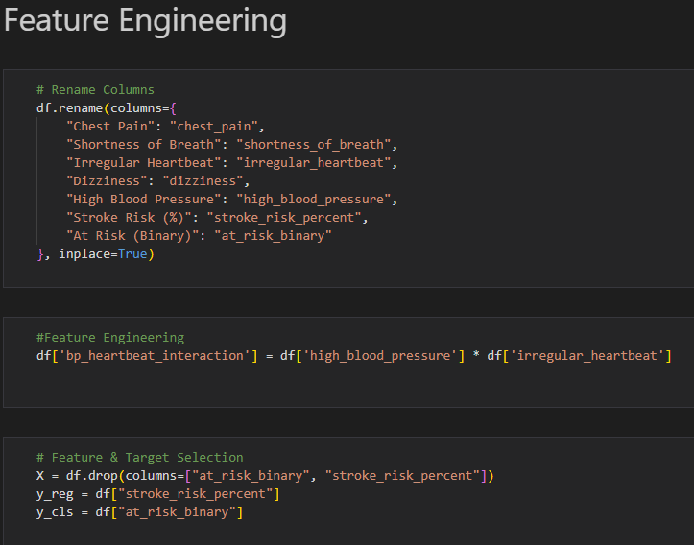

Figure : Symptom Model Feature Engineering 1

During feature engineering some of the features were renamed in lowercase and underscore was added (Chest Pain to chest_pain) to simplify column names and make the variables easier to code as it would prevent future issues while training the model. In addition to this the variables high blood pressure and irregular heartbeat are combined to form bp_heartbeat_ineraction to add an extra variable for the model to train on as based on previous analysis there is some correlation between these variables.

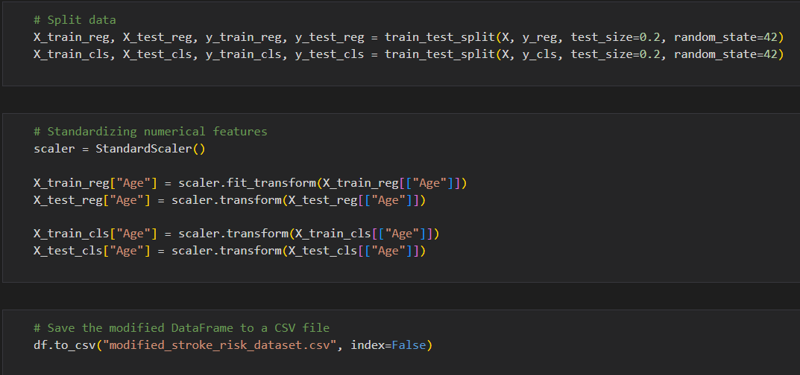

Figure : Symptom Model Feature Engineering 2

The dataset is then divided into training and testing sets of about 80% training and 20% testing for both classification and regression tasks. A fixed random state (42) is also applied to reproduce the results. To normalize the age feature as it is the only continuous variable, Standard Scaler was applied to ensure that it contains a mean of 0 and a standard deviation of 1. This would greatly help model performance and as some algorithms can be sensitive to feature scalling. After the preprocessing the updated dataset with the renamed columns and added features is saved as modified_stroke_risk_dataset.csv for later use.

Baseline Model Implementation

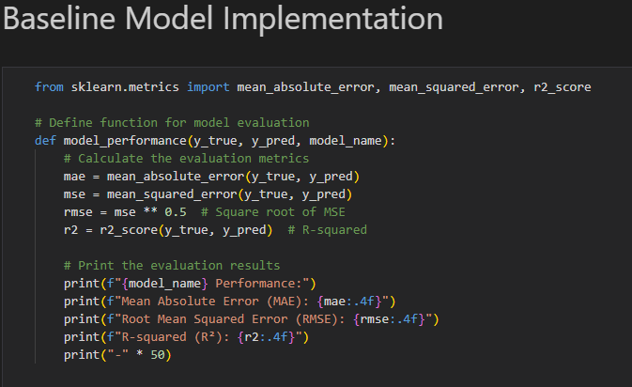

Figure : Symptom Model Baseline Model Implementation 1

Evaluation function model_preformance () was used to define the regression model using key metrics. These include Mean Absolute Error (MAE), Root Mean Square Error (RMSE) and R-squared (R2). MAE and RMSE measure the average magnitude of the prediction errors while the R2 reflects on how good the model describes the variance for its target variable. The main purpose of these functions is to make the evaluation process standardized so it can be used for comparing the results to various other models to get a clearer understanding of the performance of these models.

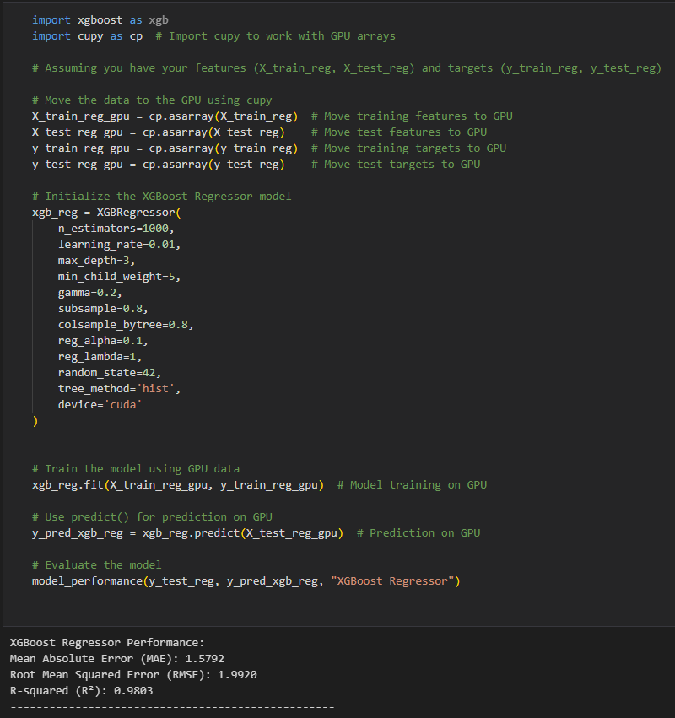

Figure : Symptom Model Baseline Model Implementation 2

An XGBoost Regressor model was trained using GPU acceleration to predict the stroke risk percentage for further speed and efficiency. The data is transferred to the GPU using cupy and the model was configured with various initializers to take full advantage of the GPU. The test performance of the model gave a MAE of 1.58, RMSE of 1.99 and R2 Score of 0.98 giving a high prediction accuracy for the model.

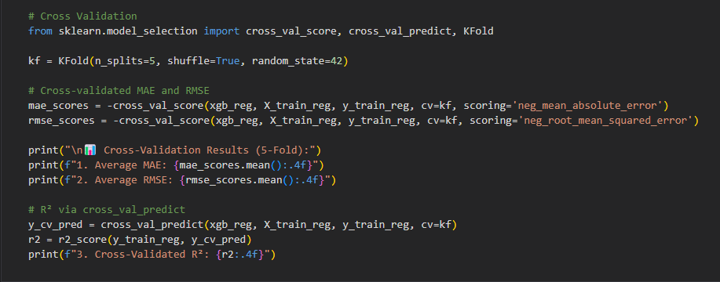

Figure : Symptom Model Baseline Model Implementation 3

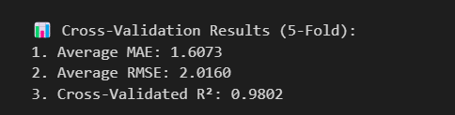

Figure : Symptom Model Cross Validation Results

The XGBoost regression model is then validated using 5-fold cross validation through KFold to check for the overall stability of the model. This method splits the training data into five subsets, and the validation fold is rotated for each repetition. At the end of the cross validation result the average MAE was 1.61, the average RMSE was 2.01 and the Cross-Validated R2 was 0.9802 which shows that the model has a strong performance across the folds and the model is robust when it comes to unseen data.

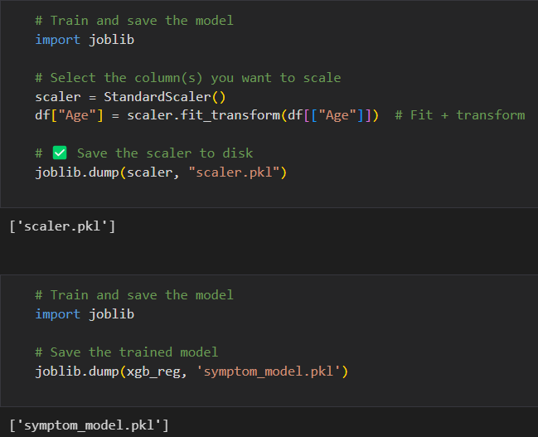

Figure : Symptom Model Baseline Model Implementation 4

To integrate the model into the main stroke system the XGBoost regression model and the standard scaler which is used for scaling the Age are saved using the joblib library. They are saved as symptom_model.pkl and scaler.pkl respectively.

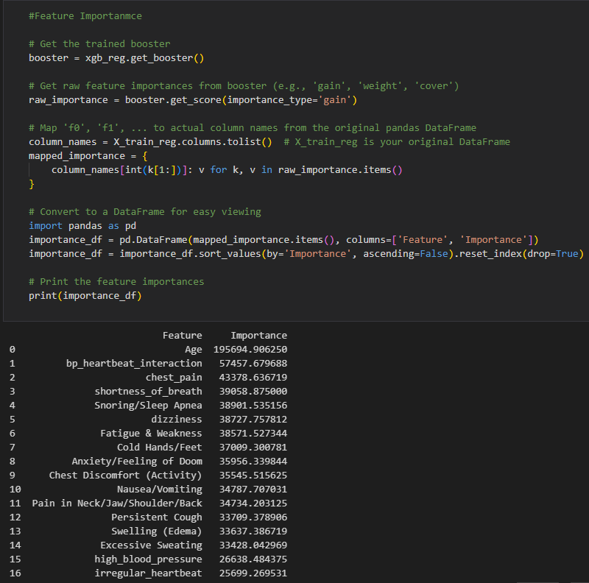

Figure : Symptom Model Baseline Model Implementation 5

To determine the most impactful variables effecting the model results feature importance was obtained for the trained XGBoost regressor model using the gain metric, which shows the average accuracy improvement based on the feature splits. The results showcase that Age variable and the combined bp_heartbeart_interaction plays the most significant role for the model results

Final Model Evaluation

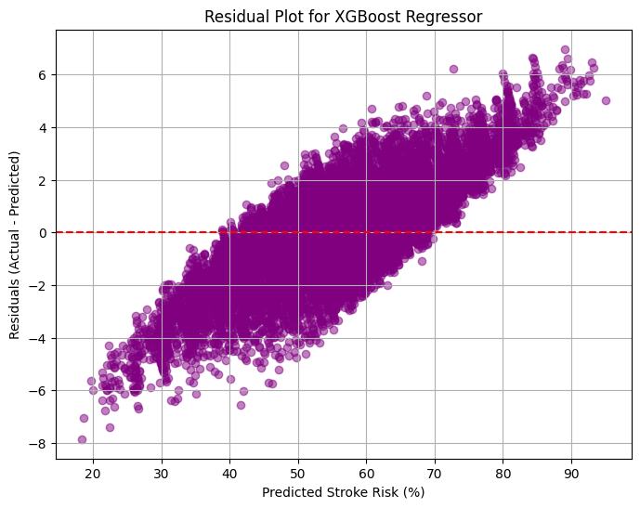

Figure : Symptom Model Final Model Evaluation

To perform a diagnostic test for the XGBoost symptom model two plots were created. One is the Predicted vs Actual plot; the next plot is the residual plot. Both these plots confirm that the model has minimal bias and can perform accurately through different variables

Explainability and Interpretability

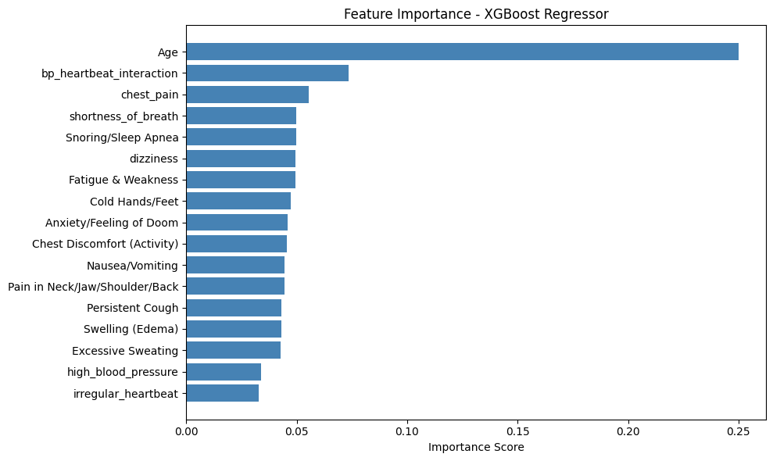

Figure : Symptom Model Explainability & Interpretability

A horizontal bar plot was also visualized to identify the importance of different variables present in the symptom model. This visualizes the same data that was mentioned earlier and showcases how impactful Age is to the overall prediction of the model.

AI Transparency

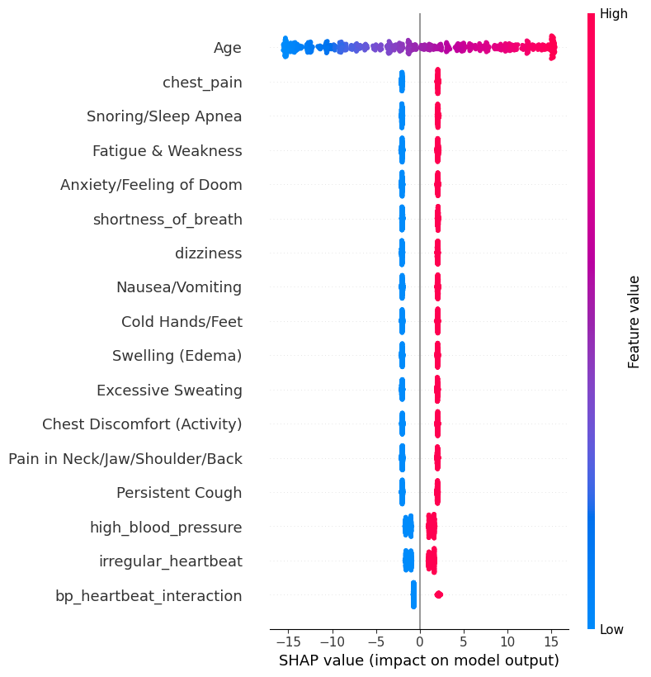

Figure : Symptom Model AI transparency with SHAP

To furthermore improve on the transparency of the symptom model advanced methods such as SHAP were also used to explain the contribution of individual variables. SHAP also showcases the direction of influence of the variable hence why bp_hearbeat_interaction is lower in this diagram compared to others.

Test Model

A simple test model was also conducted with the pkl files to ensure that the model would work in the bigger system when deployed.

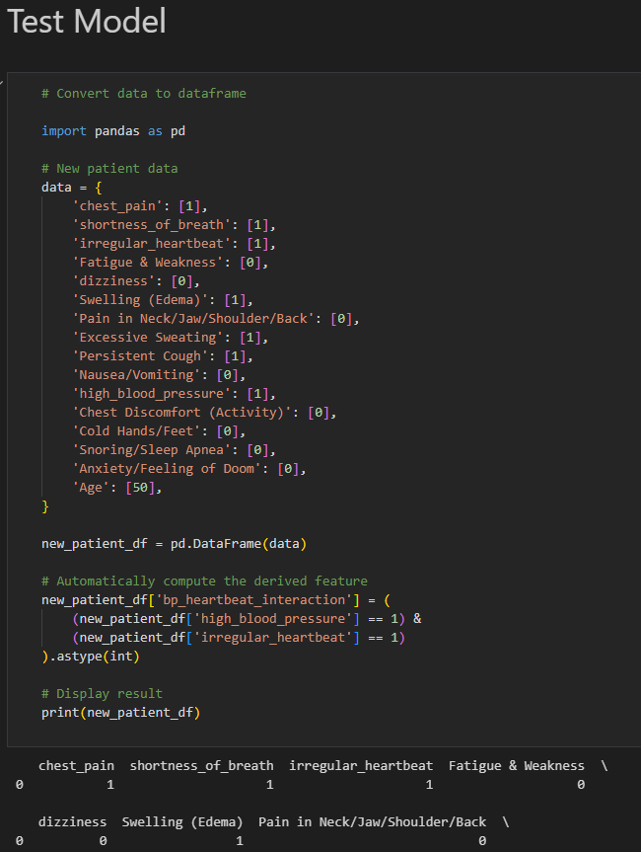

Figure : Symptom Model Test Case 1

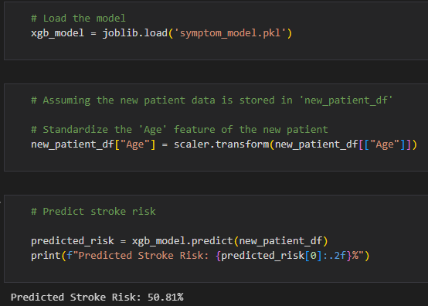

Figure : Symptom Model Test Case 2

#### CT Scan Model (CNN Model)

Dataset Used

The Dataset used for this model png image files of brain computed tomography (CT) images which are designed for classification of stroke. This original dataset was used for the Artificial Intelligence in Healthcare competition (TEKNOFEST-2021) which was under the support of the Republic of Turkey Ministry of Health and managed by Turkish Health Institutes (TUSEB). This is a public dataset available on their official government website. (Türkiye Ministry of Health, 2022)

The dataset consists of images with three different classifications, No Stroke (4,428 images), Ischemic (1,131 images) and Hemorrhagic (1094 images). The images were collected from 2019 to 2020 from e-pulse and Teleradiology Systems at Turkey. Various diagnostics codes and filters were applied to the data to keep its anonymity. In addition to this the data was also verified, labelled and prepared by 7 expert radiologists.

The version that is used for this CNN model is an English translated version of the dataset available in Kaggle under the dataset name of “Brain Stroke CT Dataset” by (Aslan, 2025). This makes it easier to integrate in the overall English main system.

Setup

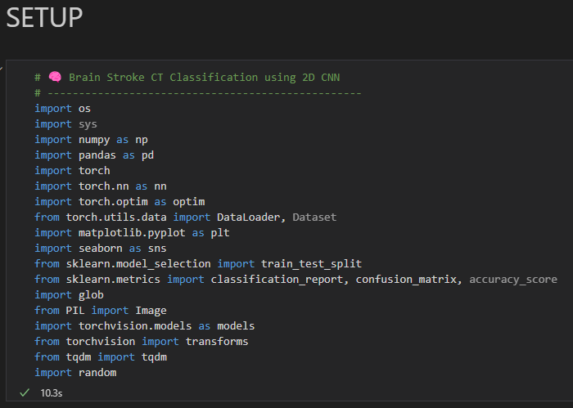

Figure : CT Scan Model Setup 1

The CT Scan Model focuses on classification of brain stroke types using CT scan images (PNG files) through the use of 2D Convolutional Neural Network (CNN). Firstly to build the system similarly to the Symptom Stroke Model all of the evaluation and training is done on Jupyter Notebook for an overall easier and efficient progression. Important Python libraries such as torchvision are imported which will be used for image preprocessing and access to other existing models.

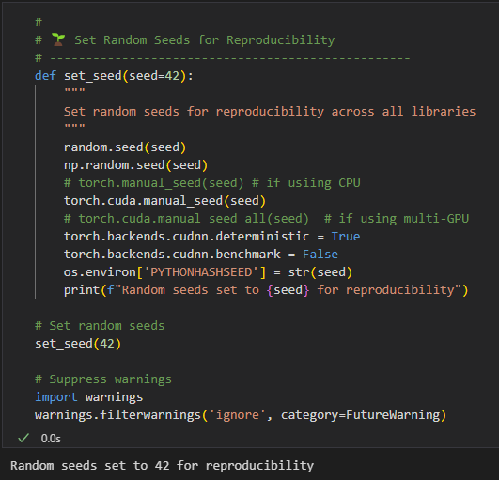

Figure : CT Scan Model Setup 2

Random seeds were also set (42) for all the libraries. This is needed when comparing the performance of the model across different runs and replications.

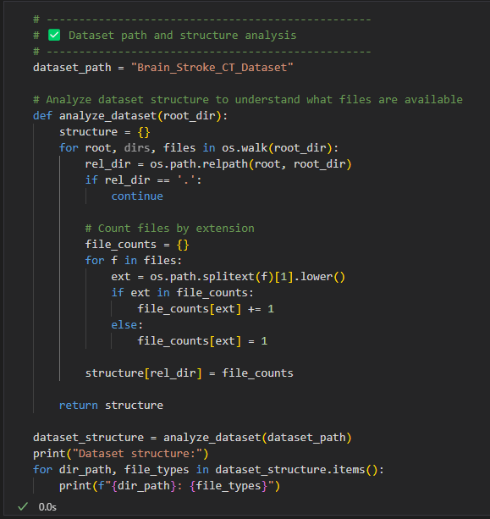

Figure : CT Scan Model Setup 3

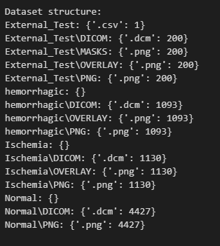

Figure : CT Scan Model Dataset Structure

The path of different folders and datasets were also analyzed for future reference when training and testing the model. The analysis revealed the dataset was organized into three different folders Normal, Ischemia and Hemorrhagic with each containing DICOM and PNG formats along with masks and overlays. In addition to that there was also an External Test folder which contained 200 images along with masks and overlays. This helped with data integrity and future preprocessing pipeline.

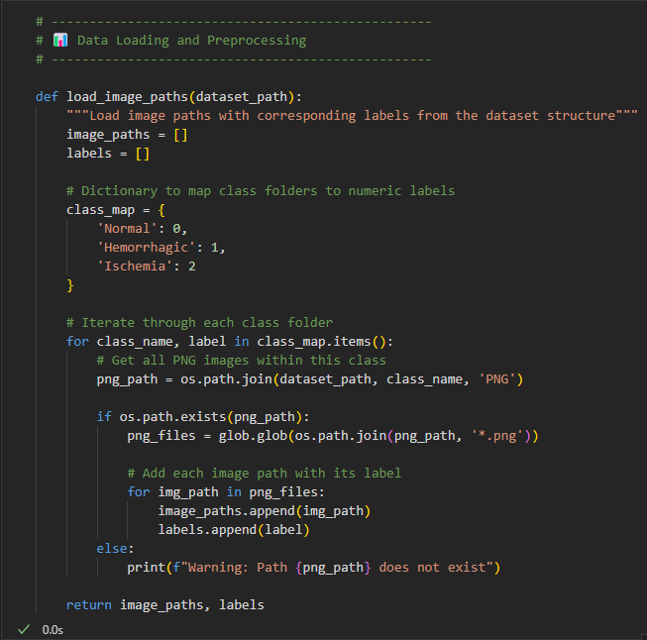

Figure : CT Scan Model Setup 4

To prepare the data for classification, PNG folders of the three image paths Normal (0), Hemorrhagic (1) and Ischemia (2) were all loaded into the model. In addition they were also assigned with numerical labels (0, 1 and 2) which formed the base to be later used for model training.

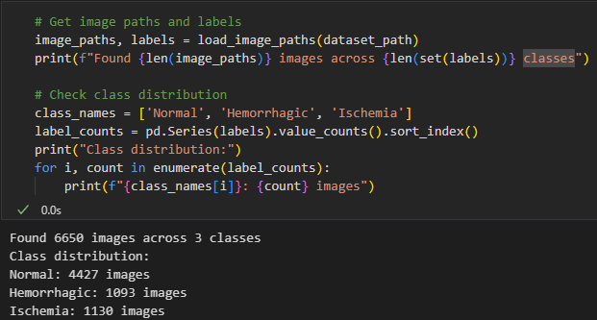

Figure : CT Scan Model Setup 5

Another analysis of the dataset is also done to check the amount of PNG images available in the dataset. The dataset contained a total of 6650 brain CT images with Normal (4427 images), Hemorrhagic (1092 images) and Ischemia (1130 images).

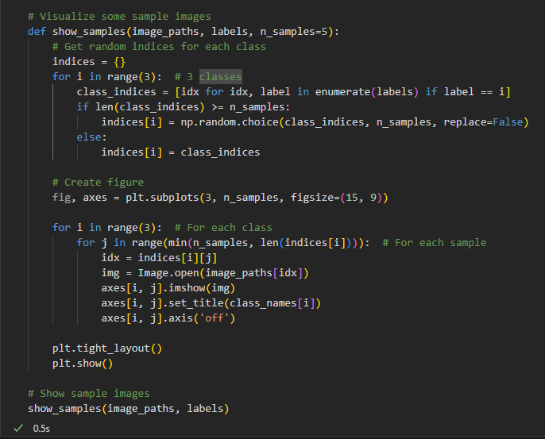

Figure : CT Scan Model Setup 6

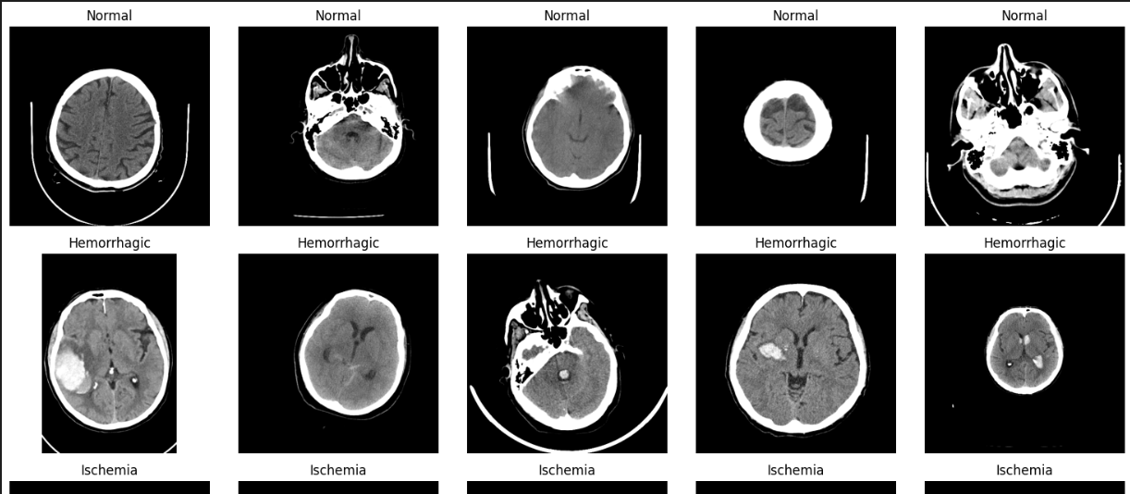

Figure : CT Scan Model visualization of samples

For getting an idea of the patterns present in the dataset random brain CT Scan images were taken from each class and displayed to check for the quality and differences of images between each stroke type

Model Training

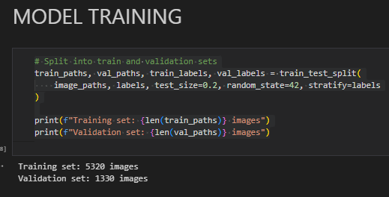

Figure : CT Scan Model Training 1

For Model Training firstly the dataset is split between a training set which contains 5320 images, and a validation set which contains 1330 images.

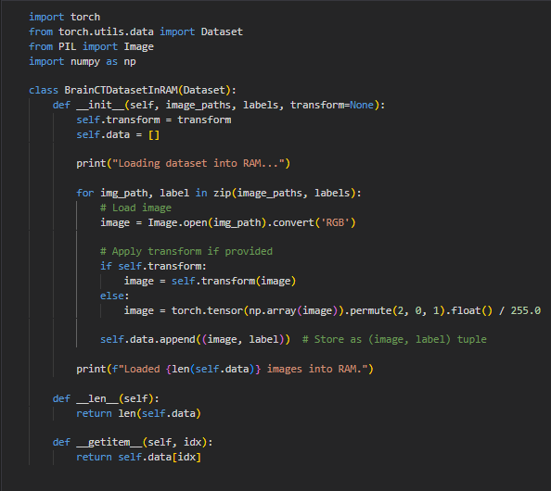

Figure : CT Scan Model Training 2

For this section a custom PyTorch dataset is created using the existing dataset labelled BrainCTDatasetinRAM which is used to load all the brain CT scan images into the system RAM during the initialization period. It also applies transformation and labels during the process for faster processing of data. The data structure which consists of the image and the label are then stored in the form of a list of tuples in the memory. Overall this process helps for faster training by avoiding repeated reading form the HDD/SDD. This would be especially compatible with this dataset due to its size.

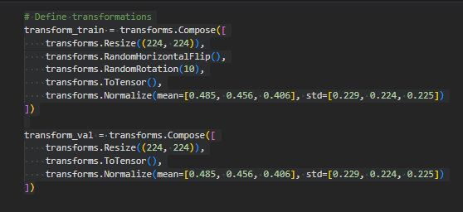

Figure : CT Scan Model Training 3

This section defines the preprocessing steps used for the training and validation of the CT scan images. Both the training and validation images go through the same process such as being resized into 224*224 and normalization but validation images go without augmentation.

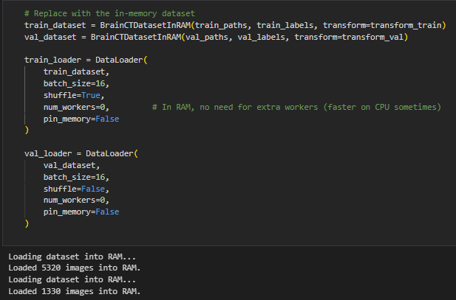

Figure : CT Scan Model Training 4

The code is used to load the training and validation data into RAM using the BrainCTDatasetInRAM class to improve the speed of the processing. Afterwards it will then prepare the PyTorch DataLoader object to batch and feed the data to the model. The training loader then shuffles to enhance a generalization while the validation loader retains the initial sequence.

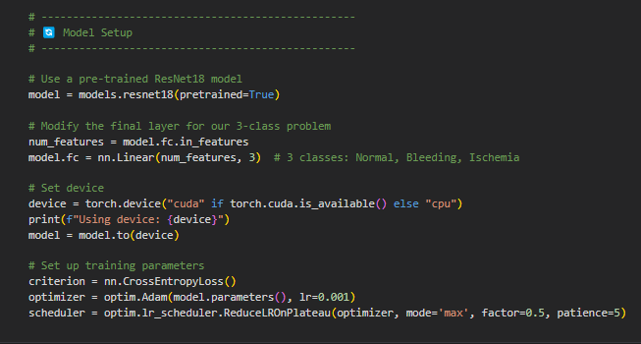

Figure : CT Scan Model Training 5

Firstly, the code sets up the deep learning model using a pre-trained ResNet18 which is a popular model regularly used as a convolutional neural network (CNN) which makes it ideal to be used to build the CT Scan Model using the custom dataset. Device for training the model is set to a GPU otherwise it is changed to a CPU. The model is then trained on cross entropy loss, Adam optimizer and a learning rate schedular which will decrease the learning rate when the validation accuracy stops increasing

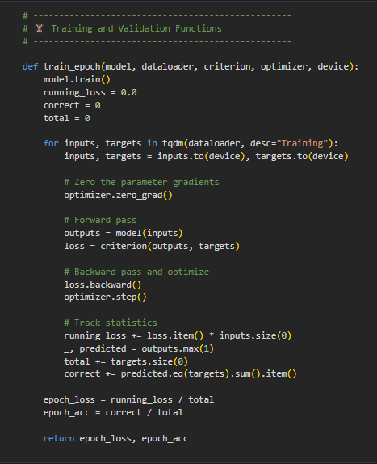

Figure : CT Scan Model Training 6

The code details the procedure for training one epoch in the model. It goes through the training data, copies the input and selects either GPU or CPU. Additionally, it also does a forward and backward pass as well as update the weights with the optimizer. Finally, it outputs the average loss and accuracy during the epoch.

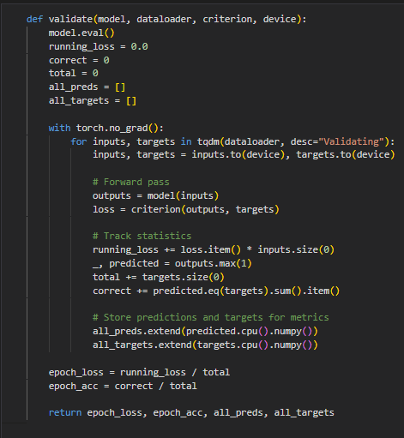

Figure : CT Scan Model Training 7

This code acts as an extension of the last code and performs validation check for the model. It tuns off gradient operations and stores the model prediction and true image and label pairing to be evaluated later. It then gives back the average loss, accuracy and a complete list of predictions and targets.

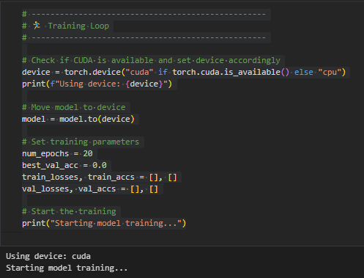

Figure : CT Scan Model Training 8

The code is used to enable and start the training loop of epochs. It sets training parameters such as making the number of epochs 20 as well as preparing to list out monitor losses and training accuracy for each epoch.

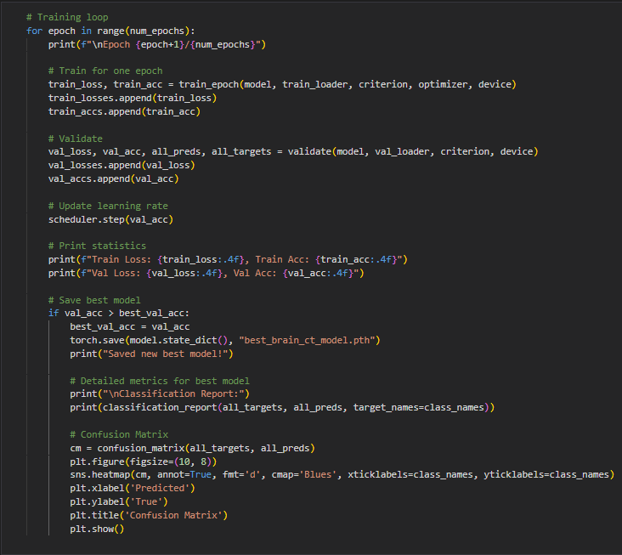

Figure : CT Scan Model Training 9

This code acts as an extension of the last code and details mainly about the training loop. The code is used for training and validating the model at each point as well as to print classification reports and display a confusion matrix for the three classes when there is a new best model.

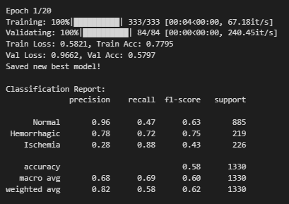

Figure : CT Scan Model Training Epoch

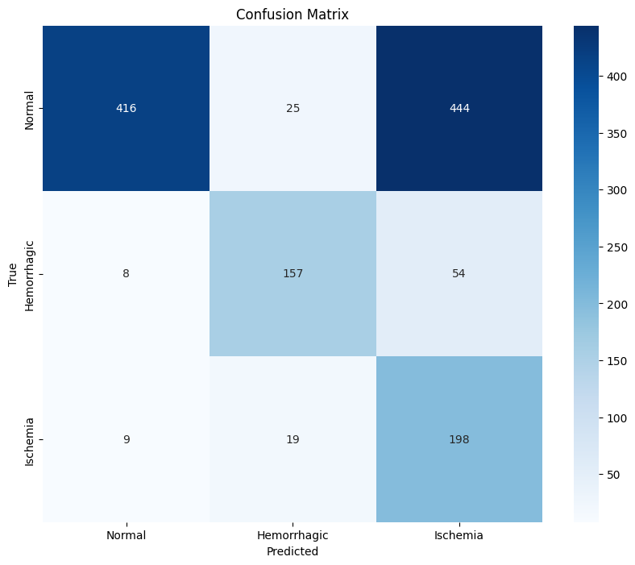

Figure : CT Scan Model Training Epoch Confusion Matrix

Shows the output of the training epoch for the first epoch. This process would be repeated about 20 times to calculate the best epoch for the model.

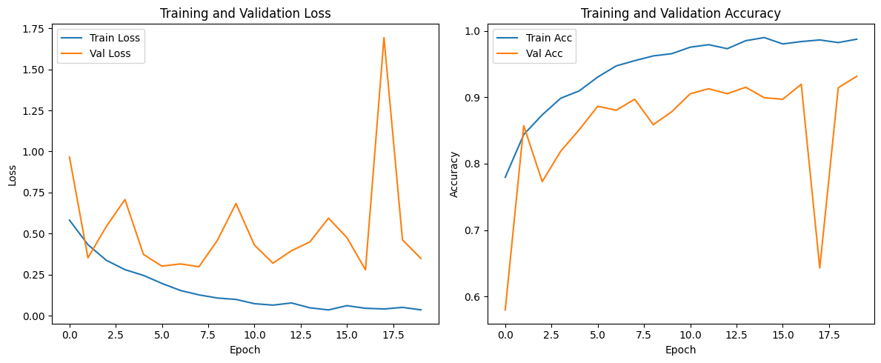

Figure : CT Scan Model Training Visualization

The training progress of epoch training is also recorded as graphs for easier understanding of the computed process. It shows a total of two graphs one for validation loss for identifying overfitting or underfitting, another graph for accuracy to display the quality of learning by the model.

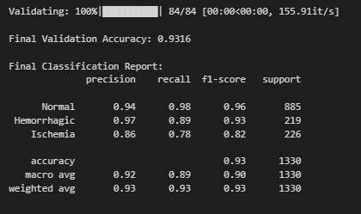

Figure : CT Scan Model Best Model Loaded

The code afterwards loads the best preforming model which is based on the previous validation accuracy and loss. The model goes through evaluation again to estimate the final accuracy and provides other classifications reports. A confusion matrix is also showcased again to visualization. At the end the best model of the CT scan model has an accuracy of 93.16% and is chosen to be the CT scan model for the main system. The model would be saved as a .pth file so it can act as a model weight to the pre trained ResNet-18 in the main system to ensure the model is guided to fit the trained dataset.

Test Model

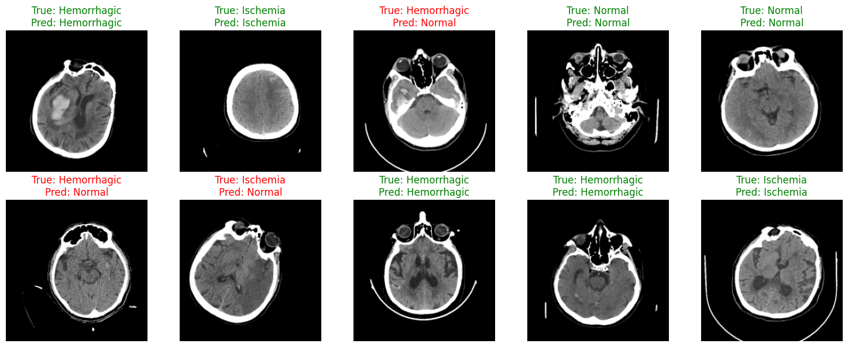

Figure : CT Scan Model Prediction Visualization

For model testing some of the predictions of the validations set are visualized. It runs the best model on these batch of images. After processing the predicted labels with the true labels are shown on the grid.

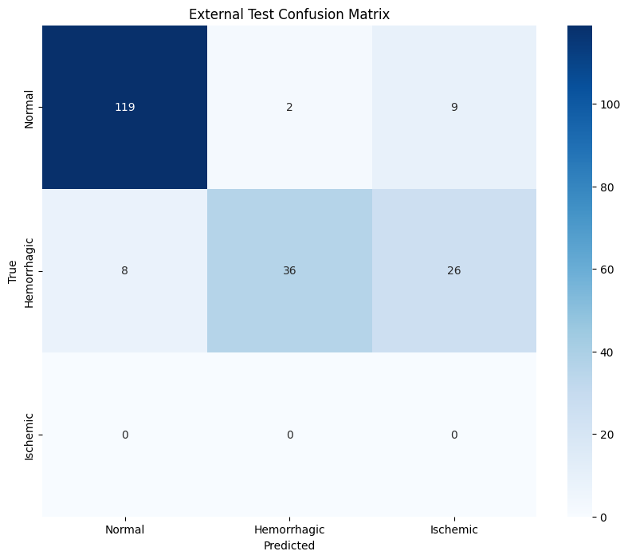

Figure : CT Scan Model External Test Confusion Matrix

The last section showcases how well the model preforms against external images. The images in the external folder mentioned before would be used to test the accuracy of the model and a confusion matrix would also be generated to showcase the accuracy of the model. Overall the model performed well during testing and would be efficient to be used for the main system.

#### MedicalBot Chatbot (RAG Based LLM Model)

Unlike the other two models, MedicalBot is not trained from scratch and most of its procedures and functions are embedded into the main system. The LLM is already fine-tuned for medical questions and answers. Instead, it is customized with the help of a combination of custom prompts and RAG documents to generate and give users custom answers. As such there are more easy customization options available for this LLM RAG model compared to other models.

llm_utils.py

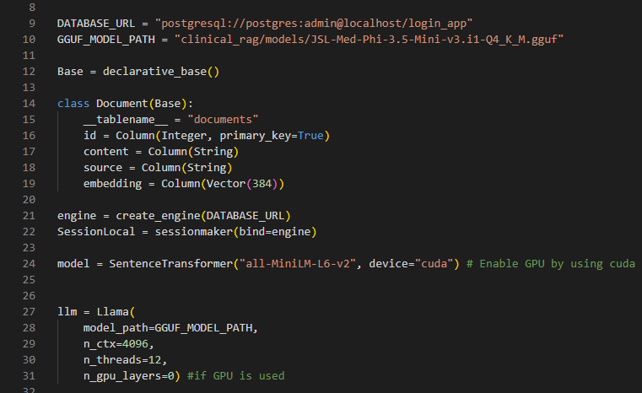

Figure : MedicalBot Chatbot Function 1

The main function of the first code batch is the installation of the back-end for the Retrieval-Augmented Generation (RAG) as well as the Large Language Model (LLM) for the chatbot. A connection is made to the primary PostgreSQL database, in which it retains documents with their specified embedding with the help of SQLAlchemy library. The Document table in the database contains text content, source (document name), and the embedding vector of 384 dimensions. These embedding models are loaded using the SentenceTransformer model “all-MiniLM-L6-v2” using a GPU for faster processing. Then the lightweight LLM model “JSL-Med-Phi-v2” is loaded using the llama-cpp-python library. This activates and readies the chatbot for the next activation codes.

In addition to this the LLM model can be easily replaced with either higher end or lower end LLMs depending on the location of deployment. A higher end LLM would be essential for places such as public hospitals, but a much lower end LLM can be used for smaller clinics. This can vastly reduce processing time for LLMs. Here are a few suggestions on a few other popular fine-tuned LLMs designed for medical queries

|  |  |
| --- | --- |
| **Model** | **Parameters** |
| Med-Mistral | 24B |
| MedQwen | 14B |
| Llama-3.1-UltraMedical | 8B |
| BioMistral | 7B |
| HuatuoGPT | 72B |

Table : MedicalBot Chatbot LLM Suggestions

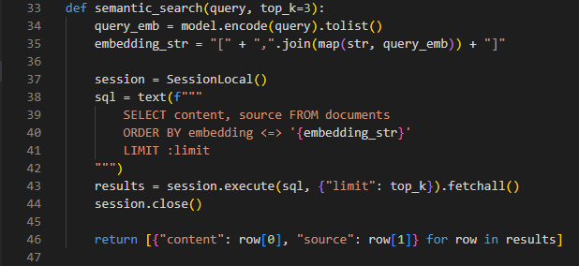

Figure : MedicalBot Chatbot Function 2

This function acts as the component for characterizing the semantic search part of the MedicalBot. It firstly accepts questions by the user then it encodes it to a vector with the aid of the sentence embedding model and then executes a similar search in the database. Afterwards the database operator calculates the difference of the query embedding and the stored document embeddings which uses pgvector and essential component for the RAG model. It then retrieves the k most similar document content (chunks) and its source.

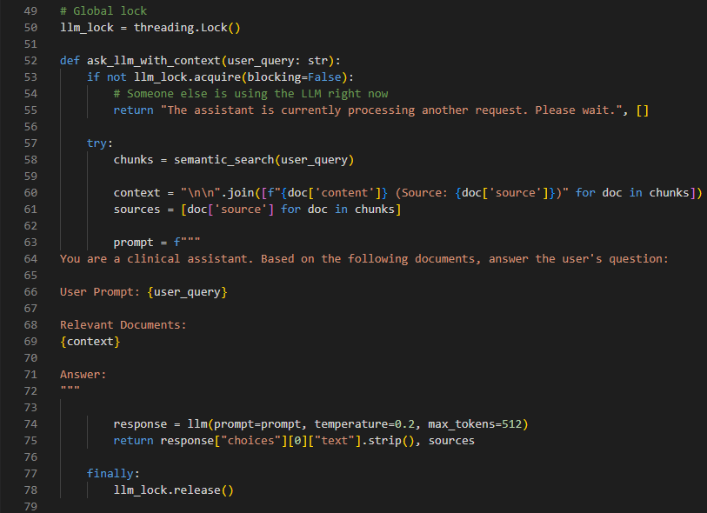

Figure : MedicalBot Chatbot Function 3

This function acts as an extension of the last function. It retrieves the most relevant document content using semantic search and then formats them into a prompt alongside the question from the user. A medical response is then generated by passing the prompt to the LLM. The function then returns the response and source used to the user. If the user repeats another question before the chatbot response is given an error is displayed by the chatbot

load_document.py

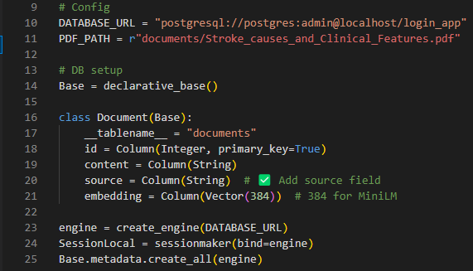

Figure : MedicalBot Chatbot Document Loading Example 1

This code script is used to create the database schema on where the medical document that will be used for MedicalBot reposes will be stored. It creates a Document table with columns for content, source and vector embeddings, which are in 384 dimensions to match the SentenceTransformer model “all-MiniLM-L6-v2”. The PDF_PATH that points to where documents will be embedded for RAG training is also configured so it can be used alongside the process.

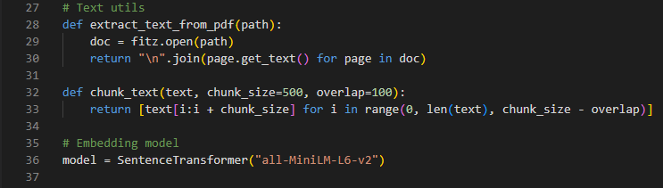

Figure : MedicalBot Chatbot Document Loading Example 2

The functions for this code script involve extracting and preparing text for semantic search. It extracts raw text from the PDF file documents and then divides the text into overlapping chunks to maintain the context of the text. These chunks will then later be embedded using the embedding model.

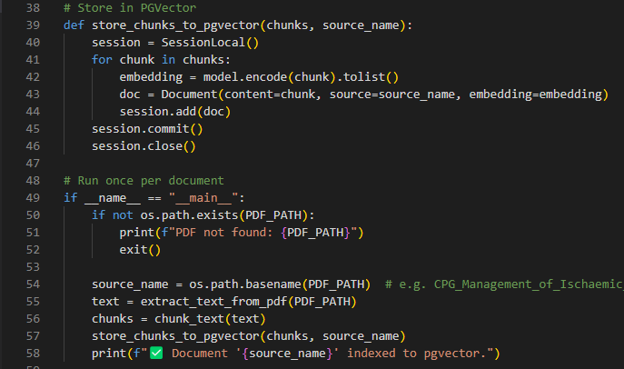

Figure : MedicalBot Chatbot Document Loading Example 3

The functions for this code script take the medical PDF document and embeds it into the database using pgvector to use for semantic search. After extraction of texts and encoding each chunk of text to embeddings by the embedding model, the chunks together with their embeddings and source file name are saved in the database under documents table. This is the base of how the RAG-based chatbot system is created so it can use semantic search to get the chunks of data in the database as explained earlier.

## Backend Functions (Sample Codes)

### Tables.py

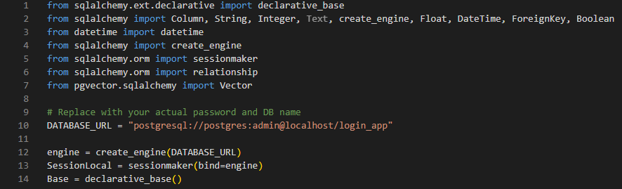

Figure : Tables.py Imports

The main function of tables.py is that it acts as a connection to the main database and as support to some of the functions available in the main.py. In addition to that, during the initial implementation of the system, users must run a batch file that connects to this file to build the database and start the system.

The initial code script consists of initialization of the database connection to the PostgreSQL database using the SQLAlchemy library and the establishment of the declarative base (Base) in which the Object-Relational Mapping (ORM) models are defined. It defines the initial connection string, creates the engine and prepares a session factory to connect to the database. In addition to that different SQLAlchemy data types and vector from pgvector to support the vector-based fields which will be used for the RAG based chatbot functions.

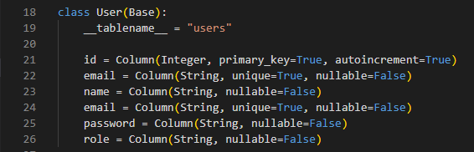

Figure : Tables.py User Class

The first declared class is the user model on the ORM system which identifies the user table from the database to the python class. Several columns are identified such as id (primary key) and email (unique value). These greatly simplify programming as these can be used as python objects for various functions and codes, which will be shown in the main.py

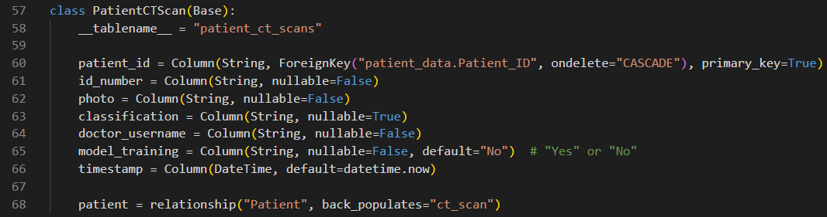

Figure : Tables.py PatientCTScan Class

The patientCTScan is heavily tied to the Patient class where patient_id acts as both a primary key and a foreign key from the Patient class. The ondelete= “Cascase” ensures that if a patient record is deleted from the database, it will also automatically remove the record in PatientCTScan with the same patient_id. The last line sets up a bidirectional relationship between the two classes allowing easy access to the associated patient object from the PatientCTScan records.

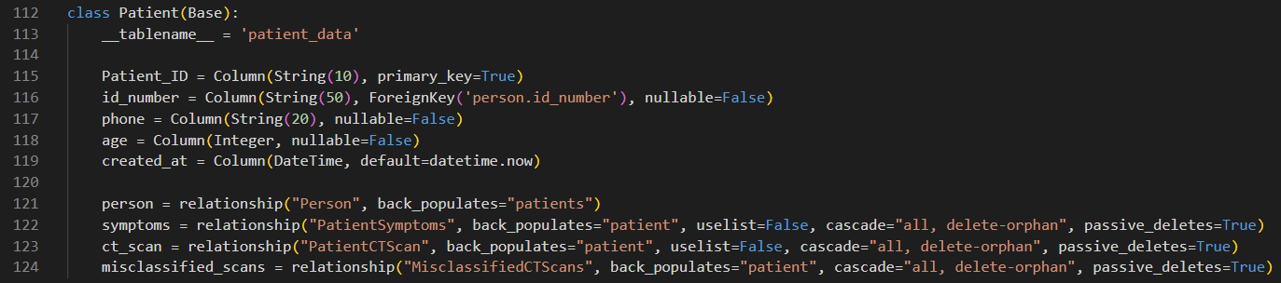

Figure : Tables.py Patient Class

As mentioned for the PatientCTScan model the Patient table contains heavy ties not only to the PatientCTScan model but to the PatientSymptoms model and MisclassifiedCTScan Model. As such when a record is deleted from the Patient table it will automatically delete the record with the associated patient_id from the other three models.

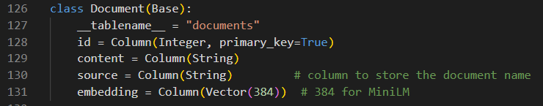

Figure : Tables.py Document Class

The document class creates a table called documents in the database which are primarily used for chatbot RAG functions. Chunks of text from PDF documents are stored to allow for the chatbot later to use semantic search to retrieve the data.

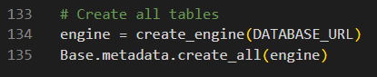

Figure : Tables.py Create All Table Function

This code acts as an extension of the first code script and initializes the database connection to create all tables defined by the ORM models present in tables.py. Users can also use the Run_tables.bat file to activate this script.

### Schemas.py

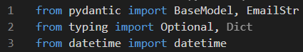

Figure : Schemas.py Imports

Firstly, the code script imports important modules and libraries to define data validation schemas that use pydantic, which are used for the FastAPI functions present in main.py and other parts of the system.

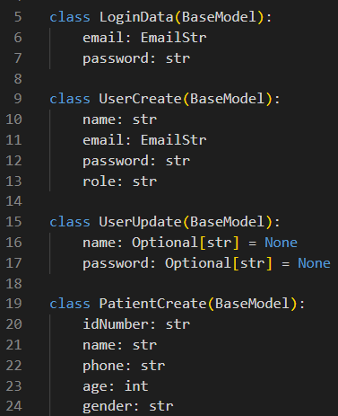

Figure : Scehmas.py Base Models

The given Pydantic models present the defined structured schemas to work and validate the user and patient information in the application. This includes LoginData for logging in the system, UserCreate for validating user information during registration, UserUpdate for changing user profile settings, and PatientCreate during registration of Patients.

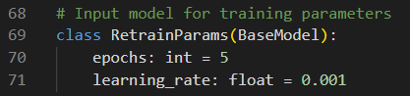

Figure : Scehmas.py Retrain Parameter Model

The RetrainParams is also another Pydantic model that is used to pass data into the training parameter during CT Scan model retraining. Epoch determines how many times a model is trained over the training dataset to find the best results (Set to 5) and learning_rate which is the step size during optimization (Set to 0.001). Users can configure this at the backend if they want to bring changes to the way the the model is retrained.

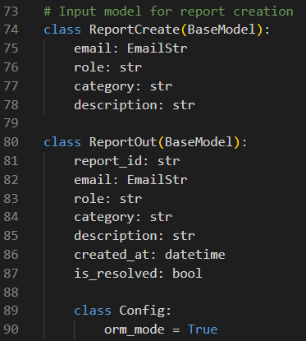

Figure : Schemas,py Report Model

The Pydantic model for report handling ReportCreate and ReportOut works similar to how the other models shown above works. The additional orm_mode = True allows the Pydantic model to work smoothly with the SQLAlchemy ORM models.

### Chatbot_routes.py

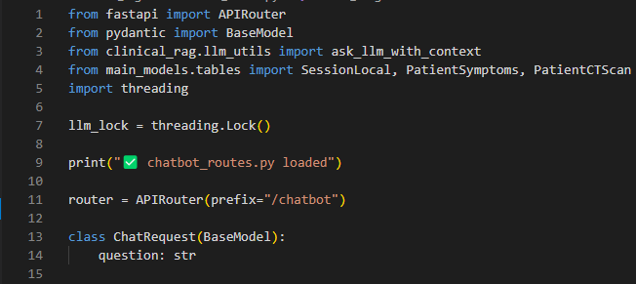

Figure : Chatbot_routes.py Initializations

The code script starts the initial chatbot route with the FastAPI’s APIRouter which sets the prefix to /chatbot. In addition to that required components for LLM response and database models are imported. The threading.lock function is also used to prevent users from sending questions to the chatbot before it can generate a response, this is important to stop the system from crashing. The Pydantic model ChatRequest is also defined to validate user questions.

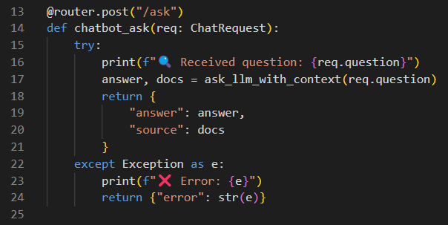

Figure : Chatbot_routes.py Ask Function

The endpoint /ask responds to requests in the form of user questions that invokes the LLM function that generates answers alongside information taken from documents through RAG by semantic search. It then responds to the user with the name of the document it used to generate the answer.

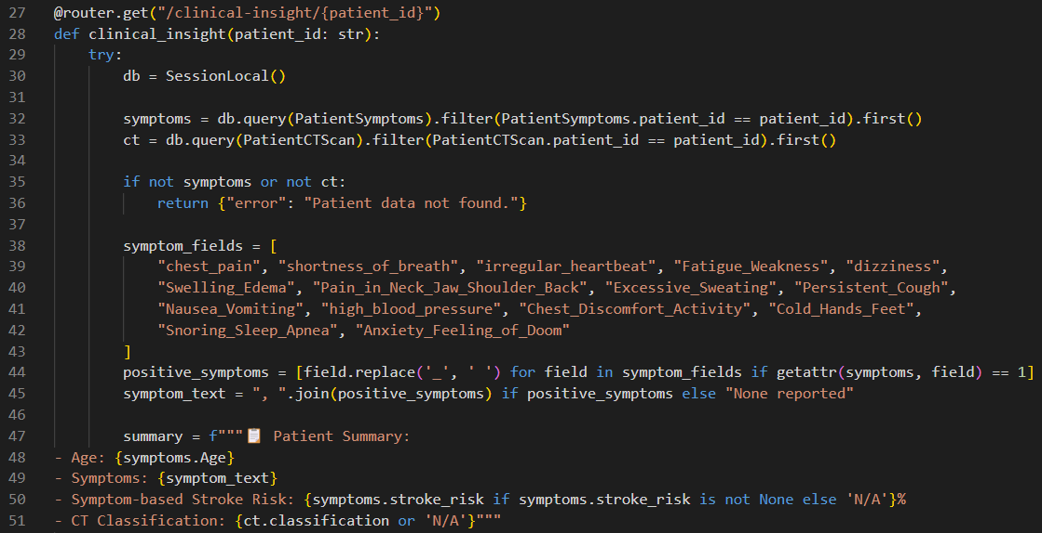

Figure : Chatbot_routes.py Clinical Insight Function 1

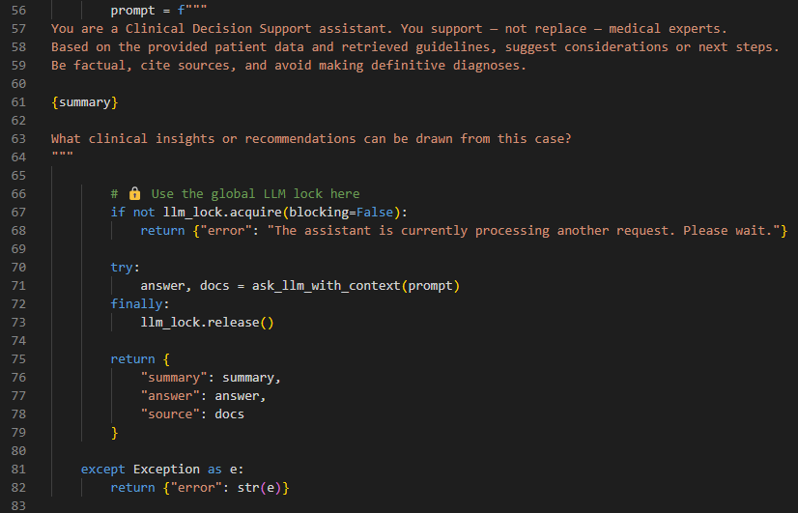

Figure : Chatbot_routes.py Clinical Insight Function 2

The endpoint /clinical-insight is used to give insight on the patient using their medical history retrieved from their patient_symptom table patient_ct_scans table. This function combines all three AI/ML models to generate a definitive answer to the user. Firstly, the Patient ID identifies the user symptom and CT scan classification from the database, if both data are not present in the database an error is shown. After successfully retrieving the data a patient summary is created with the data and passes the prompt to the LLM to create a response. The LLM then retrieves additional information from the vector database using RAG and responds to the user with appropriate source of the documents. The global lock llm is also used here to prevent the system from crashing when users send multiple questions.

### Main.py

Imports

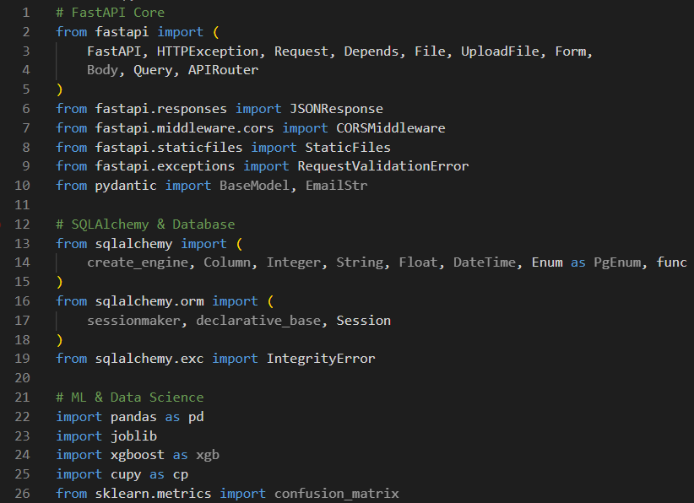

Figure : Main.py Imports 1

The first section of imports for the main.py establishes the main components of the FastAPI backend. Such imports enable the system to process HTTP requests as well as upload and respond to JSON effectively. The second section of imports loads SQLAlchemy modules into the system. These are mainly used for interactions with the database such functions related to input, output and manipulation of data present in the tables of the database. The third section of imports focuses on machine learning and data science libraries. These are used to load AI/ML models, measure accuracy of models and other data analysis and model functions.

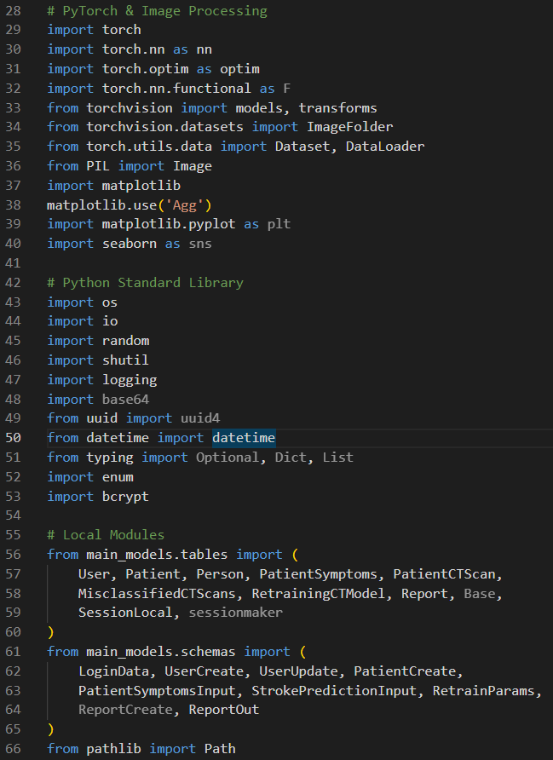

Figure : Main.py Imports 2

The fourth section imports pytorch and image processing modules. These are mostly applied to the CT Scan Model to retrain the model and manipulation of image size and quality of uploaded images. The fifth section imports general python modules such as random, implementation of I/O and time monitoring. In addition to that, bcrypt is also imported to allow for a more secure password hashing. The Sixth Section imports local models stored in the system such as local database models stored in tables.py and data schemes stored in schemas.py

Initialization

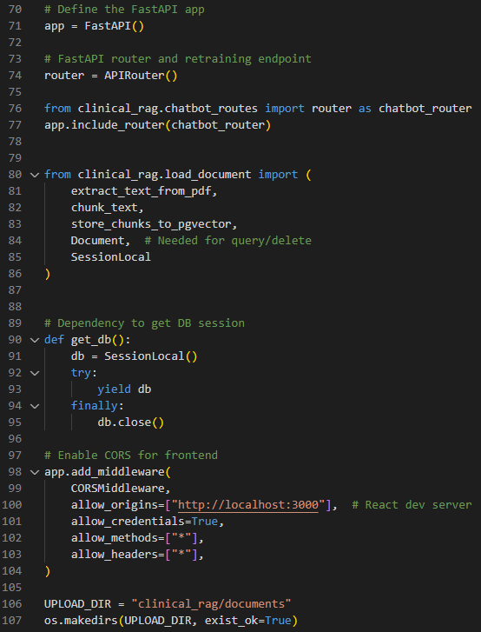

Figure : Main.py Initialization

Initialization Section sets up the FastAPI application as well as the router to group the API endpoints. The chatbot_router from chatbot_router.py is also imported here so that the system can use its endpoints when performing specific user cases. In addition to that, numerous functions of load_document.py are also imported to for RAG based functions. The get_db is also defined as a dependency that provides database sessions for each request to ensure that the sessions are properly closed and open.

CORS (Cross-Origin Resource Sharing) middleware is also set up to accept the requests from React frontend to allow proper access to all the HTTP methods for smoother interactions between backend and frontend. UPLOAD_DIR is also set to the correct folder to allow RAG documents to be saved.

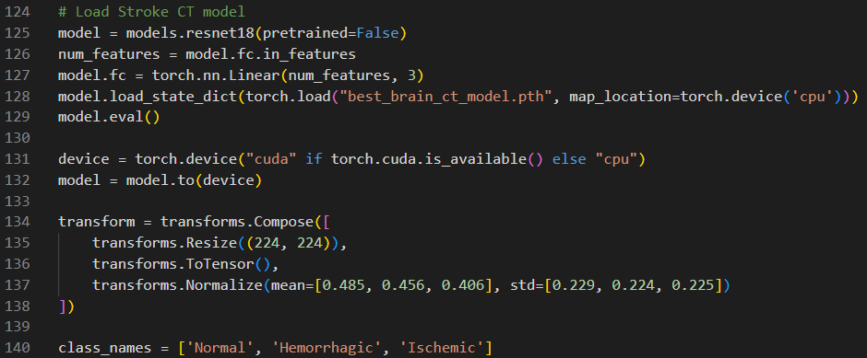

Figure : Main.py Load Stroke CT Model

The Load Stroke CT Model function is responsible for loading the pre-trained deep learning model (ResNet-18) for stroke classification. Initially the model is loaded without any pre-trained weights, but the model weights are added through best_brain_ct_model.pth which was the output during the CT Scan Model development. This makes the pre-trained model into a custom model by making it compatible with the dataset. In addition to that image preprocessing steps are also applied before the use of the model which includes the use of transforms.compose to resize the photo into the appropriate size learnt by the CNN model.

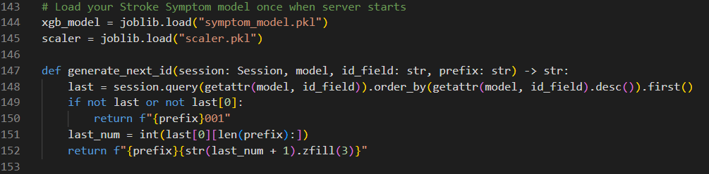

Figure : Main.py Load Stroke Symptom Model

The Load Stroke Symptom Model function is responsible for initializing the stroke-based symptom regression model and for an additional function of the generation of a unique ID for the patient_symptom table. The function initializes and loads the XGBoost model under the name of symptom_model.pkl and the scaler model scaler.pkl which was trained in the last section. This is then actively used in numerous route functions later in main.py

Routes

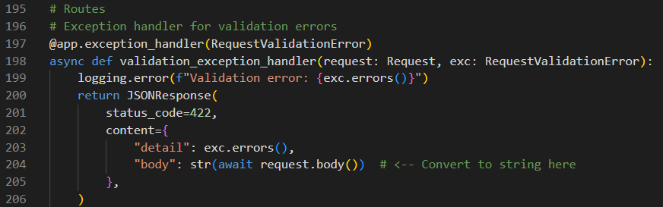

Figure : Main.py Exception Handler

This code script is used to as a custom exception handler for handling validation errors related to API request fails for Pydantic validation in FastAPI.

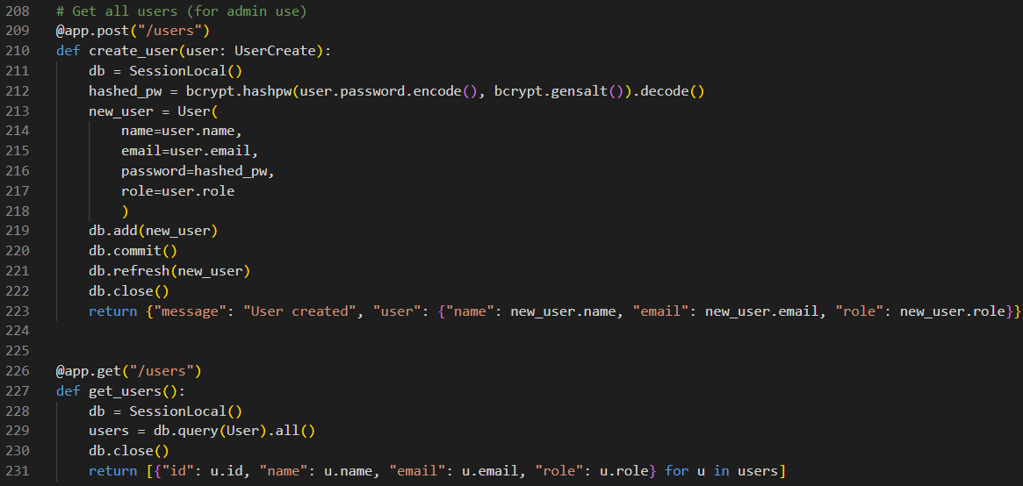

Figure : Main.py Admin User Routes

The app.post(“/users”) route is used for registering new users in the system meanwhile the app.get(“/users”) route is used fetch and return the list currently available users present in the database.

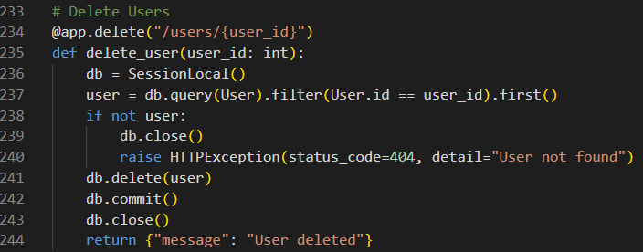

Figure : Main.py Delete Users

This route is used by the admin user to delete a user record by the ID. This deletes the user permanently from the database.

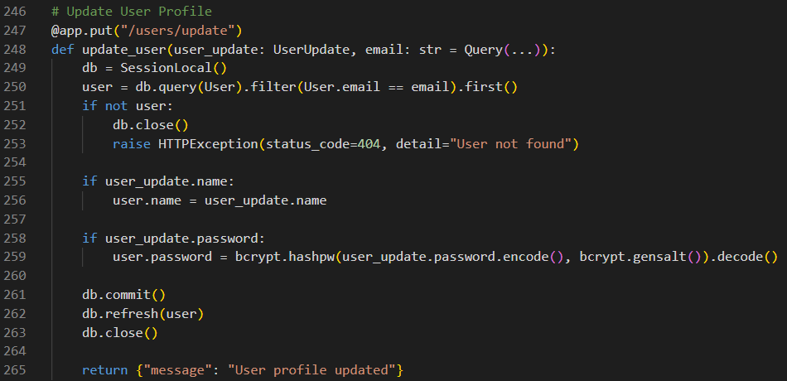

Figure : Main.py Update User Profile

This route is used for handling profile data of a user through their email. This route first fetches user data through their unique email address and allows the user to change their password and username from the database.

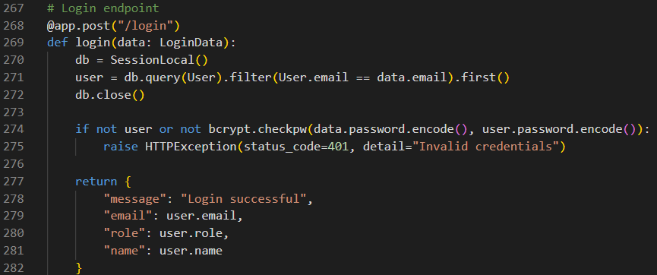

Figure : Main.py Login Endpoint

This route function acts as the main login endpoint that handles user authentication. It uses the LoginData Schema and connection with the database to check if the entered email and password are in the system. It will return an error message if credentials are incorrect.

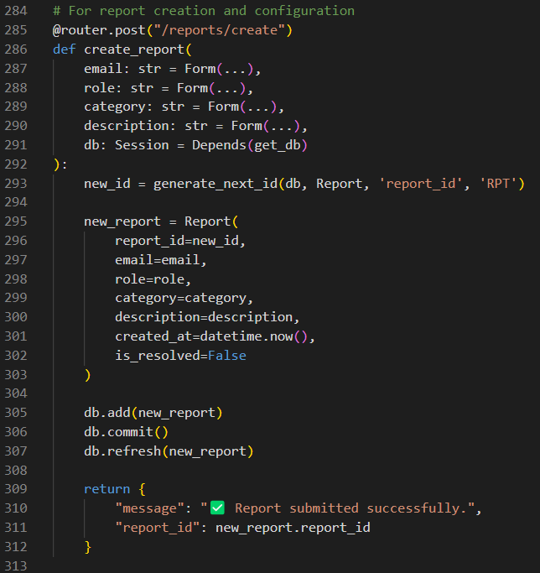

Figure : Main.py Report Creation and Configuration

This route function defined at this endpoint is used for Doctors and Supervisors to submit reports based on system bugs, suggestions and issues. In addition to that the report ID is also automatically generated with the prefix of “RPT” applied to it. Afterwards the data is saved on the database alongside a timestamp for the submission.

.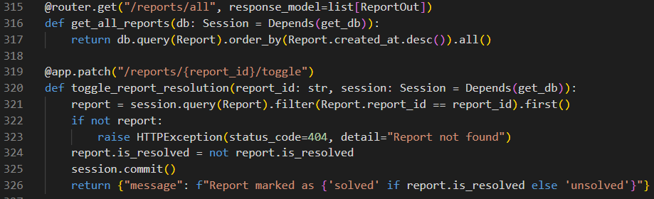

Figure : Main.py Report Functions

The first route get(“/reports/all”) is used alongside ReportOut Pydantic model by the admin user to get all the report available in the database. The second route (“reports/toggle”) is used to allow toggling of the status of the report from “unsolved” to “solve” or vice versa. Any changes made is then saved in the database.

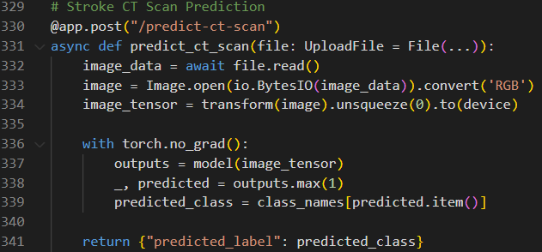

Figure : Main.py Stroke CT Scan Prediction

This route ties in with CT Scan model, when the user send a PNG file this route endpoint is used to communicate with the main CT Scan classification model which applies necessary transformations to the image and predicts the type of stroke the patient has.

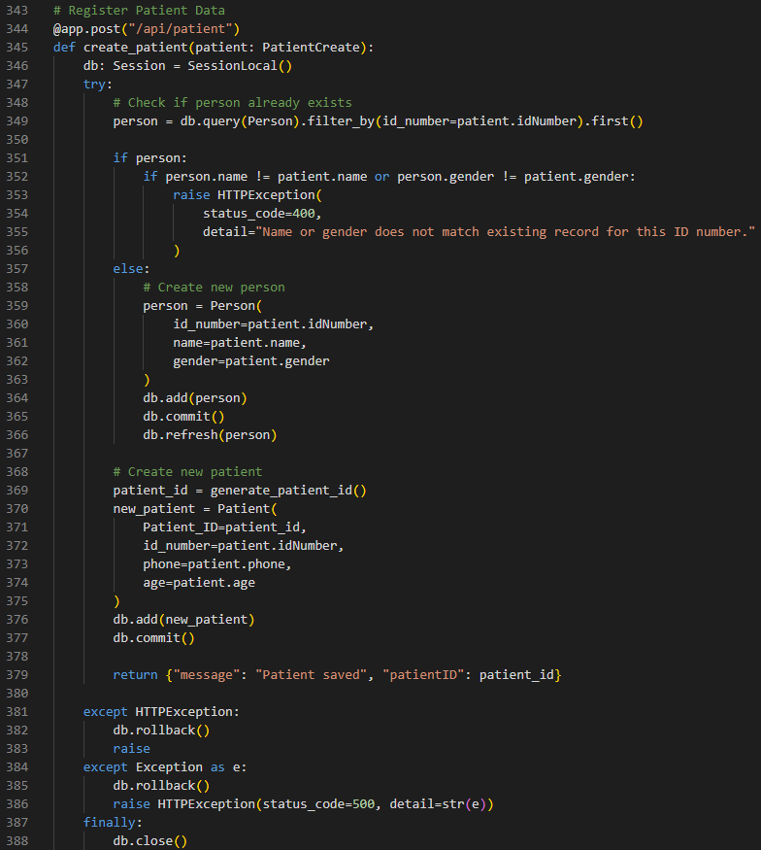

Figure : Main.py Register Patient Data

This route endpoint is used to register new patient data in the database. Firstly, it checks if there is a record in the Person table with the same input ID number. If there is a record in the database and the name and gender do not match, an error message is shown. If there is no record of the ID number a new person record is created. Afterwards the system creates a unique Patient_ID and then creates a patient record for the successfully registered patient in the database.

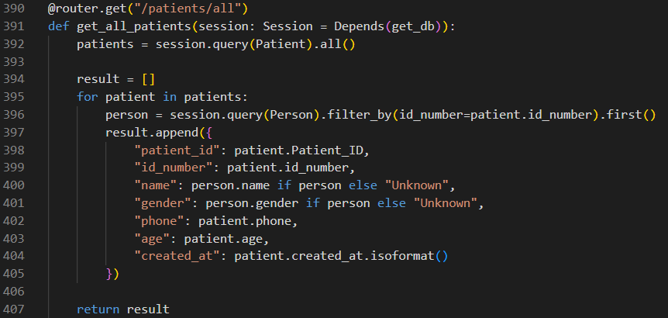

Figure : Main.py Get All Patients

For this route endpoint all the registered patient record alongside their corresponding person data information such as id_number and name are fetched from the database and displayed in the JSX frontend.

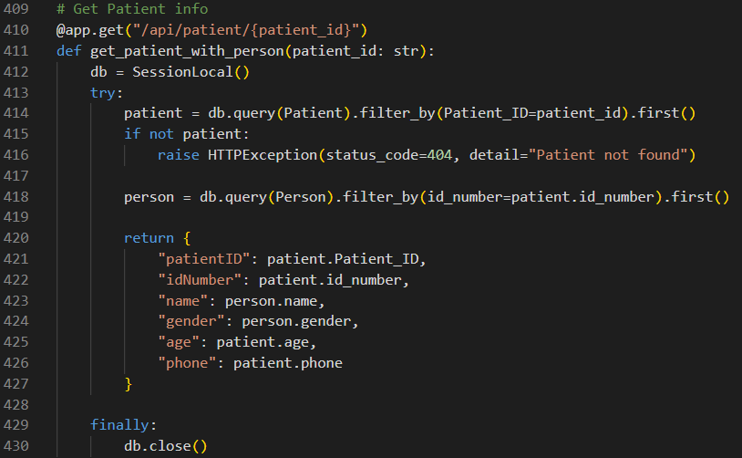

Figure : Main.py Get Patient Information

This route endpoint functions similarly to the last route endpoint but instead of displaying all the registered patients and their person table details, only the selected patient data through their unique patient_id is shown.

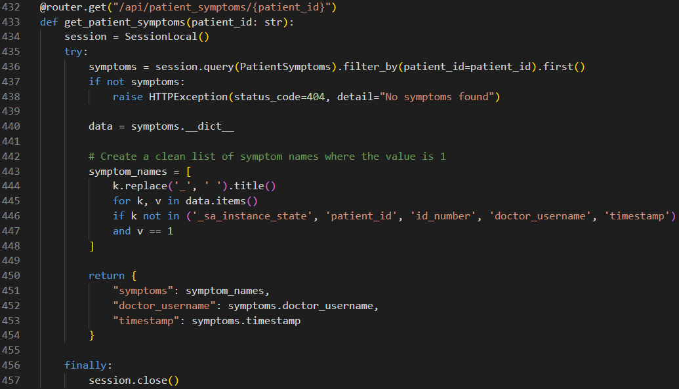

Figure : Main.py Get Patient Symptoms

This route endpoint functions as an extension of the last route endpoint where the system retrieves the recorded patient symptom data from the patient_symptom table based on their unique patient_id. In addition to showcasing symptoms the system will also showcase the doctor_username of the doctor who recorded the data as well as the timestamp the record was created.

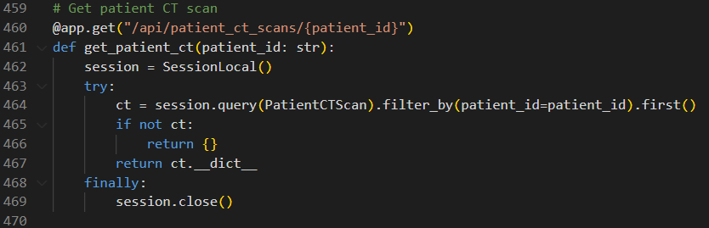

Figure : Main.py Get Patient CT Scans

This route endpoint works similarly to the last route endpoint but instead of using the patient_symptom table the patient_ct_scan table is used to showcase the image of the patient’s CT scan, the classification of the image, name of the doctor and timestamp the record was created.

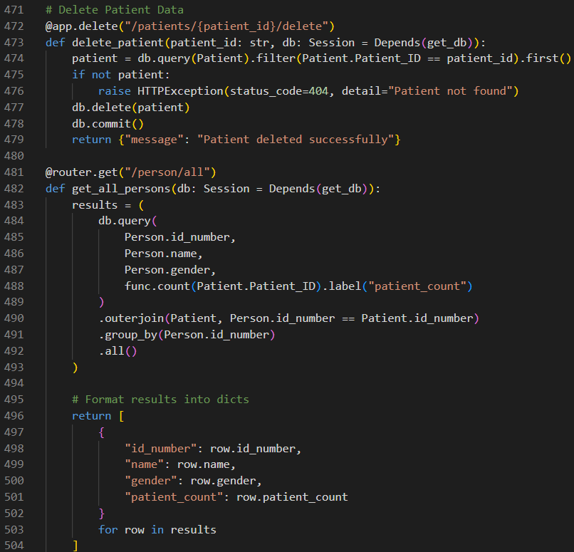

Figure : Main.py Delete Patient/ Get Person Data

The first route endpoint about patients is used to delete patient records from the database. By deleting patient records, the patient_symptom record and patient_ct_scan record from the individual user is also automatically deleted due to the ORM mentioned before in the tables.py. The second route endpoint focuses on retrieval of all entries available in the person table along with the number of linked patients each record has.

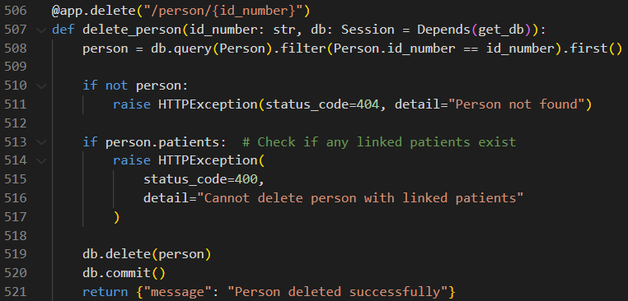

Figure : Delete Person Data

This route endpoint allows the deletion of person record based on their id_number. This is only allowed if the person record does not contain any linked patient record that has the same id_number.

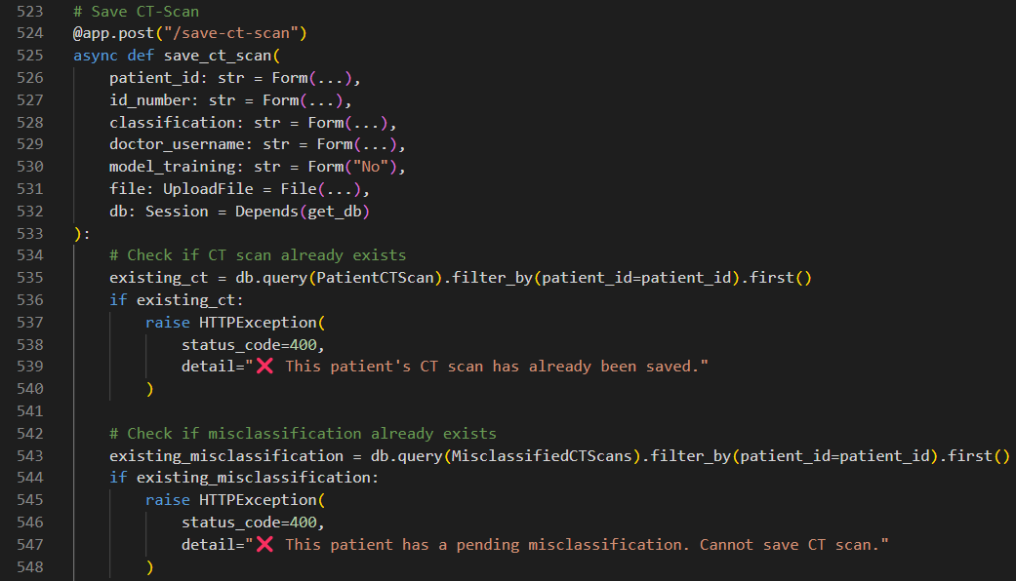

Figure : Main.py Save CT Scan 1

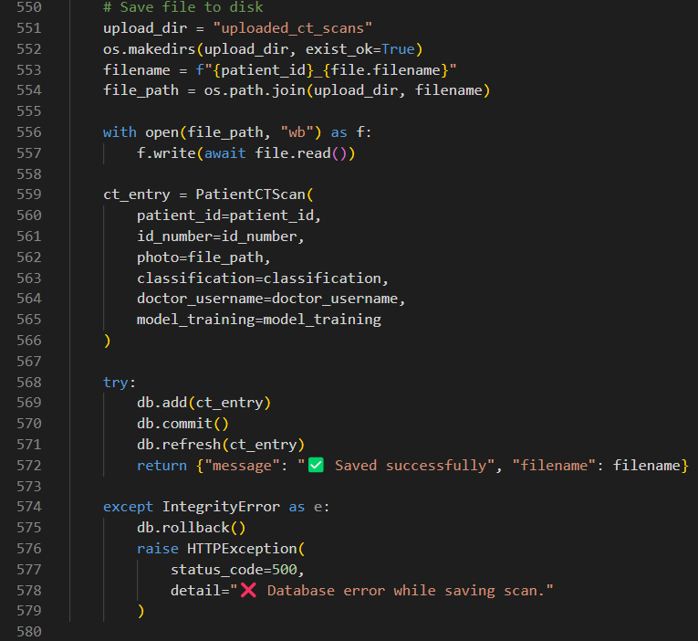

Figure : Main.py Save CT Scan 2

This route endpoint allows the user to save the patient’ CT scan image alongside additional information such as the name of the doctor who conducted the scan and timestamp. In addition to this a variable named model_training which will be set to “No” as default will also be saved so it can later be used for the model retraining function. The data is only saved if a previous CT scan image or pending misclassification record is not saved under the patient_id in the database.

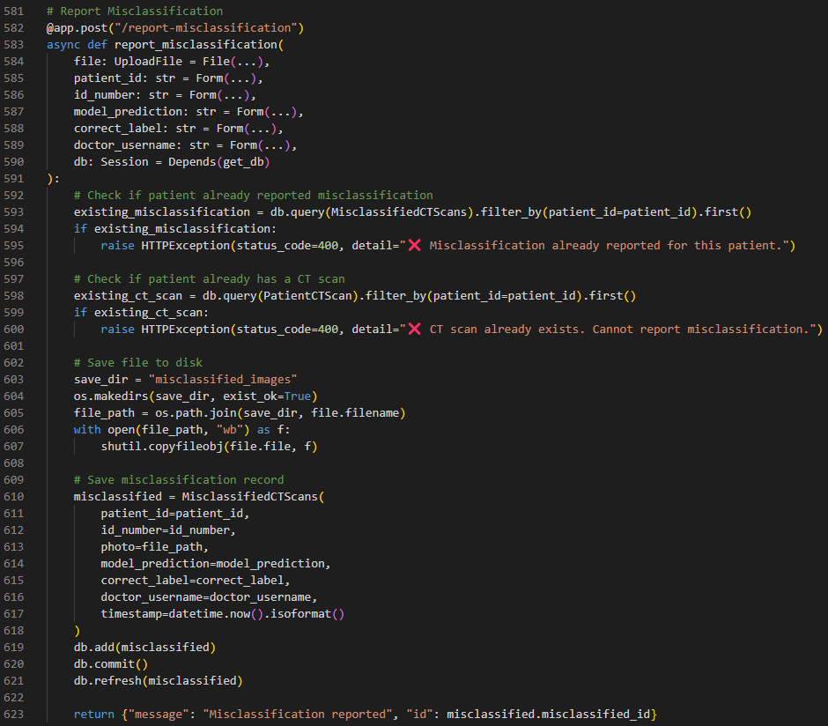

Figure : Main.py Report Misclassification

This route endpoint allows Doctor users to report any CT scan image that the model has incorrectly identified which is then saved as a new record in misclassified_ct_scans table. The record is only saved if a previous CT scan image or pending misclassification record is not saved under the patient_id in the database.

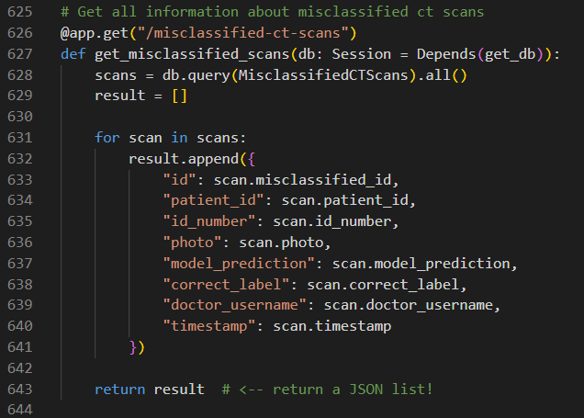

Figure : Main.py Get All Misclassification CT Scans

This route endpoint is used by the Supervisor user to retrieve all the records of the misclassified CT scans records from the database.

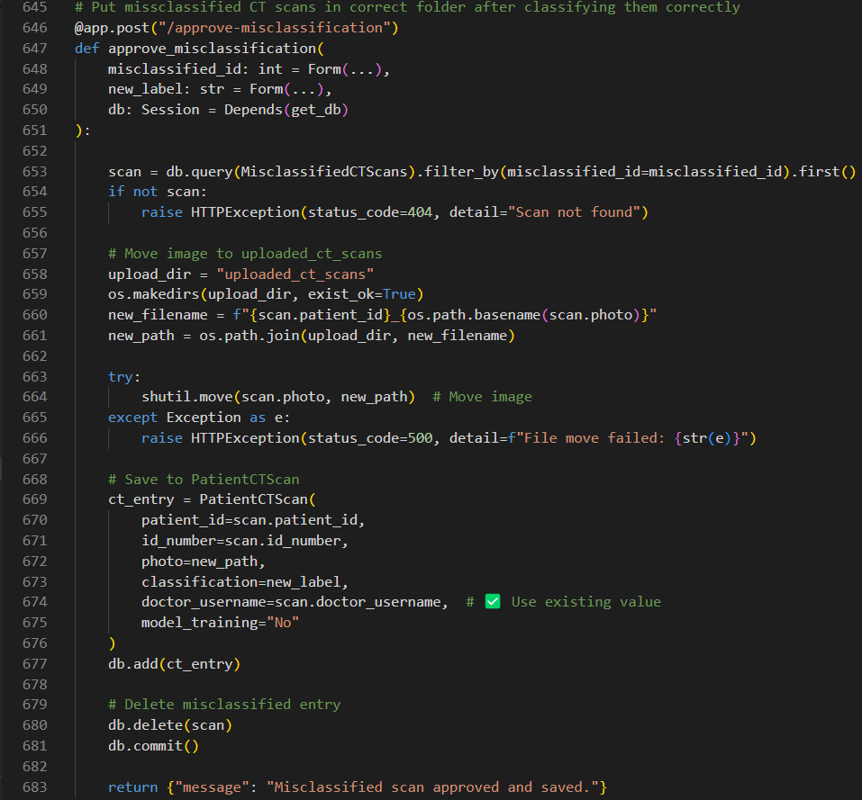

Figure : Main.py Approve Misclassification

This route endpoint is responsible for making the approval to correct misclassified CT scans present in the database. After the Supervisor conforms the corrected label or changes the label to another value the CT scan record and image path is moved from the misclassified_ct_scans table and image folder into the intended patient_ct_scans table and image folder. Once the new record is saved the old record is deleted from the database.

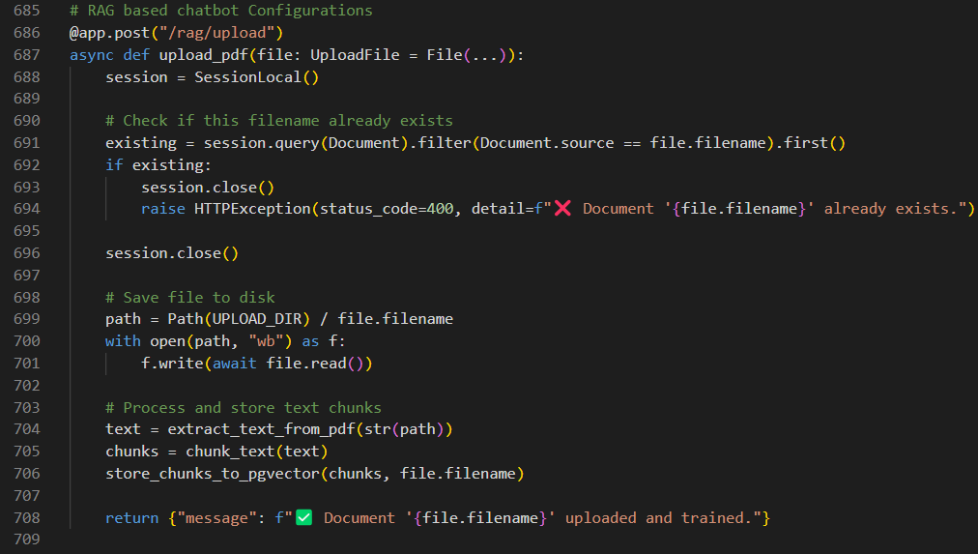

Figure : Main.py RAG Upload

This route endpoint is used to transfer the new uploaded PDF files into the vector database to be later used by the RAG based LLM chatbot. After the PDF document is uploaded by the Supervisor user the endpoint first checks if there is a file under the same name in the database, if there is an error message shown to the user to avoid duplication. If there is no error, then text will be extracted from the PDF document and divided into smaller chunks to be stored in the vector database with the help of pgvector. This is later used by the chatbot using semantic search

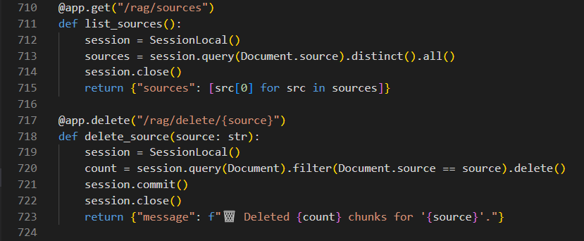

Figure : Main.py RAG Sources Routes

The first route endpoint is used to retrieve the list of unique document sources available in the database under documents table. This list is used to check what documents the chatbot is refereeing to when giving users responses. The second route endpoint is used to delete all text chunks which have the selected document source in the same record. This deletes the records completely from the database and displays how many chunks are deleted.

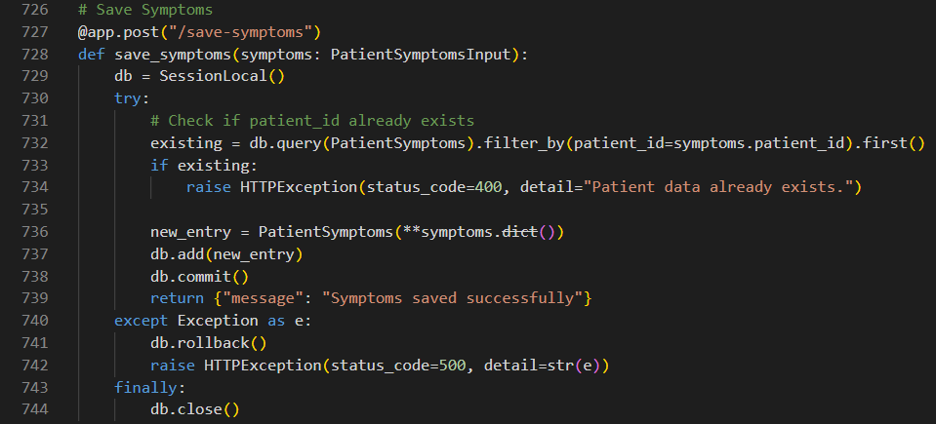

Figure : Main.py Save Symptoms

This route endpoint is used to save patient symptom records in the patient_symptom table through the individual’s unique patient_id which acts as the primary key of the record. If there is already a record with the same patient_id the request is denied and an error displayed. Otherwise a new record under the patient_id is crated in the database.

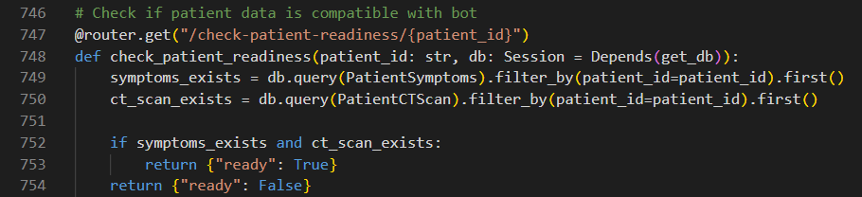

Figure : Main.py Check Patient Data Compatibility

This route endpoint is used to verify if a patient’s current medical records are complete and compatible with getting diagnosed by the chatbot. The endpoint verifies if the patient has both a patient symptom records and a patientCTScan record under the patient_id. If both records do not exist an error message is showcased until the fulfilments are completed.

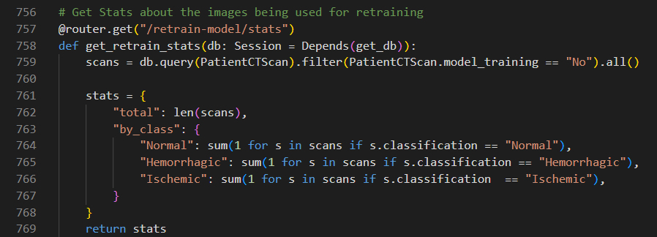

Figure : Main.py Model Retraining Stats

This route endpoint is used to provide Supervisors with statistical information regarding CT scan images which are ready to be used for retraining the model. CT scan records are filtered so that it will only allow images with model_training field set to “No”. Afterwards the total number of images are displayed based on three classifications, “Normal”, “Hemorrhagic” and “Ischemic”.

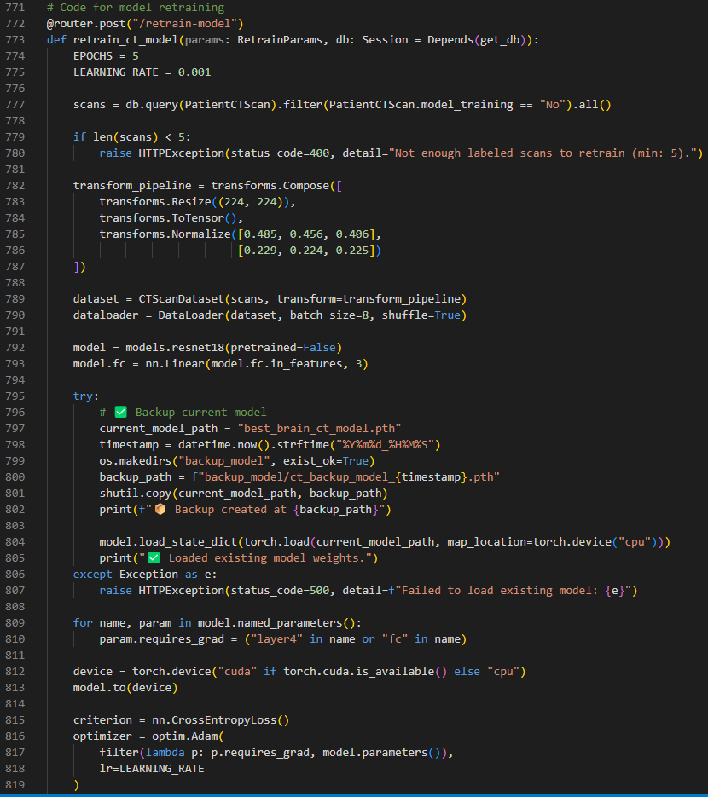

Figure : Main.py Model Retraining 1

This route endpoint acts as an extension for the last endpoint and is used for retraining the CT classification model based on the labeled CT image data present in the database. Firstly, the endpoint checks if at least 5 scan images are available to start the process. If the required number is met the images go through the image transforms similarly used last time. The endpoint then loads the ResNet18 model with the custom model wights. Afterwards the last layer of the CNN model (layer4 or fc) is unfrozen for fine tuning of the model. An option for the training to be done on GPU is also available if the requirements are met. In addition to that a backup is also taken of the current model and saved in the system incase the model needs to be used again.

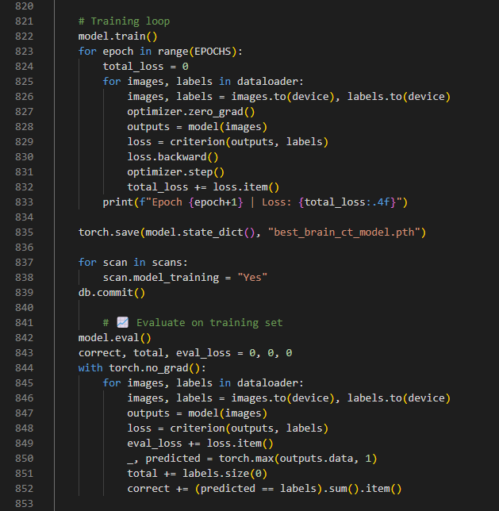

Figure : Main.py Model Retraining 2

Next would be the training section of the route endpoint where the model goes through a training process and the accuracy of the model is found. A training loop which consists of numerous epochs are executed and the loss is calculated using the cross-entropy while the wights are updated using backpropagation. Once the training is completed the new trained model wight will replace the older model wight by replacing the best_brain_ct_model.pth. This will allow the new model to be used in the system in real-time. In addition to that the CT scanned images which were used during the training have their model_training column turned to “Yes” in the database to prevent the images being available for retraining again.

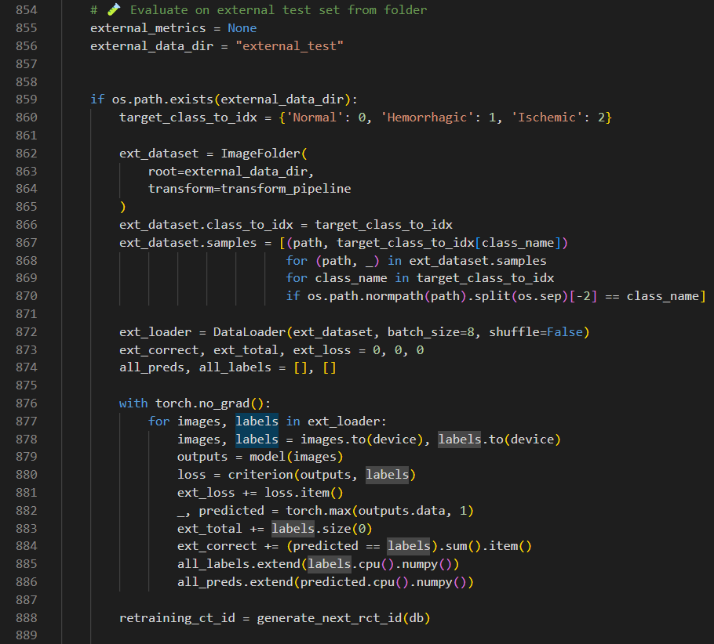

Figure : Main.py Model Retraining 3

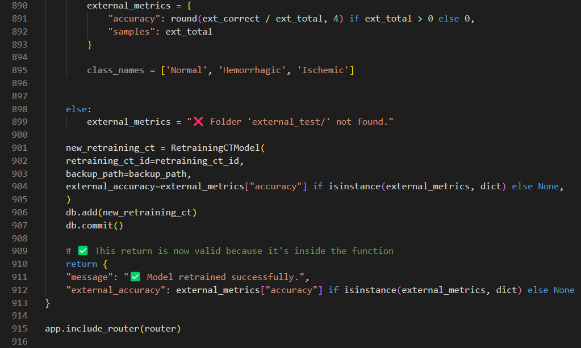

Figure : Main.py Model Retraining 4

The final part of the route endpoint involves testing the new model against external datasets to verify accuracy of the model. The external dataset in found in the external_test folder in the system and contains a total of 300 PNG images of the three different stroke types with each type having equal 100 images. The test data is automatically prepared by going through suitable transformations. Afterwards the final model prediction accuracy is measured and after evaluation the details about the retraining log will be recorded in the retraining_ct_model table.

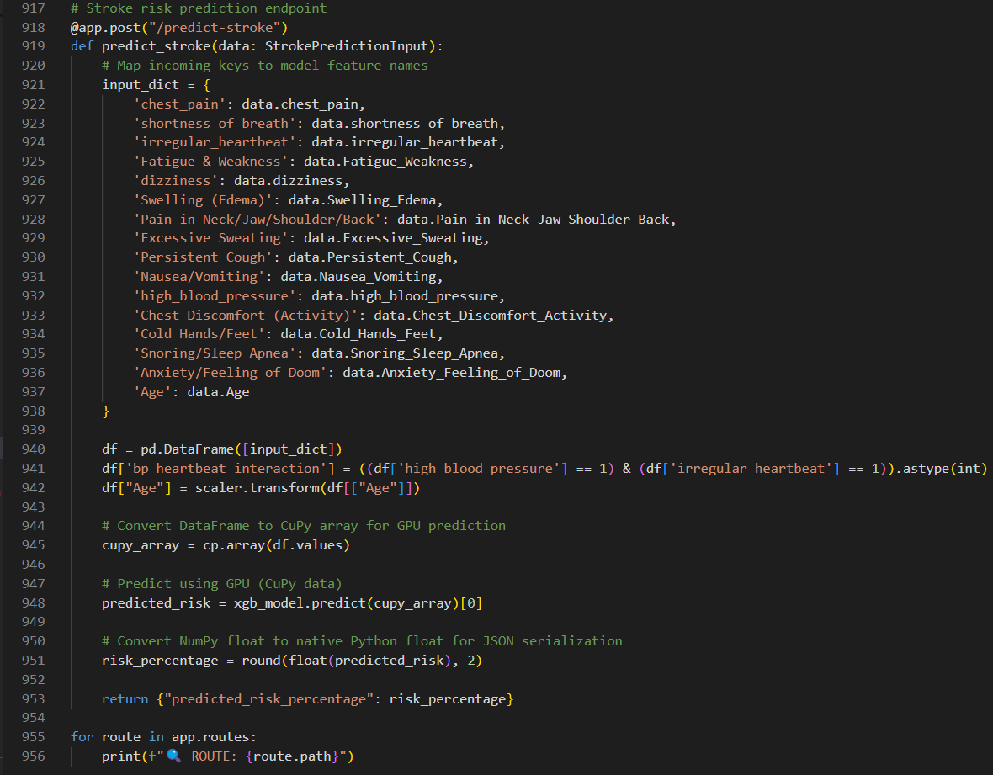

Figure : Main.py Stroke Risk Prediction

This route endpoint is mainly used to predict the percentage risk a patient has on having stroke based on their symptoms and age. This endpoint makes a direct connection to the XGBoost symptom_model,pkl to make the prediction. Firstly it takes the input gathered from the user from the frontend and preprocesses the data such as using the age scaler and adding another variable called bp heartbeat interaction by mixing high blood pressure and irregular heartbeat. This is done to mimic the procedure done during symptom_model training that was mentioned before to ensure all data matches with how the model was trained. Afterwards the data is converted to CuPy array for faster prediction of data using the GPU. The symptom_model is then used with the GPU to calculate the risk of stroke in percentage form. Afterwards the generated answer is displayed to the user.

### App.js

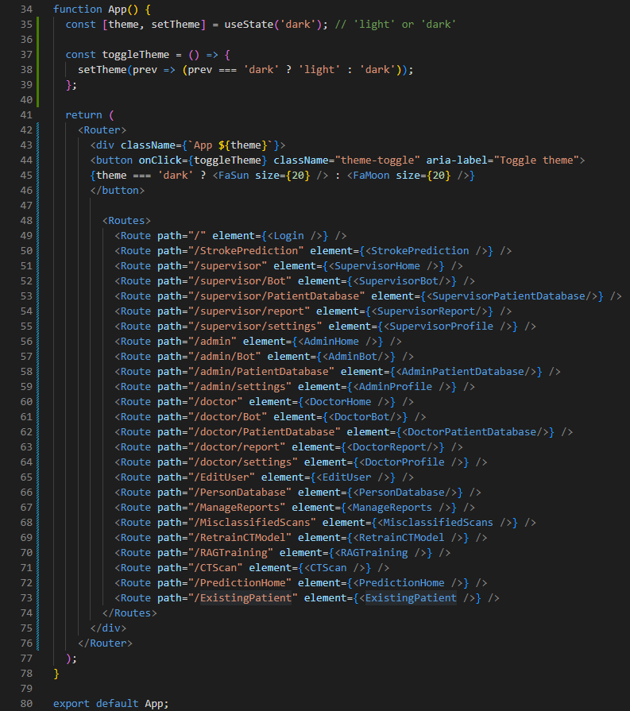

Figure : App,js routes

The App.js file contains the main routes of the .jsx react files which are used at the frontend. It allows frontend pages to communicate with each other and allows users to go from one page to the other. In addition to this, the toggle them feature to switch from dark mode to light mode and vice versa is also included in this page as this feature is consistent within all the pages of the system.

### Batch Files

Run_tables.bat

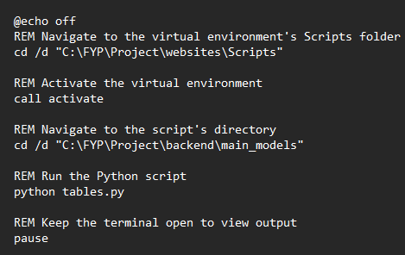

Figure : Run_tables.bat Code

This .bat file is the first file that users must run to get the system to work. It is used to automatically execute the python script for tables.py in a virtual environment which contains all the required libraries to run the system. This creates the required tables in the PostgreSQL database and connects it to the system. Users can replace parts of the code with their own virtual environment and database to execute the .bat file without any errors.

Add_admin.bat

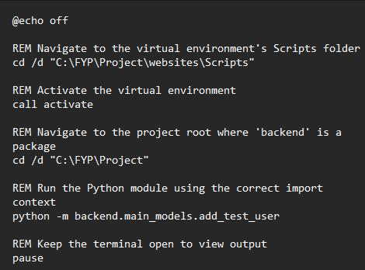

Figure : Add_admin.bat Code

This is the second .bat file users must run to add the first user into the system. It runs the python script add_test_user.py which adds the user with the name “Admin”, email “admin@hotmail.com”, hashed password “admin”, with the role of admin. Users can then login to the system using the email and password mentioned above to create users and make more adjustments to the system later.

Start_app.bat

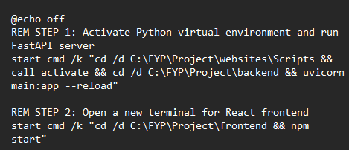

Figure : Start_app.bat Code

Lastly, this .bat file is executed after the other two batch files which start up the system by starting both FastAPI backend and the React frontend simultaneously. The user must wait till the backend has started to use the frontend properly which may take a significant period of time due to the time required to load the LLM chatbot and connect to the database. Any error that occurs is then logged in on the terminal as well.

## Summary

Chapter 4 provided a comprehensive explanation of the design and implementation of the overall system. Firstly, the system design was explained which included details about the system architecture and the 31 use cases of the system. These use cases were explained in more detail using case diagrams, use case specifications and activity diagrams. Afterwards a thorough explanation of the database design is provided showcasing an entity relationship diagram as well as information about the tables present in the database through data dictionaries for each table.

The chapter also covered the interface design of the system shedding more light into how the menu design and functions work as well as how the main UI of the system is connected through the system page navigation section. The implementation of the system is also showcased in the system which includes the frontend functions and how user interface is applied to these functions. The three core AI/ML models are also explained in this section for added transparency on how these models work in the system. Finally, the backend functions for the system are explained in the last section. This includes full explanation of the codes alongside their respective screenshots for tables.py, schemas.py, chatbot_routes.py, main.py, App.js and Batch files. In General chapter 4 plays an essential role in the documentation for understanding both frontend and backend functions of the system as well as how they are integrated and connected to each other.

# RESULT AND DISCUSSION

## Introduction

This chapter focuses on explaining the results gathered from testing the finished system. The chapter demonstrates the way the system acted during the testing showing real outputs and results. This is used to check if the system meets the required standards and goals set during the start of the project. All the test results are explained thoroughly for added clarity

The chapter also includes two key categories unit testing and user acceptance testing. Firstly, for the unit testing only one component of the system is tested each time while for user acceptance testing real external users will test the system to check if the system meets the required objectives and runs smoothly. Both tests are conducted to check the user friendliness and reliability of the system. All the outcomes are recorded and evaluated in this chapter for improvement of the system.

## Test Plan

### Unit Testing

The first level of testing for this chapter involves unit testing where one part or unit of the system is tested to check if it is responding the way it was developed to do. For a medical system such as stroke detection system unit testing becomes essential before deploying as a small error could cause delays or incorrect output from the system impacting the overall workflow of the hospital/clinic. As such it becomes necessary to prove the accuracy and reliability of each individual component of the system. These components include CT scan classification page, stroke risk prediction by symptom page, RAG-based LLM chatbot responses, data storage of patient’s medical history and other important components in the system. Each of these are tested thoroughly and the results with context are recorded on a unit testing table.

|  |  |  |  |  |  |
| --- | --- | --- | --- | --- | --- |
| **T.ID** | **Test Case** | **Test Data** | **Predicted Results** | **Returned Results** | **Status (Pass/Fail)** |
| 1.1 |  |  |  |  |  |
| 1.2 |  |  |  |  |  |

Table : Unit Testing Table Example

To carry out unit testing efficiently each test case is separated and tested with different test data to evaluate if the returned results are similar to the predicted results. Afterwards the status of the test is recorded as either a pass or fail. Overall unit testing helps to create a strong trust for the system before deployment, which is essential in the medical field.

### User Acceptance Testing

The second level of testing for this chapter involves the use of User Acceptance Testing (UAT) which is another important part of system validation that involves the testing of the system focused on meeting the end user requirements. UAT places a higher emphasis on user opinions and reviews unlike unit testing which focuses on testing the technical functions of the system. UAT is performed from the end-user’s perspective (from volunteers) which is used to simulate how the system would work in real-life scenarios when the system is deployed.

The UAT done for this system was carried out by a selected group of users which have experience in the medical field or experience using medical related systems. The tests will be conducted using Microsoft Teams screen control to allow testers to get full access of the system. Instead of getting results from each individual component UAT is designed to get individual user opinion on the overall system such as overall user interface and functionality of the system. User reviews will be fully recorded using a structured UAT form, and all individual testers will be given an option to test the system using all available roles. Overall, the UAT testing ensures that the system fully functions for its targeted userbase.

|  |  |
| --- | --- |
| **Tester Demographic Profile** | |
| **Name:** |  |
| **Age:** |  |
| **Occupation:** |  |
| **Date of Testing:** |  |

Table : UAT User Demographic Profile Example

The rating of the scale would be based on as below:

1. Strongly Disagree
2. Disagree
3. Neutral
4. Agree
5. Strongly Agree

|  |  |  |  |  |  |  |
| --- | --- | --- | --- | --- | --- | --- |
|  | **User Interface Criteria** | **1** | **2** | **3** | **4** | **5** |
| **Ⅰ** | The layout of the system is well organized and easy to use |  |  |  |  |  |
| **Ⅱ** | The overall color, fonts and design look easy to view |  |  |  |  |  |
| **Ⅲ** | The system offers easy navigation between its pages |  |  |  |  |  |
| **Ⅳ** | The interface is consistent for all pages |  |  |  |  |  |

Table : UAT User Interface Criteria Example

|  |  |  |  |  |  |  |
| --- | --- | --- | --- | --- | --- | --- |
|  | **System Functionality Criteria** | **1** | **2** | **3** | **4** | **5** |
| **Ⅰ** | User actions are confirmed and displayed on screen |  |  |  |  |  |
| **Ⅱ** | The system prevents wrong input and displays why the input was wrong on screen |  |  |  |  |  |
| **Ⅲ** | Users can submit PDF and PNG files without errors |  |  |  |  |  |
| **Ⅳ** | System responses and outputs are received quickly |  |  |  |  |  |
| **Ⅴ** | Key functions of the system work as intended |  |  |  |  |  |

Table : UAT System Functionality Criteria Example

|  |  |  |  |  |  |  |
| --- | --- | --- | --- | --- | --- | --- |
|  | **AI Model Functionality Criteria** | **1** | **2** | **3** | **4** | **5** |
| **Ⅰ** | Stroke risk percentage prediction results are consistent and easy to understand |  |  |  |  |  |
| **Ⅱ** | CT scan classification results are consistent and easy to understand |  |  |  |  |  |
| **Ⅲ** | The retraining functions (CT model retraining/RAG training) work as intended |  |  |  |  |  |
| **Ⅳ** | The chatbot responds clearly and correctly to medical related questions |  |  |  |  |  |
| **Ⅴ** | The chatbot responds well to combined patient medical records. |  |  |  |  |  |

Table : UAT AI Model Functionality Criteria Example

|  |  |  |  |  |  |  |
| --- | --- | --- | --- | --- | --- | --- |
|  | **Overall User Experience** | **1** | **2** | **3** | **4** | **5** |
| **Ⅰ** | The overall system functions align well with SDG 3: Good Health and Well-Being |  |  |  |  |  |
| **Ⅱ** | The system can accommodate both technical and non-technical users |  |  |  |  |  |
| **Ⅲ** | The system meets user expectations and can overall help doctors with tasks related to stroke and stroke prediction |  |  |  |  |  |

Table : UAT Overall User Experience Example

|  |
| --- |
| **Tester Feedback/Suggestions** |
|  |

Table : UAT Tester Feedback/Suggestions Example

Tester’s Signature:

## Testing Results and Discussion

### Unit Testing

#### Login

|  |  |  |  |  |  |
| --- | --- | --- | --- | --- | --- |
| **T.ID** | **Test Case** | **Test Data** | **Predicted Results** | **Returned Results** | **Status (Pass/Fail)** |
| 1.1 | Fill the fields with valid credentials | Email: admin@hotmail.com  Password: admin | Logged in system successfully | Predicted Results | Pass |
| 1.2 | Leave both field blank | Email: (empty)  Password: (empty) | Error text “Please fill in both fields.” | Predicted Results | Pass |
| 1.3 | Do not use “@” for email | Email: adminhotmail.com | Error message “Please include “@” in the email address | Predicted Results | Pass |
| 1.4 | Incorrect password | Email: admin@hotmail.com  Password: 123 | Error text “Invalid credentials” | Predicted Results | Pass |
| 1.5 | Incorrect Email | Email: Hello@hotmail.com  Password: admin | Error text “Invalid credentials” | Predicted Results | Pass |

Table : Unit Testing - Login

#### Manage Users

|  |  |  |  |  |  |
| --- | --- | --- | --- | --- | --- |
| **T.ID** | **Test Case** | **Test Data** | **Predicted Results** | **Returned Results** | **Status (Pass/Fail)** |
| 2.1 | Navigation to “Manage Users” page | Select: “Manage Users” text on menu sidebar | Directed to “Manage Users” Page | Predicted Results | Pass |
| 2.2 | Fill the fields with valid credentials | Name: Aisha  Email: Aisha@hotmail.com Password: hello1234  Role: Supervisor | User registered in system successfully and displays alert “User registered” | Predicted Results | Pass |
| 2.3 | Leave all fields blank | All fields: (empty) | Error alert “Please fill in all fields.” | Predicted Results | Pass |
| 2.4 | Do not use “@” for email | Email: Aishahotmail.com | Error alert “Please enter a valid email address (must contain @”) | Predicted Results | Pass |
| 2.5 | Name field contains symbols | Name: $ara | Error alert “Name must only contain letters and spaces” | Predicted Results | Pass |
| 2.6 | Name field contains numbers | Name: 5ara | Error alert “Name must only contain letters and spaces” | Predicted Results | Pass |
| 2.7 | Password less than 6 characters | Password: Hi12 | Error alert “Password must be at least 6 characters long” | Predicted Results | Pass |
| 2.8 | Use same user email registered in database | Email: admin@hotmail.com | Error alert “Failed to create user” | Predicted Results | Pass |
| 2.9 | Delete user from system | Select: “trashbin” icon near user row | Displays text “User deleted successfully” and deletes user from system | Predicted Results | Pass |
| 2.10 | Cancel delete user | Select: “cancel” when confirmation is given to delete user | Removes the alert and prevents deletion of user | Predicted Results | Pass |

Table : Unit Testing - Manage Users

#### Change Profile Settings

|  |  |  |  |  |  |
| --- | --- | --- | --- | --- | --- |
| **T.ID** | **Test Case** | **Test Data** | **Predicted Results** | **Returned Results** | **Status (Pass/Fail)** |
| 3.1 | Navigation to “Change Profile Settings” page | Select: “gear” icon on menu sidebar | Directed to “Change Profile Settings” Page | Predicted Results | Pass |
| 3.2 | Change username | Old name: Admin  New name: Ahmed | Displays text “Profile updated successfully” and database values are changed | Predicted Results | Pass |
| 3.3 | Change user password | Old password: admin  New password: Admin12345  Confirm password: Admin12345 | Displays text “Profile updated successfully” and database values are changed | Predicted Results | Pass |
| 3.4 | Different input in new password and Confirm password field | New password: Admin12345  Confirm password: Admmin123451 | Displays text error “Passwords do not match” | Predicted Results | Pass |

Table : Unit Testing - Change Profile Settings

#### Switch Themes

|  |  |  |  |  |  |
| --- | --- | --- | --- | --- | --- |
| **T.ID** | **Test Case** | **Test Data** | **Predicted Results** | **Returned Results** | **Status (Pass/Fail)** |
| 4.1 | Switch to light mode | Select: “sun” icon on top right corner of any page | Changes UI to light mode | Predicted Results | Pass |
| 4.2 | Switch to dark mode | Select: “moon” icon on top right corner of any page | Changes UI to dark mode | Predicted Results | Pass |

Table : Unit Testing - Switch Themes

#### Chat with RAG Medical Chatbot

|  |  |  |  |  |  |
| --- | --- | --- | --- | --- | --- |
| **T.ID** | **Test Case** | **Test Data** | **Predicted Results** | **Returned Results** | **Status (Pass/Fail)** |
| 5.1 | Navigation to “Medical Chatbot” page | Select: “robot” icon on menu sidebar | Directed to “Medical Chatbot” Page | Predicted Results | Pass |
| 5.2 | Valid medical question is asked | Question: “What is stroke” | Correct answers with the relevant source documents are showcased | Predicted Results | Pass |
| 5.3 | Valid medical questions are asked without being trained on any medical documents | Question: “What is stroke” | Correct answers are given but without any document sources | Predicted Results | Pass |
| 5.4 | Empty field for question | Question: (empty) | No respond from chatbot | Predicted Results | Pass |
| 5.5 | Continuous questions are sent to the chatbot at the same time | Question 1: “What is stroke”  Question 2: “What is stroke” | The chatbot responds with "The assistant is currently processing another request. Please wait." | Predicted Results | Pass |

Table : Unit Testing - Chat with RAG Medical Chatbot

#### Report Issue

|  |  |  |  |  |  |
| --- | --- | --- | --- | --- | --- |
| **T.ID** | **Test Case** | **Test Data** | **Predicted Results** | **Returned Results** | **Status (Pass/Fail)** |
| 6.1 | Navigation to “Report Issue” page | Select: “Exclamation” icon on menu sidebar | Directed to “Report Issue” Page | Predicted Results | Pass |
| 6.2 | Fill the fields with valid credentials | Category: “CT Model”  Description “There is a network error shown when I enter the page” | A new record is made in the reports table with this information | Predicted Results | Pass |
| 6.3 | Leave all fields blank | Category: (empty)  Description: (empty) | Error message “Please fill in all fields” is shown | Predicted Results | Pass |

Table : Unit Testing - Report Issue

#### Manage Reports

|  |  |  |  |  |  |
| --- | --- | --- | --- | --- | --- |
| **T.ID** | **Test Case** | **Test Data** | **Predicted Results** | **Returned Results** | **Status (Pass/Fail)** |
| 7.1 | Navigation to “Manage Reports” page | Select: “Manage Reports” text on menu sidebar | Directed to “Manage Reports” Page | Predicted Results | Pass |
| 7.2 | No reports available in database | Report table: (empty) | Shows only table columns | Predicted Results | Pass |
| 7.3 | Select “Solve”  toggle option from selected row | Toggle: Solve selected | Selected report row changes to solve from unsolve | Predicted Results | Pass |
| 7.4 | Select “Unsolve”  toggle option from selected row | Toggle: Unsolve selected | Selected report row changes to unsolved from solve | Predicted Results | Pass |

Table : Unit Testing - Manage Reports

#### Patient Database

|  |  |  |  |  |  |
| --- | --- | --- | --- | --- | --- |
| **T.ID** | **Test Case** | **Test Data** | **Predicted Results** | **Returned Results** | **Status (Pass/Fail)** |
| 8.1 | Navigation to “Patient Database” page | Select: “Patient Database” text on menu sidebar | Directed to “Patient Database” Page | Predicted Results | Pass |
| 8.2 | Appearance of “delete patient” button | Test 1: user role = Admin  Test 2: user role = Supervisor  Test 3: user role = Doctor | “Delete patient” only appears for Admin user, this button does not appear when other users enter the page. | Predicted Results | Pass |
| 8.3 | No record available in patients_data table | Patients_data table: (empty) | Shows only table columns | Predicted Results | Pass |
| 8.4 | Select “View”  Button option from selected row where the patient has both symptom model and CT model data saved | Patient row = patient_id saved in patient_data + patient_symptoms + patient_ct_scans table | Opens a modal containing patient information from three different tables separated into three sections | Predicted Results | Pass |
| 8.5 | Select “View”  Button option from selected row where the patient has no symptom model and/or CT model data saved | Patient row = patient_id saved in patient_data only | Opens a modal containing patient information from one table and a message that says, “No symptoms reported” and “No CT scan data available” | Predicted Results | Pass |
| 8.6 | Select “Print” button in modal popup | Select: Print button | Opens a new tab which allows the user to print details in modal page | Predicted Results | Pass |
| 8.7 | Select “close” button in modal popup | Select: close button | Closes the pop-up modal | Predicted Results | Pass |
| 8.8 | Select “delete patient” and confirm | Select: delete patient from patient row + select: confirm | Deletes the patient record from databases where Patient ID acts as primary and/or foreign key | Predicted Results | Pass |

Table : Unit Testing – Patient Database

#### Person Database

|  |  |  |  |  |  |
| --- | --- | --- | --- | --- | --- |
| **T.ID** | **Test Case** | **Test Data** | **Predicted Results** | **Returned Results** | **Status (Pass/Fail)** |
| 9.1 | Navigation to “Person Database” page | Select: “Person Database” text on menu sidebar | Directed to “Report Issue” Page | Predicted Results | Pass |
| 9.2 | No record available in person table | Person table (empty) | Message in page “No persons found” | Predicted Results | Pass |
| 9.3 | Selecting delete button on person with patient count > 0 | Person row = More than 1 record from patient_data linked | Delete button not functioning and greyed out | Predicted Results | Pass |
| 9.4 | Select “delete” and confirm | Select: delete button from patient row + select: confirm | Delete person record from database | Predicted Results | Pass |

Table : Unit Testing – Person Database

#### RAG Training

|  |  |  |  |  |  |
| --- | --- | --- | --- | --- | --- |
| **T.ID** | **Test Case** | **Test Data** | **Predicted Results** | **Returned Results** | **Status (Pass/Fail)** |
| 10.1 | Navigation to “Chatbot RAG Training” page | Select: “Chatbot RAG Training” text on menu sidebar | Directed to “Chatbot RAG Training” Page | Predicted Results | Pass |
| 10.2 | No record available in documents table | Documents table (empty) | Display message “No documents uploaded yet” | Predicted Results | Pass |
| 10.3 | Upload relevant PDF document to vector database | Select: Choose file button + select PDF file + Upload button PDF file chosen: stroke_causes_and_clinical_features.pdf | New records are created in the document table in the database storing chunks of text from PDF file | Predicted Results | Pass |
| 10.4 | “Upload & train” button pressed without any chosen PDF file | Select: Upload button first | The button is greyed out and the system ignores the user input | Predicted Results | Pass |
| 10.5 | Duplicate PDF file uploaded | PDF file choosen: stroke_causes_and_clinical_features.pdf again | Shows alert message “Document stroke_causes_and_clinical_features.pdf already exists” | Predicted Results | Pass |
| 10.6 | “Delete” button pressed | Select: Delete button pressed for stroke_causes_and_clinical_features.pdf row + select: confirm | Deletes all records in the document table under the PDF name and displays the alert message “Deleted” | Predicted Results | Pass |

Table : Unit Testing – RAG Training

#### CT Model Retraining

|  |  |  |  |  |  |
| --- | --- | --- | --- | --- | --- |
| **T.ID** | **Test Case** | **Test Data** | **Predicted Results** | **Returned Results** | **Status (Pass/Fail)** |
| 11.1 | Navigation to “CT Model Retraining” page | Select: “CT Model Retraining” text on menu sidebar | Directed to “CT Model Retraining” Page | Predicted Results | Pass |
| 11.2 | No image record is available for model retraining | All patient_ct_scan table records = model_training = “Yes” | The page is still displayed correctly and shows values 0 for all categories | Predicted Results | Pass |
| 11.5 | All requirements are fulfilled for model retraining | 10 CT scan records (3 normal, 3 ischemic, 4 hemorrhagic) + select retrain model button | The model is retrained successfully and shows the model accuracy | Predicted Results | Pass |
| 11.4 | Eligible images are less than 5 scans | > 5 patient_ct_scan table records = model_training = “No” + select: retrain model button | Error message is shown “Need atleast 5 eligible scans to retrain model” | Predicted Results | Pass |

Table : Unit Testing – CT Model Retraining

#### Misclassified Scans

|  |  |  |  |  |  |
| --- | --- | --- | --- | --- | --- |
| **T.ID** | **Test Case** | **Test Data** | **Predicted Results** | **Returned Results** | **Status (Pass/Fail)** |
| 12.1 | Navigation to “Misclassified Scans” page | Select: “Misclassified Scans” text on menu sidebar | Directed to “CT Model Retraining” Page | Predicted Results | Pass |
| 12.2 | No records in misclassified_ct_scan table | misclassified_ct_scan table (empty) | Displays message on page “No scans found” | Predicted Results | Pass |
| 12.4 | Change label and press “Approve & save” button | Select: drop down menu = Normal + select: Approve & save button | The record containing the image is transferred from misclassified table to the ct_scan table and model_training is set to “No” | Predicted Results | Pass |
| 12.3 | “Approve & save” button pressed without changing any labels | Select: Approve & save button | The value in the corrected label column of the record is selected by default and then follows the steps of T.ID 12.4 | Predicted Results | Pass |

Table : Unit Testing – Misclassified Scans

#### Register Patients/Person

|  |  |  |  |  |  |  |
| --- | --- | --- | --- | --- | --- | --- |
| **T.ID** | **Test Case** | **Test Data** | **Predicted Results** | **Returned Results** | | **Status (Pass/Fail)** |
| 13.1 | Navigation to “Stroke Prediction Hub” page | Select: “Stroke Prediction Hub” text on menu sidebar | Directed to “Stroke Prediction Hub” Page | | Predicted Results | Pass |
| 13.2 | Fill the fields with valid credentials | ID number: A563380  Patient Name: Jhonny Smith  Phone Number: 0149988329  Age: 21  Gender: Male | Patient is successfully registered. If the ID number was never registered in the system a person record is also created under the ID number. | | Predicted Results | Pass |
| 13.3 | Leave all fields blank | All fields: (empty) | Error alert “Please fill in all fields.” | | Predicted Results | Pass |
| 13.4 | Name field contains symbols | Patient Name: Jh@nny $mith | Error alert “Name must only contain letters and spaces” | | Predicted Results | Pass |
| 13.5 | Name field contains numbers | Patient Name: Jhonny 5555 | Error alert “Name must only contain letters and spaces” | | Predicted Results | Pass |
| 13.6 | Phone number less than 7 or more than 15 | Test 1: Phone Number:  123  Test 2: Phone number:  22222222222222222222222222 | Error alert “please enter valid phone number (only digits, 7-15)” | | Predicted Results | Pass |
| 13.7 | Letters used in phone number | Phone Number: seven seven two | Error alert “please enter valid phone number (only digits, 7-15)” | | Predicted Results | Pass |
| 13.8 | Entered Age less than 1 | Age:  0.5 | Error alert “Please enter a valid age” | | Error alert “Unexpected error occurred” | Fail |
| 13.9 | Person details do not match with database | **Database:**  ID number:  A563380  Name: Jhonny Smith  Gender: Male  **Input value:**  ID number:  A563380  Name: Jhonn Smith  Gender: Female | Error alert message “Name or gender does not match existing record for this ID number” | | Predicted Results | Pass |

Table : Unit Testing – Register Patient/Person

#### Register Existing Patient

|  |  |  |  |  |  |
| --- | --- | --- | --- | --- | --- |
| **T.ID** | **Test Case** | **Test Data** | **Predicted Results** | **Returned Results** | **Status (Pass/Fail)** |
| 14.1 | Navigation to “Access Existing User” page | Select: “Access Existing User” text inside the “Stroke Prediction Hub” page | Directed to “Access Existing User” Page | Predicted Results | Pass |
| 14.2 | Fill the patient ID field with valid credentials | Patient ID: P432940 | User is validated to enter either the stroke symptom model page or CT scan model page | Predicted Results | Pass |
| 14.3 | Leave the field blank | Patient ID: (empty) | Error alert message “Please enter a Patient ID” | Predicted Results | Pass |
| 14.4 | Invalid Patient ID entered | Patient ID: B500403 | Error alert “No patient found with that ID” | Predicted Results | Pass |

Table : Unit Testing – Register Existing User

#### Stroke CT Scan Model

|  |  |  |  |  |  |
| --- | --- | --- | --- | --- | --- |
| **T.ID** | **Test Case** | **Test Data** | **Predicted Results** | **Returned Results** | **Status (Pass/Fail)** |
| 15.1 | Navigation to “CT Scan Model” page | Select: “CT Scan Model” after patient registration | Directed to “CT Scan Model” Page | Predicted Results | Pass |
| 15.2 | Valid Image file is uploaded | Select: Choose file button + select Ischemic_stroke_example.png + Upload and Predict button | The CT Scan model is used by the system to predict the classification of stroke (ischemic in this test case) | Predicted Results | Pass |
| 15.3 | “Upload and Predict” button is pressed first | Select: Upload and Predict button | An error message is displayed “Please select an image” | Predicted Results | Pass |
| 15.4 | Another file format other than PNG is used | Select: choose file button + select JPG CT scan | Only PNG files show up during file searching | Predicted Results | Pass |
| 15.5 | “Confirm & Save” button is used for a valid image prediction | After T.ID 15.2 select: Confirm & Save button | A new record under the patient ID is made in the patient_ct_scans table for the selected image and classification | Predicted Results | Pass |
| 15.6 | “Confirm & Save” button is used for patient ID with already existing CT Scan records | After T.ID 15.2 select: Confirm & Save button | Displays the error “This patient’ CT scan has already been saved” or “Misclassification data already exists” | Predicted Results | Pass |
| 15.7 | “Report Misclassification” button is used | After T.ID 15.2 select: Report Misclassification button + Any chosen label from drop list | Allows the user to report classifications that the user deems misclassified and allows the user to choose any other classification label | Predicted Results | Pass |
| 15.8 | “Submit Correction” button is used | After T.ID 15.7 select: submit correction button | A new record under the patient ID is set up in the misclassified table for the misclassified data | Predicted Results | Pass |
| 15.9 | “Submit Correction” button is used for patient ID with already existing CT Scan records | After T.ID 15.7 select: submit correction button | Displays the error “This patient’ CT scan has already exists. Cannot report misclassification” or “Misclassification already reported for this patient” | Predicted Results | Pass |

Table : Unit Testing – Stroke CT Scan Model

#### Stroke Symptom Model

|  |  |  |  |  |  |
| --- | --- | --- | --- | --- | --- |
| **T.ID** | **Test Case** | **Test Data** | **Predicted Results** | **Returned Results** | **Status (Pass/Fail)** |
| 16.1 | Navigation to “Stroke Symptom Model” page | Select: “Stroke Symptom Model” after patient registration | Directed to “Stroke Symptom Model” Page | Predicted Results | Pass |
| 16.2 | Valid prediction is made and the “Save Data” button is pressed | Select: Appropriate labels for symptoms + select: Predict button + select: Save Data button | First the valid stroke risk percentage is generated by the stroke model and then the data long with the symptom and age is saved as a record in patients_symptoms table | Predicted Results | Pass |
| 16.3 | “Save Data” button pressed before any prediction | Select: Save Data button | Displays the alert message “Please generate the stroke prediction before saving” | Predicted Results | Pass |

Table : Unit Testing – Stroke Symptom Model

#### RAG Chatbot with Previous Model Data

|  |  |  |  |  |  |
| --- | --- | --- | --- | --- | --- |
| **T.ID** | **Test Case** | **Test Data** | **Predicted Results** | **Returned Results** | **Status (Pass/Fail)** |
| 17.1 | Activation of “MedicalBot” button with valid data | Select: MedicalBot button in either symptom model page or CT scan model page with records from both pages linked to the patient ID | Directed to “Medical Chatbot” Page alongside an automatically generated message called “Patient Summary” which consists of all the Patient medical history from the three tables. This is passed on to the chatbot model to generate a response. | Predicted Results | Pass |
| 17.2 | Activation of “MedicalBot” button with missing data from CT Scan record and/or symptom record | Select: MedicalBot button in either symptom model page or CT scan model page with a patient ID that has missing records. | Displays the alert message “ MedicalBot access requires both symptom and CT scan data” | Predicted Results | Pass |

Table : Unit Testing – RAG Chatbot with Previous Model Data

#### Logout

|  |  |  |  |  |  |
| --- | --- | --- | --- | --- | --- |
| **T.ID** | **Test Case** | **Test Data** | **Predicted Results** | **Returned Results** | **Status (Pass/Fail)** |
| 18.1 | Logout and navigate back to “Login” Page | Select: “logout” icon on menu sidebar | The user is logged out of the system and navigate to the login page where user must get authenticated to use the system again | Predicted Results | Pass |

Table : Unit Testing – Logout

### User Acceptance Testing

#### UAT Tester 1

|  |  |
| --- | --- |
| **Tester Demographic Profile** | |
| **Name:** | Abdulla Naail Niyaz |
| **Age:** | 26 |
| **Occupation:** | Medical Insurance Agent |
| **Date of Testing:** | 21/7/2025 |

The rating of the scale would be based on as below:

1. Strongly Disagree
2. Disagree
3. Neutral
4. Agree
5. Strongly Agree

|  |  |  |  |  |  |  |
| --- | --- | --- | --- | --- | --- | --- |
|  | **User Interface Criteria** | **1** | **2** | **3** | **4** | **5** |
| **Ⅰ** | The layout of the system is well organized and easy to use |  |  |  |  | x |
| **Ⅱ** | The overall color, fonts and design look easy to view |  |  |  |  | x |
| **Ⅲ** | The system offers easy navigation between its pages |  |  |  |  | x |
| **Ⅳ** | The interface is consistent for all pages |  |  |  |  | x |

|  |  |  |  |  |  |  |
| --- | --- | --- | --- | --- | --- | --- |
|  | **System Functionality Criteria** | **1** | **2** | **3** | **4** | **5** |
| **Ⅰ** | User actions are confirmed and displayed on screen |  |  |  |  | x |
| **Ⅱ** | The system prevents wrong input and displays why the input was wrong on screen |  |  |  |  | x |
| **Ⅲ** | Users can submit PDF and PNG files without errors |  |  |  |  | x |
| **Ⅳ** | System responses and outputs are received quickly |  |  |  |  | x |
| **Ⅴ** | Key functions of the system work as intended |  |  |  |  | x |

|  |  |  |  |  |  |  |
| --- | --- | --- | --- | --- | --- | --- |
|  | **AI Model Functionality Criteria** | **1** | **2** | **3** | **4** | **5** |
| **Ⅰ** | Stroke risk percentage prediction results are consistent and easy to understand |  |  |  |  | x |
| **Ⅱ** | CT scan classification results are consistent and easy to understand |  |  |  |  | x |
| **Ⅲ** | The retraining functions (CT model retraining/RAG training) work as intended |  |  |  |  | x |
| **Ⅳ** | The chatbot responds clearly and correctly to medical related questions |  |  |  |  | x |
| **Ⅴ** | The chatbot responds well to combined patient medical records. |  |  |  |  | x |

|  |  |  |  |  |  |  |
| --- | --- | --- | --- | --- | --- | --- |
|  | **Overall User Experience** | **1** | **2** | **3** | **4** | **5** |
| **Ⅰ** | The overall system functions align well with SDG 3: Good Health and Well-Being |  |  |  |  | x |
| **Ⅱ** | The system can accommodate both technical and non-technical users |  |  |  |  | x |
| **Ⅲ** | The system meets user expectations and can overall help doctors with tasks related to stroke and stroke prediction |  |  |  |  | x |

|  |
| --- |
| **Tester Feedback/Suggestions** |
| Develop a way to add newborn babies to the portal without an identification. Arrange patient list age vice. |

Tester’s Signature:



#### UAT Tester 2

|  |  |
| --- | --- |
| **Tester Demographic Profile** | |
| **Name:** | Yamaan Ibrahim |
| **Age:** | 24 |
| **Occupation:** | Health Protection Agency Supervisor |
| **Date of Testing:** | 21/7/2025 |

The rating of the scale would be based on as below:

1. Strongly Disagree
2. Disagree
3. Neutral
4. Agree
5. Strongly Agree

|  |  |  |  |  |  |  |
| --- | --- | --- | --- | --- | --- | --- |
|  | **User Interface Criteria** | **1** | **2** | **3** | **4** | **5** |
| **Ⅰ** | The layout of the system is well organized and easy to use |  |  |  |  | x |
| **Ⅱ** | The overall color, fonts and design look easy to view |  |  |  |  | x |
| **Ⅲ** | The system offers easy navigation between its pages |  |  |  |  | x |
| **Ⅳ** | The interface is consistent for all pages |  |  |  |  | x |

|  |  |  |  |  |  |  |
| --- | --- | --- | --- | --- | --- | --- |
|  | **System Functionality Criteria** | **1** | **2** | **3** | **4** | **5** |
| **Ⅰ** | User actions are confirmed and displayed on screen |  |  |  |  | x |
| **Ⅱ** | The system prevents wrong input and displays why the input was wrong on screen |  |  |  | x |  |
| **Ⅲ** | Users can submit PDF and PNG files without errors |  |  |  |  | x |
| **Ⅳ** | System responses and outputs are received quickly |  |  |  | x |  |
| **Ⅴ** | Key functions of the system work as intended |  |  |  |  | x |

|  |  |  |  |  |  |  |
| --- | --- | --- | --- | --- | --- | --- |
|  | **AI Model Functionality Criteria** | **1** | **2** | **3** | **4** | **5** |
| **Ⅰ** | Stroke risk percentage prediction results are consistent and easy to understand |  |  |  | x |  |
| **Ⅱ** | CT scan classification results are consistent and easy to understand |  |  |  | x |  |
| **Ⅲ** | The retraining functions (CT model retraining/RAG training) work as intended |  |  |  |  | x |
| **Ⅳ** | The chatbot responds clearly and correctly to medical related questions |  |  |  |  | x |
| **Ⅴ** | The chatbot responds well to combined patient medical records. |  |  |  |  | x |

|  |  |  |  |  |  |  |
| --- | --- | --- | --- | --- | --- | --- |
|  | **Overall User Experience** | **1** | **2** | **3** | **4** | **5** |
| **Ⅰ** | The overall system functions align well with SDG 3: Good Health and Well-Being |  |  |  | x |  |
| **Ⅱ** | The system can accommodate both technical and non-technical users |  |  |  |  | x |
| **Ⅲ** | The system meets user expectations and can overall help doctors with tasks related to stroke and stroke prediction |  |  |  | x |  |

|  |
| --- |
| **Tester Feedback/Suggestions** |
| Add a sorting function to the stored data.  When changing passwords, add a field to confirm current/previous passwords |

Tester’s Signature:

**Yamaan**

#### UAT Tester 3

|  |  |
| --- | --- |
| **Tester Demographic Profile** | |
| **Name:** | Fathimath Mahin Mohamed |
| **Age:** | 23 |
| **Occupation:** | Dental Assistant |
| **Date of Testing:** | 21/07/2025 |

The rating of the scale would be based on as below:

1. Strongly Disagree
2. Disagree
3. Neutral
4. Agree
5. Strongly Agree

|  |  |  |  |  |  |  |
| --- | --- | --- | --- | --- | --- | --- |
|  | **User Interface Criteria** | **1** | **2** | **3** | **4** | **5** |
| **Ⅰ** | The layout of the system is well organized and easy to use |  |  |  |  | x |
| **Ⅱ** | The overall color, fonts and design look easy to view |  |  |  | x |  |
| **Ⅲ** | The system offers easy navigation between its pages |  |  |  |  | x |
| **Ⅳ** | The interface is consistent for all pages |  |  |  |  | x |

|  |  |  |  |  |  |  |
| --- | --- | --- | --- | --- | --- | --- |
|  | **System Functionality Criteria** | **1** | **2** | **3** | **4** | **5** |
| **Ⅰ** | User actions are confirmed and displayed on screen |  |  |  |  | x |
| **Ⅱ** | The system prevents wrong input and displays why the input was wrong on screen |  |  |  |  | x |
| **Ⅲ** | Users can submit PDF and PNG files without errors |  |  |  |  | x |
| **Ⅳ** | System responses and outputs are received quickly |  |  |  |  | x |
| **Ⅴ** | Key functions of the system work as intended |  |  |  |  | x |

|  |  |  |  |  |  |  |
| --- | --- | --- | --- | --- | --- | --- |
|  | **AI Model Functionality Criteria** | **1** | **2** | **3** | **4** | **5** |
| **Ⅰ** | Stroke risk percentage prediction results are consistent and easy to understand |  |  |  |  | x |
| **Ⅱ** | CT scan classification results are consistent and easy to understand |  |  |  |  | x |
| **Ⅲ** | The retraining functions (CT model retraining/RAG training) work as intended |  |  |  |  | x |
| **Ⅳ** | The chatbot responds clearly and correctly to medical related questions |  |  |  |  | x |
| **Ⅴ** | The chatbot responds well to combined patient medical records. |  |  |  |  | x |

|  |  |  |  |  |  |  |
| --- | --- | --- | --- | --- | --- | --- |
|  | **Overall User Experience** | **1** | **2** | **3** | **4** | **5** |
| **Ⅰ** | The overall system functions align well with SDG 3: Good Health and Well-Being |  |  |  |  | x |
| **Ⅱ** | The system can accommodate both technical and non-technical users |  |  |  |  | x |
| **Ⅲ** | The system meets user expectations and can overall help doctors with tasks related to stroke and stroke prediction |  |  |  |  | x |

|  |
| --- |
| **Tester Feedback/Suggestions** |
| Slight adjustment to the light mode colors for easier visuals |

Tester’s Signature:



#### UAT Tester 4

|  |  |
| --- | --- |
| **Tester Demographic Profile** | |
| **Name:** | Mariyam Maldha Musthafa |
| **Age:** | 22 |
| **Occupation:** | Student |
| **Date of Testing:** | 22nd July 2025 |

The rating of the scale would be based on as below:

1. Strongly Disagree
2. Disagree
3. Neutral
4. Agree
5. Strongly Agree

|  |  |  |  |  |  |  |
| --- | --- | --- | --- | --- | --- | --- |
|  | **User Interface Criteria** | **1** | **2** | **3** | **4** | **5** |
| **Ⅰ** | The layout of the system is well organized and easy to use |  |  |  |  | x |
| **Ⅱ** | The overall color, fonts and design look easy to view |  |  |  |  | x |
| **Ⅲ** | The system offers easy navigation between its pages |  |  |  | x |  |
| **Ⅳ** | The interface is consistent for all pages |  |  |  |  | x |

|  |  |  |  |  |  |  |
| --- | --- | --- | --- | --- | --- | --- |
|  | **System Functionality Criteria** | **1** | **2** | **3** | **4** | **5** |
| **Ⅰ** | User actions are confirmed and displayed on screen |  |  |  |  | x |
| **Ⅱ** | The system prevents wrong input and displays why the input was wrong on screen |  |  |  | x |  |
| **Ⅲ** | Users can submit PDF and PNG files without errors |  |  |  |  | x |
| **Ⅳ** | System responses and outputs are received quickly |  |  |  |  | x |
| **Ⅴ** | Key functions of the system work as intended |  |  |  |  | x |

|  |  |  |  |  |  |  |
| --- | --- | --- | --- | --- | --- | --- |
|  | **AI Model Functionality Criteria** | **1** | **2** | **3** | **4** | **5** |
| **Ⅰ** | Stroke risk percentage prediction results are consistent and easy to understand |  |  |  | x |  |
| **Ⅱ** | CT scan classification results are consistent and easy to understand |  |  |  | x |  |
| **Ⅲ** | The retraining functions (CT model retraining/RAG training) work as intended |  |  |  | x |  |
| **Ⅳ** | The chatbot responds clearly and correctly to medical related questions |  |  |  |  | x |
| **Ⅴ** | The chatbot responds well to combined patient medical records. |  |  |  |  | x |

|  |  |  |  |  |  |  |
| --- | --- | --- | --- | --- | --- | --- |
|  | **Overall User Experience** | **1** | **2** | **3** | **4** | **5** |
| **Ⅰ** | The overall system functions align well with SDG 3: Good Health and Well-Being |  |  |  | x |  |
| **Ⅱ** | The system can accommodate both technical and non-technical users |  |  |  | x |  |
| **Ⅲ** | The system meets user expectations and can overall help doctors with tasks related to stroke and stroke prediction |  |  |  |  | x |

|  |
| --- |
| **Tester Feedback/Suggestions** |
| Overall, a good system, Can suggest to include some symptoms together eg chest pain and pain in shoulder etc for better accuracy. |

Tester’s Signature:



## Summary

This chapter describes how the stroke detection system is tested and validated by using unit testing and user acceptance testing (UAT). Unit testing is used to check the validity of each component of the system while the UAT is used for user-derived feedback and suggestions to get an idea of how the system would work in real-world scenarios. The outcomes of these tests confirmed that the system was accurate, and the UI was easy to navigate. Some suggestions include combining more symptoms in the prediction model for better accuracy, option for entering data for newborns under their parents’ names, option to view password when editing user profile and changes in light mode UI.

# CONCLUSION

## Critical Evaluation

### Overall Project Achievement

Firstly, the project successfully built the fundamental elements for the AI-based stroke prediction system through focusing on system design and research. A detailed study was conducted on stroke prediction models, domains related to the system, AI methodologies as well as the methodology that was going to be used when making the model was determined, Rapid Application Development (RAD). Afterwards, other key achievements include obtaining and preparing CT scan images and medical patient information for training and testing the AI models. Additionally, a google form survey was also conducted to collect information about the public’s awareness of stroke, and their opinion on using AI for healthcare. The data from the analysis of the survey was used to adjust the goals and objectives of the system.

All these key achievements were then combined during its designing and implementation stage to build an advanced stroke detection system which has three integrated AI models that meets the initial set objectives of the system. The core AI models include a CT scan classification model, A stroke Risk Regression Model based on patient symptoms and a RAG-based LLM model which were all designed to work individually or together based on the scenario of the function. Additionally, from the previous research and suggestions the system and its AI models were further expanded to go further beyond the initial scope. After successful development of the system, thorough testing of the system was accomplished involving unit testing and user acceptance testing which was used to confirm the system accuracy, usability for tech-savvy and non-tech-savvy users, overall speed of the system and overall effectiveness of helping doctors and medical staff with stroke related issues. Overall, the feedback was positive, ensuring that the system can be used for real-world scenarios, completing the main objectives of the system.

### Justification of Project

The research conducted for this project created a foundation to create the AI-based stroke prediction system. The research examined the two main stroke types with the risk components attached to the stroke types. In addition to that the research also covered AI-based diagnosis protocols to make sure that the system supported the clinical medical requirements. Comparison with current stroke prediction systems also allowed researchers to determine the key advantages together with various shortcomings. The research findings helped to determine which method of stroke classification through CNN and ML would be the most optimal and accurate for predicting stroke.

The final developed system can contribute to not only advancing the medical industry but also the technology industry. The system provides doctors and medical professionals an efficient and easy way of accessing stroke risks with the aid of numerous AI models built in the system. This system does not act to replace doctors but make their work much easier and faster, which is crucial when dealing with high-risk diseases such as stroke. The system’s user friendly and collaborative capabilities which support three users: doctors, supervisors and admin provide an extra layer of insurance to avoid any misclassification or error through the system with an option of retraining models included as well. The system also contributes to explainable AI (XAI) use in the medical industry by making the system and AI interfaces easier for non-tech savvy individuals to understand, which is essential in the current industry due to some professionals still not seeing AI as efficient enough to be deployed into real-world scenarios.

The project by integrating AI into stroke prediction contributes to supporting the project’s goal SDG 3 by reducing stroke mortality and improving early interventions which would resolve a major worldwide health issue. In addition to that, the research findings provide a strong base for the development of the system ensuring the project delivered appropriate results that align with its core goals.

### Strengths of the Project

The biggest strength of the project is its incorporation of three AI/ML models into the system which are the CT scan classification model which uses CNN, stroke risk regression model based on patient symptoms which use ML as well as a RAG-based LLM chatbot model. These models can work individually as well as work together in real-time to give a multi-model that supports diagnosis of stroke by combining image patterns, relationship between different symptoms, age and stroke risk as well as integration of custom PDF documents into the LLM to generate appropriate medical responses based on earlier generates values from other models. This creates an efficient and fast system that would be suitable in busy medical settings.

The clean interface, switching of themes and easy navigation make it usable by people from different tech expertise. In addition to that, the model retraining features and the implementation of RAG training enables the system to improve and adapt to the data it processes without the user requiring any knowledge of AI/ML. All the interfaces of these functions are designed in a way it is accustomed to users with limited understanding of complex computer functions. This is essential as the target users for these systems are medical professionals and hospitals.

The system’s backend is also designed in a way to accommodate the scale of the place where it will be deployed. All the AI models in the system can be replaced from the backend easily without changing the overall structure of the code. Large public hospitals have larger servers to accommodate their huge number of patients as when the system is deployed in locations such as these the current LLM can be replaced with a model with bigger parameters to accommodate the size of the medical staff that would be using the system. The reverse can be said about deployment in small clinics that may lack resources to accommodate this system. For such locations the LLM can be replaced with a model with a much smaller parameter. This does not only help in these scenarios but also works for future scalability and enhancements of the system.

## Limitation

While the stroke detection system offers a wide range of useful functions to help doctors with stroke prediction, there are some limitations to the current system. One notable limitation is that retraining the CT scan model on one category of data might affect the overall accuracy of the model negatively. All the images used to retrain the model comes directly from different patient CT scans. These scans might not be balanced, for example majority of new patients of about 60% might have only ischemic stroke. When model is retrained the use of these unbalanced datasets could affect the performance of the system. While there is no preventive measure taken several safety measures are put in place such as saving backup of old models and only retraining in the last layer to minimize any accuracy losses.

Another notable limitation is the issue of the dataset used for training the symptom model. The dataset used simplifies complex medical data which contains symptoms in a binary representative which could miss small key details for a more accurate prediction. Another notable issue is that due to the complexity of stroke other variables not mentioned in the dataset such as blood pressure, BMI, blood glucose level which play a vital role for stroke prediction is not used in the system which could reduce the overall accuracy of the mode. Furthermore, the symptom model could experience negative fluctuations in its accuracy on regions that might have a less balanced statistic. For example, in South Asian Counties due to diet and other factors there would be a higher amount of people with hypertension compared regions like Russia. To prevent this the symptom model must be trained from scratch with the local data gathered from the deployment location.

Another limitation is the use of documents in RAG-based chatbot model. The chatbot accuracy will be heavily depended on the document PDF user uploads. The user has to be sure to upload recent or correct PDF files, as the chatbot will have no means to verify if the given data is correct. In addition to this all text available in the document is used for RAG functions as such irrelevant information such as references from text chunks might also be used to give answers to users.

## Recommendation

Due to the scalability of the system, to increase the system performance and flexibility several enchantments can be made to the stroke detection system in the future. Firstly, Improving Security measures of the system. Having advanced security measures would be crucial in a setting such as a medical facility where numerous patient data are being used for the improvement of the AI system. As from the survey data, privacy was a major concern of the participants. As such data privacy and security protocols are necessary to keep in mind when making the system.

Another recommendation would be, optimizing the detection system for mobile deployment. Currently the system is directly connected to the server, so that medical professionals can access the system through the local browser of the PC. While the system will work with mobile browser, some of the layouts and design for mobile is not optimized causing layout issues. Optimizing mobile allows users to access patient databases to get critical patient information quickly without the need to start the desktop every time.

Another notable recommendation would be using AI for blood flow analysis for brain scans. Using AI to detect blood flow abnormalities for stroke detection can greatly help with the rapid identification of stroke within patients. It automatically detects blood flow dynamics within the brain by analyzing image sequences like CT scans used in the system. Combining both models can greatly increase the overall accuracy of the system.

# References

Ali, S. A. (2023). The enlightening role of explainable artificial intelligence in medical & healthcare domains: A systematic literature review. *Computers in Biology and Medicine*, Volume 166, https://www.sciencedirect.com/science/article/pii/S001048252301020X.

Alzghoul, B. (2024). Impact of Artificial Intelligence on Healthcare Quality: A Systematic Review and Meta-Analysis. *The Open Public Health Journal*, Volume 17, https://www.sciencedirect.com/org/science/article/pii/S187494452400090X.

Anaya-Isaza, A. M.-J.-A. (2023). Optimizing MRI-based brain tumor classification and detection using AI: A comparative analysis of neural networks, transfer learning, data augmentation, and the cross-transformer network. *European Journal of Radiology Open*, Volumne 10.

Aslan, O. (2025, March). *Brain Stroke CT Dataset*. Retrieved from Kaggle: https://www.kaggle.com/datasets/ozguraslank/brain-stroke-ct-dataset/data

Bell Law. (2024, October 23). *The Impact of Stroke Misdiagnosis & Mismanagement*. Retrieved from Belllawfirm: https://www.belllawfirm.com/the-impact-of-stroke-misdiagnosis-mismanagement/

Beres, J. ( 2024 , September 13). *What is Rapid Application Development*. Retrieved from App Builder: https://www.appbuilder.dev/blog/rapid-application-development

Bruckert, S. F. (2020). The Next Generation of Medical Decision Support: A Roadmap Toward Transparent Expert Companions. *Frontiers in Artificial Intelligence*, Volume 3, https://www.frontiersin.org/journals/artificial-intelligence/articles/10.3389/frai.2020.507973/full.

Ferdous, M. J. (2024). An ensemble convolutional neural network model for brain stroke prediction using brain computed tomography images. *Healthcare Analytics*, Volume 6, https://www.sciencedirect.com/science/article/pii/S2772442524000704.

Gadhavi, M. (2023, December 18). *Rapid Application Development: An Ultimate Guide for 2025*. Retrieved from radixweb: https://radixweb.com/blog/introduction-to-rapid-application-development

geeksforgeeks. (2024, October 10). *Introduction to Convolution Neural Network*. Retrieved from geeksforgeeks.org: https://www.geeksforgeeks.org/introduction-convolution-neural-network/

Hassan, S. U.-S. (2025). Local interpretable model-agnostic explanation approach for medical imaging analysis: A systematic literature review. *Computers in Biology and Medicine*, Volume 185. https://www.sciencedirect.com/science/article/pii/S0010482524016548.

Hossain, M. M. (2025). A novel hybrid ViT-LSTM model with explainable AI for brain stroke detection and classification in CT images: A case study of Rajshahi region. *Computers in Biology and Medicine*, Volume 186, https://www.sciencedirect.com/science/article/abs/pii/S0010482525000617.

IBM. (2024). *What are convolutional neural networks?* Retrieved from ibm.com: https://www.ibm.com/think/topics/convolutional-neural-networks

Indeed Editorial Team. (2025, March 5). *What Is a Software Development Methodology? (With 11 Types)*. Retrieved from indeed: https://au.indeed.com/career-advice/career-development/software-development-methodology

Johnson, A. (2023, February 8). *The consequences of a delayed or missed diagnosis of a stroke*. Retrieved from penningtonslaw: https://www.penningtonslaw.com/news-publications/latest-news/2023/the-consequences-of-a-delayed-or-missed-diagnosis-of-a-stroke

Kandhan, D. (2024, November 20). *Do You Really Need a GPU for AI Models? The Truth, Hardware Needs, and Deployment Insights*. Retrieved from Medium: https://itzmedhanu.medium.com/do-you-really-need-a-gpu-for-ai-models-the-truth-hardware-needs-and-deployment-insights-37b650adfb91

Kingston Technology. (2021, May). *The 5 benefits of SSDs over Hard Drives*. Retrieved from Kingston: https://www.kingston.com/en/blog/pc-performance/benefits-of-ssd#:~:text=SSDs%20offers%20shorter%20boot%20times,such%20as%20an%20operating%20system.

Kourounis, G. E. (2023). Computer image analysis with artificial intelligence: a practical introduction to convolutional neural networks for medical professionals. *Postgraduate Medical Journal*, Volume 99, Pages 1287–1294, https://academic.oup.com/pmj/article/99/1178/1287/7289070.

Krones, F. M. (2025). Review of multimodal machine learning approaches in healthcare. *Information Fusion*, Volume 114, https://www.sciencedirect.com/science/article/pii/S1566253524004688.

Liu, F. Z. (2023). A medical multimodal large language model for future pandemics. *npj Digit. Med.*, Volume 6, https://www.nature.com/articles/s41746-023-00952-2#citeas.

Lucid Software Inc. (2025). *4 phases of rapid application development methodology*. Retrieved from Lucidchart: https://www.lucidchart.com/blog/rapid-application-development-methodology

Muhammad, G. A. (2021). A comprehensive survey on multimodal medical signals fusion for smart healthcare systems. *Information Fusion*, Volume 76. Pages 355-375, https://www.sciencedirect.com/science/article/abs/pii/S1566253521001330.

NIH. (2023, May 26). *What Is a Stroke?* Retrieved from nhlbi.nih.gov: https://www.nhlbi.nih.gov/health/stroke

Nikitin, V. (2024, April 16). *Software development methodologies: types, selection criteria & stats* . Retrieved from itransition: https://www.itransition.com/software-development/methodologies

Nvidia. (2025). *PyTorch*. Retrieved from nvidia: https://www.nvidia.com/en-us/glossary/pytorch/

Oladele, A. (2023, July 27). *Top 15 Software Development Methodologies: Benefits and Drawbacks*. Retrieved from Velvetech: https://www.velvetech.com/blog/software-development-methodologies/

P Candelaresi, C. D. (2023). Stroke chameleons: Diagnostic challenges. *European Journal of Radiology Open*, Volume 11, https://www.sciencedirect.com/science/article/pii/S235204772300059X.

Pacal, I. O. (2025). A novel CNN-ViT-based deep learning model for early skin cancer diagnosis. *Biomedical Signal Processing and Control*, Volume 104, https://www.sciencedirect.com/science/article/abs/pii/S1746809425001387.

Phillips, Q. (2022, May 4). *What Is a Stroke? Symptoms, Causes, Diagnosis, Treatment, and Prevention*. Retrieved from everydayhealth.com: https://www.everydayhealth.com/stroke/guide/

Polat, Ö. D. (2024). Classification of brain strokes using divergence-based convolutional neural networks. *Biomedical Signal Processing and Control*, Volume 93, https://www.sciencedirect.com/science/article/pii/S1746809424002519.

Qika Lin, Y. Z. (2025). Has multimodal learning delivered universal intelligence in healthcare? A comprehensive survey. *Information Fusion*, Volume 116, https://www.sciencedirect.com/science/article/pii/S1566253524005736.

Rguibi, Z. H. (2022). CXAI: Explaining Convolutional Neural Networks for Medical Imaging Diagnostic. *Electronics*, Volume 11, https://www.mdpi.com/2079-9292/11/11/1775.

Rikkeisoft Corporation. (2022, December 14). *What is Software Development Methodology? 10 Key Methodologies*. Retrieved from rikkei: https://rikkeisoft.com/blog/methodologies-in-software-development/

S. Lewis, F. B. (2024). Medical imaging and radiation science students' use of artificial intelligence for learning and assessment. *Radiography*, Volume 30, Supplement 2, Pages 60-66, https://www.sciencedirect.com/science/article/pii/S1078817424003043.

Sherrer, K. (2024, April 8). *What is Rapid Application Development (RAD)?* Retrieved from TechnologyAdvice : https://technologyadvice.com/blog/project-management/rapid-application-development/

Stroke Association. (2024). *Types and causes of stroke*. Retrieved from stroke.org: https://www.stroke.org.uk/stroke/types

The Tinker Law Firm. (2024). *Misdiagnosis of Strokes*. Retrieved from seattlemalpracticelawyers.com: https://seattlemalpracticelawyers.com/legal-services/medical-malpractice-lawyer/misdiagnosis-of-strokes/

Türkiye Ministry of Health. (2022). *İNME VERİ SETİ*. Retrieved from acikveri.saglik.gov: https://acikveri.saglik.gov.tr/Home/DataSetDetail/1

Tursynova, A. O. (2023). Deep Learning-Enabled Brain Stroke Classification on Computed Tomography Images. *Computers, Materials and Continua, Volume 75, Issue 1*, 1431-1446, https://www.sciencedirect.com/org/science/article/pii/S1546221823004897.

Tusher, M. A. (2025, February ). *Stroke Risk Prediction Dataset Based on Symptoms*. Retrieved from Kaggle: https://www.kaggle.com/datasets/mahatiratusher/stroke-risk-prediction-dataset/data

Verma, V. K. (2022). Machine learning applications in healthcare sector: An overview. *Materials Today: Proceedings*, Volume 57, Part 5, Pages 2144-2147,.

World Stroke Organization. (2024). *Impact of Stroke*. Retrieved from world-stroke.org: https://www.world-stroke.org/world-stroke-day-campaign/about-stroke/impact-of-stroke

Yadoshchuk, V. (2024, April 29). *Why Use Python for AI and Machine Learning*. Retrieved from Waverley: https://waverleysoftware.com/blog/python-for-ai-and-ml/

Yetman, D. (2023, May 19). *What’s the Difference Between an Ischemic and Hemorrhagic Stroke?* Retrieved from healthline.com: https://www.healthline.com/health/stroke/ischemic-vs-hemorrhagic-stroke

# APPENDICES

## Appendix A: PPF

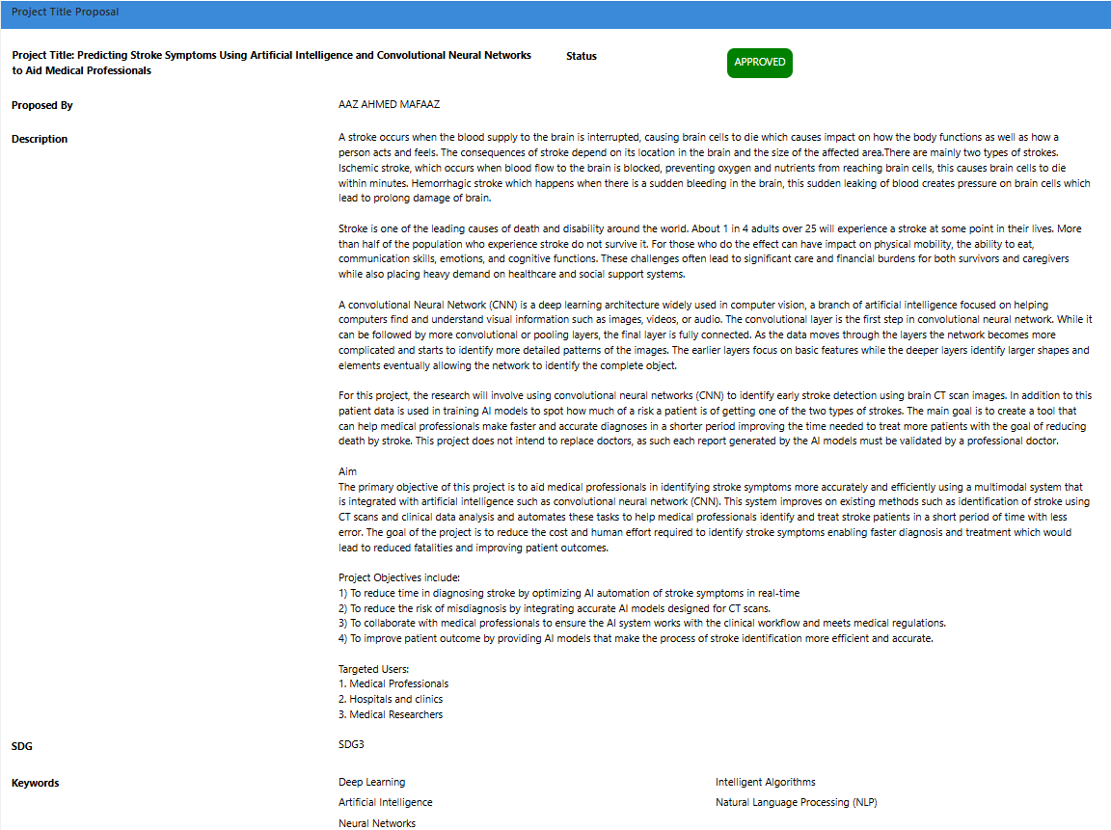



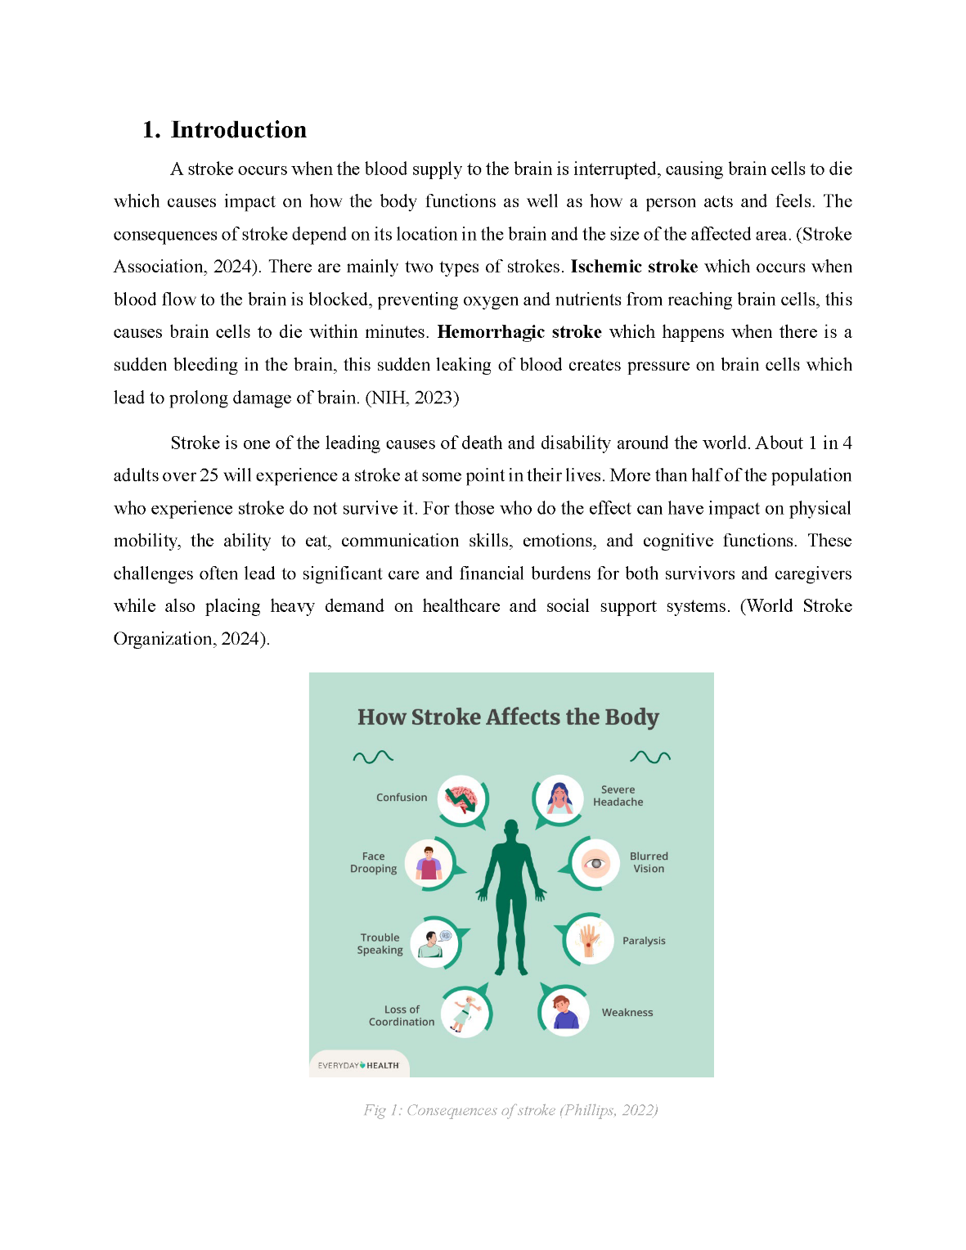

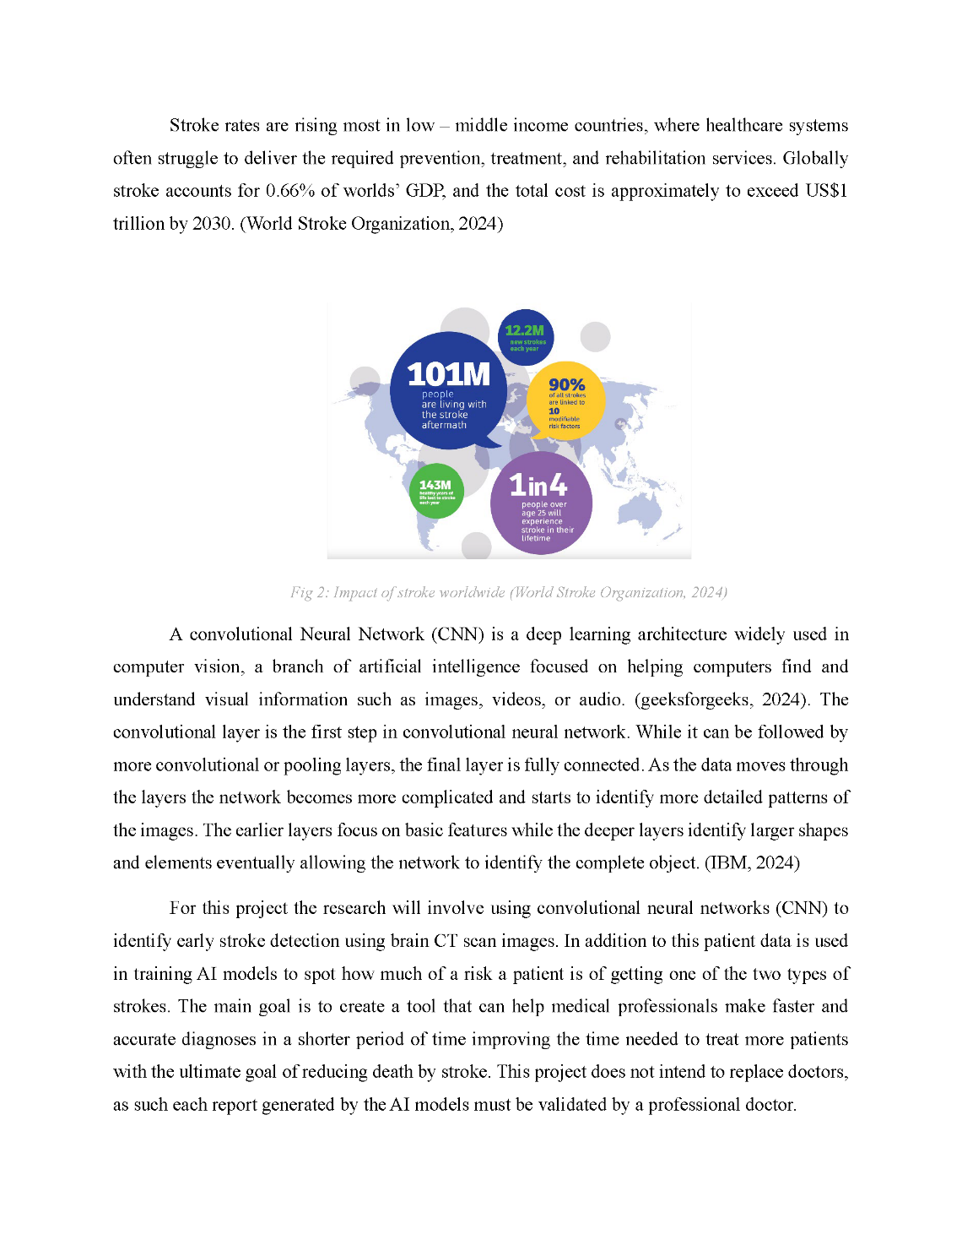

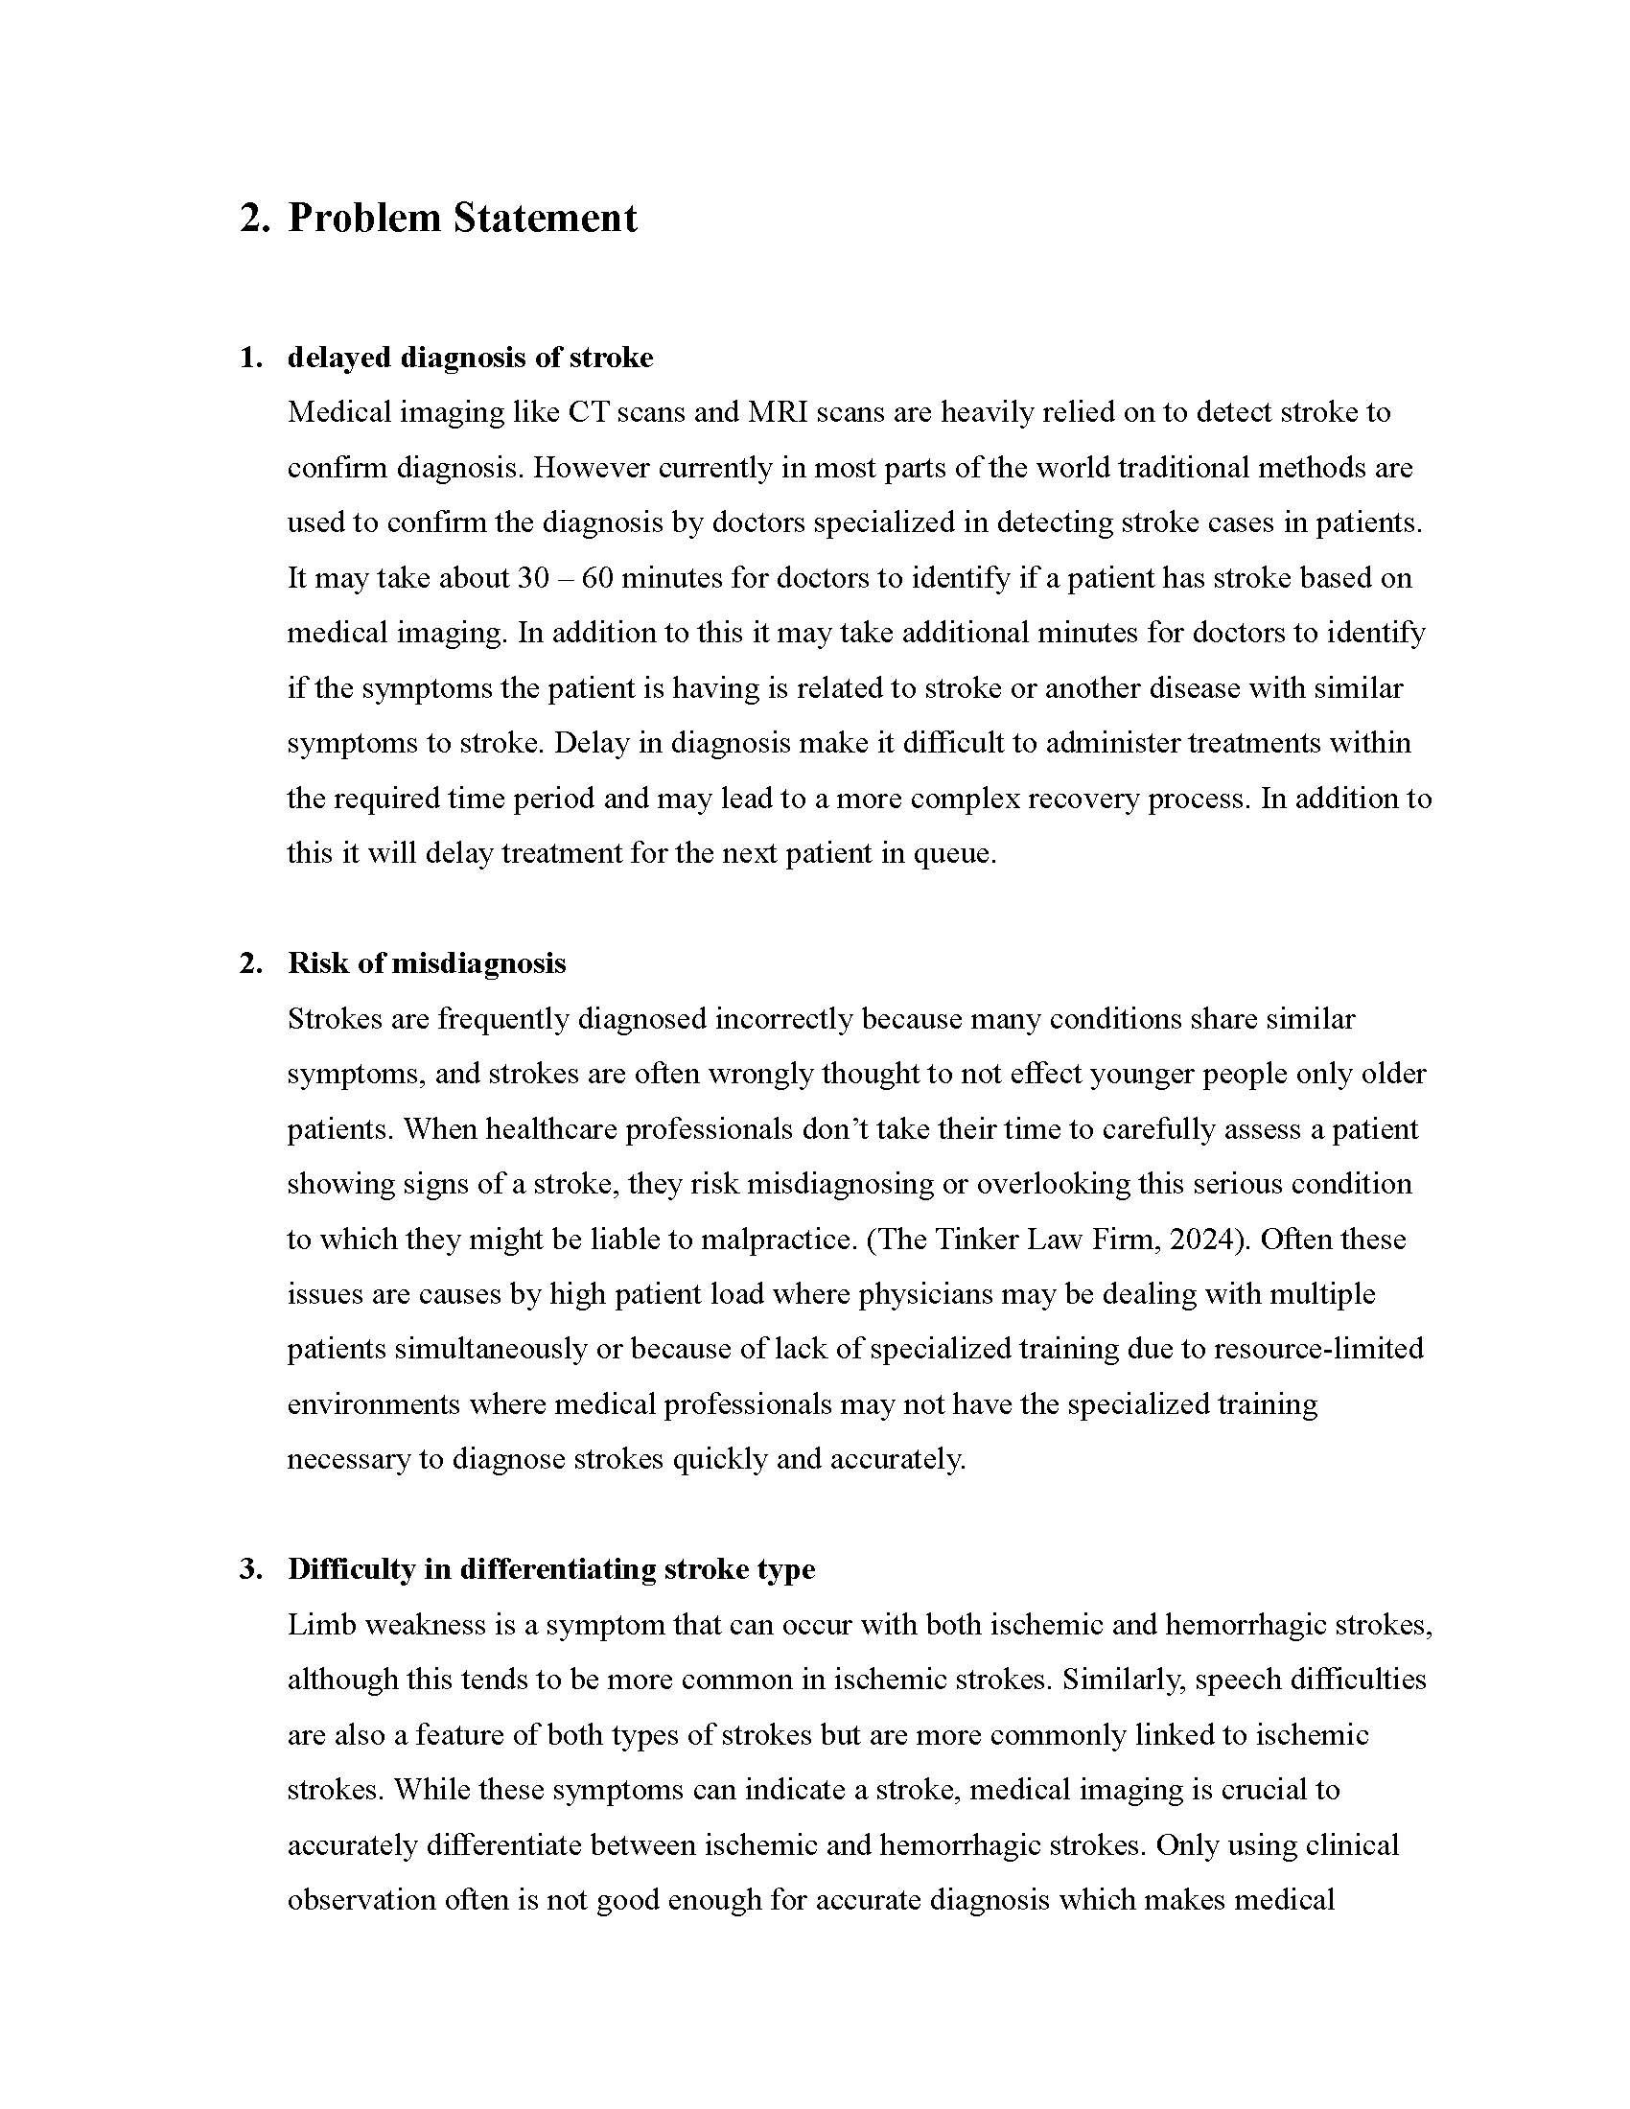

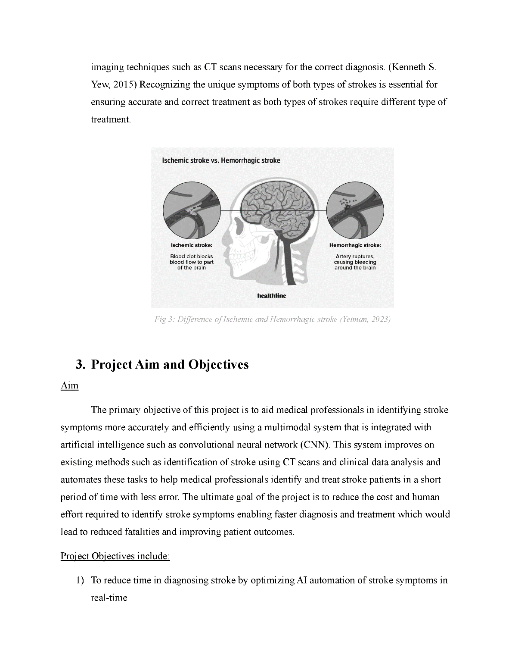

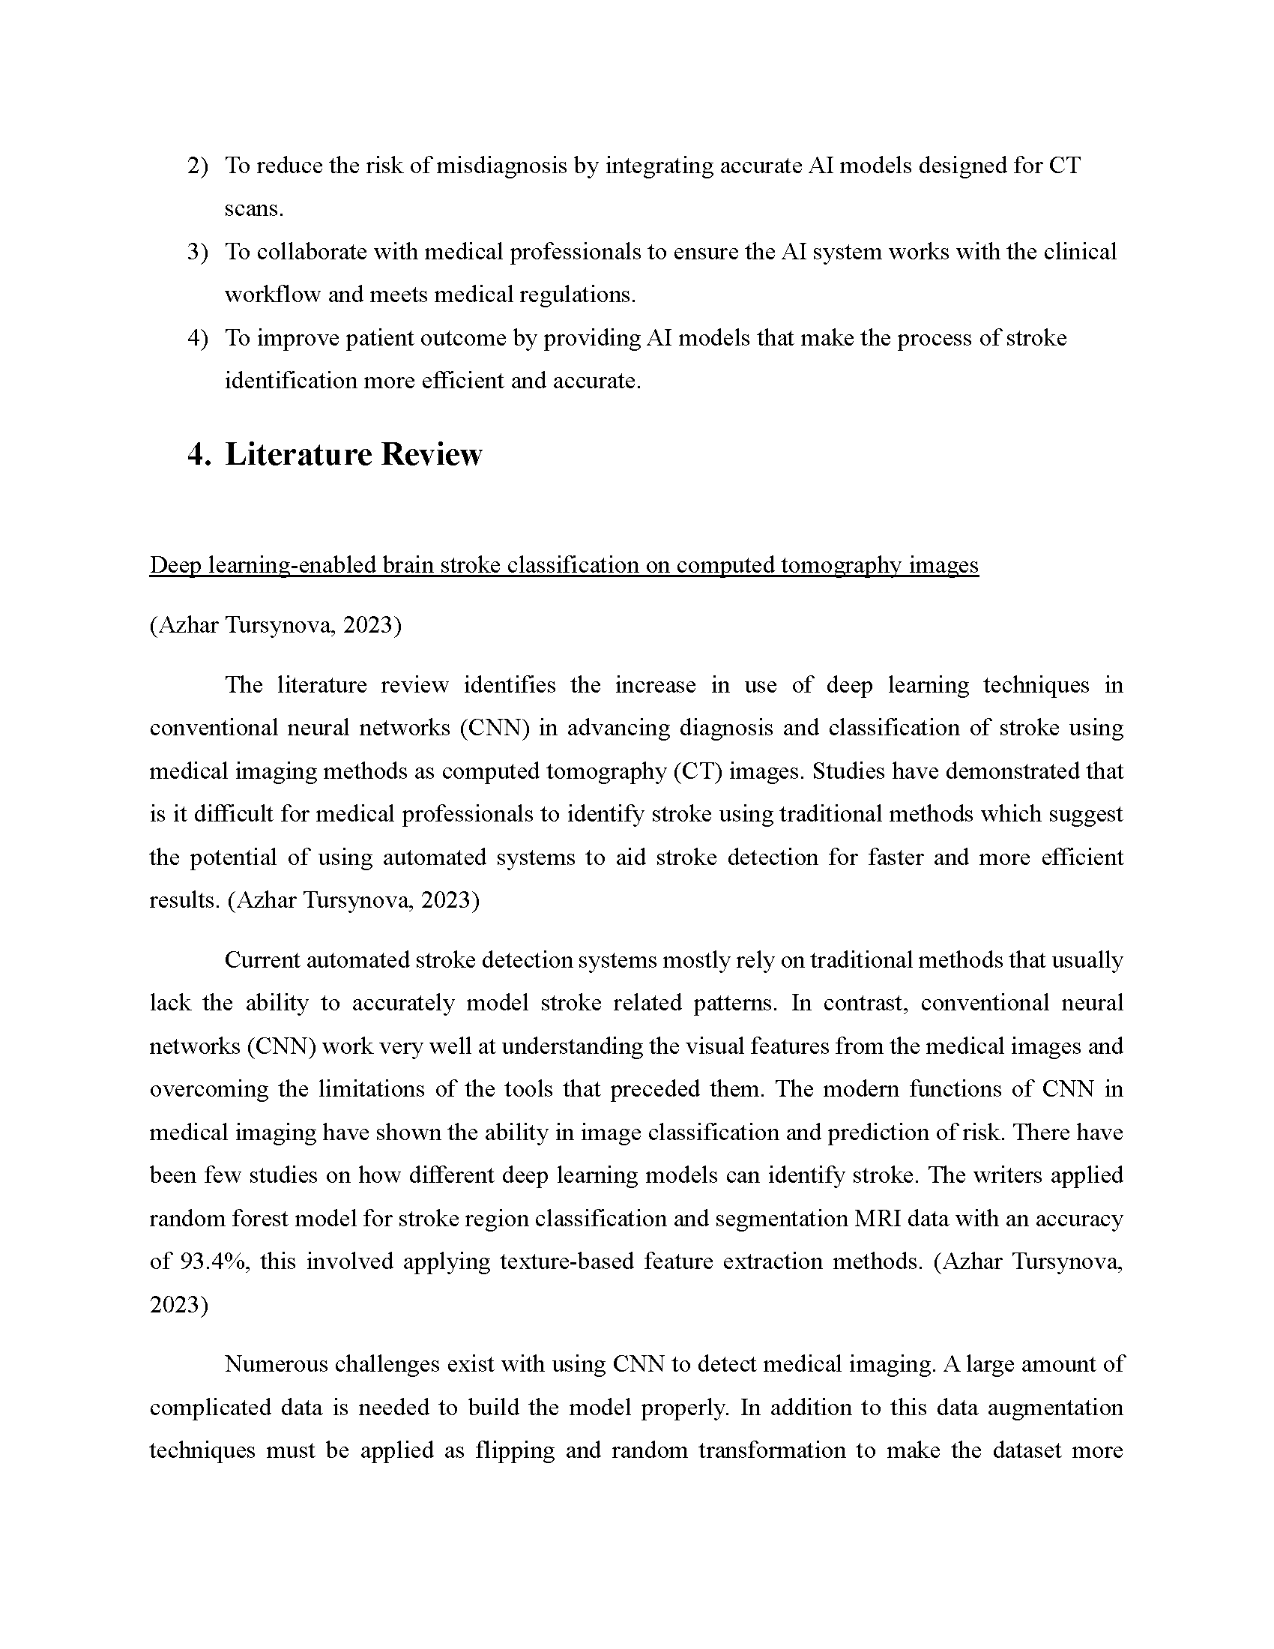

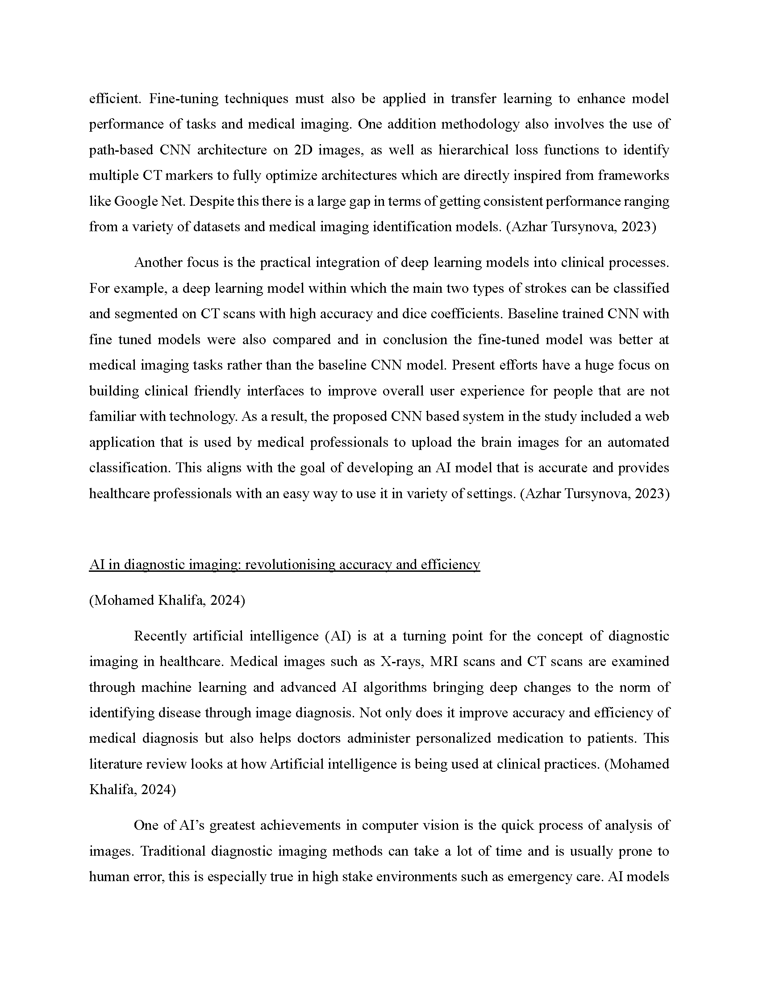

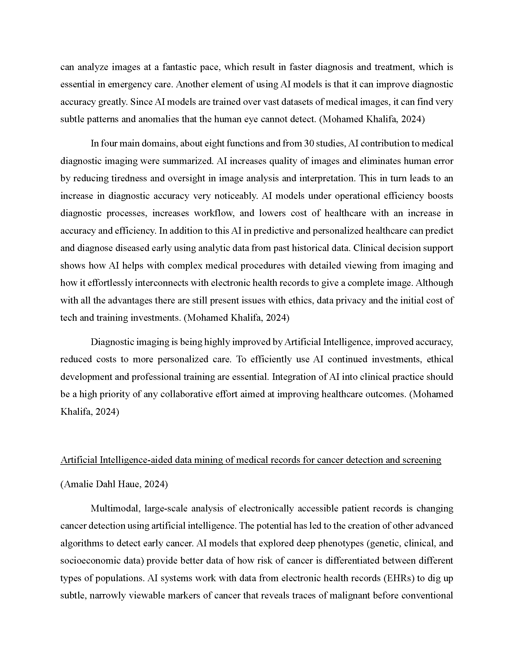

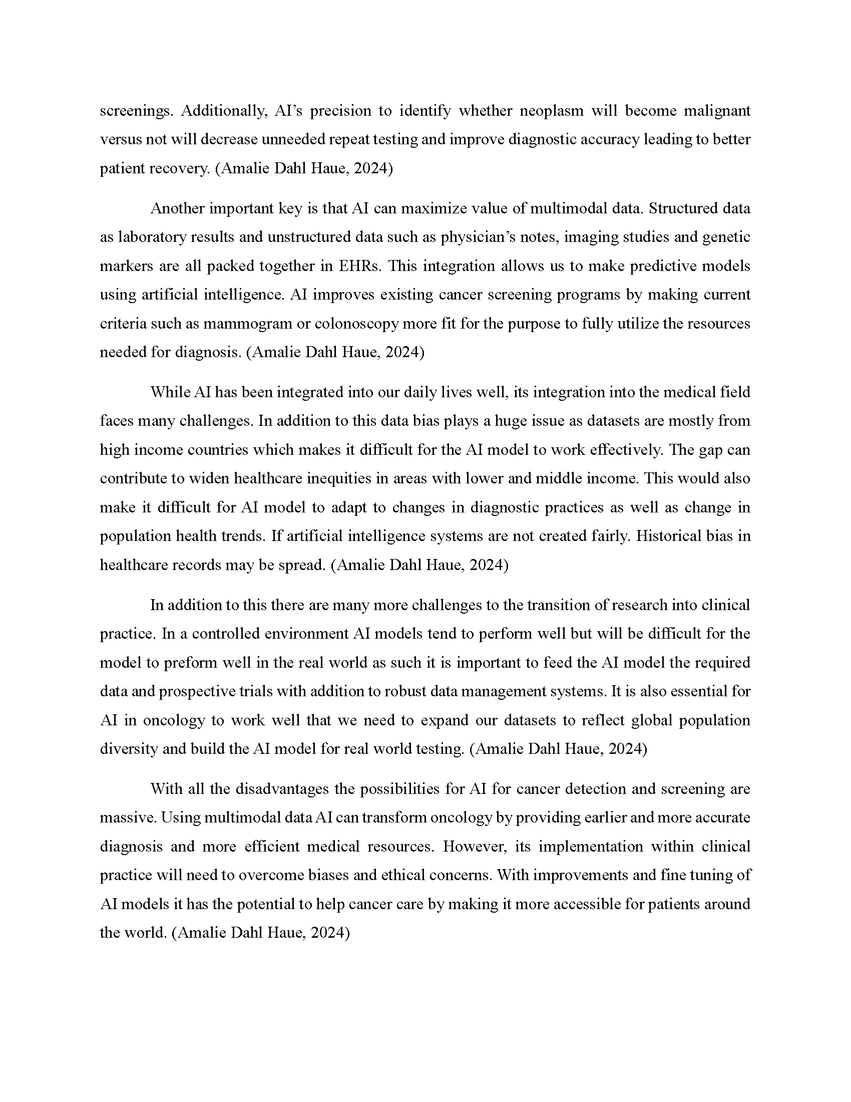

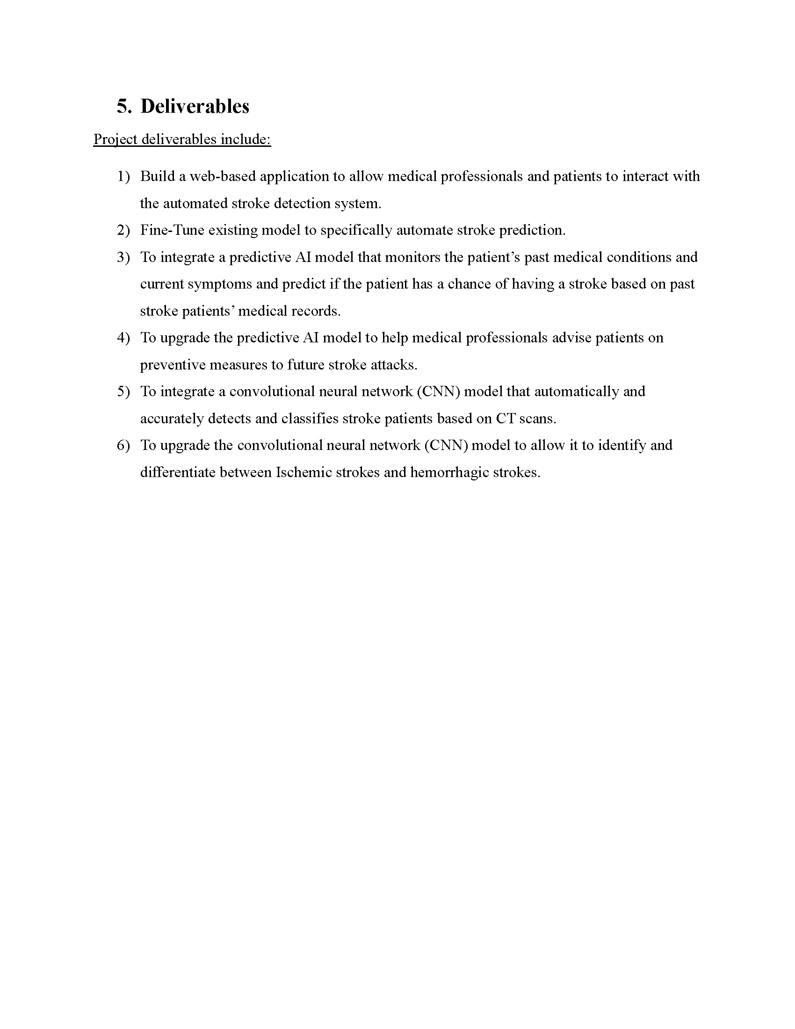

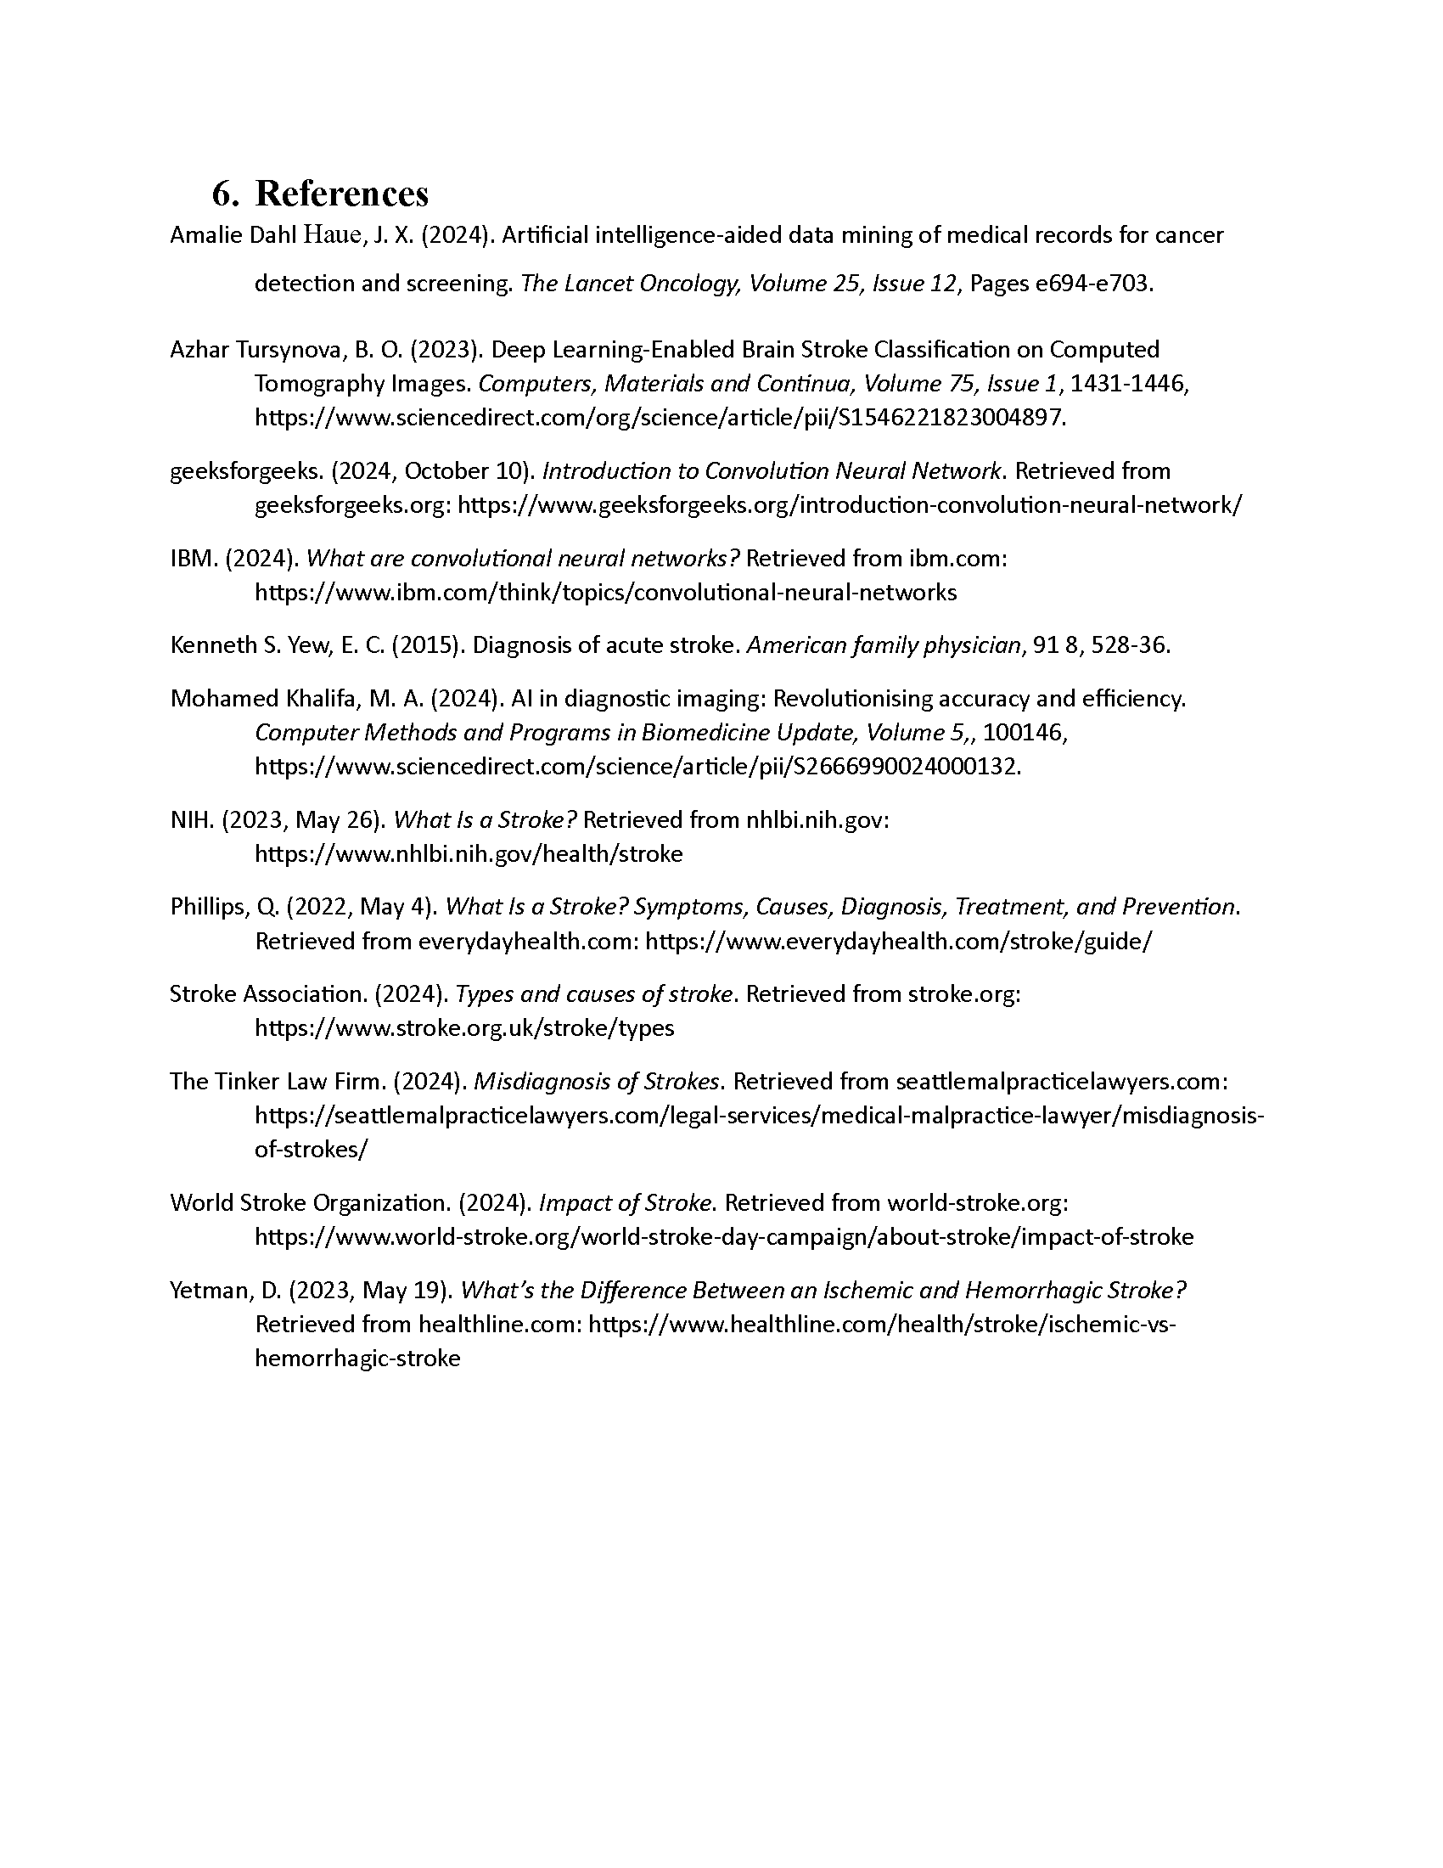

Figure : Draft Project Proposal

## Appendix B: Ethic Form (Fast Track)

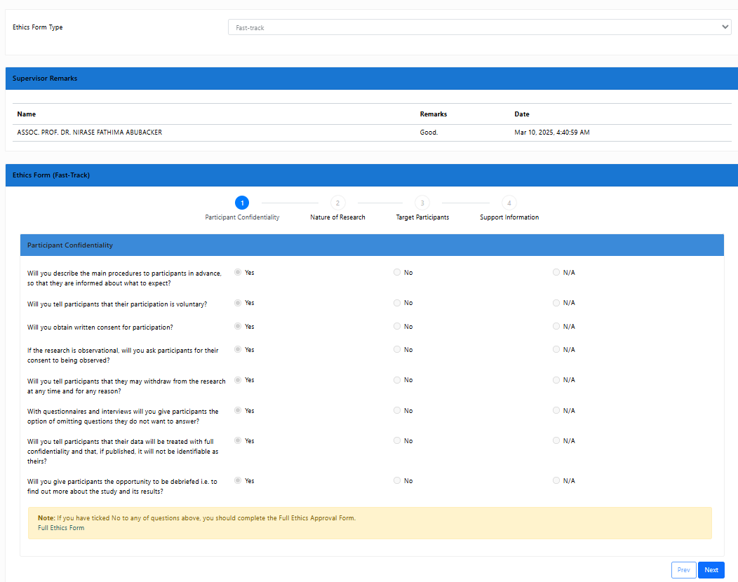

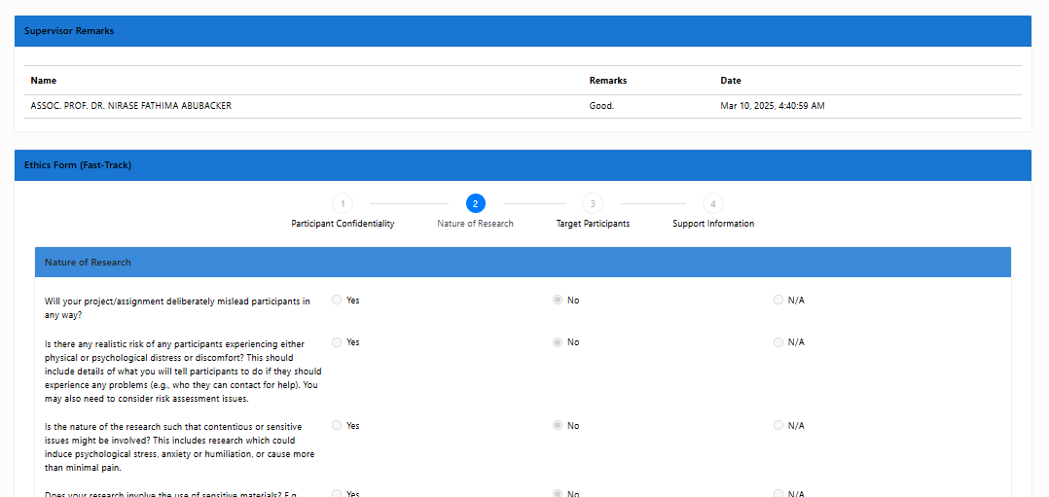

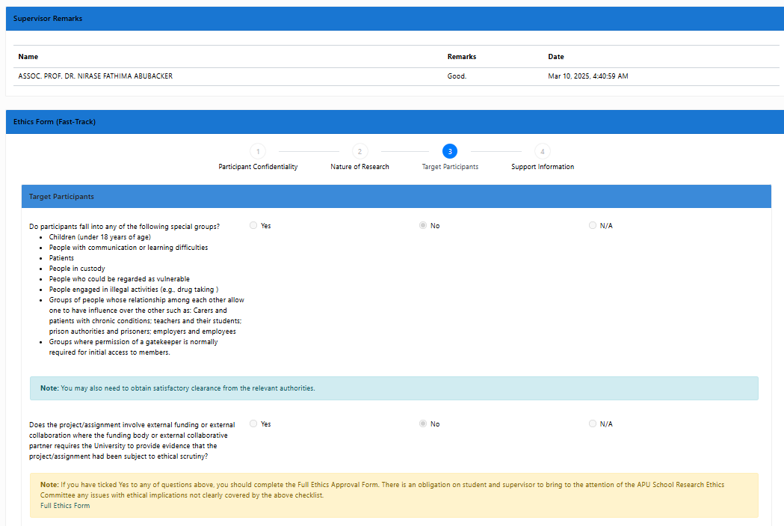

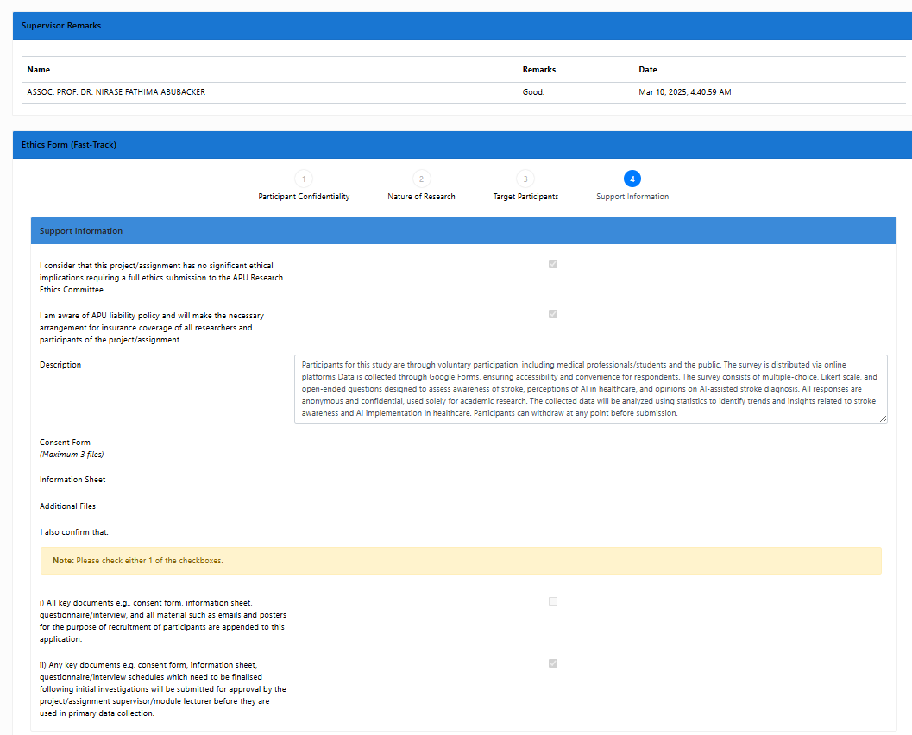

Figure : Ethic forms (Fast Track)

## Appendix C: Log Sheets

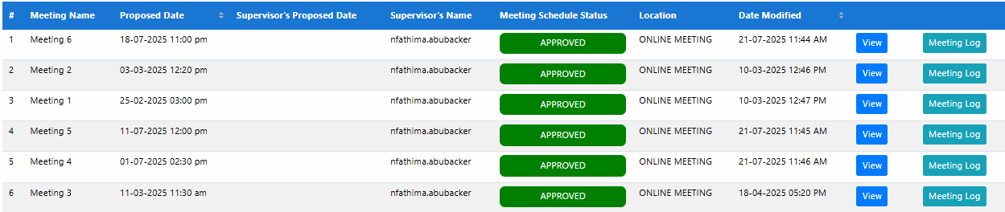

Figure : Log Sheets

## Appendix D: Poster

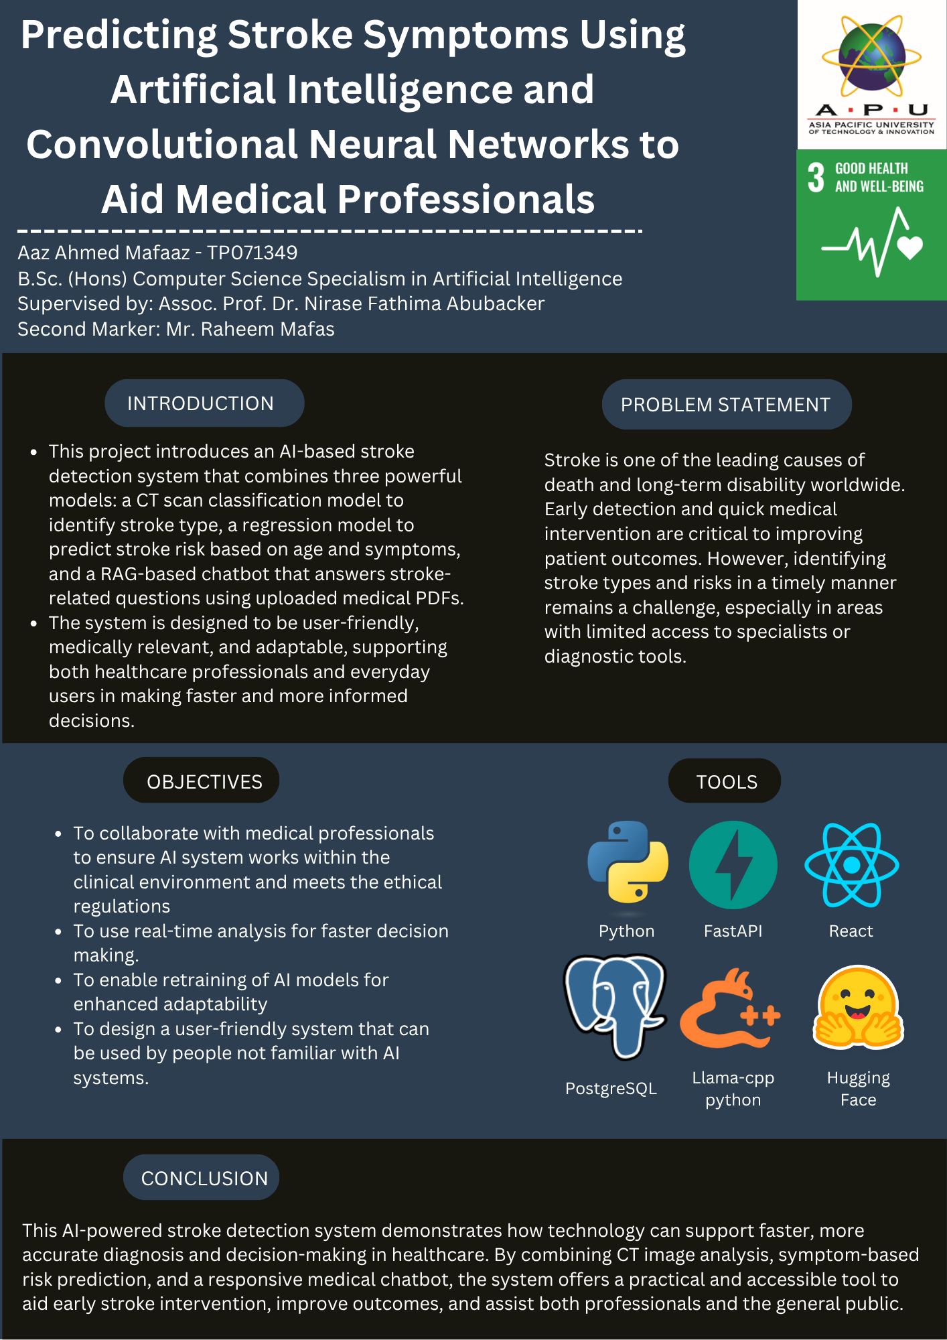

Figure : FYP Poster

## Appendix E: Gantt Chart

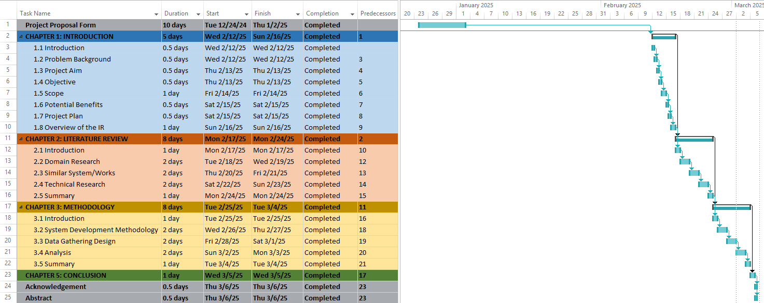

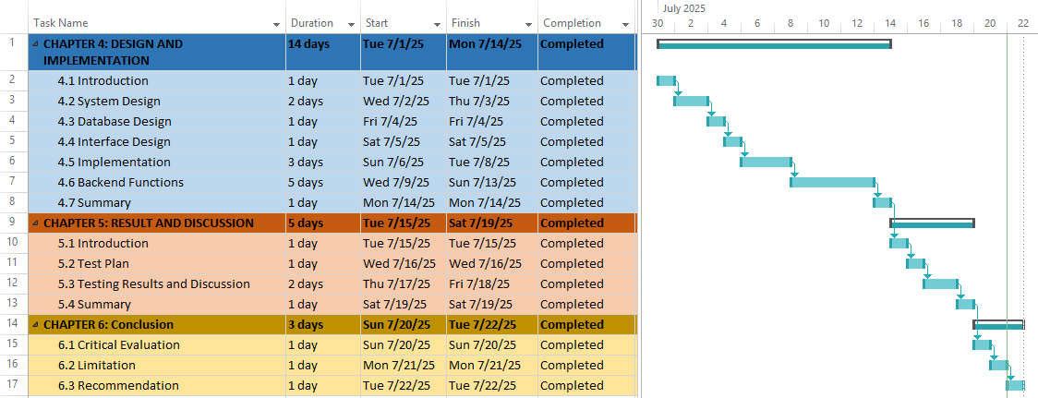

Figure : Gantt Charts

## Appendix F: Sample Code Implementation

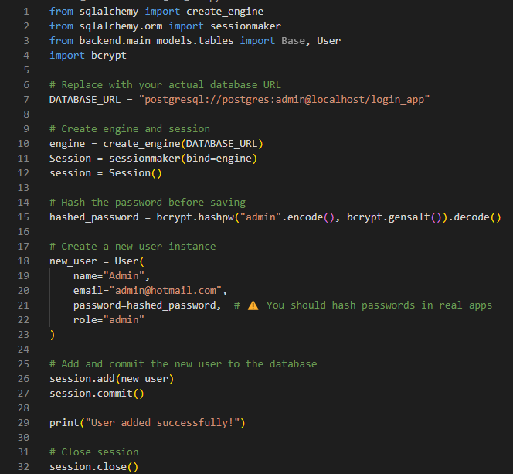

Figure : add_test_user.py

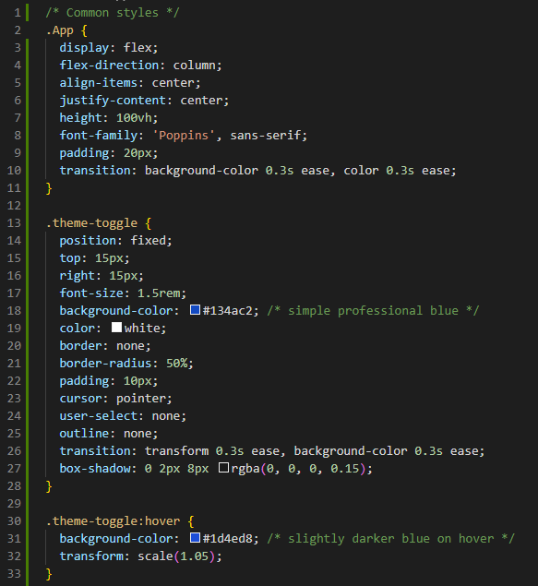

Figure : App.css Example

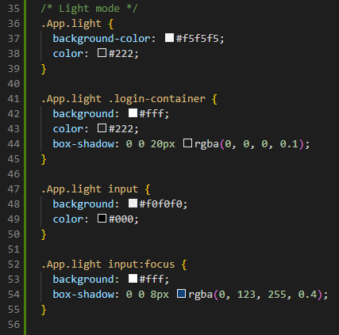

Figure : App.css Light Mode Example

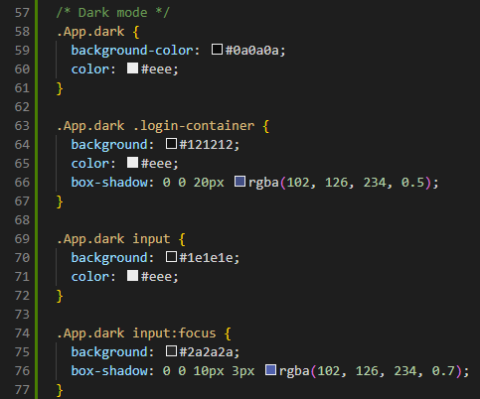

Figure : App.css Dark Mode Example

## Appendix G: Respondent Demographic Profile

|  |  |  |  |
| --- | --- | --- | --- |
| **Name** | **Gender** | **Age** | **Nationality** |
| 1. Maldha | Female | 18 - 25 | Maldivian |
| 1. Shubashah | Female | 18 - 25 | Maldivian |
| 1. Musthafa | Male | 46 - 55 | Maldivian |
| 1. Iba | Female | 18 - 25 | Maldivian |
| 1. Afra | Female | 18 - 25 | Maldivian |
| 1. Mauva | Female | 18 - 25 | Maldivian |
| 1. Mariyam | Female | 36 - 45 | Maldivian |
| 1. Hassan | Male | 36 - 45 | Maldivian |
| 1. Mafaaza | Female | 36 - 45 | Maldivian |
| 1. Hanif | Male | 18 - 25 | Maldivian |
| 1. Fathimath | Female | 36 - 45 | Maldivian |
| 1. Sheen | Female | 46 - 55 | Maldivian |
| 1. Chipu | Female | 36 - 45 | Maldivian |
| 1. Mohammed | Male | 46 - 55 | Maldivian |
| 1. Raeefa | Female | 36 - 45 | Maldivian |
| 1. Ahmed | Male | 46 - 55 | Maldivian |
| 1. Shirneel | Male | 46 - 55 | Maldivian |
| 1. Haleem | Male | 46 - 55 | Maldivian |
| 1. En | Female | 18 - 25 | Maldivian |
| 1. Maahin | Female | 18 - 25 | Maldivian |
| 1. Yamaan | Male | 18 - 25 | Maldivian |
| 1. Naail | Male | 26 - 35 | Maldivian |
| 1. Shivny | Female | 46 - 55 | Maldivian |
| 1. Shaulan | Male | 26 - 35 | Maldivian |
| 1. Sofoora | Female | 36 - 45 | Maldivian |
| 1. Alhaja | Male | 18 - 25 | Syrian |
| 1. Abdullah | Male | 18 - 25 | Syrian |
| 1. Zayed | Male | 18 - 25 | Indonesian |
| 1. Sepehr | Male | 18 - 25 | Iranian |
| 1. Yjun | Male | 18 - 25 | Malaysian |
| 1. Kai | Male | 18 - 25 | Malaysian |
| 1. Malvin | Male | 18 - 25 | Malaysian |
| 1. Chenyu | Female | 18 - 25 | Malaysian |
| 1. Vidi | Male | 18 - 25 | Indonesian |
| 1. Reno | Male | 18 - 25 | Malaysian |

Table : Respondent Demographic Profile

## Appendix H: Similarity Report

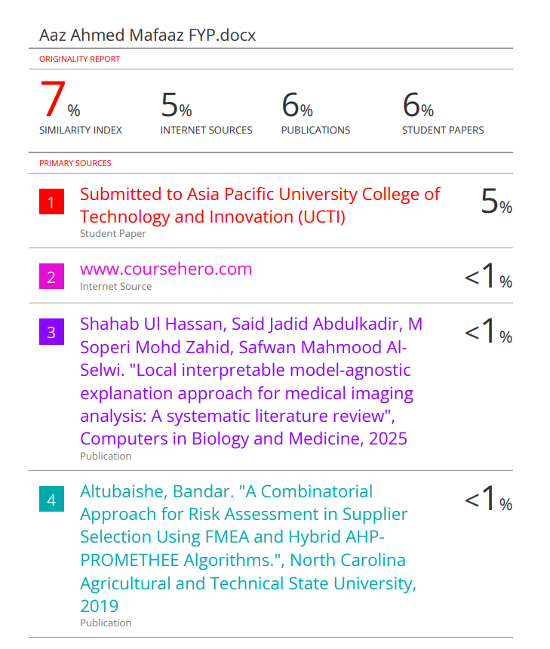

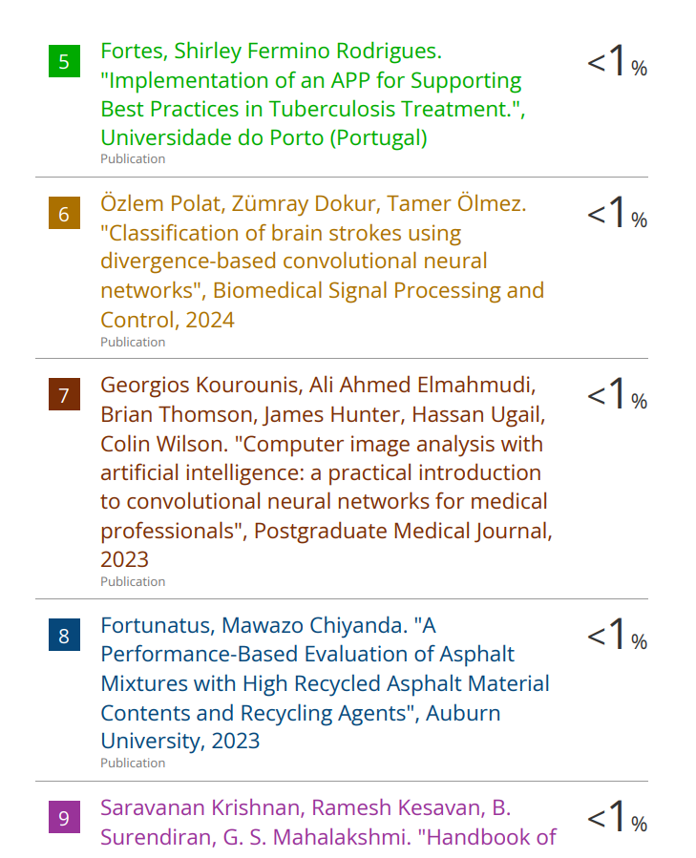

Figure : Similarity Report

## Appendix I: LLM Cloud Storage Link

[LLM Model](https://cloudmails-my.sharepoint.com/:f:/g/personal/tp071349_mail_apu_edu_my/ElfozTGeUr1EsjDSNS0PYgYBcAPylkZdauK3snEFhCMDHA?e=dZTii1)

Contains the download link for the LLM model, and the instructions on where to place the file.